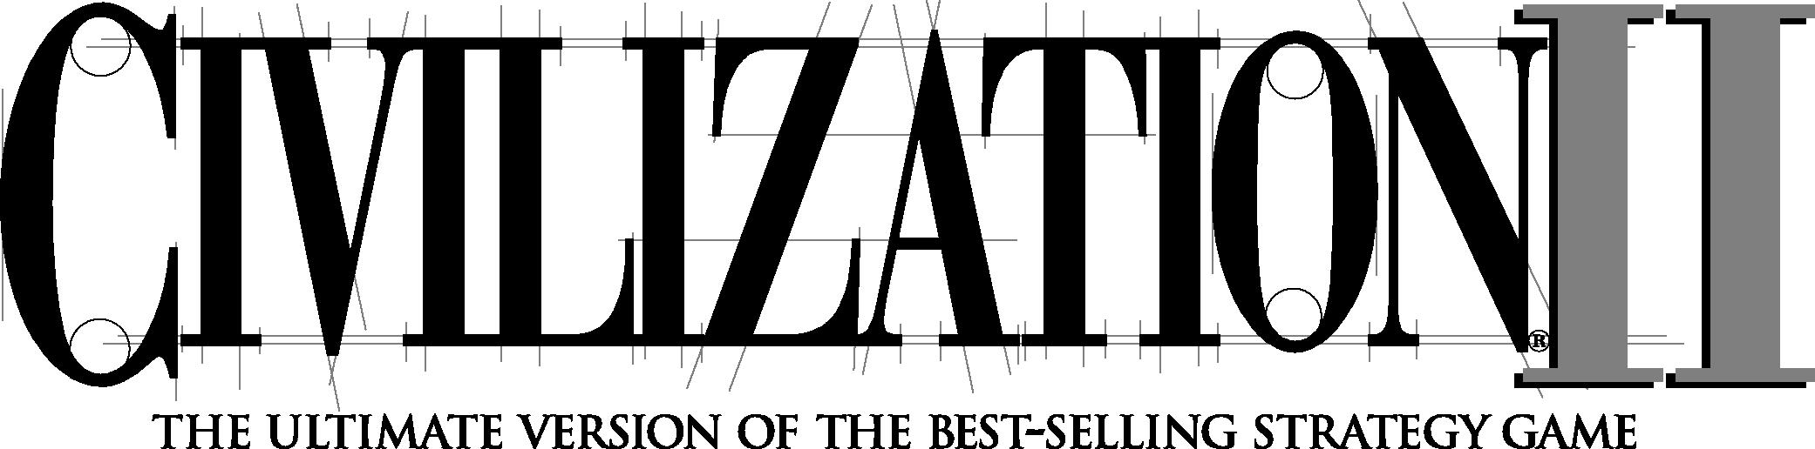

Preface

&

Instruction Manual

**PLAYING**

**a**

Once the automated installation and set-up are complete, the game is ready to play. To start:

* If you want to see and hear the uninstalled video and multimedia portions of the game, make sure that the ***Civilization II*** CD-ROM is in its drive. (Note that, if you did not install the **Recommended** files, there will be no sound effects regardless of whether the CD is in the drive. There will be some music.)
* If it is not already running, start Windows.
* Now simply double-click on the ***Civilization II*** icon (or click ***Civ2*** on the Windows 95 Start Menu) to start the game.

**FEATURES UPDATE: CHANGES TO THE CHEAT MENU**

Remember, the CHEAT menu comes with no guarantees—use it at your own risk and don’t blame Customer Service if they can’t help when it causes problems.

Though it has other uses, the CHEAT menu is intended to supplement the map editing utility. Once you’ve created a world in which to play, you can use the CHEAT menu options to further customize the situation. You can create your own game *scenarios*—and save them for later play. In combination, the Map Editor and CHEAT menu can give you the same power as the “Mission Builder” included with many of the best flight simulations.

To this end, the DISCOVER ALL TECHNOLOGIES option described in the manual has been replaced with the more specific EDIT TECHNOLOGIES. (The shortcut key hasn’t changed; it’s still *c* shift a).) This gives you complete control over the technological status of every civilization in the game, including yours. One by one, you can select then give or take away advances. Use the GIVE/TAKE ALL button to bestow every advance there is, except for Future Tech. Click on it again to ruthlessly strip them all away! Note, however, that some technologies (IRRIGATION, for one) are known by all civilizations at the dawn of time; you cannot take these away.

A TERRAIN button has been added to the CHANGE TERRAIN AT CURSOR option. This allows you to change the terrain type of the square at the current cursor location. Note that you cannot specify special resources for any terrain square; they just happen.

**b**

Four new options have been added to the CHEAT menu.

**EDIT UNIT** *c s* **0**

Use this to change the attributes of any unit at the current cursor location. The veteran status, movement points, hit points, home city, and fortification status are manipulable. If you’re editing a Caravan or Freight unit, you can change the type of commodity it is carrying. You cannot, however, change a unit to another type.

**EDIT CITY** *c s*

This option allows you to meddle with the status of any city on the map—as long as you position the cursor on it first. You can set the size (population) of the town, determine exactly how many shields are in the PRODUCTION Box, make all the Wonders of the World in that burg suddenly disappear, or copy all of the improvements in some other city to this one. If the city is in disorder or celebrating a We Love the _____ Day, you can clear either state of affairs. Finally, you can make the city an *objective* of the scenario (the number in parentheses will change to ‘1’) or remove it from the list of objectives (‘0’).

What good is an objective? Read about the **Scenario Parameters** option to find out.

**EDIT KING** *c s* QK

No, this doesn’t let you change what the rulers of other civilizations look like. You can, however, specify any ruler’s treaty status with every other civilization, the most recent turn when two civilizations had contact, the ruler’s current attitude toward other rulers, and any ruler’s current reputation. In addition, you can clear a ruler’s patience counter (making them very tolerant for a while), set or clear a research goal for any civilization, and determine how far each ruler has progressed toward the advance currently being researched. You can copy the technology of one civilization to another—quite a shortcut from doing it one advance at a time with the EDIT TECHNOLOGIES option. Finally, you can change the name and sex of every leader in the world.

**SCENARIO PARAMETERS** Ctrl Shift



This is a catch-all that includes some powerful tools for setting up scenarios. Most of these options have little or no use during a game already in progress.

TECH PARADIGM affects how long it takes to research technological advances. The default is 10/10. By lowering the numerator, you decrease the time necessary to discover new advances; the fastest you can allow research to progress is 1/10. Conversely, increasing the numerator makes scientific progress slower.

TURN YEAR INCREMENT allows you to decide how much time passes with each game turn. If you leave this at zero, ***Civilization II*** uses the default increment, which changes with time as described in the manual. Any positive integer sets a number of years to pass per turn; a negative integer sets a number of months to pass per turn.

STARTING YEAR determines the year or month in which the scenario will begin (month if you’ve set the TURN YEAR INCREMENT to a number of months, year if you’ve set it to a number of years). Any positive number is AD, and any negative number is BC.

MAXIMUM TURNS allows you to set the length of the game in turns.

TOGGLE SCENARIO FLAG tells ***Civilization II*** whether or not you want to save this game setup as a scenario. Note that the CHEAT menu option SAVE AS SCENARIO automatically sets this toggle for you.

WIPE ALL GOODY BOXES removes all of the villages of minor tribes from the world, permanently.

RESTORE ALL GOODY BOXES recreates all of the minor tribe villages in the world, except for those which were originally on a terrain square that is now occupied by a city or unit.

REVEAL WHOLE MAP makes the scenario take place in a known world. The entire map, excluding enemy units but including their cities, will be visible from the beginning of the game.

COVER WHOLE MAP makes the scenario take place in an unexplored world, the ***Civilization*** standard.

SET SCENARIO NAME allows you to give your scenario a title.

TOGGLE TOTAL WAR FLAG silences the senate in all republics and democracies. Set this to ‘1’ to force the assumption that there is a war going on at the outset of the scenario, and that the usual senatorial meddling in foreign affairs has been effectively stifled for the duration.

EDIT VICTORY CONDITIONS itself contains multiple options:

**d**

* The first, TOGGLE USE OBJECTIVE VICTORY FLAG, must be set to ‘1’; otherwise, the game ignores the rest of these settings. Essentially, the objective victory flag tells ***Civilization II*** to completely ignore the usual scoring conventions. Rather, all that counts is the taking of the pre-set objectives in the scenario. Using the EDIT CITY option on the CHEAT menu, you can make any city a scenario objective.
* Toggle Count Wonders as Objectives determines whether or not captured Wonders of the World also count toward the objective score.
* Next, you decide which civilization will be the protagonist; this is *not* the player’s civilization. This setting only determines which civilization is used as the benchmark for the four final settings.
* These last four allow you to set conditions for the types of outcome possible in an objective scenario. For each, enter the number of objectives that the protagonist civilization must control (that is, have conquered or kept) at the end of the game in order to accomplish that level of victory or defeat. Other civilizations are automatically assigned the corresponding outcome. For example, if the Romans as protagonists achieve a Marginal Defeat, all other groups win a Marginal Victory.

EDIT SPECIAL RULES also contains a few sub-options, each of which is fairly straightforward. You can prevent any civilization from *ever* changing its form of government, make it impossible to obtain advances by taking over enemy cities, and remove the spectre of pollution from the game. One caveat is necessary; you should ***NEVER*** use the last option—SPECIAL WWII-ONLY AI. This was put in as an aid for the game designers and will almost certainly cause your scenario to crash.

**TABLE OF CONTENTS**

**i**

**INTRODUCTION . . . . . . . . . . . . . . . . . . . . . . . . . . . . . . . . . . . . . . . . . . . . . . . . . . . . . . . . 1 FOUR IMPULSES OF CIVILIZATION. . . . . . . . . . . . . . . . . . . . . . . . . . . . . . . . . . . . . . . . . . . 2** Exploration **•** Economics **•** Knowledge **•** Conquest

**THEBIG PICTURE . . . . . . . . . . . . . . . . . . . . . . . . . . . . . . . . . . . . . . . . . . . . . . . . . . . . . . 3
  
WINNING. . . . . . . . . . . . . . . . . . . . . . . . . . . . . . . . . . . . . . . . . . . . . . . . . . . . . . . . . . . . 4
  
THE VARIOUS DOCUMENTATION . . . . . . . . . . . . . . . . . . . . . . . . . . . . . . . . . . . . . . . . . . . 4**

Interface Conventions. . . . . . . . . . . . . . . . . . . . . . . . . . . . . . . . . . . . . . . . 5

**TUTORIAL. . . . . . . . . . . . . . . . . . . . . . . . . . . . . . . . . . . . . . . . . . . . . . . . . . . . . . . . . . . . . . . 7 BUILDING YOUR FIRST CITY . . . . . . . . . . . . . . . . . . . . . . . . . . . . . . . . . . . . . . . . . . . . . . 8** Examining the City Display **•** First Priorities

**RESEARCHING CIVILIZATION ADVANCES . . . . . . . . . . . . . . . . . . . . . . . . . . . . . . . . . . . . . 12
  
MEANWHILE, BACK IN THE CITY. . . . . . . . . . . . . . . . . . . . . . . . . . . . . . . . . . . . . . . . . 13**

Your First Unit **•** Your First Civilization Advance **•** Changing Production

**FINDING A MINOR TRIBE . . . . . . . . . . . . . . . . . . . . . . . . . . . . . . . . . . . . . . . . . . . . . . . 14 POPULATION INCREASE . . . . . . . . . . . . . . . . . . . . . . . . . . . . . . . . . . . . . . . . . . . . . . . . . . 15**

**INTERIM. . . . . . . . . . . . . . . . . . . . . . . . . . . . . . . . . . . . . . . . . . . . . . . . . . . . . . . . . . . . . 16 EXPANDING YOUR EMPIRE . . . . . . . . . . . . . . . . . . . . . . . . . . . . . . . . . . . . . . . . . . . . . . . 16**

Meeting Another Civilization . . . . . . . . . . . . . . . . . . . . . . . . . . . . . . . . . . 18

**IMPROVING THE TERRAIN. . . . . . . . . . . . . . . . . . . . . . . . . . . . . . . . . . . . . . . . . . . . . . . . 19**Establishing a Trade Route . . . . . . . . . . . . . . . . . . . . . . . . . . . . . . . . . . . 20
  
**CHANGING GOVERNMENTS . . . . . . . . . . . . . . . . . . . . . . . . . . . . . . . . . . . . . . . . . . . . . . 22
  
CONCLUSION . . . . . . . . . . . . . . . . . . . . . . . . . . . . . . . . . . . . . . . . . . . . . . . . . . . . . . . . . 22**

**SETTING UP A GAME. . . . . . . . . . . . . . . . . . . . . . . . . . . . . . . . . . . . . . . . . . . . . . . . . . . . 23**

**YOUR FIRST DECISION. . . . . . . . . . . . . . . . . . . . . . . . . . . . . . . . . . . . . . . . . . . . . . . . . . 23**

**CUSTOMIZING GAME SET UPS . . . . . . . . . . . . . . . . . . . . . . . . . . . . . . . . . . . . . . . . . . . . 24**

Select Size of World **•** Customize: Landmass **•** Customize: Land Form **•** Customize: Climate **•** Customize: Temperature **•** Customize: Age **•**

Difficulty Levels **•** Level Of Competition **•** Level of Barbarian Activity **•** Select Game Rules **•** Select Your Gender **•** Select Your Tribe **•**

Select Your City Style **•** Ready, Set, Go

**CHANGES FROM CIvILIZATION TO CIvILIZATION II . . . . . . . . . . . . . . . . . . . . . . 31 CIVILIZATION’S NEW LOOK . . . . . . . . . . . . . . . . . . . . . . . . . . . . . . . . . . . . . . . . . . . . . . 31** The Map **•** The Units **•** The Cities **•** The Displays

**NEW COMBAT CONCEPTS. . . . . . . . . . . . . . . . . . . . . . . . . . . . . . . . . . . . . . . . . . . . . . . . 32** Hit Points & Firepower **•** Restoration **•** New and Changed Units **•**

Special Combat Cases

**NEW PRODUCTION CONCEPTS . . . . . . . . . . . . . . . . . . . . . . . . . . . . . . . . . . . . . . . . . . . 34** Waste **•** Penalties for Switching Production **•**

**ii**

New and Changed Improvements

**NEW TERRAIN CONCEPTS . . . . . . . . . . . . . . . . . . . . . . . . . . . . . . . . . . . . . . . . . . . . . . . 36** Rivers **•** New Special Terrain **•** Upgrading City Squares

**NEW MOVEMENT CONCEPTS . . . . . . . . . . . . . . . . . . . . . . . . . . . . . . . . . . . . . . . . . . . . . 37**

NewOrders . . . . . . . . . . . . . . . . . . . . . . . . . . . . . . . . . . . . . . . . . . . . . . 38

**GOVERNMENT IMPROVEMENTS. . . . . . . . . . . . . . . . . . . . . . . . . . . . . . . . . . . . . . . . . . . . 38 NEW CONCEPTS IN DIPLOMACY. . . . . . . . . . . . . . . . . . . . . . . . . . . . . . . . . . . . . . . . . . . 39** Reputation **•** Diplomatic States **•** Counterespionage

**NEW AND IMPROVED WONDERS . . . . . . . . . . . . . . . . . . . . . . . . . . . . . . . . . . . . . . . . . . 41
  
MISCELLANEOUS CHANGES. . . . . . . . . . . . . . . . . . . . . . . . . . . . . . . . . . . . . . . . . . . . . . . 42**

**THE BASICS OF CITIES . . . . . . . . . . . . . . . . . . . . . . . . . . . . . . . . . . . . . . . . . . . . . . . . . . 43 CITYCONCEPTS. . . . . . . . . . . . . . . . . . . . . . . . . . . . . . . . . . . . . . . . . . . . . . . . . . . . . . . 44 GAINING NEW CITIES . . . . . . . . . . . . . . . . . . . . . . . . . . . . . . . . . . . . . . . . . . . . . . . . . . 45**

Founding New Cities . . . . . . . . . . . . . . . . . . . . . . . . . . . . . . . . . . . . . . . . 45

Choosing Your Location **•** Proximity Of Cities **•**

Strategic Value

Capturing Cities . . . . . . . . . . . . . . . . . . . . . . . . . . . . . . . . . . . . . . . . . . . 47
  
Converting Minor Tribes . . . . . . . . . . . . . . . . . . . . . . . . . . . . . . . . . . . . . 48

**THE PARTS OF A CITY . . . . . . . . . . . . . . . . . . . . . . . . . . . . . . . . . . . . . . . . . . . . . . . . . . 49** The City Square **•** The City Radius

**MANAGING YOUR CITIES . . . . . . . . . . . . . . . . . . . . . . . . . . . . . . . . . . . . . . . . . . . . . . . 51**

City Management Concepts . . . . . . . . . . . . . . . . . . . . . . . . . . . . . . . . . . . 52

**POPULATION GROWTH • RESOURCE DEVELOPMENT . . . . . . . . . . . . . . . . . . . . . . . . . . . . 53** Tax Revenue **•** Technological Research **•** Industrial Production

**CITY PROTECTION . . . . . . . . . . . . . . . . . . . . . . . . . . . . . . . . . . . . . . . . . . . . . . . . . . . . . 56
  
IMPROVEMENTS . . . . . . . . . . . . . . . . . . . . . . . . . . . . . . . . . . . . . . . . . . . . . . . . . . . . . . . 57**

Losing Improvements . . . . . . . . . . . . . . . . . . . . . . . . . . . . . . . . . . . . . . . 58

Capture **•** Fire Sale **•** Sabotage **•** Selling Improvements **•**

RushJobs . . . . . . . . . . . . . . . . . . . . . . . . . . . . . . . . . . . . . . . . . . . . . . . 59
  
Renaming Your City . . . . . . . . . . . . . . . . . . . . . . . . . . . . . . . . . . . . . . . . 60

**MANAGING YOUR TRADE . . . . . . . . . . . . . . . . . . . . . . . . . . . . . . . . . . . . . . . . . . . . . . . 61** Trade Management Concepts. . . . . . . . . . . . . . . . . . . . . . . . . . . . . . . . . . 62

**TRADE RATES• GOVERNMENTS . . . . . . . . . . . . . . . . . . . . . . . . . . . . . . . . . . . . . . . . . . . 63** Anarchy **•** Despotism **•** Monarchy **•** Republic **•** Communism **•**

Fundamentalism **•** Democracy

**HAPPINESS & CIVIL DISORDER . . . . . . . . . . . . . . . . . . . . . . . . . . . . . . . . . . . . . . . . . . . 70**Special Unhappiness Factors **•** Civil Disorder. . . . . . . . . . . . . . . . . . . . . . . 71
  
Restoring Order . . . . . . . . . . . . . . . . . . . . . . . . . . . . . . . . . . . . . . . . 72

We Love the _____ Day . . . . . . . . . . . . . . . . . . . . . . . . . . . . . . . . . . . . . . 73 Anarchy **•** Despotism **•** Monarchy/Communism/Fundamentalism **•** Republic/Democracy

**iii**

**TERRAIN AND MOVEMENT. . . . . . . . . . . . . . . . . . . . . . . . . . . . . . . . . . . . . . . . . . . . . . 75**

Terrain & Movement Concepts . . . . . . . . . . . . . . . . . . . . . . . . . . . . . . . . 76

**TYPES OF TERRAIN . . . . . . . . . . . . . . . . . . . . . . . . . . . . . . . . . . . . . . . . . . . . . . . . . . . . . 77** A Note about Rivers **•** Standard Terrain Squares **•**

Special Terrain Squares **•** Optimal City Sites **•** Terrain Conversion

**PLANETARY CARETAKING . . . . . . . . . . . . . . . . . . . . . . . . . . . . . . . . . . . . . . . . . . . . . . . . 80** Pollution . . . . . . . . . . . . . . . . . . . . . . . . . . . . . . . . . . . . . . . . . . . . . . . . 80

Nuclear Contamination . . . . . . . . . . . . . . . . . . . . . . . . . . . . . . . . . . . . . . 81

Nuclear Weapons **•** Nuclear Meltdown

Pollution’s Effects **•** Monitoring Pollution **•** Global Warming. . . . . . . . . . . . . 82 **MINORTRIBES. . . . . . . . . . . . . . . . . . . . . . . . . . . . . . . . . . . . . . . . . . . . . . . . . . . . . . . . 83 MOVEMENT. . . . . . . . . . . . . . . . . . . . . . . . . . . . . . . . . . . . . . . . . . . . . . . . . . . . . . . . . . 84 THE ACTIVE UNIT . . . . . . . . . . . . . . . . . . . . . . . . . . . . . . . . . . . . . . . . . . . . . . . . . . . . . 85**

No Orders **•** GoTo Orders **•** Wait Orders **•** Paradrop Orders **•**

Airlift Orders **•** Activating Fortified and Sleeping Units

**NAVIGATING THE MAP WINDOW . . . . . . . . . . . . . . . . . . . . . . . . . . . . . . . . . . . . . . . . . 86 MOVEMENT RESTRICTIONS. . . . . . . . . . . . . . . . . . . . . . . . . . . . . . . . . . . . . . . . . . . . . . . 87** Ground Units **•** Naval Units **•** Air Units **•** Zones of Control

**CIVILIZATION ADVANCES. . . . . . . . . . . . . . . . . . . . . . . . . . . . . . . . . . . . . . . . . . . . . . . 89**

The Concept of Civilization Advances. . . . . . . . . . . . . . . . . . . . . . . . . . . . 90

**CLIMBING THE TECHNOLOGY TREE . . . . . . . . . . . . . . . . . . . . . . . . . . . . . . . . . . . . . . . . 91 THEPOSTER. . . . . . . . . . . . . . . . . . . . . . . . . . . . . . . . . . . . . . . . . . . . . . . . . . . . . . . . . . 92** Future Technology **•** Special Advance Effects

**WONDERS OF THE WORLD . . . . . . . . . . . . . . . . . . . . . . . . . . . . . . . . . . . . . . . . . . . . . 95**

The Concept of Wonders . . . . . . . . . . . . . . . . . . . . . . . . . . . . . . . . . . . . . 96

**CONSTRUCTING WONDERS . . . . . . . . . . . . . . . . . . . . . . . . . . . . . . . . . . . . . . . . . . . . . . 96**

**UNITS. . . . . . . . . . . . . . . . . . . . . . . . . . . . . . . . . . . . . . . . . . . . . . . . . . . . . . . . . . . . . . . . . 99
  
UNIT CONCEPTS . . . . . . . . . . . . . . . . . . . . . . . . . . . . . . . . . . . . . . . . . . . . . . . . . . . . . 100
  
MILITARY UNITS. . . . . . . . . . . . . . . . . . . . . . . . . . . . . . . . . . . . . . . . . . . . . . . . . . . . . . 101**Ground Units . . . . . . . . . . . . . . . . . . . . . . . . . . . . . . . . . . . . . . . . . . . . 101

Pillage. . . . . . . . . . . . . . . . . . . . . . . . . . . . . . . . . . . . . . . . . . . . . . 101

Air Units **•** Naval Units

**COMBAT. . . . . . . . . . . . . . . . . . . . . . . . . . . . . . . . . . . . . . . . . . . . . . . . . . . . . . . . . . . . 103**

The Effect of Damage . . . . . . . . . . . . . . . . . . . . . . . . . . . . . . . . . . . . . . 104

Calculating the Winner **•** Adding in Adjustments . . . . . . . . . . . . . . . . . . . 105 Air Battles **•** Air Defense **•** City Attacks **•** City Defenses **•**

Fortresses **•** Nuclear Attacks **•** Pearl Harbor **•** Shore Bombardments

**CARAVANS & FREIGHT . . . . . . . . . . . . . . . . . . . . . . . . . . . . . . . . . . . . . . . . . . . . . . . . . 108** Trade Routes . . . . . . . . . . . . . . . . . . . . . . . . . . . . . . . . . . . . . . . . . . . . 108 Supply & Demand **•** Food Caravans

**iv**

Building Wonders . . . . . . . . . . . . . . . . . . . . . . . . . . . . . . . . . . . . . . . . . 109 **DIPLOMATS & SPIES . . . . . . . . . . . . . . . . . . . . . . . . . . . . . . . . . . . . . . . . . . . . . . . . . . . 110**

Bribing Enemy Units . . . . . . . . . . . . . . . . . . . . . . . . . . . . . . . . . . . . . . . 110

Counter-Espionage **•** Entering Enemy Cities **•**

International Incidents . . . . . . . . . . . . . . . . . . . . . . . . . . . . . . . . . . . . . 111 Investigate City **•** Establish Embassy **•** Steal Advance **•**

Industrial Sabotage **•** Incite a Revolt **•** Poison the Water Supply **•** Plant Nuclear Device

**SETTLERS & ENGINEERS . . . . . . . . . . . . . . . . . . . . . . . . . . . . . . . . . . . . . . . . . . . . . . . . 114**

Founding New Cities & Increasing Existing Ones **•** Making Improvements. . . 115

Irrigate **•** Clear **•** Build Farm **•** Build Fortress **•** Mine **•** Reforest **•** Clean

Up Pollution **•** Build Road **•** Build Railroad **•** Transform **•** Build Airbase **EXPLORERS• BARBARIANS . . . . . . . . . . . . . . . . . . . . . . . . . . . . . . . . . . . . . . . . . . . . . . . 119**

Ransoming Barbarian Leaders . . . . . . . . . . . . . . . . . . . . . . . . . . . . . . . . 120

**DIPLOMACY . . . . . . . . . . . . . . . . . . . . . . . . . . . . . . . . . . . . . . . . . . . . . . . . . . . . . . . . . . . 121 CONCEPTS OF DIPLOMACY • YOUR RIVAL’S ANTECHAMBERS . . . . . . . . . . . . . . . . . . . . . 122 CONDUCTING DIPLOMACY WITH COMPUTER OPPONENTS . . . . . . . . . . . . . . . . . . . . . . 123**

Mood and Personality **•** Reputation

**THE FIVE DIPLOMATIC STATES . . . . . . . . . . . . . . . . . . . . . . . . . . . . . . . . . . . . . . . . . . . 125** Alliance **•** Peace **•** Cease-fire **•** Neutrality **•** War

**NEGOTIATIONS . . . . . . . . . . . . . . . . . . . . . . . . . . . . . . . . . . . . . . . . . . . . . . . . . . . . . . . 127** Diplomacy Menu. . . . . . . . . . . . . . . . . . . . . . . . . . . . . . . . . . . . . . . . . . 128

“Have a Proposal to Make...” . . . . . . . . . . . . . . . . . . . . . . . . . . . . . . . . . 129

Proposal Menu. . . . . . . . . . . . . . . . . . . . . . . . . . . . . . . . . . . . . . . . 129 “Have a Gift to Offer...” . . . . . . . . . . . . . . . . . . . . . . . . . . . . . . . . . . . . . 130

GiftMenu . . . . . . . . . . . . . . . . . . . . . . . . . . . . . . . . . . . . . . . . . . . 130

**WINNING THE GAME . . . . . . . . . . . . . . . . . . . . . . . . . . . . . . . . . . . . . . . . . . . . . . . . . . 131 THE SPACE RACE. . . . . . . . . . . . . . . . . . . . . . . . . . . . . . . . . . . . . . . . . . . . . . . . . . . . . . 131 SPACESHIPS. . . . . . . . . . . . . . . . . . . . . . . . . . . . . . . . . . . . . . . . . . . . . . . . . . . . . . . . . . 132**

Population **•** Support **•** Energy **•** Mass **•** Fuel **•** Flight Time **•**

Probability of Success **•** Space Ship Launch **•** Construction **•**

Components **•** Modules **•** Structural Support

**CONQUERING THE WORLD. . . . . . . . . . . . . . . . . . . . . . . . . . . . . . . . . . . . . . . . . . . . . . 135**

Bloodlust Option . . . . . . . . . . . . . . . . . . . . . . . . . . . . . . . . . . . . . . . . . 135 **SCORING. . . . . . . . . . . . . . . . . . . . . . . . . . . . . . . . . . . . . . . . . . . . . . . . . . . . . . . . . . . 136**

Throne Room **•** Demographics **•** Civilization Score

**CREATING YOUR OWN WORLDS. . . . . . . . . . . . . . . . . . . . . . . . . . . . . . . . . . . . . . . . 139 YOURTOOLS . . . . . . . . . . . . . . . . . . . . . . . . . . . . . . . . . . . . . . . . . . . . . . . . . . . . . . . . 140** The Toolbox **•** Map Window **•** World Window **•** Status Window

**v**

**THEMENUS . . . . . . . . . . . . . . . . . . . . . . . . . . . . . . . . . . . . . . . . . . . . . . . . . . . . . . . . . 142** Editor Menu **•** View Menu **•** Map Menu **•** Brush Menu **•** Tools Menu

**REFERENCE: SCREEN BY SCREEN . . . . . . . . . . . . . . . . . . . . . . . . . . . . . . . . . . . . . . . . 145
  
THE CITY DISPLAY . . . . . . . . . . . . . . . . . . . . . . . . . . . . . . . . . . . . . . . . . . . . . . . . . . . . 145**Title Bar **•** Population Roster . . . . . . . . . . . . . . . . . . . . . . . . . . . . . . . . . 147

Specialists. . . . . . . . . . . . . . . . . . . . . . . . . . . . . . . . . . . . . . . . . . . 147

Food Storage Box . . . . . . . . . . . . . . . . . . . . . . . . . . . . . . . . . . . . . . . . . 148 The Resource Bars . . . . . . . . . . . . . . . . . . . . . . . . . . . . . . . . . . . . . . . . 149 Food **•** Shields **•** Trade

Resource Map **•** Production Box . . . . . . . . . . . . . . . . . . . . . . . . . . . . . . . 150 Change **•** Buy **•** Production Menu Button

Unit Roster **•** Improvement Roster **•** General Information Box . . . . . . . . . . 152 City Info Chart **•** Happiness Chart **•** Foreign Service Map

The Buttons . . . . . . . . . . . . . . . . . . . . . . . . . . . . . . . . . . . . . . . . . . . . . 155

**THE MENU BAR . . . . . . . . . . . . . . . . . . . . . . . . . . . . . . . . . . . . . . . . . . . . . . . . . . . . . . 155**

Game. . . . . . . . . . . . . . . . . . . . . . . . . . . . . . . . . . . . . . . . . . . . . . . . . 155 Game Options *c* O **•** Graphic Options *c* P **•**

City Report Options *c* E **•** Save Game *c* S **•** Load Game *c* L **•** Retire *c* R **•** Quit *c* X **•**

Kingdom . . . . . . . . . . . . . . . . . . . . . . . . . . . . . . . . . . . . . . . . . . . . . . . 159

Tax Rate *s* T **•** View Throne Room *s*H **•** Find City *s* C **•** REVOLUTION *s* R

View. . . . . . . . . . . . . . . . . . . . . . . . . . . . . . . . . . . . . . . . . . . . . . . . . . 160

Move Pieces V **•** View Pieces V **•** Zoom In Z **•** Zoom Out X **•** Max Zoom In *c* Z **•** Standard Zoom *s* Z **•**

Medium Zoom Out *s* X **•** Max Zoom Out *c* X **•**

Show Map Grid *c* G **•** Arrange Windows **•** Show Hidden Terrain T **•** Center View C

Orders. . . . . . . . . . . . . . . . . . . . . . . . . . . . . . . . . . . . . . . . . . . . . . . . . 162

Build New City/Join City B **•** Build Road/Railroad R **•**

Build Irrigation/Change to... I **•** Build Mines/Change to... M **•** Transform to... O **•** Build Airbase E **•** Build Fortress F **•** Clean up Pollution P **•** Pillage *s* P **•** Unload U **•**

Go To G **•** Paradrop P **•** Airlift L**•** Set Home City H **•** Fortify F **•** Sleep S **•** Disband *s* D **•** Activate Unit A **•** Wait W **•** Skip Turn *z*

Advisors . . . . . . . . . . . . . . . . . . . . . . . . . . . . . . . . . . . . . . . . . . . . . . . 165 Town Council *c* ❑T **•** City Status 1 **•** Defense Minister 2 **•**

**vi**

Foreign Minister 3 **•** Attitude Advisor 4**•**

Trade Advisor 5 **•** Science Advisor 6

World. . . . . . . . . . . . . . . . . . . . . . . . . . . . . . . . . . . . . . . . . . . . . . . . . . 168 Wonders of the World 7**•** Top 5 Cities 8 **•**

Civilization Score 9 **•** Demographics **•** Spaceships =

Cheat. . . . . . . . . . . . . . . . . . . . . . . . . . . . . . . . . . . . . . . . . . . . . . . . . 169 Toggle Cheat Mode *c* ❑K **•** Create Unit *s* 1 **•**

Reveal Map *s* 2 **•** Set Human Player *s* 3 **•**

Set Game Year *s* 4 **•** Kill Civilization *s* 5 **•**

Technology Advance *s* 6 **•**

Discover All Technologies *c s* 6 **•**

Force Government *s* 7 **•** Change Terrain at Cursor *s* 8 **•** Destroy All Units at Cursor *c s* Fp **•**

Change Money *s* 9 **•** Save as Scenario

Civilopedia . . . . . . . . . . . . . . . . . . . . . . . . . . . . . . . . . . . . . . . . . . . . . . 171 Civilization Advances **•** City Improvements **•**

Wonders of the World **•** Military Units **•** Governments **•**

Terrain Types **•** Game Concepts **•** Search Civilopedia

**THE STATUS WINDOW . . . . . . . . . . . . . . . . . . . . . . . . . . . . . . . . . . . . . . . . . . . . . . . . . 173**

World Peace Bar **•** Summary Box . . . . . . . . . . . . . . . . . . . . . . . . . . . . . . 173

Population **•** Date **•** Treasury **•** Trade Balance **•** Scientific Research **•** Environment

Active Unit/Location Box . . . . . . . . . . . . . . . . . . . . . . . . . . . . . . . . . . . . 175

Mode **•** Icons **•** Nationality **•** Home City **•** Unit Type **•** Movement **•** Terrain

**THE MAP WINDOW . . . . . . . . . . . . . . . . . . . . . . . . . . . . . . . . . . . . . . . . . . . . . . . . . . . 177** Multiple Windows **•** Zoom Buttons **•** Moving the View **•**

Centering on a City **•** Centering on a Unit

**WORLD WINDOW . . . . . . . . . . . . . . . . . . . . . . . . . . . . . . . . . . . . . . . . . . . . . . . . . . . . 178 DESIGNERS’ NOTES . . . . . . . . . . . . . . . . . . . . . . . . . . . . . . . . . . . . . . . . . . . . . . . . . . . . 179 CREDITS . . . . . . . . . . . . . . . . . . . . . . . . . . . . . . . . . . . . . . . . . . . . . . . . . . . . . . . . . . . . . . 184 INDEX. . . . . . . . . . . . . . . . . . . . . . . . . . . . . . . . . . . . . . . . . . . . . . . . . . . . . . . . . . . . . . . . 187**

INTRODUCTION



***Sid Meier’s Civilization II*** improves on a beloved classic. ***Civilization,***

**1**

its predecessor, cast you as the ruler of an infant civilization, struggling to

survive and prosper in the earliest moments of history. Eventually, growth and

exploration brought you into competition with ruthless, competent, but

sometimes predictable computer opponents. ***Civilization II*** adds depth to the

diplomacy and smarts to the artificial intelligence, as well as tweaking features that

millions of ***Civ*** players had come to know too well. The result is the same compelling quality and fresh challenges for the expert player— and a wide-open world to explore for the novice.

Both you and your opponents begin with a small band of settlers surrounded by the

hazards and delights of unexplored territory. Each decision you make can have

important ramifications later. Should you build a city on a coast or inland? Should you concentrate on military production or agricultural improvement? Innovative displays make it easy to understand the shifting situation and implement action. If you prove an able ruler, your civilization grows larger and even more interesting to manage. The inevitable contact with neighboring civilizations opens new doors of opportunity: treaties, embassies, sabotage, trade, and war.

As time passes, you are confronted with increasingly difficult decisions. First, you must think tactically. Where is the optimum location for another city? When should you produce specific military units and city improvements? How rapidly should you explore the surrounding land? Soon, circumstances demand that you formulate strategic plans. Should you pursue war or peace with neighbors? When should you explore and expand overseas? Is it advantageous to change your type of government? Where should you focus technological research?

**2**

The success of the civilization that you build depends on your decisions. As ruler, you manage the economy, diplomacy, exploration, research, and the war machine of your civilization. Your policies must be flexible to fit an evolving world. Military units inevitably become obsolete and need replacement as you gain more advanced technologies. The balance of power among your rivals shifts often. You might have to modify your economic and governmental policies, lest you fall behind in a critical area. The empires of Alexander the Great, the Hittites, Napoleon, and Genghis Khan (to name just a few) all held pride of place on the world’s stage at one time. All eventually collapsed. In ***Civilization II*,** the challenge is to build an empire that stands the test of time. You might succeed where great predecessors have failed. If you locate cities properly, build them soundly, defend them aggressively, and neutralize the danger from potential enemies, the descendants of your first tiny tribe might not only survive, but lead the colonization of space.

**FOUR IMPULSES OF CIVILIZATION**

There is no single driving force behind the urge toward civilization, no one goal toward which every culture strives. There is, instead, a web of forces and objectives that impel and beckon, shaping cultures as they grow. In ***Civilization II,*** there are four basic impulses that seem to be of the greatest importance to the health and flexibility of your fledgling society.

**EXPLORATION**

An early focus in ***Civilization II*** is exploration. You begin the game knowing almost nothing about your surroundings. Most of the map is dark. Your units move into this darkness of unexplored territory and discover new terrain; mountains, rivers, grasslands, and forests are just some of the features they might reveal. The areas they explore might be occupied by minor tribes or another culture’s units. In either case, a chance meeting provokes a variety of encounters. As your units “map” the unknown by revealing terrain squares that once were black, they also lessen the likelihood that you will be surprised by random barbarian attacks.

**ECONOMICS**

INTRODUCTION

**3**

As your civilization grows, you need to manage its ever-more-complex production and resource requirements. Adjusting the tax rates and choosing the most productive terrain for your purposes, you can control the speeds at which your population grows larger and your cities produce goods. By setting taxes higher and science lower, you can tilt your economy into a cash cow. You can also adjust the happiness of your population. Perhaps you’ll make luxuries more available, or you might clamp down on unrest with a larger military presence. You can establish trade routes with other powers to bring in supplemental income every turn.

**KNOWLEDGE**

On the flip side of your economics management is your commitment to scholarship. By setting taxes lower and science higher, you can increase the frequency with which your population discovers new technologies. With each new advance, further paths of learning open up and new units and city improvements become available for manufacture. Some technological discoveries let your cities build unique Wonders of the World.

**CONQUEST**

Perhaps your taste runs to military persuasion. ***Civilization II*** allows you to pursue a range of postures from pure defense through imperialistic aggression to cooperative alliance. One way to win the game is to be the last civilization standing when the dust clears. Of course, you’ll face both random barbarian attacks and calculated sorties by your computer opponents.

**THE BIG PICTURE**

A winning strategy for ***Civilization II,*** is one that combines all of these aspects into a flexible whole. Your first mission is to survive; your second is to thrive. It is not true that the largest civilization is necessarily the winner, nor that the wealthiest always has the upper hand. In fact, a balance of knowledge, cash, and military might allows you to respond to any crisis that occurs, whether it is a barbarian invasion, an aggressive rival, or an upsurge of internal unrest.

**WINNING**

**4**

To win ***Civilization II*,** you must follow one of two broad strategies to a final goal: Either win the space race or conquer the world. The first civilization to colonize Alpha Centauri wins; this nation most often has a large factory base dedicated to producing the specialized components of spacecraft and a head-and-shoulders lead in technological development. However, it’s possible to use industrial espionage and judicious invasions to steal the necessary advances, while sabotaging the production lead of a more advanced but less well defended opponent. A leader who pursues the second option, conquering the world, is likely to focus on military strategy, though building a strong economy and financing insurrections can be pretty successful, too. See **Winning the Game** for an in-depth analysis of ***Civilization II***’s scoring system.

**THE VARIOUS DOCUMENTATION**

It’s a truism at computer game companies that most customers never read the manual. Until a problem rears its head, the average player just bulls through by trial and error; it’s part of the fun. When a problem does come up, this type of player wants to spend as little time in the book as possible, then get back to the game. For those of you who just need a quick reference, the **Reference: Screen by Screen** section is the place to go.

For the rest of you, we’ve tried to organize the chapters in the order that you’ll need them if you’ve never played ***Civilization*** or ***Civilization II*** before. If you’re new to ***Civ,*** the sidebars on concepts should help you understand the fundamentals of the game.

The **Technical Supplement** is the place to find installation and startup instructions and any late changes to the game. Since it was written later, the information in it supersedes anything in the manual.

The **README** file that comes on the CD-ROM has the rundown on the very latest changes (due to printing and binding time, the manual has to be completed before the playtesters recommend their final tweaks). That info supersedes even the Technical Supplement.

In addition to the printed stuff and the README, ***Civilization II*** comes with a unique compendium of on-screen help. Click on the CIVILOPEDIA menu to call up a list of options describing units, improvements, governments, and even game concepts. Entries are hyperlinked so that you can jump from one entry to another with ease, and the new SEARCH feature allows you to brows alphabetically through every topic.

**INTERFACE CONVENTIONS**

INTRODUCTION

**5**

You play ***Civilization II*** using a combination of both mouse and keyboard. Many people find that the short-cut keys on the keyboard significantly speed up their play.

**Using a Mouse:** Throughout the text, we assume that you understand basic mouse functions and terms, like “clicking and dragging.” Since not everybody knows these things, we’ve provided brief definitions of how we use the most common terms. One preliminary note: ***Civilization II*** puts both buttons on a two-button mouse to use. If you are using a three-button mouse, the center button has no function for this game.

* “Clicking” refers to placing the mouse pointer over an area of the screen and clicking with the left mouse button.
* “Right-clicking” is clicking with the right mouse button.
* “Click-and-hold” means keeping your finger on the mouse button longer than usual (long enough that the game recognizes the “hold”).
* “Dragging” means holding the left button down while moving the mouse.
* “Selecting” means clicking on something.
* “Pressing a button” with the mouse means clicking on one of the on-screen buttons.
* You can “scroll” some of the menus and boxes in the game by dragging the button along a slider bar that’s on one side of the box.

**Menus:** The MENU BAR runs across the top of the screen. As is standard in Windows games, clicking on the name of a menu opens that menu, giving you access to the menu options. If you prefer not to use the keyboard and have enabled mouse movement of units, you can play ***Civilization II*** using the mouse and menus exclusively.

**Short-Cut Keys:** Almost all of the menu options in ***Civilization II*** have a short-cut key (® for Roads, for example), which is noted on the menu. Pressing this key (or combination of keys) has the same effect as selecting the option from the menu. Another quick way to use menu options is also a Windows standard. The name of each menu has one underlined letter. Holding the pit key and typing that letter opens the menu. The name of each option on the menu also has one underlined letter. Typing that letter when the menu is open activates the option.

**Cursors:** The mouse pointer, or cursor, has many different shapes in ***Civilization II,*** depending on what task you’re currently attempting.

Most often, the cursor looks like an arrow. If you have chosen a special “desktop theme” in Windows 95 or otherwise customized your cursor, you’ll see your own cursor sometimes, too.



An outline around a terrain square indicates that you are in VIEW PIECES mode. By moving the cursor with the number keypad on your keyboard, you can use this cursor to count squares from one location to another or move around the map without moving units. Toggle back to the arrow cursor by pressing the M key or choosing MOVE PIECES from the VIEW menu.

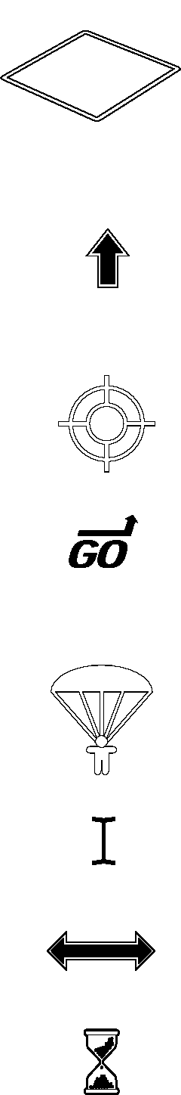

**6**

A bold (black) arrow indicates the direction the unit on which your
  
mouse pointer is positioned will move when you click. If you don’t
  
like this unit-movement cursor, you can disable it by unchecking the

MOVE UNITS WITH MOUSE option under GAME OPTIONS in the GAME menu.

***Civilization II*** starts with this option disabled.

A cross-hair indicates that you can click on the spot where your mouse pointer is positioned in the World Window to center the active VIEW UNITS window on that spot.

The word “Go” and a bent arrow indicates that when you release the mouse button, the active unit will begin moving toward the indicated square. See **GoTo Orders** in the **Terrain and Movement** section for complete details.

A parachute indicates that the active paratrooper unit will make a paradrop into the designated square; a “crossed-out” parachute indicates that the designated square is not a valid paradrop target. See **Paradrop Orders** in the **Terrain and Movement** section for complete details.

As in most Windows programs, an I-beam or vertical line indicates that you can type in text from the keyboard.

As in most Windows programs, a double-ended arrow indicates that you can resize the window frame on which your mouse pointer is positioned.

As in most Windows programs, an hourglass indicates the program is working; please wait.

TUTORIAL

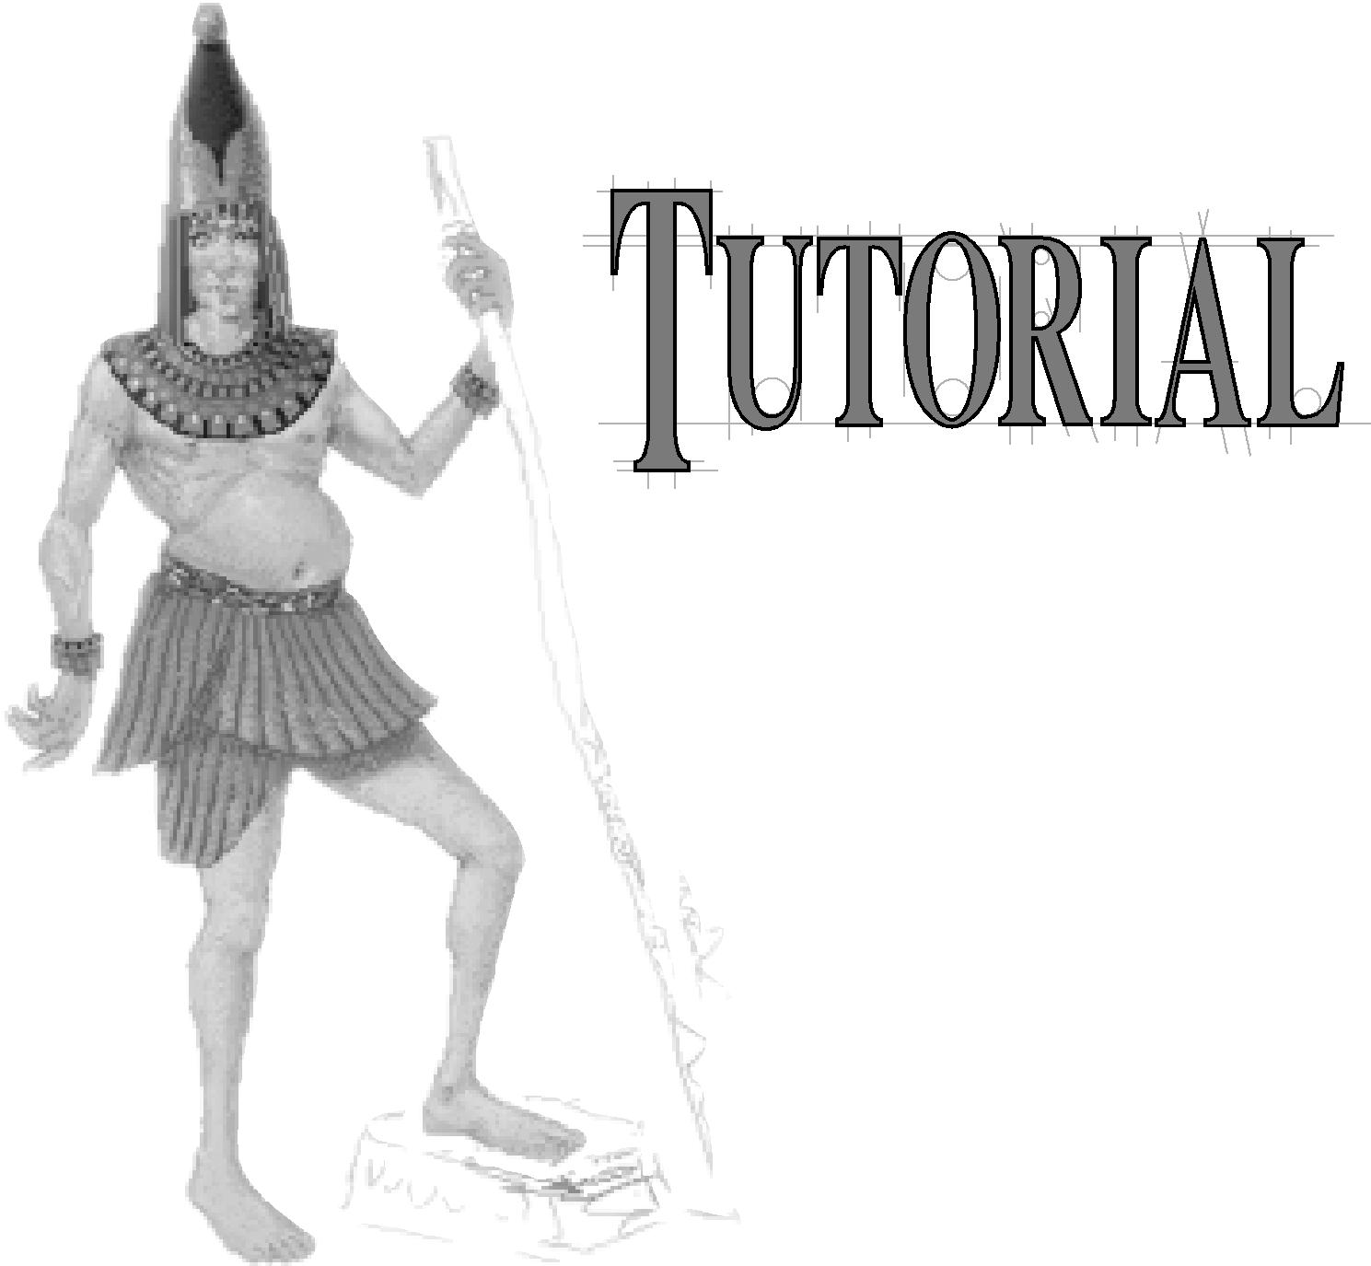

Those who have played either ***Civilization*** or ***CivNet*** are already familiar with most of the concepts presented in this tutorial. However, even if you are well acquainted with the DOS, Windows, or Macintosh version, you will

find that there are many new features in ***Civilization II***. Also, many of

the game’s existing elements, including screen layout, icons, and

controls have changed from the earlier games.

The primary purpose of this tutorial is to introduce new players to

the basic elements of ***Civilization II***. It provides an overview of the basic game elements, and guides you through several centuries of a sample game. New actions and events are explained as they occur. The tutorial game has been set up in such a way that most of the events should be fairly predictable; however, one of the things that makes ***Civilization II*** exciting game after game is the element of random chance that exists. The way your computer-controlled opponents act and react to one another (and to you) might cause certain events to deviate from the path described in this tutorial. If you feel that things have gotten too far out of control, feel free to reload the saved game and start again.

**7**

To begin the tutorial, start the game and select LOAD A GAME from the GAME menu. Load the game called **tutorial.say**. The tutorial game is set to CHIEFTAIN level, the easiest difficulty option available. The game starts on the first turn, in 4000 BC, with you taking the part of Abraham Lincoln, leader of the Americans. You might want to go to the GAME OPTIONS in the GAME menu and turn off the INSTANT ADVISOR and TUTORIAL HELP options, if you find the pop-up boxes distracting.

**8**

*Instructions you are to follow are set in italics.* Explanations and descriptions are set in regular type. Keep in mind that this tutorial is a simple walk through, and only touches briefly on game concepts and control features. If you want more information on anything, detailed descriptions can be found in the other chapters of this manual.

**BUILDING YOUR FIRST CITY**

At the start of the game, your civilization consists of a single band of wandering nomads. This is a Settlers unit. Although Settlers are capable of performing a variety of useful tasks, your first task is to move the Settlers unit to a site that is suitable for the construction of your first city.

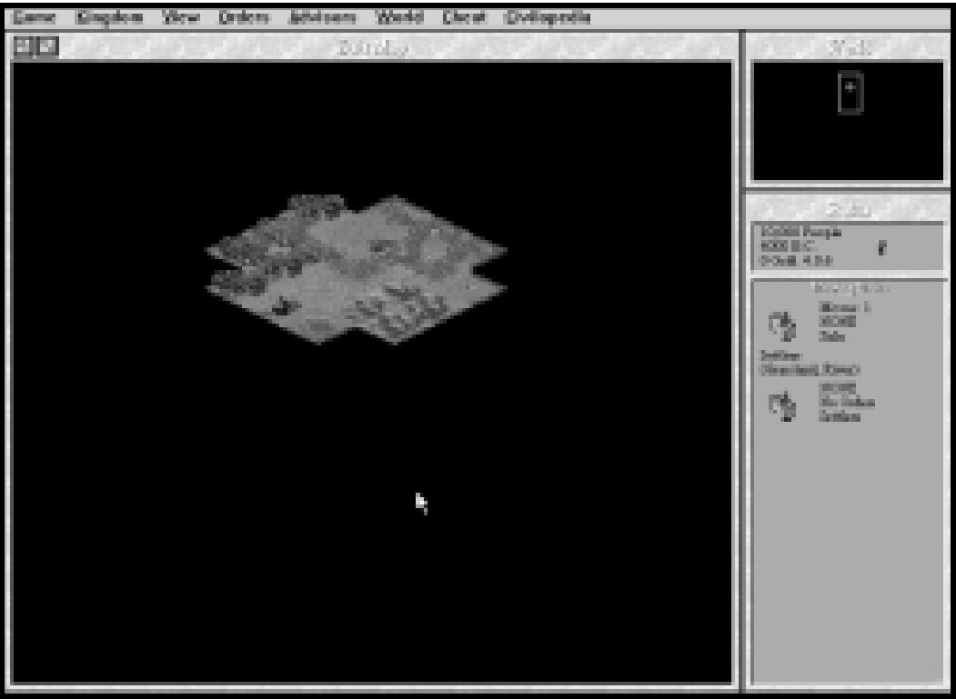

*Looking for a place to settle.*

Finding suitable locations in which to build cities, especially your first city, is one of the most important decisions you make in the game. In order to survive and grow, each city must have access to all three resource types: food (represented by grain), production (represented by shields), and trade goods (represented by arrows). The map in ***Civilization II*** is divided into individual “squares,” each of which contains a different type of terrain. Each terrain type yields resources in differing amounts. A good city site provides all three resource types. Normally, the lines dividing the map squares are invisible. To get an idea of how the terrain is divided, turn on the map grid by choosing SHOW MAP GRID from the VIEW menu, or holding down *Ctri* and pressing M.

Before you move your Settlers, take time to examine the surrounding terrain. You will note that only 21 map squares are visible. This represents the extent to which your civilization has explored the world. (This 21-square pattern is significant with regard to cities as well, as you will see later.) The surrounding black areas represent unexplored terrain. You can build a city on any terrain square except for Ocean. As mentioned earlier, each terrain type yields differing proportions of resources, so the type of terrain you choose for a city site determines the level of the city’s success.

**9**

Your Settlers currently occupy a Grassland square. Normally, Grassland produces two grain when worked by one of your citizens. Note that a small shield symbol appears in the center of this particular Grassland square. That means that, in addition to its normal resources, this Grassland square also yields one shield when worked. Normal Grassland squares (without shields) appear to the northwest and northeast of your Settlers.

TUTORIAL

Directly to the north and directly to the west of the Settlers are Plains squares. The Plains terrain type produces one grain and one shield when worked by one of your citizens. Southeast, south, and southwest of the Settlers are Ocean squares, which produce one grain and two arrows each when worked. Surrounding the edge of the visible terrain are a Plains square with a river running through it, two additional Grassland squares, and four additional Ocean squares. There are also two Hills squares and a Mountains square along the northwest edge, two Forest squares to the southwest, and an Ocean square two squares to the southeast with a Whale in it. We’ll look at these in a moment.

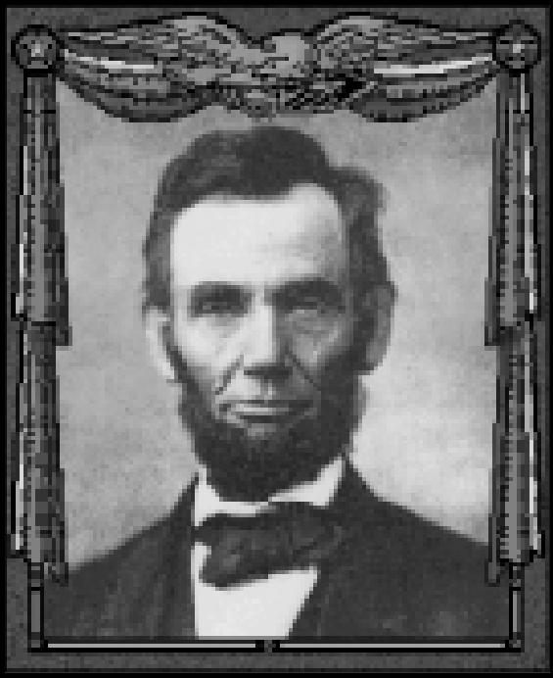

*Abraham Lincoln*

You have the option of moving around to find a suitable city site. If the nearby terrain is less than optimal it is worth doing so, considering the importance of proper city placement. You shouldn’t waste too much time looking, however. Settlers move only one square per turn, and 20 years pass every turn this early in the game. Luckily, your starting position here is excellent: The local terrain provides a diverse resource mix, you are adjacent to a sea coast, and Grassland squares make good city locations.

*Build your first city by selecting BUILD NEW CITY from the ORDERS menu, or by pressing the* © *key.* You can rename the city if you like, but we’ll refer to it as Washington.

**EXAMINING THE CITY DISPLAY**

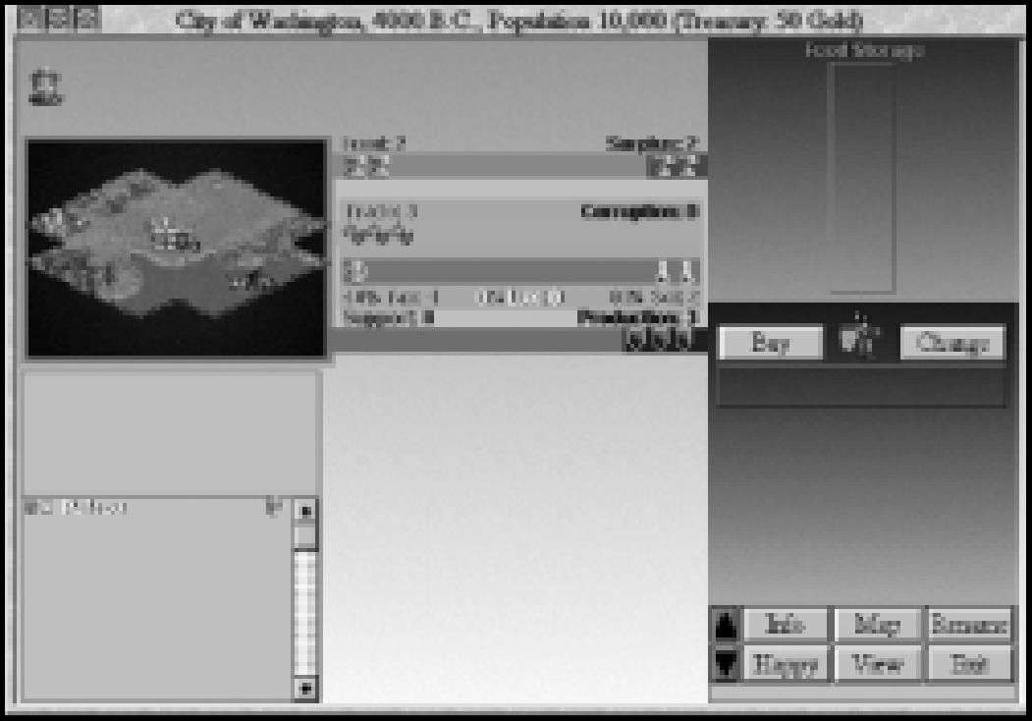

*Washington’s City Display*

**10**

As soon as the city is built, a new window
  
appears. This window is called the CITY
  
DISPLAY. The CITY DISPLAY gives detailed

information on the city’s current status, including the amount of resources generated, the item currently being built by the city, and the size and attitude of the city’s population.

Your first priority is to check the status of the city’s resources. The POPULATION ROSTER shows that there is one citizen in Washington, and he is content. Under most circumstances, each citizen in the city is working in one of the terrain squares surrounding the city, generating resources for the city’s use. As new citizens are added to the population, the game puts them to work in the terrain square it considers the most productive available. In this case, the city’s single resident is producing resources in the Ocean square that contains the Whale.

You have the option of moving citizens to different terrain squares if you want to produce different combinations of resources. As you can see by the icons on the RESOURCE MAP, the Whale square is generating two grain, two shields, and two arrows. *Click the Whale square to* “*pick up” the citizen working there, then click on the Plains square with the river running through it, directly to the east (right) of the city.* Notice that, in the Plains square with the river, the citizen now generates one grain, one shield, and one arrow. *Click on the Plains square with the river and then click on one of the Forest squares southwest of the city.* In the Forest square, the citizen generates one grain and two shields, but no arrows. *Since the Whale square is one of the most productive types of terrain, click on the Forest square and then on the Whale square to return the citizen to his original position.*

As you can see, the combination of resources produced is based on terrain type. Under normal circumstances, each city can assign citizens to generate resources in any of the 20 terrain squares surrounding the city. The pattern of 21 squares with the city at the center that is seen in Washington’s RESOURCE MAP is called the CITY RADIUS. In addition to the terrain squares in the CITY RADIUS, the city square itself always generates resources. Like the squares worked by your citizens, the number and type of resources produced in the city square is dependent on the terrain type.

Washington is currently generating four units of food. Each citizen requires two units of food each turn in order to survive. Excess grain icons accumulate in the FOOD STORAGE BOX. The more surplus food the city generates, the faster it grows. Washington is also generating three shields. Shields represent raw materials used for supporting units and building new items. Since there are currently no units to support, the shields generated each turn go directly into the PRODUCTION BOX. Finally, the city is producing three arrows, which represent trade goods. Trade goods are divided into three separate categories: Taxes (gold icons), Luxuries (goblet icons), and Science (beaker icons). Currently, one arrow is being used to generate taxes, while the other two are generating science.

**11**

Washington’s IMPROVEMENTS ROSTER shows that the only building in the city is the Palace. Your Palace denotes that Washington is your civilization’s capital.

TUTORIAL

**FIRST PRIORITIES**

Because there is so much information to assimilate at the start of the game, it’s hard to know what you should do first. There are four priorities that you must keep in mind early in the game: defense, research, growth, and exploration.

**Defense:** Your top priority is to defend Washington from potential enemies. After all, who knows who might be lurking in all that unexplored territory? To defend the city, you must build a military unit. When the city is built, it automatically begins to construct a defensive unit. The PRODUCTION BOX shows that Washington is currently producing a Warriors unit.

**Research:** The science portion of your trade income is used to research new Civilization Advances. Civilization Advances are new discoveries and technologies that allow you to build newer and better military units, city improvements, and Wonders of the World.

**Growth:** The surplus food generated by the city eventually leads to population growth. When the FOOD STORAGE BOX is completely filled with grain, a new citizen is added to the population. Steady city growth leads to increased productivity and the ability to expand your civilization by building more Settlers to colonize the continent.

**Exploration:** If you don’t explore the dark areas of the map, you have no way of knowing what benefits and dangers might be lurking there. By using spare units to explore the world around you, you can discover the villages of minor tribes (which often provide you with benefits such as money and new discoveries), sites for new cities, and neighboring civilizations.

*When you’re finished examining Washington, close the CITY DISPLAY by clicking the EXIT button in the lower right corner.*

**RESEARCHING CIVILIZATION ADVANCES**

**12**

*After closing the CITY DISPLAY, press the* enter *key to end the turn.* At the start of the next turn, you are prompted to choose the first civilization advance you want to research.

When the game begins, your civilization has only minimal knowledge, usually consisting of only Irrigation, Mining, and Roads. (In some games you might be given additional advances at the start of the game, but in the tutorial this is not the case.) The bulk of your knowledge throughout the game is gained through research. There are many different strategies dictating the order in which advances are researched. For the purposes of this tutorial, we’ll adopt a conservative, defensive strategy. You can experiment with research strategies of your own as you become more familiar with the game.

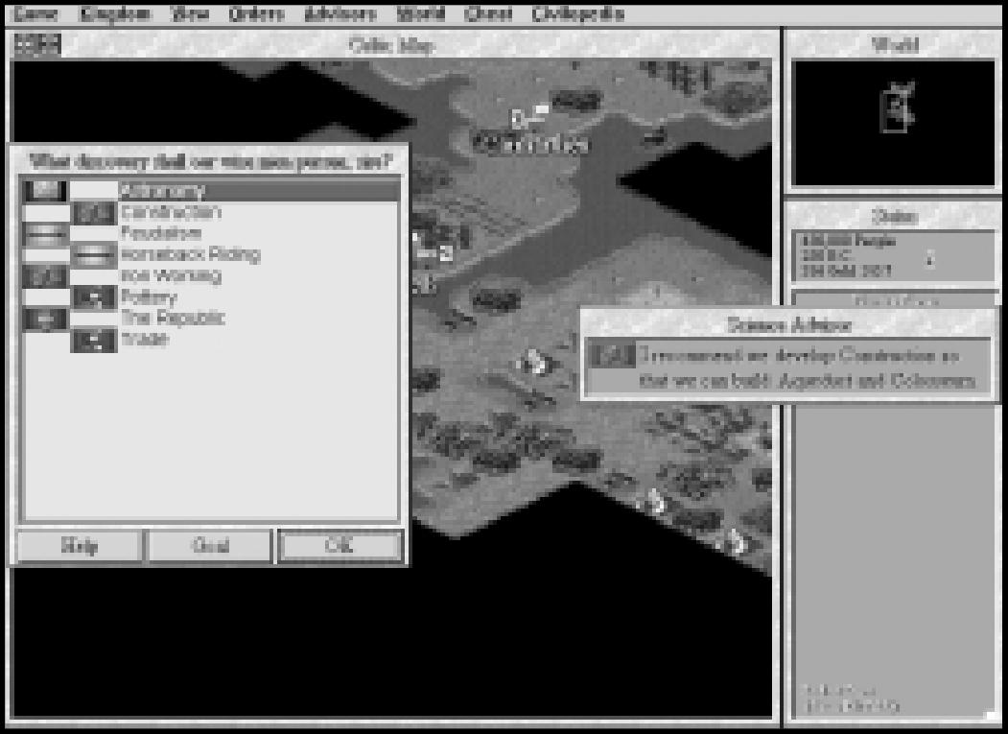

*You can only choose one.*

*When the menu of possible advances appears, select Bronze Working, then click OK.* We have chosen Bronze Working because the discovery of this advance allows you to build the Phalanx unit. Phalanxes are twice as effective at defending cities as Warriors.

The amount of time required to research discoveries is based on the amount of science your city is currently generating. Remember, science is one of the components of trade. *Select the TRADE ADVISOR option from the ADVISORS menu, or press the* F5  *key.* As you can see from this display, it currently takes five turns to make a new discovery. The more beaker icons you generate each turn the faster you make new discoveries. *Click OK to close the TRADE ADVISOR window.*

As you can see by looking at the STATUS window, 20 years of game time pass. (On CHIEFTAIN level, turns start out spanning 20 years each. As the game progresses, the turns get shorter, dropping to ten years per turn, then five, two, and eventually one year per turn.)

The amount of trade allocated to taxes, luxuries, and science can be adjusted to a certain degree to suit your needs. *Select TAx RATE from the KINGDOM menu.* As you can see, there are three sliders in the TAX RATE window, each of which controls the percentage of one of the three elements of trade. Moving a slider left or right decreases or increases (respectively) the percentage of trade allocated to that element, and adjusts the other elements accordingly so that the total percentage equals 100 percent.

Unlike ***Civilization*** and ***CivNet, Civilization II*** limits the maximum percentage of trade that can be allocated to taxes, luxuries, and science based on your civilization’s government type. You start the game in Despotism, so the maximum percentage you can allocate to any trade element is 60 percent. Note that the game automatically sets science at 60 percent and taxes at 40 percent. Since your focus should be on research at this time, and you currently require no luxuries to keep your population happy, the default settings are fine for now. *Close the TAX RATE window by clicking the OK button.*

**13**

**MEANWHILE, BACK IN THE CITY...**

TUTORIAL

Now, let’s take a look at what happened in the city after the first turn. *Open Washington’s CITY DISPLAY by clicking the city icon on the map.* Several things have changed since you last looked inside Washington. First, the information in the TITLE BAR indicates that your treasury now contains 51 gold instead of the original 50. That is because Washington is generating one gold coin of taxes each turn. Since there are currently no improvements in Washington that require upkeep, the gold is added to your treasury for future use.

*Look at the FOOD STORAGE BOX*. It is no longer empty. There are now two grain icons in it. This is the surplus food that was generated by the city on the first turn. It is stored in the FOOD STORAGE BOX for later use.

*Finally, look at the PRODUCTION BOX.* Like the FOOD STORAGE BOX, it is no longer empty. The three shields generated on the first turn were used to help build the Warriors unit currently under production.

An alternate way to close the CITY DISPLAY is to click on the button in the upper left



corner. Use whichever method you find most comfortable.

**YOUR FIRST UNIT**

Until your Warriors unit is completed, you have little to do. *Press the ENTER key three
  
times.* It is now the fourth turn, and you have just built your first military unit. The Warriors
  
unit is now flashing on and off in the city square. The unit is now ready to receive orders.

There are two things you can do with your first military unit. You could use the unit to defend your city. In most cases, it is unwise to leave a city undefended. This is especially true if you know that an enemy unit is nearby. However, early in the game, the world is sparsely populated, so you can take a chance and send the unit out to explore hidden terrain outside the CITY RADIUS.

*Move the Warriors unit to the west by pressing the ® key on the numeric keypad.* Note that one of the black, unexplored terrain squares is revealed when the unit moves. Most units can “see” one square in any direction. Your turn ends automatically when your last unit finishes its movement. Since Warriors can move only one square per turn, your turn is now over.

**YOUR FIRST CIVILIZATION ADVANCE**

**14**

We’ll go back to exploring the world in a moment. For now, something more interesting has happened. At the start of this turn, your scientists announce that they have discovered the secret of Bronze Working. Congratulations! You have discovered your first civilization advance. After the initial message of discovery, the CIVILOPEDIA appears. The CIVILOPEDIA is an on-line encyclopedia of game facts. The CIVILOPEDIA screen that appears after the discovery of each advance shows the units, improvements, and Wonders you can now build as a result of the advance, as well as new lines of research available. Bronze Working allows you to build Phalanx units and the Colossus Wonder, and allows you to research Currency. Bronze Working also allows you to research Iron Working, but only after you have researched Warrior Code. *Close the CIVILOPEDIA screen by clicking the EXIT button.*

Once again the list of research choices appears, allowing you to choose the next advance you want to discover. Since Bronze Working has provided the ability to build a good defensive unit, you can now move on to a research path that enhances your exploration capability. *Choose Horseback Riding from the menu, and click OK.*

**CHANGING PRODUCTION**

Before you do anything else, its time to look inside the city again. *Open Washington’s CITY DISPLAYby clicking the city’s icon on the map.* When you look at the PRODUCTION BOX, you’ll notice that the city has automatically begun to build another Warriors unit. In fact, a city goes on producing unit upon unit until it receives orders to the contrary.

Since the city is still defenseless, you need to build a unit to protect Washington from possible invaders. A Phalanx is a better defensive unit than Warriors, so that is what you should build. *Click the CHANGE button above the PRODUCTION BOX.* When you do so, a menu listing the possible production options appears. *Choose Phalanx by clicking on it. Click OK to exit the PRODUCTION menu.* The Phalanx’s icon now appears above the PRODUCTION BOX to indicate that the city is now building a Phalanx. *Click EXIT to close the CITY DISPLAY.*

**FINDING A MINOR TRIBE**

Remember your Warriors unit? It’s flashing again, indicating that it is once again ready to move. *Move the Warriors one square to the west by pressing the* ® *key on the numeric keypad.* Note that, as the unit moves, any unexplored (black) terrain within one square of the unit is revealed. Press Enter to end the turn.

When the unit starts flashing again (indicating that it is the next turn) move it one square to the southwest by pressing the D key on the numeric keypad. Now here’s something interesting! Your exploration has revealed a “hut,” one square to the southwest of the Warriors’ present position. This hut is home to a minor tribe. Minor tribes are not rival civilizations; rather, they are small villages populated with people who might be inclined to help you.

*Save your game by choosing the SAVE GAME option from the GAME menu, or by holding down the* Ciro *key and pressing* ❑s *.* You are about to make contact with the minor tribe. The results of such contact are random. You could receive a gift of knowledge or gold; the tribe might band together to form a mercenary military unit and join you; or the tribe might decide to honor you by establishing a new city in your empire. Of course it is possible that negative events might occur as well: The village could be empty, or populated by hostile Barbarians. By saving the game prior to contact, you have the option of reloading from the save if you don’t like the results of exploring the village.

**15**

*When the Warriors start flashing again, move your unit onto the hut.* As stated earlier, one of a number of random events will occur as a result of contacting a minor tribe. For the purposes of this tutorial, we’ll assume that you receive a gift of gold from the minor tribe.

TUTORIAL

**POPULATION INCREASE**

*Continue your exploration for the next three turns. Move the Warriors back toward Washington, twice to the east, and once north, so you are right next to the city.*

On this turn, two things happen simultaneously. First, Washington completes the Phalanx it was building. Second, the population of the city increases to two, as indicated by the number next to the city’s icon. *Open Washington’s CITYDISPLAY.* Notice that the FOOD STORAGE BOX has only two food in it now. Next turn it will start filling up again, accumulating grain for the next population increase.

Notice that the POPULATION ROSTER now contains two citizens. On the RESOURCE MAP, you can see that the new citizen is already at work generating resources; specifically, the citizen is generating two grain and one shield in one of the Grassland-Shield squares to the north. That’s fine for now, so leave the citizen there.

As for production, its time to change again. This early in the game, one defensive unit is more than adequate for city protection. *Click the CHANGE button, and select Settlers from the PRODUCTION menu.* Its time to start thinking about the next priority: growth. In order to expand your civilization, you need to build other cities; and for that, you need Settlers. *Close the CITY DISPLAY.*

As noted on the PRODUCTION menu, it will take Washington ten turns to produce a Settlers unit. You can speed this up a bit through the use of your Warriors unit. Once the CITY DISPLAY is closed, the Warriors should be flashing. *Move the Warriors unit into the city, and re­open the CITY DISPLAY.* In the center section of the CITY DISPLAY you should see two icons: a Phalanx unit and a Warriors unit. *Click on the Warriors unit icon. From the menu of options that appears, choose DISBAND and click OK. Now, look at the PRODUCTION BOX.* Five shields appear as soon as the Warriors unit is disbanded. When a unit is disbanded inside one of your cities, half of its original cost in shields is added to the production currently in progress. *Close the CITY DISPLAY.*

Now, back on the map, the Phalanx is flashing. In order to protect the city, the Phalanx must remain inside Washington. Units provide the best protection when they are fortified. *Fortify the Phalanx by choosing FORTIFY from the ORDERS menu, or by pressing the* ❑F *key.* Fortified units remain in their defensive position until you manually reactivate them. For now, the Phalanx should be left alone to guard Washington.

**16**

**INTERIM**

Because you have so few units and cities early in the game, there are often periods of time that pass without your having to take any action. *After fortifying your Phalanx, press* Enter *two times.* At this point, your wise men discover Horseback Riding. In addition to allowing the research of several new advances, Horseback Riding allows you to build Horsemen, fast-moving military units that are great for exploration.

*Choose Code of Laws as the next advance to research.* For the purposes of this tutorial, our goal now is to develop Trade. In order to do so, you must research both Code of Laws and Currency. Code of Laws also leads to Monarchy, a more advanced form of government that helps to increase your productivity. *Continue pressing* Enter *.*

About six turns later, you are notified that Washington has completed the Settlers it has been building. Choose the ZOOM TO CITY option on the notification menu to open the CITY DISPLAY. Once there, change production so that Washington is building a Horsemen unit. You’ll be using the Horsemen to do some more exploration as soon as it’s built.

You’ll notice that Washington’s population has dropped to one. That is because Settlers units represent citizens that leave the city in order to improve the surrounding terrain or to establish a new city. Also, one of the three shields generated by the city is now being used for support. That is because, under Despotism, any units beyond the size of the city’s population require one shield each turn to support them. Right now, you have two units, but only one citizen. At any rate, the FOOD STORAGE BOX shows that the population is about to increase again, so these situations are only temporary. *Close the CITY DISPLAY.*

**EXPANDING YOUR EMPIRE**

Now it’s time to expand your empire. *Move your Settlers directly west until they reach the sea coast, then move them one square to the southwest. Use the BUILD CITY command on the ORDERS menu, or press* © *to build a new city.* Again, you can name the city anything you want, but we’ll refer to it by its default name, “New York.”

When New York’s CITY DISPLAY opens, you’ll notice a couple of differences from Washington when it was first built. Although New York is generating just as much food as Washington did, raw materials and trade goods generation are both significantly lower. That’s because there are no special resources, like Whales, to take advantage of within

New York’s CITY RADIUS at this time. Which brings us to another oddity: the entire CITY RADIUS of New York is not visible. That’s because there is still some unexplored terrain nearby. In order for the city to take advantage of its entire CITY RADIUS, all the terrain therein must be explored. You’ll have to take care of that as soon as possible; you never know what useful resources might be lurking in the dark.

**17**

Notice that New York is currently producing a Phalanx. Since this city needs to be protected too, a Phalanx is just what you want. *Close the CITY DISPLAY.*

After a couple of turns pass, the Horsemen unit is completed in Washington. *When the Horsemen unit appears, open Washington’s CITY DISPLAY, and click the CHANGE button.* Since you have enough units for the time being, and you aren’t quite ready to incur the upkeep expense of a Barracks, let’s build your first Wonder of the World. *Choose Colossus from the PRODUCTION menu, and close the CITY DISPLAY.*

TUTORIAL

Meanwhile, let’s go and explore that hidden terrain near New York. *Move your Horsemen west, toward New York.* Notice that Horsemen have twice the movement capability of the other units you’ve used so far. That’s why they are so good for exploring.

As you move toward New York, your wise men make another discovery: Code of Laws. *When you are offered the choice of what to research next, choose Currency.*

*On the next two turns, move the Horsemen southwest.* Halfway through the second turn’s movement, the Horsemen should reach the coast just south of New York, revealing several new terrain squares. One of these is a Whale. (Remember how productive that was back in Washington?) Maybe it is inside New York’s CITY RADIUS...

*Open New York’s CITY DISPLAY.* The entire CITY RADIUS is now visible; and you’re in luck! The Whale square is inside the CITY RADIUS. *Click the Grassland square northeast of the city to “pick up” your worker, then click the Whale square to put him to work again.* Note that New York’s resource generation has now significantly increased. *Close the CITY DISPLAY.*

*Move your Horsemen directly east until you reach the Forest on the coast west of Washington.* Notice that your unit only gets to move once when moving into a Forest. That’s because it takes two movement points to move into Forest squares. Because of their rugged features, many terrain types require more than one movement point in order to move through them. *Now, move your Horsemen east, past Washington, until you get to the River. Then, proceed roughly east-southeast, following the coast.*

After your Horsemen unit is several squares past Washington, the Phalanx in New York is completed. *Fortify the Phalanx, just as you did in Washington, and change the production in New York to Settlers.*

As you continue to explore, your Horsemen might encounter one or two minor tribes*. When you discover Currency select Trade as your next research project. Save the game again, and enter these villages just as you did the first time you met a minor tribe. Restart from the saved game if you don’t like the results.*

**MEETING ANOTHER CIVILIZATION**

**18**

If you continue along the coastline as instructed, you eventually meet your nearest neighbors, the Sioux. Their capital city, Little Bighorn, is located some distance away, on the opposite coast directly southeast of Washington. As soon as you enter Sioux territory, their leader, Sitting Bull, requests an audience with you. *Accept Sitting Bull’s invitation by clicking OK.*

Establishing effective communication with your neighbors is vital to your success. Early in the game, you should take any reasonable actions to ensure that nearby civilizations enjoy your company. Not only does this keep your civilization reasonably safe from attack, it can also lead to profitable exchanges of money and information. You can see your opponent’s attitude toward you when you make contact with one another. The attitudes of rival leaders are based on your past behavior when dealing with other civilizations. Since this is your first contact with any civilization, Sitting Bull should have a fairly good attitude when you first meet (“cordial” at the very least).

The most likely result of this encounter is that Sitting Bull will offer to exchange knowledge or sign a peace treaty. *Whatever Sitting Bull offers, accept his proposals.* Notice that each time you agree to his proposals, Sitting Bull’s attitude steadily improves. This is important, because you want to make friends at this stage in the game. *If Sitting Bull’s attitude is particularly good (“enthusiastic” or “worshipful”), offer to SUGGEST A PERMANENT STRATEGIC ALLIANCE with the Sioux.* A permanent alliance is better than a treaty, because it allows both civilizations to move freely through one another’s territory. *Whether the alliance is accepted or rejected, end the meeting*

*by choosing CONSIDER THIS DISCUSSION COMPLETE and clicking OK. If the*

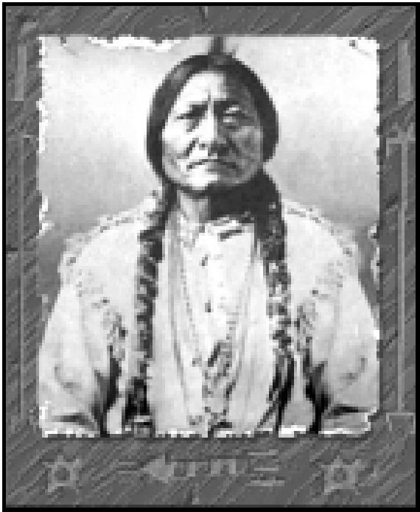

*Sitting Bull*

*alliance was rejected, move your Horsemen unit away from Little Bighorn as soon as possible to avoid violating the peace treaty.* If you establish a reputation of violating peace treaties, your opponents are less likely to sign agreements and treaties with you in the future.

After this encounter, you have gained a friend (for now), and possibly one or two free civilization advances as a result of technology exchange with the Sioux. Now that you have made contact, you can chat with Sitting Bull at any time by selecting the FOREIGN MINISTER option from the ADVISORS menu, and sending an emissary to the Sioux. Sitting Bull can also contact you at any time. You shouldn’t pester your opponents too frequently, however, because rival leaders quickly grow weary of interruptions.

*If you are contacted by the Sioux at any time during the remainder of this tutorial, agree to their demands.* During the tutorial game, you want to keep the Sioux happy so they won’t attack you. During a real game, use your own judgment as to how to respond to an opponent’s demands.

**IMPROVING THE TERRAIN**

**19**

*Continue exploring with your Horsemen to the northeast of Little Bighorn. Avoid entering
  
Little Bighorn’s CITYRADIUS, because this will be viewed as a violation of your peace treaty.*

After a number of turns, your wise men discover Trade. *Select Ceremonial Burial as your next advance. If you already have Ceremonial Burial (as a result of knowledge exchanged with the Sioux), select Monarchy.*

Several turns later, New York finishes building its Settlers. *Open New York’s CITY DISPLAY and click the CHANGE button.* Notice that there are now several more options on the PRODUCTION menu: the discovery of Code of Laws allows you to build a Courthouse, and the discovery of Trade allows you to build Caravan units. *Select Caravan, and close the*

TUTORIAL

*CITY DISPLAY.*

*When the Settlers unit becomes active, move it one square to the northeast of New York (using the* ❑9 *key on the numeric keypad), onto the Grassland-Shield square. For the next couple of turns, keep exploring with the Horsemen, but skip the Settler’s turn by pressing the S acebar. Continue to do this until New York’s population has increased to two. When this happens, open New York’s CITY DISPLAY.*

When you look at New York’s RESOURCE MAP, you see that the Grassland-Shield square northeast of the city is currently generating one shield and two grain. That’s not bad, but you can use your Settlers unit to improve the production in that terrain square. *Close the CITY DISPLAY. When the Settlers becomes active, choose BUILD ROAD from the ORDERS menu, or press the* ® *key.* For the next couple of turns, the Settlers unit spends its time building a road. When the Settlers become active again, you see on the map that there is now a road leading out of New York to the northeast. *Now, open New York’s CITYDISPLAY again and look at the RESOURCE MAP.* Notice that, after the construction of the road, the same Grassland-Shield square is now generating one trade good icon in addition to its former resources. In addition to this benefit, roads increase movement speed: units only expend one-third of a movement point to move along a road, no matter what type of terrain the road occupies.

*Close the CITY DISPLAY.* Believe it or not, the terrain can still be further improved. *When the Settlers become active again, choose BUILD IRRIGATION from the ORDERS menu, or press the* [D *key.*

Building irrigation takes a bit longer than building roads. While you’re waiting for the Settlers to complete their task, you discover another civilization advance. *If you just discovered Ceremonial Burial, select Monarchy as your next advance. If you just discovered Monarchy, select Writing as your next advance, and choose NOT JUST YET... when you are offered the chance to start a revolution to change governments.*

Several turns later, the Settlers complete their irrigation project; the terrain square is now marked to show that it is irrigated. *Open the CITY DISPLAY for New York.* Notice that the resource production has not changed as a result of irrigation. Normally, this would not be the case: irrigation usually increases the grain output of Grasslands by one. However, under Despotism, your current system of government, any terrain square producing three or more of any resource type has its production reduced by one. So, instead of three grain, the square still produces only two. This illustrates the drawbacks of Despotism, and explains why your research is now proceeding toward Monarchy, where such penalties do not exist. *Close the CITY*

**20**

*DISPLAY.*

*While you’re waiting for the next advance to be discovered, use the Settlers unit to build a road between New York and Washington. Move one square toward Washington and build a road. Continue until you have connected the two cities.* This will facilitate fast travel between your cities. *After the road is built, use the Settlers to start improving the terrain around Washington.*

**ESTABLISHING A TRADE ROUTE**

Shortly after you start building your inter-city road, the Caravan in New York is completed. You’ll be using this Caravan to establish a trade route between New York and Little Bighorn. Trade routes increase the amount of trade goods generated in both their home city and the city with which the trade route is established. Trade routes also give the Caravan’s home city a cash and science bonus on the turn when the route is established. Each city can operate up to three separate trade routes.

After you are notified of the Caravan’s completion, a menu appears listing the possible trade goods that the Caravan can carry. *Select each commodity in turn, and click the SUPPLY AND DEMAND button to review what cities traffic in that item. If Little Bighorn demands one of the items on your list, select that item and click OK. Otherwise, select any item and click OK.* You get both the trade increase and a cash and science bonus no matter what your Caravan carries, but the cash and science bonuses are bigger if you supply goods demanded by the destination city. *Confirm your choice by clicking CONFIRM AND ZOOM. When New York’s CITYDISPLAYappears, change the city’s production to Marketplace.* The Marketplace improvement increases both tax and luxury output in New York.

*As soon as the Caravan becomes active, start moving toward Washington.* It takes a while to get to Little Bighorn, because a Caravan moves at a rate of one square per turn. It’s worth the trip, though. The farther away the destination, the higher your cash and science bonus.

En-route to Washington, you discover another civilization advance (Monarchy or, if you’re ahead of the game, Writing). *For now, don’t declare a revolution. Select your next advance: Writing (if you don’t already have it) or Map Making.* We’ll come back to Monarchy shortly. You will, in fact, discover another advance before your Caravan reaches Little Bighorn. *This time, choose Map Making (if you don’t have it) or Warrior Code.*

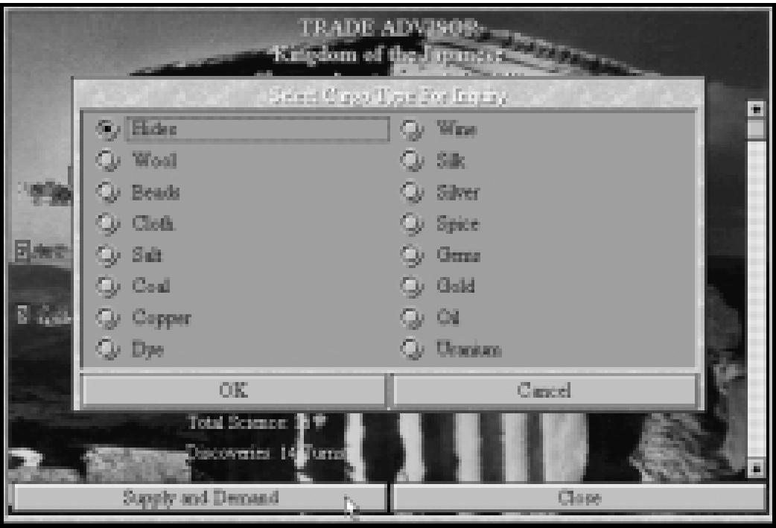

*Possible commodities a Caravan can carry*

**21**

Meanwhile, back on the trade route, your Caravan reaches Washington. *Move the Caravan into the city.* When the Caravan enters Washington, you get a list of options. You can establish a trade route with Washington (which you don’t want to do). You are also given the option to HELP BUILD WONDER. (Remember, Washington is still in the process of building the Colossus.) If you were to choose this option, the Caravan would be disbanded, and 60 shields would be added to the production of the Colossus. This is an excellent way to accelerate the construction of Wonders of the World which, obviously, take quite a long time to build. For now, however, your goal is to establish a trade route with Little Bighorn. *Choose KEEP MOVING and click OK.*

TUTORIAL

*Continue moving the Caravan until you reach Little Bighorn, then move the unit into the city. Choose ESTABLISH TRADE ROUTE from the menu.* You have now established your first trade route! A message appears telling you how much money you receive as an immediate bonus. An equivalent number of beakers is added to your current research project at the same time. *Open New York’s CITY DISPLAY.* Note that the trade route is now listed in the bottom center portion of the CITY DISPLAY, and that New York’s arrow production has increased as a result of the trade route.

**CHANGING GOVERNMENTS**

**22**

By now, you have established a small, but thriving, civilization. You are doing well, but you could do better. The last thing you’ll learn in this tutorial is how to improve your civilization by switching to better forms of government.

*Open New York’s CITY DISPLAY.* Note that the city is currently generating six grain, five arrows, and four shields (assuming that the trade route with Little Bighorn is generating one arrow. Your actual number of arrows might vary slightly.) *Close the CITY DISPLAY.*

Now, it’s time to change governments. *Select the REVOLUTION! option from the KINGDOM menu and confirm your choice to overthrow the government.* Within a few turns, a menu appears listing the systems of government currently available to you. *Choose MONARCHY and click OK.* Your civilization is now ruled through a Monarchy. The TAX RATE window appears, giving you the opportunity to reset your division of trade between taxes, luxuries, and science. Note that your maximum rate is now capped at *70 percent and close the window.* Now, you’ll make discoveries more quickly.

Let’s take a look at the effects of the government change. *Open New York’s CITY DISPLAY.* Look at the production changes. The city’s grain production has increased from six to eight. Note that the Grassland-Shield square you irrigated earlier is now generating three grain instead of two. The other extra grain is coming from the city square itself (it is automatically irrigated when the city is built). Trade has also increased as a result of the change in government. The Whale square is now generating one additional arrow. This has the effect of increasing the number of beakers from three to four. Shield generation has remained the same because none of the terrain currently in use around New York is capable of producing more than two shields under the present circumstances. If you look at the CITY DISPLAY for Washington, you’ll notice similar increases in that city as well.

**CONCLUSION**

So ends the tutorial. You should now be familiar with many of the basic concepts of ***Civilization II***. Feel free to continue playing the tutorial game and see how you do, or go back and start a new game on a randomly generated world. Remember, you have only scratched the surface when it comes to learning the game. Use the rest of this manual and the on-line CIVILOPEDIA in the game to help you with new concepts as you encounter them.

Have fun, and good luck! May your reign be long and fruitful.

**YOUR FIRST DECISION**

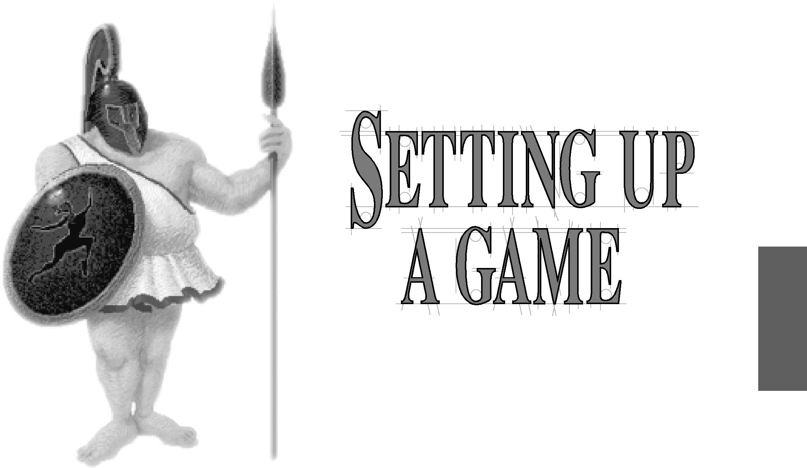

Beginning a game of ***Civilization II*** means choosing the circumstances in which you want to play. Your options include specifying the number and location (physical starting point) of your opponents and manipulating the environmental and physical parameters of the world you’ll explore.

SETTING UP
  
A GAME

**23**

To launch the game, click on the ***Civilization II*** icon. After the game has initialized itself, choose the language in which you’d like text to appear. When you click OK, the opening animation begins (if you chose to install it). You can wait for it to end or press any key to cut it short. Setting up a game means making easy decisions on a series of options screens. At the first of these, you decide whether to start a new game or continue a previous one, among other things. The full list of options is described below. Once you’ve chosen an option, you’ll need to click OK to continue.

**Start a New Game:** Begin an entirely new game. Choosing this option means going through the basic pre-game options screens, as we explain below.

**24**

**Start on Premade World:** Play on a custom map created with the **CivMaps** utility. A dialog box lists all of the saved maps available in the current directory. Choose the map you wish to load. You can switch directories to find maps you’ve saved in other locations.

**Customize World:** Build a world right down to the picky details of land form, climate, and geologic age. When you choose this option, you see all of the set-up screens, not just the important ones.

**Begin Scenario:** Choose this option to load a pre-set historical scenario. A dialog box lists all of the available choices. You choose which side you want to play.

**Load a Game:** Load and continue a previously saved game. A dialog box lists all of the saved games available in this directory. Choose the game you wish to load. You can switch directories to find games you’ve saved in other locations.

**View Hall of Fame:** See the standings of previous conquerors and despots.

Use the OK button to confirm your choice, or the CANCEL button to quit ***Civilization II***.

**CUSTOMIZING GAME SET UPS**

These option screens progress from whole-world effects down to the name of your tribal leader. If at any point you realize that you’d like to reset an earlier parameter (you suddenly wonder what a jungle planet would be like, but you’re past that screen), you can click the CANCEL buttons located on each screen to “turn back the pages” to a previous screen, then make another choice. When you are happy with the choices you have selected, click the OK button to continue on to the next screen. If you want to be surprised, you can click the RANDOM button to let the game select a parameter for you.

**SELECT SIZE OF WORLD**

By choosing the size of the map, you can determine how much territory there is, and to a large degree, how long the game takes to play.

**Small:** This size map leads to short, intensely contested games. Tribes find each other quickly.

**Normal:** This is the standard size map.

**Large:** This sprawling map takes longer to explore and exploit. Consequently, games go on longer.

**Custom:** Choose this option to specify the height and width of your map. The dialog box explains the limits of your choices.

**CUSTOMIZE: LANDMASS**

**25**

This parameter sets the number of terrain squares that are land.

**Small:** Choosing this option gives your world a small number of land squares and a larger number of ocean squares.

**Normal:** This option yields about equal numbers of land and ocean squares.

**Large:** This option produces a large number of land squares, and a small number of ocean squares.

**CUSTOMIZE: LAND FORM**

This parameter determines the way in which your world’s land is shaped into land masses.

**Archipelago:** This option produces relatively large numbers of relatively small continents.

**Varied:** Choosing this option gives your world an average number of average sized continents.

SETTING UP
  
A GAME

**Continents:** This option yields one or two large land masses.

**CUSTOMIZE: CLIMATE**

This parameter sets the relative frequency with which particular terrain types occur.

**Arid:** Choosing this option gives your world a larger number of “dry” terrain squares, such as Plains and Desert.

**Normal:** This option yields about equal numbers of “wet” and “dry” terrain squares.

**Wet:** This option produces a larger number of “wet” terrain squares, such as Grassland,
  
Forest, and Swamp. It also increases the number and length of rivers generated.

**CUSTOMIZE: TEMPERATURE**

This parameter determines the relative frequency with which particular terrain types occur.
  
**Cool:** This option produces larger numbers of polar terrain squares, like Tundra and Glacier.

**Temperate:** Choosing this option gives your world an average number of each terrain type.

**Warm:** This option yields a larger number of tropical terrain, like Desert, Plains, and Jungle.

**CUSTOMIZE: AGE**

**26**

This parameter determines whether like terrain squares clump together, or are widely scattered.

**3 Billion Years:** This option yields a young world, one in which terrain squares seem to occur in clusters.

**4 Billion Years:** This option yields a middle-aged world, one in which glaciation and plate tectonics have been acting to diversify terrain.

**5 Billion Years:** This option produces an old world, one in which the forces of nature and chaos have almost wholly randomized the terrain features.

**DIFFICULTY LEVELS**

Choose the level of difficulty at which you wish to play. Although ***Civilization II*** is not necessarily more difficult as a whole than its predecessor, there are new features and adjustments that will not be familiar to players of previous versions. (New players don’t need to worry, as they have no bad habits to break.) If you are used to playing ***Civilization*** at a particular level, we recommend that you start your first ***Civilization II*** game at one level easier difficulty.

A number of factors are adjusted at each difficulty level, including the general level of discontent among your citizens, the average number of barbarian units encountered in a surprise attack, the pace of technological advancement, and the total number of turns in the game.

**Chieftain:** This easiest level is recommended for first-time players. The program provides advice when a player must make decisions.

**Warlord:** Civilization advances take longer to acquire at this level of play. Warlord level best suits the occasional player who doesn’t want too difficult a test.

**Prince:** At this difficulty level, advances come much more slowly. You need some experience and skill to win.

**King:** Experienced and skilled players often play at this level, where the slow pace of advancement and the unstable attitude of citizens presents a significant challenge.

**Emperor:** This level is for those who feel the need to be humbled. Your opponents will no longer pull their punches; if you want to win, you’ll have to *earn* it.

**Deity:** The ultimate ***Civilization*** challenge, for those who think they’ve learned to beat the game. You’ll have to give a virtuoso performance to survive at this level. And yes, some of us can actually win (sometimes). Good luck!

**LEVEL OF COMPETITION**

**27**

Choose between three and seven civilizations in the world. More opponents do not necessarily mean more danger, although more opponents means earlier contact and an increased risk of war. Of course, contact with other civilizations also offers opportunities for trade, alliances, and the rewards of the spoils of war when you emerge victorious. The fewer your opponents, the more time you have to peaceably expand and develop before encountering rivals. Barbarians are a factor in either situation, and do not count as a rival civilization.

Your civilization counts as one of the cultures, so if you choose a world with three civilizations, you only face two rivals. Seven civilizations (you and six others) is the maximum number for any ***Civilization II*** game.

**LEVEL OF BARBARIAN ACTIVITY**

A new feature in ***Civilization II*** is your ability to set the aggressiveness of barbarian units in the game.

**Villages Only:** Players who really hate barbarians can choose to play in this “ideal world.” There is a significant scoring penalty, however, so you’ll have to make the most of it.

SETTING UP
  
A GAME

**Roving Bands:** Barbarian bands and pirates occasionally appear, but half as frequently and in smaller numbers than at higher levels. There is a slight scoring penalty at this level.

**Restless Tribes:** Barbarians, in moderate to significant numbers, appear at intervals. This represents the “standard” level of barbarian activity found in the original ***Civilization***. Your score is unaffected at this level.

**Raging Hordes:** You asked for it! The world is full of barbarians, and they appear in large numbers. If you survive, you receive a scoring bonus.

**SELECT GAME RULES**

**28**

The default option here is USE STANDARD RULES. If you want to tweak the parameters of the game, choose the CUSTOMIZE RULES option to change the whole flavor of the challenge. The SELECT CUSTOM FEATURES screen offers several different possibilities.

**Simplified Combat:** When this box is not checked, units have hit points and firepower statistics. When it is checked, combat is absolute — the unit that wins is completely whole, and the unit that loses is demolished.

**Flat World:** When this box is checked, the map edges are the boundaries of the world,

and no ships can cross from the east margin of the map to the west margin.

**Select Computer Opponents:** The location of your first unit and the proximity of your rivals is usually determined randomly. However, you can choose to specify the identities of your opponents. For each rival position, a dialog box gives you three tribes from which to choose, and a RANDOM button if you have no strong preference. You can select the starting locations of some or all of your opponents if you create a custom map of the world. See **Customizing Maps** for details.

**Accelerated Startup:** When this box is checked, you can choose from a starting date one or two millennia into the game. The computer settles your first city (or two) for you, builds initial units, and completes initial research into advances, all in the blink of an eye.

**Bloodlust (no spaceships allowed):** When this box is checked, no player can build spaceship parts, and the only way to see the winner’s animation is to conquer the world.

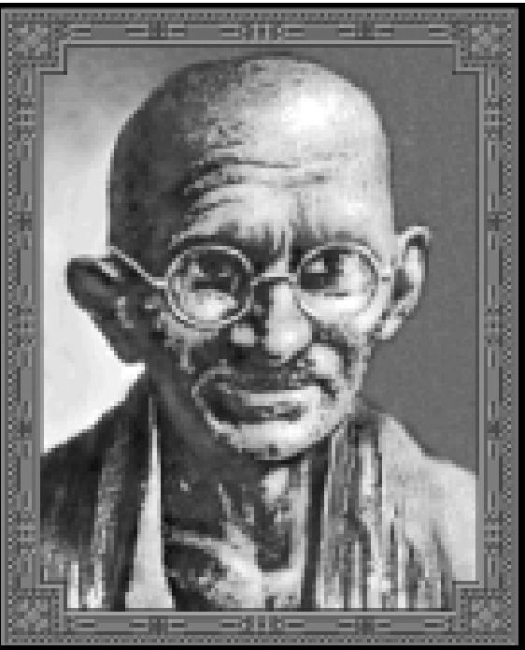

*“Mahatma”Gandhi*

**Don’t Restart Eliminated Players:** Normally, when a civilization is wiped out, the computer looks to see if conditions are right to settle another civilization carrying shields the color of the eliminated culture. When this button is checked, no colors are resurrected, and each opponent eliminated is one less power in the world.

**SELECT YOUR GENDER**

**29**

You can choose to play a male or a female leader. Each civilization has one default leader of each gender, and of course, you can customize your leader’s name.

**SELECT YOUR TRIBE**

Select the name of your tribe from the options available, or click on the CUSTOM button. The **Customize Your Tribe** dialog box includes spaces for you to enter your LEADER’S NAME, your TRIBE’S NAME, and the adjectival form of your tribe’s name (for messages and announcements). The default options give examples of each entry.

**Titles:** Choose this option to specify the titles by which you prefer to be addressed for each form of government in the game.

**Portrait:** This option offers several rows of portraits from which you can choose the face you’d like to present to the world.

When you’re satisfied with your choices in each screen, click the OK button.

SETTING UP
  
A GAME

**SELECT YOUR CITY STYLE**

Here you can choose the style in which your citizens build. The default style is chosen to reflect your tribe’s national origins as closely as possible.

**Bronze Age Monolith:** In the style of the Mayan and Sumerian empires, your city icons
  
build from simple stone boxes to complex clusters of megalithic proportions.

**Classical Forum:** Following the Greek and Roman styles, your city icons progress from neat marble structures to gleaming colonnaded vistas.

**Far East Pavilion:** In the Oriental tradition, your city icons build from red-tiled gables to elaborately layered pagodas.

**Medieval Castle:** Following European models, your city icons grow from narrow thatched cottages to tightly packed labyrinths of humanity.

**READY, SET, GO**

**30**

|  |  |
| --- | --- |
| After you are satisfied with your settings, click OK to start the clock ticking on your civilization. A screen pops up welcoming you to your position as leader and detailing the accomplishments of your culture thus far. When you have finished reading the screen, press any key or click the OK button on the screen to begin the game. |  |

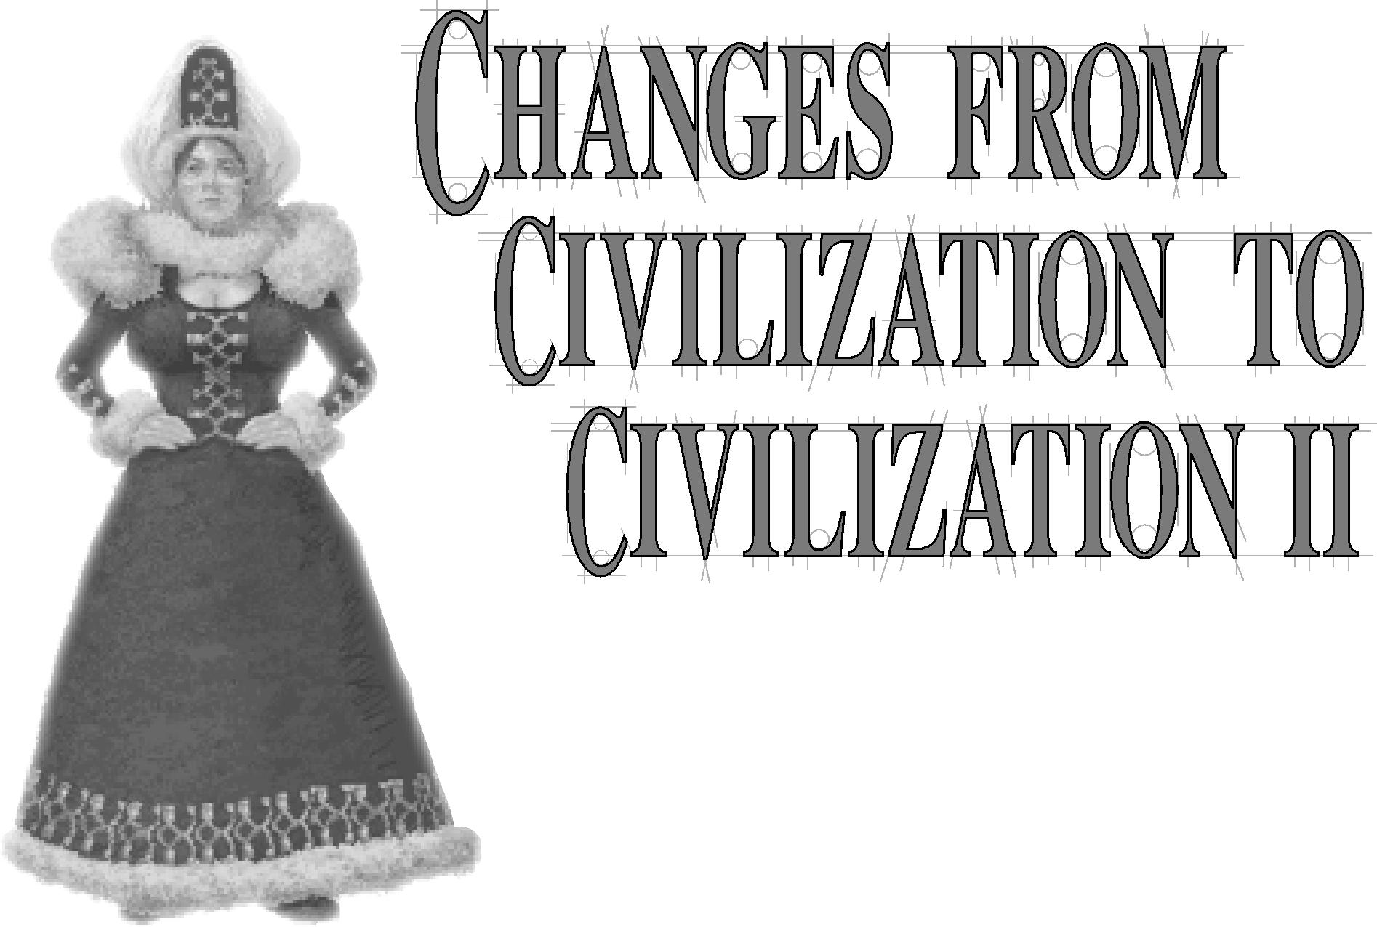If you’re already familiar with ***Civilization*** in one of its previous incarnations — the Macintosh version, the DOS version, the Windows version, or the multi-player version — there are a lot of features that are familiar. However, that familiarity can lead you into some pitfalls, because the game has evolved and grown, so that this new version is substantially different. Take a few moments to peruse this section for a summary of the changes you can expect.

CNILIZATION TO
  
CNILIZATION II

**31**

**CIVILIZATION’S NEW LOOK**

As ***Civilization*** has matured as a game, the quality of graphics has also matured. ***Civilization II*** has high resolution graphics now, scaleable fonts and windows, and whole new units and improvements. Settlers units are no longer represented by those old, familiar covered wagon icons. But more is new than simply different pictures.

**THE MAP**

**32**

***Civilization II*** uses an isometric grid instead of the old, square grid. This means each square (what we call a *terrain square*, or just *square*) is now a diamond shape, as if you are viewing it from an angle. Movement still proceeds along the compass points as it always did. Some players may have difficulty getting used to this new view, finding it hard to tell where a city’s radius begins and ends, for instance. If you have this problem, we recommend you select SHOW MAP GRID from the VIEW menu or press the Ctri and **G❑** keys simultaneously. This activates a grid overlay which outlines each map square.

**THE UNITS**

Every unit icon in the game now carries a shield. The color of the shield body indicates the civilization to which that unit belongs. As in ***Civilization,*** barbarian units are always red. The colored strength bar at the top of the shield indicates the overall health of the unit. We’ll go into detail in **New Combat Concepts,** but for now you should know that green indicates a healthy unit, yellow means the unit is somewhat damaged, and red shows a critically injured unit.

**THE CITIES**

You can choose what style of architecture your civilization prefers to build when you set up a game. As your cities increase in size, the icons that represent them on the map also change, reflecting the increasing urbanization and population of the site. Whenever you capture a city, its icons change to reflect your preferred style of architecture. Once your civilization reaches the industrial era, the architecture of your cities begins to reflect your new level of technology.

**THE DISPLAYS**

Many screens and displays have been redesigned to better present new information and to take advantage of the more sophisticated graphics now available. Most of the information should be self-explanatory; all the major game windows are illustrated in **Reference: Screen by Screen**.

**NEW COMBAT CONCEPTS**

Players of ***Civilization*** were occasionally disconcerted when a “lucky” veteran Phalanx unit, fortified in an enemy city, destroyed an attacking Battleship unit. Mathematically it was possible, but the image conjured up just didn’t sit right. How could ancient spearmen take out a modern steel warship? To smooth out such freakish reaches of probability, ***Civilization II*** has added two new statistics for each unit: *hit points* and *firepower*.

**HIT POINTS & FIREPOWER**

**33**

Hit points are graphically indicated by the colored *strength bar* across the top of each unit’s shield. Both the length of the strength bar and the color are significant. As a unit loses hit points in an attack, its strength bar gets shorter. In addition, when the unit is reduced to approximately two-thirds of its full strength, the strength bar changes from green to yellow. When a unit’s hit points are reduced to around one-third of its full strength, the bar changes from yellow to red.

Hit points represent a unit’s relative durability in combat situations. Ancient and unarmed units generally have ten hit points. Units with firearms have 20, and units with steel armor have 30. Battleships, with their extraordinarily thick armor, are unique in having 40 hit points. A unit with ten hit points can be hit ten times before being destroyed. This does not necessarily mean that ten units each hit it one time. Units also have a new statistic, firepower, which indicates the number of points of damage that unit does each time it successfully scores a hit.

These new statistics widen the gap between primitive technologies and modern weaponry. A Musketeers unit with a strength of three attacking Pikemen of strength two has an “effective strength” of far greater than three, simply because its increased hit points (20, representing its firearms) allow it to sustain twice as much damage as the Pikemen. A veteran Phalanx unit might still damage a Battleship, but the chance of utterly demolishing it is negligible.

**RESTORATION**

The new stats also bring with them the need for *restoration*. When combat was all-or-nothing, defeated units were always destroyed, and victorious units emerged unscathed. Now, victory is not always without cost. A damaged unit might suffer curtailed movement points and is vulnerable to counterattacks by further enemy units. So how do you regain full strength?

CNILIZATION TO
  
CNILIZATION II

A damaged unit can partially restore itself by skipping its *entire* turn — pressing the S acebar ). Units repair faster when they remain in cities for a full turn. If the city they occupy has certain improvements, they can heal even more rapidly. Along with its former capacity for turning out veteran units, a Barracks can repair ground units. The new Port Facility city improvement can repair naval units, and the new Airport city improvement can repair air units — in all three cases, the damaged unit is restored to full strength in a single turn.

**NEW AND CHANGED UNITS**

**34**

People have been suggesting new units to include in ***Civilization*** since the initial release of the game. For ***Civilization II,*** we wanted a more continuous progression of development in the three types of ground troops: the basic, all-purpose Infantry, the swift-moving Cavalry, and the heavy-weapon Artillery. In addition, there are more gradations in ships and in air units. Modern units often fulfill specialized roles, and more units have special abilities and unique capabilities. Finally, each non-combat unit of old gains an advanced version, so that Settlers are followed by Engineers, Diplomats by Spies, and Caravans by Freight. Engineers work and move twice as quickly as Settlers, and can *transform* terrain using modern technology. Spies can perform normal diplomatic missions more effectively than Diplomats, and have several new missions available, including poisoning water supplies and even planting nuclear devices! Freight units move more quickly than Caravans, and provide greater economic bonuses for trading.

The existence of all of these new units gave rise to the opportunity to rebalance some old ones. Chariots have been toned down to an ADM of 3/1/2, for instance, while Legions have been beefed up to an ADM of 4/2/1. You’ll find the full details in the CIVILOPEDIA entries for each unit.

**SPECIAL COMBAT CASES**

To better reflect their real-world abilities and handicaps, many units have unique combat rules and abilities. For instance, when a ship bombards a ground unit on shore, the firepower of both units is reduced to one. This simulates the low accuracy of shore bombardment. Similarly, ships defending in port have their firepower reduced to one, because of the limitations of maneuverability. Air units attacking ships in port have their firepower doubled, to represent the vulnerability of their targets. The **Combat** section of **Units** gives the full details for each exceptional case.

**NEW PRODUCTION CONCEPTS**

We’ve tweaked the economics of the game a little to help fill in some gaps and to make playing more of a challenge for experienced loophole dodgers.

**WASTE**

In previous versions of ***Civilization,*** trade is modified by corruption. When an empire sprawls over a great area, and its form of government is low on the scale of sophistication, corruption lowers the total trade goods intake in cities on the fringes and frontiers. The more sophisticated the government and the smaller the sprawl, the less effect corruption has.

***Civilization II*** extends this concept of modification to include another resource. Now shield production is also affected by the level of government and the sprawl of empire. In fringe locations, some proportion of the shields that workers generate each turn is lost as *waste*.

**35**

**PENALTIES FOR SWITCHING PRODUCTION**

A city can produce three different types of things: units, improvements, and Wonders. To close several loopholes that players had been exploiting, ***Civilization II*** introduces a significant penalty for switching production between different types (changing a city’s production from City Walls to Knights, for instance, or from City Walls to a Wonder of the World). Switching from one type of production to another in mid-stream (or mid-build) costs a 50 percent reduction in the number of shields already accumulated. Switching production within a type — from one unit to a different unit, for instance — incurs no penalty.

**NEW AND CHANGED IMPROVEMENTS**

Along with new units, ***Civilization II*** also includes new city improvements. These improvements address needs that have arisen because of other changes in the game. For instance, the new concept of restoration (mentioned under **New Combat Concepts**) led to the development of facilities where restoration could take place in one turn. Port Facilities repair naval units, Airports repair air units, and Barracks restore ground units (as well as continuing their “old” function of producing veteran units). The new Superhighways improvement grants a 50 percent increase in trade to citizens working land within a CITY RADIUS, and the new Supermarket improvement allows workers on irrigated land to produce 50 percent more food. To compensate, laying railroad track in a square now only increases workers’ shield production in the underlying terrain, instead of increasing all resources. All of these details are listed in full in the CIVILOPEDIA entries for each improvement.

In addition, some classic city improvements have been adjusted to fit the new demands of play. Colosseums (which in ***Civilization*** made three citizens content) now make four citizens content once your tribe discovers the Electronics advance. This represents the effects of television on the masses. On the other hand, a Cathedral is less effective as an improvement (making only three citizens content instead of four). Further, other discoveries can improve or undermine a Cathedral’s influence. Achieving the advance of Theology increases the effectiveness by one citizen; however, the discovery of Communism reduces it by one citizen. This represents the diminished influence of organized religion in the modern world. Courthouses, under a Democracy, now make one content person happy in addition to their classic effect. Under other forms of government, Courthouses now also make a city more difficult for opponents to bribe. You cannot build a Manufacturing Plant in a city that does not yet have a Factory. Further, plants in cities where the Factory has been

CNILIZATION TO
  
CNILIZATION II

sold or lost increase output 50 percent (not 100 percent) until the Factory is rebuilt. The same loss of bonus applies to the Bank & Marketplace combination and to the University & Library pairing. City Walls are cheaper and no longer cost maintenance. Aqueducts are now required for cities to increase beyond size eight; they used to be required above size ten. The full details are listed in the CIVILOPEDIA entries for each improvement, so be sure to check them out.

**36**

**NEW TERRAIN CONCEPTS**

Redrawing the squares as isometric diamonds doesn’t affect the gameplay in ***Civilization II***. However, there were some elements of terrain that we decided could be jazzed up, including new special resources and upgrades for city squares.

**RIVERS**

In ***Civilization,*** rivers were considered their own terrain type. Now, they are features that can be found running through almost any terrain, making their appearance more true-to-life. To simulate the beneficial effect rivers had on trade, especially in ancient times, any ground unit can follow a riverbed (either upstream or down) for a cost of only one-third of a movement point per square. The presence of a river in an adjacent terrain square still indicates access to water for irrigation, if that adjoining terrain can be irrigated. Rivers still convey a defense bonus of 50 percent, and squares through which they run can still be worked for trade goods in addition to the yield of the basic terrain.

**NEW SPECIAL TERRAIN**

To spice up your world, special terrain resources have been re-allocated in ***Civilization II***. Now each terrain type (except Grassland) has *two* associated special resources, each with its own developmental bonuses. Each special resource has an icon that rests on top of the basic terrain square. To allow for these new resources, some of the special icons with which you are familiar have been renamed and adjusted —for instance, the special resource for Swamp used to be Oil. This resource yielded an extra four shields, along with the one food that basic swamps could generate. Now the Peat resource allows workers to produce four extra shields. In addition, Swamps might also be enhanced by Spice, which allows citizens working them to produce four extra trade arrows, but does not yield any shields. The **Special Terrain Chart** on the **Poster** summarizes all special terrain resource icons, names, and statistics.

**UPGRADING CITY SQUARES**

**37**

It makes sense that city squares should improve as civilizations become more advanced. In ***Civilization II,*** city squares are automatically improved from roads to railroad once your tribe discovers the Railroad advance. Now units can slide through them without losing one-third of a movement point. Once you have discovered Refrigeration, each city square in your empire is automatically improved to farmland.

**NEW MOVEMENT CONCEPTS**

To simulate the effect of river transport, which was particularly important to early civilizations, ground units moving along rivers only use one-third of a movement point for each square (i.e., as if they were moving along a road). Note that the unit must follow the main river channel to receive this benefit: Simply hopping from one bend to another doesn’t count. See figure for details.

In addition, some new units (like Alpine Troops, Explorers, and Partisans) have the ability and equipment to move quickly through even the most difficult terrain. In game terms, they *treat all terrain as roads*. This means that it never costs them more than one-third of a movement point to enter any square —regardless of the terrain type or the actual existence of roads. Units with the ability to treat all terrain as roads can still use railroads for free movement, just as any other unit.

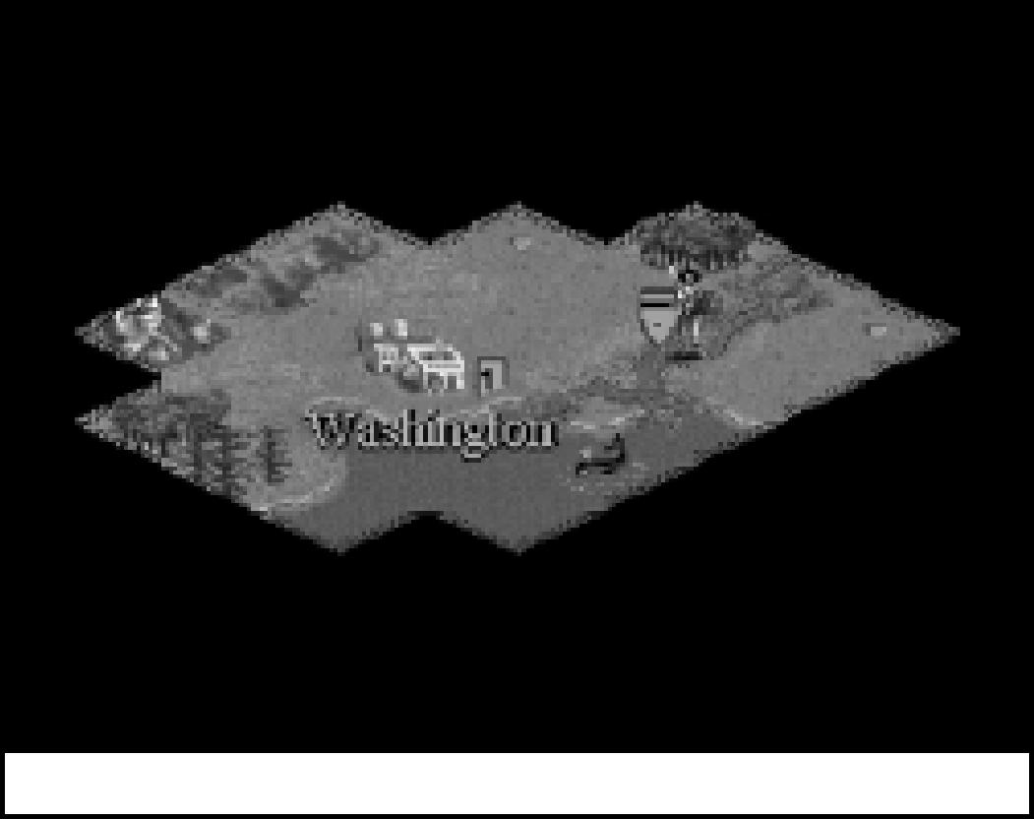

*Close Up of unit on riverbed*

*Sailing experience accumulates with new advances.* In the early days, your Triremes have a 50 percent chance of being lost at sea each time they end their turn in a square that is not touching the shoreline. However, once your civilization discovers Seafaring, your crews’ experience of the coastal waters is vaster, and they are less likely to panic, only foundering 25 percent of the time; the chance of a Trireme being lost at sea is correspondingly reduced. Once you discover Navigation, the crews’ knowledge and confidence is greater still, and their likelihood of unexpected foundering is reduced to one in eight. (If you possess the Lighthouse Wonder, the chance of foundering is eliminated altogether— but we’ll tell you more about that in **New & Improved Wonders** later on).

CNILIZATION TO
  
CNILIZATION II

Finally, *teamwork counts* in ***Civilization II***. Two Settlers (or Engineers, as we’ll explain in just a moment) improving a square (irrigating, building railroads, or whatever) will work as a team and finish the job twice as fast. You can add even more Settlers or Engineers on a tough task, like draining and irrigating a Swamp. The full details are explained under **Settlers & Engineers**.

**38**

**NEW ORDERS**

There are three new orders available to Settlers and Engineer units once you’ve discovered the appropriate advances. The new Engineer unit (which becomes available with discovery of Explosives and works twice as quickly as a regular Settlers unit) can TRANSFORM terrain into a vastly different type. Which terrain results from transformation is noted in the **Terrain Chart**.

Once you have discovered Radio, Settlers or Engineer units can BUILD AIRBASE in any square in which they could ordinarily build a fortress. An airbase allows friendly planes to land and refuel.

Once you’ve discovered Refrigeration, Settlers or Engineer units can IMPROVE FARMLAND to prepare high-yield market gardens.

**GOVERNMENT IMPROVEMENTS**

There have been significant changes in the way different government types function. In addition, a new type of government, Fundamentalism, has been added to round out your choices. A quick rundown of the most important adjustments follows; for complete details, see **Governments**.

*Monarchy* has been vastly improved in that the first three units from each city cost no shield support. We now strongly suggest switching to Monarchy as soon as it becomes available.

Similarly, *Communism* does not have to support the first three units from each city, and units are twice as effective at imposing martial law (so up to six unhappy citizens can be suppressed). No corruption occurs under Communism, and all Spy units produced by Communist governments are considered veterans.

*Republic* has been improved in that the first unit away from a city does not cause unrest and the Senate only concludes unwanted peace treaties 50 percent of the time.

And perhaps most importantly, units in *Democracies* and *Republics* do not cause unrest *if they are in a fortress square within three squares of a friendly city*. This is intended to allow realistic defensive frontiers.

You can no longer avoid Senate interference in your foreign policy by simply refusing to meet foreign emissaries. However, in the Senate of a Republic the “Doves” are in power about 50 percent of the time (in a Democracy the Doves are always a force to be reckoned with).

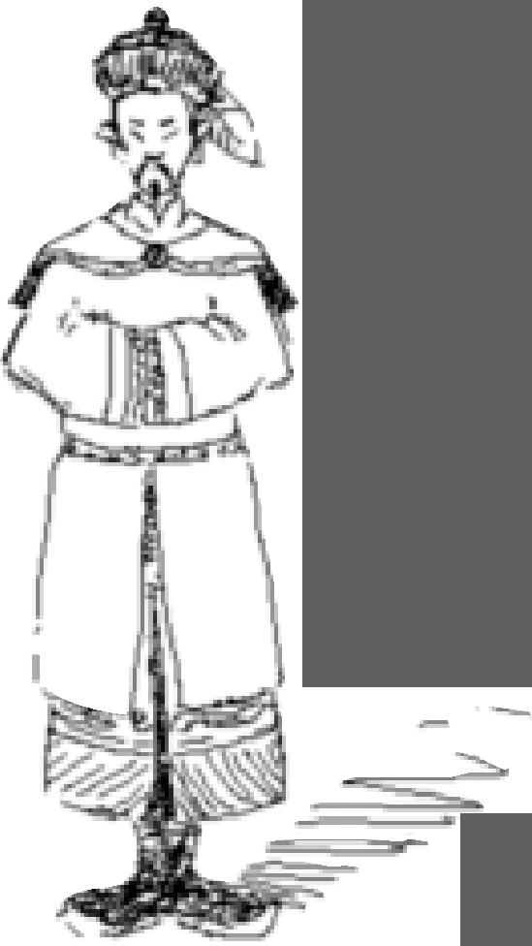When you undertake a Revolution to change your government, you experience the usual period of Anarchy. However, once the menu appears allowing you to select a new form of government, you may freely and instantly change your government for the rest of that turn (by selecting REVOLUTION from the KINGDOM menu). This allows you to compare the effects of various government types.

**39**

Note that science, tax, and luxury rates are now restricted by your government type. Under *Despotism*, for instance, no single rate can be set higher than 60 percent. Under *Monarchy* the maximum rate rises to 70 percent. The other government forms all allow up to 80 percent, except for *Democracy* which allows complete control with rate caps only at the 100 percent mark.

**NEW CONCEPTS IN DIPLOMACY**

Diplomacy has expanded significantly in ***Civilization II***. The AI (Artificial Intelligence) has been improved so that rival civilizations remember your actions and can learn from their past dealings with you, adding a topic to your Foreign Minister’s report known as *reputation*. To complement this concept, there are finer gradations of hostilities between the extremes of peace and war, and a variety of new ways to progress between them. No longer are you considered at war with a rival merely because you have no treaty with him or her.

Once you make contact with a rival, you can speak to him or her at any time by calling up the FOREIGN MINISTER’S report and clicking the SEND EMISSARY button. You are no longer limited by having to set up an embassy with a rival civilization first. However, constantly chatting up opponents makes them weary, and you can exhaust their patience with too many requests.

**REPUTATION**

CNILIZATION TO
  
CNILIZATION II

Rumors of your past transgressions will proceed you! Breaking a treaty or an alliance carries a slight but permanent diplomatic penalty in all future negotiations with all other players. The more treaties you break, the less other players trust you. If you break treaties systematically, the other players learn from their mistakes and become as ruthless as you. If you have an excuse for breaking a treaty (the rival in question uses a Diplomat to steal

technology from you, for instance, or another opponent offers you money to break an alliance or treaty), the diplomatic penalty is eliminated or reduced.

Since keeping your word is more important than behaving peaceably, refusing to sign a peace treaty or opting for a temporary cease fire instead are honorable alternatives. It is possible to maintain a spotless reputation while waging a war of conquest.

**DIPLOMATIC STATES**

**40**

New to ***Civilization II*** are the states of *cease fire*, *neutrality,* and *alliance*; they fill out the classic ***Civilization*** states of *peace* and *war*. If you don’t want to be friends for all time, but you’d like time to regroup, or to pull a city back from the brink of disaster, you now have the option to propose a temporary cease fire. In game terms, cease fires expire after approximately 16 turns, and they are automatically extended when tribute is paid by either side. You are informed when a cease fire has expired.

Neutrality is the state your civilization adopts by default. Neutrality exists when you have not yet encountered a culture, and when you decline to enter into a cease fire or permanent peace agreement.

If you’d like an even closer relationship than simple peace, you have the option to propose a permanent alliance. In game terms, alliances allow you to ignore your ally civilization’s zones of control. This means your units can move freely through his territory and his can move through yours. Your ally’s nearby units will not disrupt production in your cities, and vice versa.

Finally, peace treaties now recognize territorial borders. Moving into the city radius of an enemy city might be taken as a violation of your accord and used as an excuse to declare war. Rivals will warn you when you are violating their territory.

**COUNTERESPIONAGE**

In addition to their foreign service tasks, envoys can engage in counterespionage when they stay home. Diplomats and Spies stationed in friendly cities have a chance to thwart “steal technology” attempts by enemy Diplomats and Spies.

**NEW & IMPROVED WONDERS**

**41**

Along with adding and rebalancing units, improvements and advances, we couldn’t resist the chance to dress up the Wonders of the World. In fact, there are seven new Wonders sprinkled in the Renaissance and Industrial ages. More important to veteran ***Civilization*** players, several of the old Wonders have changed considerably in effect, and many have had expiration dates tweaked. Some Wonders no longer expire at all. A quick summary follows.

The *Pyramids* now act as a granary in every one of your cities. In addition to the old plus-one movement effect, the *Lighthouse* now allows Triremes to move across open ocean without fear of swamping, and all new ships start with veteran status. The *Great Wall* doubles your units’ combat strength against barbarians in addition to forcing your opponents to offer peace *and* acting as a City Wall in every one of your cities.

*Magellan’s Expedition* now confers a plus-two movement bonus on all your ships. *Michaelangelo’s Chapel* now counts as a Cathedral in every one of your cities, instead of its previous ability of increasing the effect of existing Cathedrals. The *United Nations*, in addition to its classic effect also counts as an embassy with every player and gives Democracies a 50 percent chance to override the Senate’s interference in foreign policy negotiations. Finally, the *SETI Program* now counts as a Research Lab in every one of your cities, which reduces its science benefit from the previous 100 percent increase to a more balanced 50 percent.

The effect of the *Colossus* expires once your tribe discovers Flight. The *Great Library* expires once your tribe discovers Electronics. The *Great Wall* expires once your tribe discovers Metallurgy. And finally, *J.S. Bach’s Cathedral* now requires the advance of Theology to build.

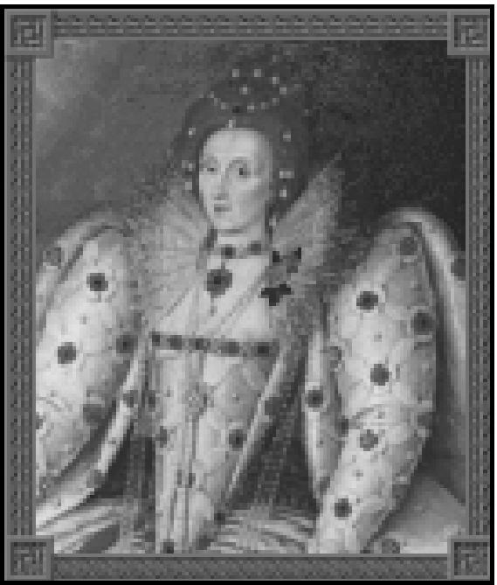

*Elizabeth I*

For the full scoop on these and all the other Wonders, see WONDERS OF

CNILIZATION TO
  
CNILIZATION II

THE WORLD in the CIVILOPEDIA.

**MISCELLANEOUS CHANGES**

**42**

Some civilization advance prerequisites have changed slightly, mostly to eliminate redundancies. Physics, for example, used to require Navigation and Mathematics; however, Navigation already presumes that your culture discovered Mathematics (via Astronomy). Physics now requires Navigation and Literacy. Since some people find the Advance Chart {found on the **Poster**) difficult enough to follow without memorizing the additional changes, we’ve provided help in a variety of places. When deciding which next civilization advance to research you can use the GOAL button to help you find your way through the chart. In addition, each CIVILOPEDIA entry includes the relevant segment of the “advance tree.”

Many civilization advances which used to be dead ends (e.g., Chivalry, Feudalism, Conscription, Pottery) now lead to bigger and better things. Chivalry, Feudalism, and Conscription, for instance, are all directly on the prerequisite chain for Mobile Warfare (Armor Unit).

Computer players are no longer “given” Wonders of the World. They must build them. You will be told whenever a computer player has begun construction of a Wonder.

When you disband a unit in a city square, it contributes half of its production cost in shields to the city’s current project. This represents your ability to “retrain” old troops with new weapons, or to make an all-out effort to complete a city improvement or Wonder. Caravans and Freight units retain their special ability to add their *full* production value to Wonders of the World when they enter a city which is producing one.

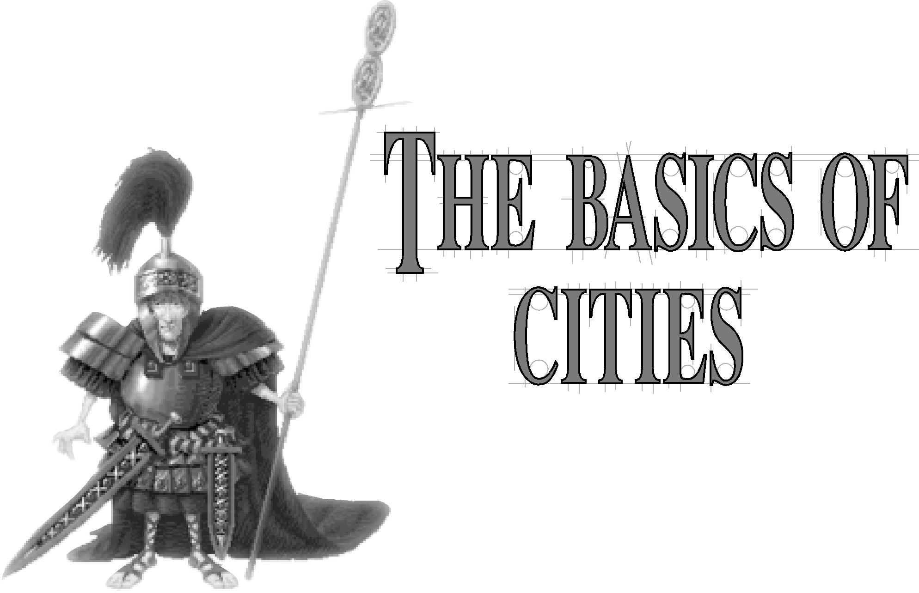

When you start a game of ***Civilization II,*** your Settlers unit stands

on a terrain square surrounded by the darkness of the unknown.

Though you can choose to let this single group of Settlers (if you’re

really special, you could possibly have two Settlers units) wander

the world alone, that’s not the point of the game. As soon as you’ve

found a decent site, you want your Settlers to build a permanent

settlement — a city. You must build at least one city, because only cities

can produce new units, allowing your civilization to grow and develop. You’ll probably build a dozen or more cities over the course of the game.

Cities are the residences of your population, the sources of tax dollars, and the homes of your scientists. Each city organizes the development of the area surrounding it, harvesting the nearby agricultural land, natural resources, and potential trade goods, then converting these resources into food, industrial production, technology, and cash.

One way to measure the success of your civilization is by the number and size of the cities you have built or captured. Larger cities collect more taxes, conduct more technological research, and produce new items faster. Civilizations with small numbers of cities and small city sizes risk being overrun by larger and more powerful neighbors.

THE BASICS
  
OF CITIES

**43**

**CITY CONCEPTS**

**44**

To comprehend the CITY DISPLAY in ***Civilization II,*** you must understand the symbolism the game uses to represent the concepts relevant to population growth and urban dynamics. Take a look at the CITY DISPLAY while you’re reading — it’ll make things a lot clearer.

Cities arose when stationary populations banded together to produce not only enough food to feed themselves day to day, but sufficient leftovers to store for later use. Once food storage developed, not every citizen had to produce food all day, and some people specialized in producing other goods. Eventually, cities accumulated enough surplus food and goods that they could trade their excess with nearby populations.

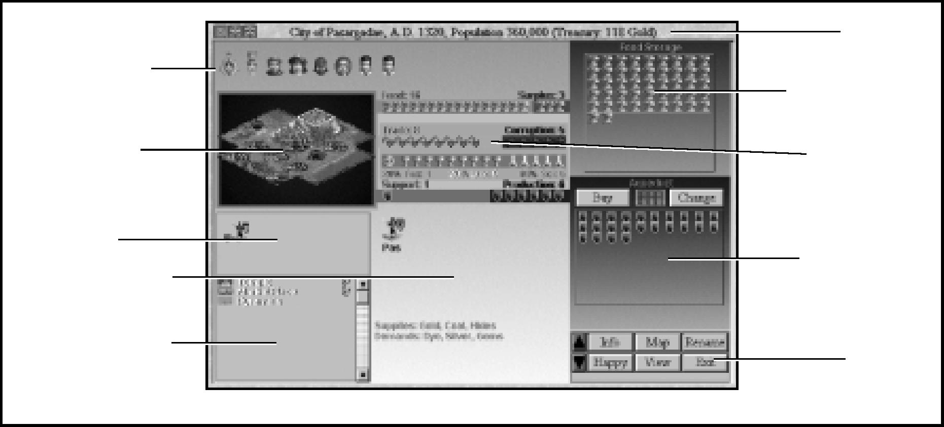

General Information Roster

Population Roster

Resource Map

Unit Roster

Improvement Roster

*The City Display*

Food Storage Box

Production Box

Resource Bars

Title Bar

Buttons

To represent the accumulated population in a game city, ***Civilization II*** maintains a POPULATION ROSTER. Each citizen *icon* — a small symbol — stands for a segment of that city’s population (the exact number of people he or she represents changes as the city grows). The roster displays both citizens who work the land around the city and citizens whose specializations produce other effects. The POPULATION ROSTER tells you more than just how large your city has grown (you’ll find lots more details under **Population Roster** in **Reference: Screen by Screen**), but there are other points of interest in this display, so we’re moving on.

Other icons in the CITY DISPLAY represent a city’s production of food, raw materials, and trade goods. We’re going to call these materials the *resources* of the city. Production is linked to terrain in the game, just as it is in the real world (deserts are not the best food-producing areas in either case). A full discussion of the types of terrain available in ***Civilization II*** and their resources is outside the scope of this chapter (you’ll find it under **Terrain & Movement**). For now, you need to know that citizens working on terrain squares (or “map squares”) can produce three different types of icon: *grain*, which represent food; *shields*, which represent raw materials the city can use to produce goods; and *arrows*, which represent trade goods. On some terrain squares, workers produce a larger proportion of one than of the others. On some squares, workers can’t produce any of one type (a citizen working on Tundra produces no shields, for instance).

**45**

The resource icons — grain, shields, and arrows — that appear on the map are recapitulated in other displays, where they reveal further details of your city’s economy and growth. We’ll explain all the details in the reference sections that describe those displays.

**GAINING NEW CITIES**

You can acquire new cities in three ways. Most frequently, you build them with Settlers
  
units. If you are aggressive, you can conquer the cities of your neighbors. Occasionally, you
  
can gain a city when a minor tribe discovered by your units elects to join your civilization.

**FOUNDING NEW CITIES**

The most common way to gain new cities is to send out Settlers to tame the wilderness. In fact, you start the game with a Settlers unit whose primary task is to found your first city. The terrain under and around your city is important, so if you want to select the best possible place for your metropolis, skip down to **Choosing Your Location**. If you want to jump right in, choose a square with rivers, plains and/or grasslands near it.

When your active Settlers unit stands on the square where you wish to build a new city, choose the option BUILD NEW CITY from the ORDERS menu. If you accidentally build a city by mistake, you can select the CANCEL button on the NAME CITY screen to retrieve your Settlers unit.

Your advisors propose a name for the new city; you can type in a different name if you prefer something else. When you are satisfied with the name, press Enter or click the OK button. The CITY DISPLAY opens so that you can arrange the city’s initial production and economic development. When the display closes, your new city appears on the map. The Settlers unit disappears, having converted into the first citizens of your new city.

THE BASICS
  
OF CITIES

**46**

|  |  |
| --- | --- |
| CHOOSING YOUR LOCATION  When building a new city, carefully plan where you place it. Citizens can work the terrain surrounding the city square in an X-shaped pattern (see **City Radius** for a diagram showing the exact dimensions). This area is called the CITY RADIUS (the terrain square on which the Settlers were standing becomes the city square). The natural resources available where a population settles affect its ability to produce food and goods. Cities built on or near water sources can irrigate to increase their crop yields, and cities near mineral outcroppings can mine for raw materials. On the other hand, cities surrounded by desert are always handicapped by the aridness of their terrain, and cities encircled by mountains find arable cropland at a premium. |  |

In addition to the economic potential within the city’s radius, you need *Choose a location carefully*

to consider the proximity of other cities and the strategic value of a

location. Ideally, you want to locate cities in areas that offer a combination

of benefits: food for population growth, raw materials for production, and river or coastal areas for trade. Where possible, take advantage of the presence of special resources on terrain squares (see **Terrain & Movement** for details on their benefits).

PROXIMITY OF CITIES

Another consideration when planning new cities is the current or potential location of other cities. You want to minimize the chance that one city’s radius overlaps another’s. Since a map square can only be used by one city at a time, radius overlap restricts the potential growth of one or both cities. Explore nearby lands as soon as possible to begin planning the placement of future cities. You want to take best advantage of the terrain. Of course, the geography of your particular continent will limit your choices. If you find yourself on a small island, your potential city sites will necessarily be more crowded than if you can sprawl across a vast continent.

STRATEGIC VALUE

**47**

The strategic value of a city site is a final consideration. A city square’s underlying terrain can increase any defender’s strength when that city comes under attack. In some circumstances, the defensive value of a particular city’s terrain might be more important than the economic value; consider the case where a continent narrows to a bottleneck and a rival holds the other side. Good defensive terrain (Hills, Mountains, and Jungle) is generally poor for food production and inhibits the early growth of a city. If you need to compromise between growth and defense, build the city on a Plains or Grassland square with a river running through it if possible. This yields decent trade production and gains a 50 percent defense bonus.

Regardless of where a city is built, the city square is easier to defend than the same unimproved terrain. In a city you can build the City Walls improvement, which triples the defense factors of military units stationed there. Also, units defending a city square are destroyed one at a time if they lose. Outside of cities, all units stacked together are destroyed when any military unit in the stack is defeated (units in Fortresses are the only exception; see **Fortresses**).

Placing some cities on the seacoast gives you access to the ocean. You can launch ship units to explore the world and to transport your units overseas. With few coastal cities, your sea power is inhibited.

**CAPTURING CITIES**

Other civilizations normally defend their cities with one or more military units (armies for short), and sometimes with the city improvement City Walls. A defended city flies a pennant showing its owner’s color. A walled city is surrounded by a short wall. There are two ways to acquire enemy cities: force and subversion. If you choose force, you must destroy the defenders by successfully attacking with your military units. Once the city is undefended, you can move a friendly army into the city and capture it. If you prefer subversion, you must successfully bribe dissidents in the city with your Diplomat or Spy unit (and sufficient funds—see **Diplomats & Spies** for all the details on such espionage). The dissidents capture the city for you, as their armies automatically convert to your side. Once captured, the city becomes yours to control and manage as you would any other.

Capturing an enemy city can also lead to side benefits, such as the discovery of a new technological advance and plundered cash to add to your coffers. Capture, however, eliminates one point of population (unless the City Walls, which can prevent this loss, are still standing). Therefore, when your units enter a city with only one point of population remaining, it is destroyed instead of captured. Diplomats and Spies can incite dissidents (see **Diplomats & Spies**) to capture a city without reducing its population below one.

THE BASICS
  
OF CITIES

Occupation of an enemy city destroys roughly half of the improvements the city has built, including all Temples and Cathedrals. Certain military units, such as Fighters and Bombers, are also destroyed rather than captured. Capture does not affect Wonders of the World (though, of course, destroying a city does — see **Wonders of the World** for more details). Inciting revolt creates less damage to the city, as the dissidents rely less on bombardment, and their familiarity allows them to pinpoint targets more accurately. A city captured by revolt loses only the Temple and Cathedral improvements (if it had them).

**48**

**CONVERTING MINOR TRIBES**

As your units explore the world, they might encounter the villages of minor tribes — civilizations too small or too peripatetic to count as “settled” (see **Minor Tribes** for the scoop on these situations). Minor tribes react to contact with a range of emotions, from delight to hostility. Occasionally, a minor tribe is sufficiently awed by your emissaries to immediately form a new city and become part of your civilization.

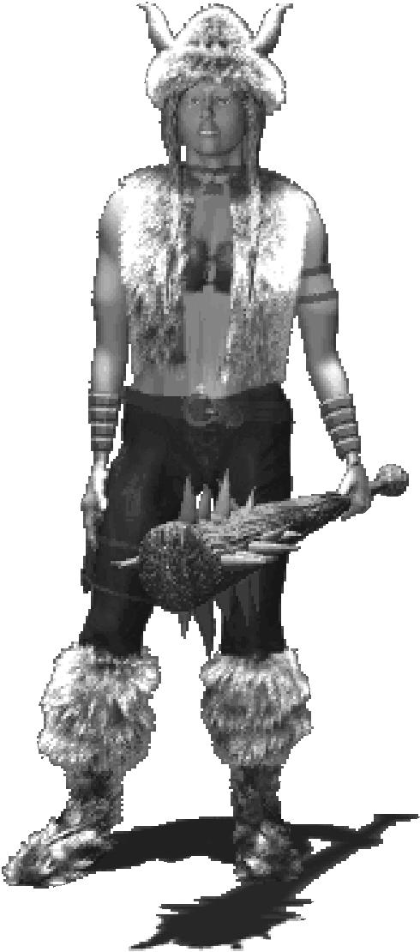

Move your exploring unit onto the village icon to discover the tribe’s attitude towards your civilization. If they choose to form a new city, you need do nothing: Your advisors propose a name for the new city (which you can change if you prefer something else). When you are satisfied with the name, press Enter or click the OK button. The CITY DISPLAY opens so that you can arrange the city’s initial production and economic development. When you close the display, your new city appears on the map. The village icon is replaced by the new city square, and members of the tribe settle in as the first citizens of your new city.

*Viking*

**THE PARTS OF A CITY**

**49**

**THE CITY SQUARE**

The terrain a city occupies is especially important because it is always under development. You cannot take workers off of this square when adjusting resource development on the RESOURCE MAP (see **Resource Map** in **Reference: Screen by Screen**). If this area is not useful, especially for producing food, then population growth in the new city is handicapped. For this reason, you’ll find new cities do best when they are built on Plains or Grasslands squares or squares with rivers. These terrain types provide the best food production and, thus, faster population growth.

Note that all beginning civilizations possess the technologies of building Roads, Mining, and Irrigation. When you found a city on a Plains, Grassland, Hills, or Desert square, (or the special terrains based on those types) including squares with rivers running through them, the city square is automatically improved by roads and irrigation. When you found a city on any other type of terrain, the city square is automatically improved by roads and, if applicable, mining. You cannot assign a Settlers or Engineer unit to further improve a city square by, for example, adding mining or railroads, regardless of terrain, although you *can* change the terrain to another type (Forest to Plains, for example). Move a Settlers or Engineer unit into the city square and check the ORDERS menu to see what changes are possible. City squares *do* automatically improve with the discovery of certain advances.

**THE CITY RADIUS**

The potential area of development, called the *City Radius*, extends two map squares out from a city in every direction except vertically or horizontally. Since the development area only extends one square from the city square in these directions, the resulting “radius” actually looks like a fat X, not like a circle. If the city grows large enough, its citizens can bring all of this area into development. When planning a new city, consider the long-term benefits of all the terrain squares within this radius.

For the city’s population to increase, the radius must encompass terrain that workers can cultivate to produce food. Your (potentially) most important cities also have raw materials available. These cities can quickly build and support military units and Wonders. Hills and Forests allow your citizens to produce good quantities of raw materials, as do squares containing special terrain icons (pheasants, buffalo, coal, fish, and others —see **Special Terrains** for complete details).

THE BASICS
  
OF CITIES

**50**

|  |  |  |  |
| --- | --- | --- | --- |
| The importance of trade in generating taxes and civilization advances makes river squares especially good sites for cities early in the game. Where you have no rivers or coastal areas, you can generate trade by building roads on Plains or Grasslands.  When a square within your CITY RADIUS is outlined, it indicates that another city is claiming that terrain’s resource production. It could be one of your cities, if the city radii overlap. If you own both cities, you can flip between Resource Maps to adjust production in each to the best benefit of both locations. It could also be a rival city that one of your opponents has built close to you. Finding an outlined square in your city’s radius might even lead you to discover a rival city in unrevealed territory or outside of your units’ observation range. |  | | |
|  | *City Radii* |  |

MANAGING
  
YOUR CITIES

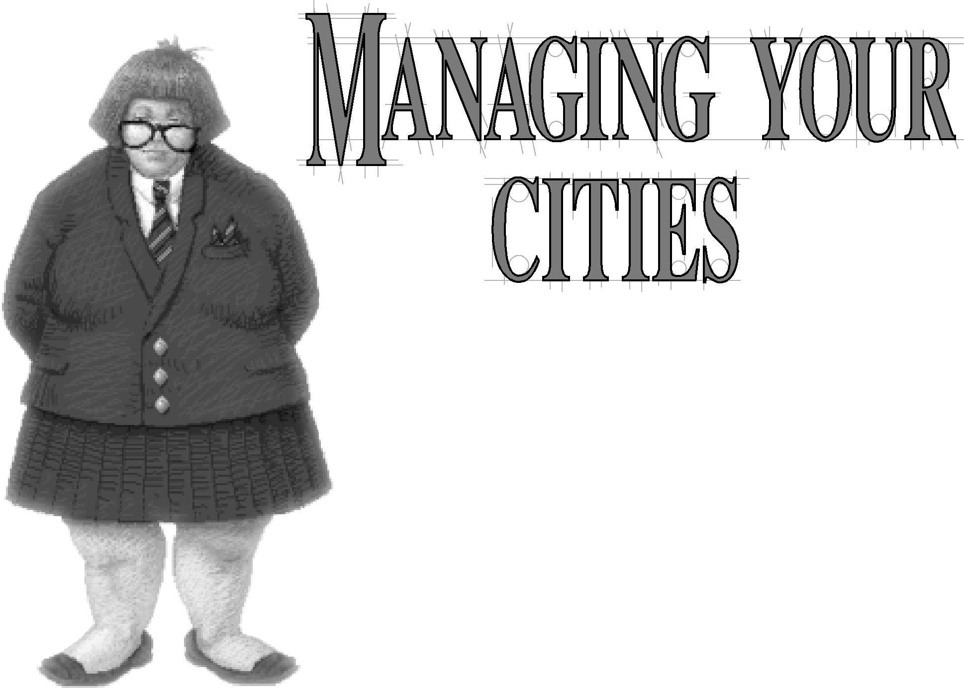

Once you’ve founded, captured, or gained a city, you need to direct its

**51**

growth and production. Each city has different assets and demands, so each

should be managed individually. You must keep several goals in mind when

managing a city: maintaining population growth, maximizing a useful mix of

economic development (food, raw materials, and trade), producing tax

revenue, producing technological research, and producing useful units and

improvements, all the while maintaining an attitude of contentment and thereby avoiding civil disorder. For cities to grow and prosper, they need to balance economic output with the citizens’ needs for infrastructure and services.

**CITY MANAGEMENT CONCEPTS**

**52**

As your city increases in size, its population expands, and it produces more and more food, shields, and trade. These represent your city’s basic resources: edibles, raw materials, and trade goods. In city management, you add another layer of concepts which address how you turn these materials into products you can use. Refer to the CITY DISPLAY as you read.

*Grain feeds your population and supports the city’s units.* When a city produces more food than its population and units consume each turn, the excess accumulates in the FOOD STORAGE BOX. When the box is full, another citizen is added to the POPULATION ROSTER, and the city increases in size. If your city is not producing enough food each turn to feed its population, the shortfall is noted, and stores are removed from the FOOD STORAGE BOX. If the box empties, any units that require food for support are disbanded, one by one, until a balance is achieved. If your city still experiences a shortfall, one citizen is removed from the POPULATION ROSTER, and your city decreases in size.

*Shields power your industrial capacity and support the city’s units.* When a city produces more shields than your units expend each turn, the excess shields accumulate in the PRODUCTION BOX each turn. When the PRODUCTION BOX is full, your city produces something. It can “build” one of three kinds of things: *units* which move around the map (like Settlers and Chariots), *city improvements* which are tied to specific cities (like Libraries and Aqueducts), and *Wonders of the World*, which give unique benefits to the civilization that builds them (like the Pyramids or Magellan’s Expedition) — but more about these details later. The type of government your people develop and the distance remote cities are located from your palace affect your shield production. Sometimes raw materials can be lost to waste. You can read all about the details of waste under **Trade Management Concepts**. If your city runs short of the raw materials it requires each turn, one or more units (that it supports) are forced to disband. The units farthest from home are disbanded first.

*Based on the tax rates you set, trade arrows are further divided into three commodities that your civilization acquires: luxuries, taxes, and science.* These commodities each have their own icons: Luxuries are represented by goblets, taxes are represented by gold, and science or research is represented by beakers. The type of government your people develop and the distance remote cities are located from your palace affects your trade income. Sometimes trade can be lost to corruption. You can read all about the details of trade transactions under **Trade Management Concepts**.

**POPULATION GROWTH**

MANAGING
  
YOUR CITIES

**53**

Keeping a city’s population growing is important because each additional citizen contributes something to your civilization. Each new citizen brings a new terrain square under production in your CITY RADIUS until there are no empty squares to work. After this point, each new citizen becomes an Entertainer (see **Specialists** for details on what Entertainers do). Thus, population growth increases your economic power, and concurrently, the strength of your civilization. The size of your population is a major factor in determining your civilization score, and is a measure of how well you have ruled.

**RESOURCE DEVELOPMENT**

The citizens of a city that work the surrounding countryside harness the economic resources within the city’s radius. Depending on the needs of your civilization, there might be times when you prefer increased industrial output from a particular city over population growth. At other times, you’ll want increased trade revenues. Still other times, sheer population growth might be the most important goal.

You can manipulate the output of a city by reassigning workers on the RESOURCE MAP. Each terrain square that shows resource icons is being worked by a citizen. Click on one of those squares, and you take the citizen off work. An Entertainer icon (a little Elvis) appears at the end of the POPULATION ROSTER. Now click on an empty terrain square. Elvis disappears from the POPULATION ROSTER and resources appear in that square, indicating that a citizen is now working there. By experimenting with the placement of workers on the RESOURCE MAP, you can find the optimum production ratio of food to raw materials to trade for that city.

Having an Entertainer on your POPULATION ROSTER might change the attitude of one or more of your citizens. For more information on this reaction, see **Happiness & Civil Disorder**.

**TAX REVENUE**

The percentage of your trade that is converted into tax revenue, or gold icons, is determined by the tax rate you set— see **Trade Rates** for information on how to manipulate the ratios of taxes, science, and luxuries. Why do you need tax revenue, anyway? You need revenue, or cash, because most improvements you build within cities require a stipend of gold for maintenance. Gold is also useful for speeding industrial production (see **Rush Jobs**), bribing enemy armies or inciting revolts in enemy cities (see **Diplomats & Spies**), and for negotiating peace with your neighbors (see **Diplomacy**).

The combined tax revenues of all your cities must exceed their combined maintenance requirements before gold can accumulate in your treasury. It is not necessary for each city to have a positive cash flow. However, enough cities must do so to cover your civilizations’ expenses, or your treasury will be depleted to cover the deficit. You can watch your STATUS window or check with your TRADE ADVISOR to see if you have a surplus or a deficit, as we’ll explain under **Advisors** in **Reference: Screen by Screen**.

**54**

Some cities might not be especially suited for industrial production because of terrain or other factors. But they might still be good trading centers, and capable of generating lots of income. Develop these locations with roads (and later, railroads), trade routes (see **Caravans & Freight** for the lowdown on trade route bonuses), city improvements like Marketplace, Bank, and Stock Exchange, and Wonders to be your civilization’s cash cows. If you get to the point where you are no longer interested in building new items in a location, you can use the Capitalization improvement to convert a city’s shields into gold — see the CIVILOPEDIA entry for details.

**TECHNOLOGICAL RESEARCH**

The greater the research contribution each city makes toward new civilization advances, the faster your people discover each new advance. The science rate you set determines the amount of research done in each city (see **Trade Rates** for the essentials of adjusting the ratios of science, taxes, and luxuries).

A city’s research contribution can be influenced by adjusting the city’s total trade income — research is a fraction of trade — by creating Scientists (see **Specialists**), and by building certain city improvements. Improvements that can help are the Library, University, and Research Lab which all increase research, and several Wonders. The **Civilization Advances** chapter goes into detail about how to read the advance tree, so if you want the nuts and bolts, flip there next.

**INDUSTRIAL PRODUCTION**

Your most valuable cities can be those with the greatest industrial capacity—those whose workers produce the greatest number of shields. These cities can quickly produce expensive military units with which you can extend the power of your civilization. They are also best at producing Wonders of the World, as Wonders generally cost immense numbers of shields. But city management is dynamic. You must regularly monitor the production of your cities to ensure you are building the items you most need.

Several factors influence a city’s production of shields: The terrain within your CITY RADIUS is most important, as citizens working on some types of terrain produce no shields at all (see **Terrain & Movement** for further explanations). You might find it worthwhile to set Settlers (and later, Engineers) to improving the terrain squares within your CITY RADIUS so that they yield more or different resources (see **Settlers & Engineers** for examples of what improvements they can make).

MANAGING
  
YOUR CITIES

**55**

Beyond terrain, the form of government your civilization chooses can cause each city to spend some of its raw materials as maintenance for the military units that call the city home. It is possible that you can have so many units drawing raw materials from a city that there are no surplus shields. In a city where this is the case, progress on the item under construction (unit, improvement, or Wonder) stops until the situation is resolved.

A number of strategies allow you to adjust industrial capacity. The simplest is to shift citizens working on the RESOURCE MAP so that they produce more shields (see **Resource Development** for instructions). You can also use Settlers or Engineers to improve a terrain square within the CITY RADIUS so that it yields more shields. Or, order Settlers units to build a new city (they’ll no longer draw support from the city that sponsored them when they’ve settled their own town). You might also try reassigning units so that they are attached to a different city (see **Homing Units** for the low down on how to do this).

Within each city, you can order the construction of improvements such as a Factory, Hydro Plant, or Offshore Platform that increase shield production. Several Wonders also affect shield output. Consult the CIVILOPEDIA for the complete list of possible city improvements and Wonders. It shows the construction and maintenance cost of each item, its purpose, and what advance is required to make it available.

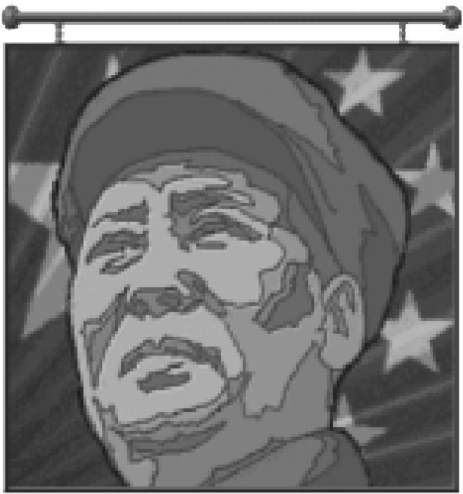

*Mao Tse-tung*

**CITY PROTECTION**

**56**

Great economic management of a city is worthless if the city is captured by rivals or barbarians. Therefore, part of your management plan must concern the defense of each city. The minimum city defense is one army, preferably one with a good defense factor. A second defender can provide back-up in case the first is taken out (see **Military Units** for details of combat). An army with a strong attack factor is also useful. This unit can strike at enemies that move adjacent to the city, perhaps destroying them before they can launch an attack. Fortify any armies that you expect to defend a city (choose the FORTIFY option from the ORDERS menu or press the FE) key) because fortified units gain an increased defense strength — as we’ll explain more fully under **Military Units**.

A city’s defense can be substantially increased by building City Walls, an improvement that triples any defender’s strength against most attackers (although not against Howitzers or air units). Veteran status and terrain bonuses are figured in before this tripling takes effect. City Walls also prevent population loss when defending units are destroyed (see **Combat**).

When civilization advances make available new army types with better defense factors, take the first opportunity to replace old defenders with better units. Since the offensive capability of your enemies improves as they acquire new advances, your defenses must improve to keep up.

Linking cities with roads and railroads can be very helpful in speeding the movement of units from one end of your empire to trouble spots elsewhere. This puts your defensive armies on “interior lines,” allowing them to move rapidly to where they are needed.

**IMPROVEMENTS**

MANAGING
  
YOUR CITIES

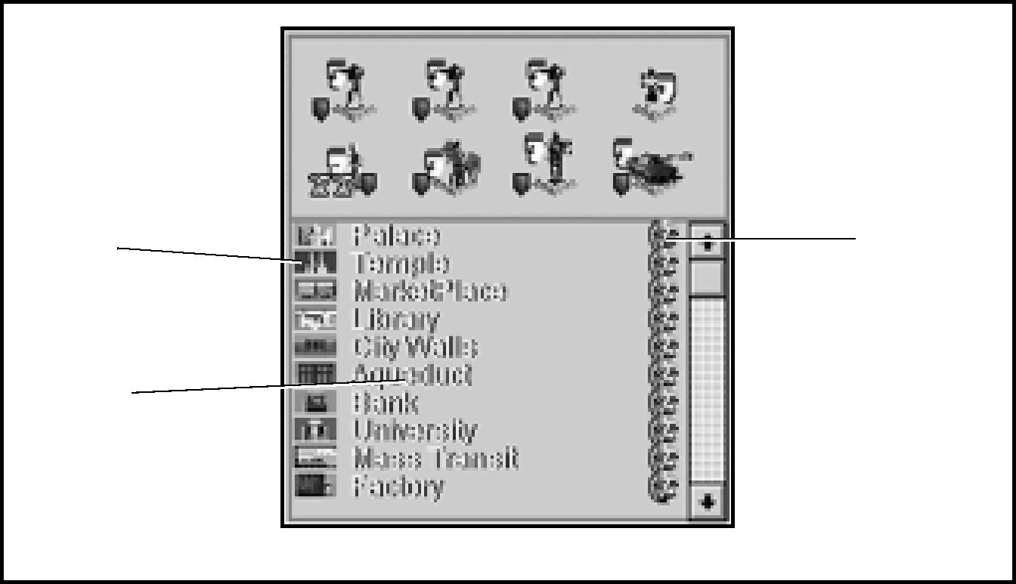

Icon

Name

*Improvement Roster*

Sell icons

**57**

City improvements represent the commercial, bureaucratic, educational, and public works infrastructure that make large and efficient cities possible. In the real world, New York City’s dense population depends on the extensive subway system for transportation, and buys electrical power generated by distant grids. Los Angeles is located in a desert and pipes in much of its water from sources hundreds of miles away.

In ***Civilization II*,** improvements are also critical to the growth and importance of cities. Inadequate provision of these facilities can limit the potential size of a city. Each improvement provides some service or otherwise makes a city work more efficiently. You must choose which improvement to implement at what time —does your city need a Marketplace or a Library more? Would a Courthouse provide more benefit than a Colosseum? City improvements are listed alphabetically in the CIVILOPEDIA. It explains the building costs, benefits, and maintenance fees of each improvement, along with any conditions which make the improvement obsolete or non-functional.

**LOSING IMPROVEMENTS**

**58**

Improvements are not invulnerable, nor are they guaranteed to be permanent fixtures in an ever-dynamic city. The Barracks improvement, for instance, has a planned obsolescence. Once your civilization discovers the advance of Gunpowder, your old Barracks is rendered obsolete, and it disappears. (The same result attends your discovery of Combustion. These military installations are sensitive to changes in technology.) To regain its benefits each time, you must rebuild a Barracks improvement in each city you desire to have one.

Most improvements don’t disappear over time, but they can be vulnerable to capture, fire sale, and sabotage. If you’re really strapped for cash, you can even sell a city’s improvements.

CAPTURE

Some, all, or none of a city’s improvements might be destroyed when it is captured by another civilization. When a city is completely destroyed, all improvements are destroyed as well.

FIRE SALE

If you have less money in your treasury than is needed to pay a city improvement’s maintenance cost at the beginning of your turn, ***Civilization II*** automatically sells the improvement for cash. Deficit spending is not allowed — even if by the end of the turn you would have had a positive cash flow again.

SABOTAGE

Foreign Diplomats or Spies can enter one of your cities and attempt industrial sabotage (of course, your envoys can attempt to sabotage your rivals’ cities, too). This might result in the destruction of an existing improvement (or it might scrap the item that city is currently producing — see **Diplomats & Spies** for complete details on diplomatic actions). There are two defenses against this type of attack— destroying the Diplomat or Spy before he or she can enter your city, or stationing Diplomats or Spies of your own in the city for counterespionage.

**SELLING IMPROVEMENTS**

MANAGING
  
YOUR CITIES

**59**

To raise cash, click on the improvement in the IMPROVEMENTS ROSTER of the CITY DISPLAY. A dialog box shows how much gold you could receive for selling the improvement. Normally you can gain one gold per resource invested in construction. If you sell, the improvement disappears from the city and the money is added to your treasury.

Selling improvements can be useful when you are short of money and are threatened with the random sale of an improvement. It can also be useful when you are under attack with no reasonable chance of defending or recovering a city. By selling off its improvements, you reduce its value to the enemy and salvage something. You can sell only one improvement per turn in each city. You cannot sell Wonders of the World.

**RUSH JOBS**

There are also times when you need the specific benefits of an improvement right now, and not 20 turns down the line. If you have sufficient funds, you can rush completion of a partially built item by paying cold, hard cash. However, speeding construction in this manner costs a premium. When workers are rushed, they receive overtime wages, and must pay surcharges on material delivery and fabrication. The surcharges for a rush job depend on what proportion of the work is already completed, whether the job is civil or military or a Wonder, and can cost up to eight times as much gold as the normal accumulation of shield icons.

To rush a job without paying cash, you have two options. Any Caravan or Freight unit can enter a city where a Wonder is under construction and deliver its goods specifically to the project by choosing the HELP BUILD WONDER option when it arrives. It contributes the unit cost in shields directly to the RESOURCE BOX. Alternatively, any unit that disbands in a city contributes one-half its unit cost in shields to the current construction, whether it is a Wonder, an improvement, or another unit. This represents the retraining of troops and redisbursement of their supplies.

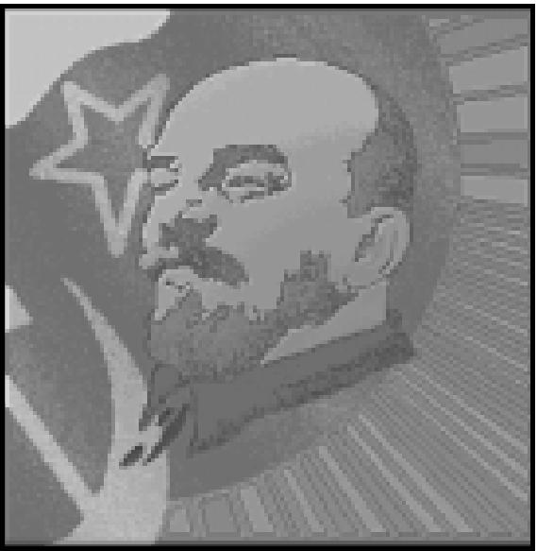

*Vladimir Lenin*

Items completed by rush jobs are available at the beginning of your next turn, so there is no advantage for rushing items that would be complete on the next turn anyway. To judge whether an item can be completed next turn without rushing, compare the surplus raw materials the city is generating to the number needed for completion. For very expensive items, it might be useful to consult your CITY STATUS advisor from the ADVISORS menu for an exact count of the remaining cost.

**RENAMING YOUR CITY**

**60**

You may rename any of your cities whenever you wish. This feature is useful when you capture a city and wish its name to be consistent with the names of cities you have founded, or when you discover that you’re confusing units from two cities because their names are too similar.

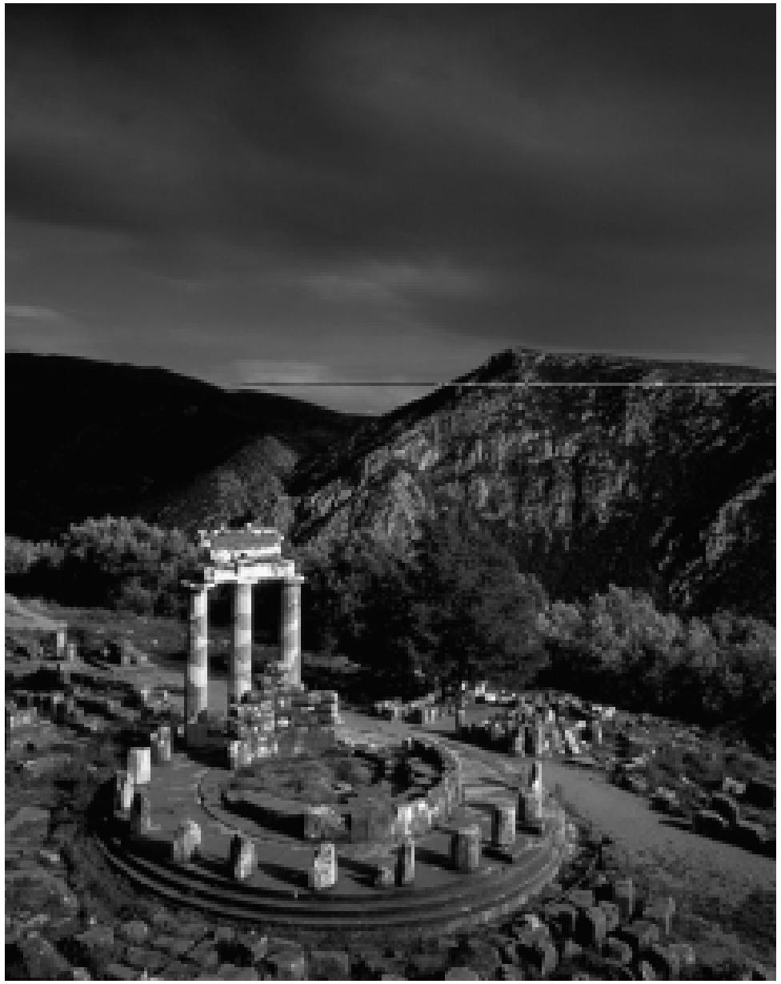

Open the CITY DISPLAY and then click on the RENAME CITY button. A dialog box opens where you can type in the new city name. Press enter or click the OK button to accept the name. If you decide not to change it, click CANCEL.

MANAGING
  
YOUR TRADE

Trade is a fundamental force driving civilizations. It introduces unique and exotic valuables, stimulates the economy, and fires the imaginations of a culture’s foremost thinkers. The effects of trade permeate society in many surprising and subtle ways, and your ability to direct trade’s impact is likewise varied.

**61**

**TRADE MANAGEMENT CONCEPTS**

**62**

Taking up where we left off in **City Management Concepts,** these are the further divisions that result from trade income (arrow icons): luxuries (goblets), taxes (gold), and science funding (beakers).

*Luxuries make your population more content.* The availability of luxuries means that some citizens can enjoy a more pampered existence. Every two goblets make one contented citizen happy. We’ll talk more about happiness a little later.

*Taxes maintain city improvements and add to your treasury.* Taxes support basic city services, and surplus funds accumulate in your treasury. There are plenty of useful ways to spend money in ***Civilization II*,** as we’ll explain in a little while. If funding dries up, your city might be forced to sell off improvements.

*Research funding powers your technological research.* Each new advance requires the accumulation of a certain number of beakers to achieve. The **Civilization Advances** chapter explains the details of the search for knowledge, but for now, you just need to know that new discoveries often allow you to build new units and city improvements, and sometimes open up the possibility of building Wonders of the World. In addition, each discovery leads to further discoveries, creating a chain of progress. If your cities don’t produce many beakers, your civilization doesn’t progress very fast.

Which of these three is the most important? That varies according to what you want to achieve right now. To give trade management the most flexibility, ***Civilization II*** lets you adjust the proportion of trade income that is devoted to each of these three areas. The TAX RATE option on the KINGDOM menu lets you change the ratio of taxes to science to luxuries by ten percent increments, and also shows you how these rates affect your funding and the speed at which your knowledge increases.

In **City Concepts,** we mentioned that the POPULATION ROSTER can tell you more than just the number of citizens in your city. It can also tell you your citizens’ general level of contentment. Citizen icons appear in three different attitudes: *happy, content,* and *unhappy*. When you start building cities, you start with content citizens. The type of government your civilization develops and the level of difficulty at which you chose to play affect how rapidly unrest begins to trouble your populations. Unhappy citizens must be balanced by happy citizens, or your city falls into *civil disorder*. Not only does civil disorder sound bad, it has all sorts of nasty consequences, as we’ll explain shortly.

For now, you need to know that you can increase the happiness of your citizens several different ways, among them: *building specific city improvements* like Temples and Marketplaces (we’ll explain all about **Improvements** shortly), *reassigning military units* (the dirt about martial law and foreign service effects appears under **Military Units**), *adjusting the tax rates* (as we’ll discuss under **Kingdom Menu** in **Reference: Screen by Screen**), and *pulling citizens off production work to make them specialists* (see **Specialists** for the skinny on this).

Phew! That’s a lot of stuff to digest all at once. Just one more thing — we mentioned types of governments two paragraphs ago. Discovering new advances encompasses more than just new gadgets to improve sanitation and military might. The game counts philosophical concepts and theories as “new technologies,” too. Every civilization starts out as a Despotism, but you can develop new forms of government. These might, in turn, have a profound effect on the happiness of your citizens and the rate at which your citizens produce raw materials, food, and trade.

**TRADE RATES**

**63**

When you start a new game of ***Civilization II,*** none of your trade benefits are tied up in luxuries — instead, 40 percent of your trade goes toward revenue from taxes, and 60 percent of it is funneled into science. To change the proportion of tax and science income, pull down the KINGDOM menu and choose the option TAX RATE. Choose a new rate by sliding one or more of the buttons along the slider bars. A notation at the top of the box mentions the maximum any one percentage can be, given your current form of government. Another notation lists the income and outflow as gold per turn, and finally, an entry calculates how many turns it will take to achieve a new advance. If you are interested in focusing on civilization advances, you might want to increase the amount of science being conducted. If you rapidly build city improvements, you might want to increase your taxes to cover the maintenance costs. If you are concerned about the attitude of your citizens, you might want to increase the availability of luxuries to make your citizens happier (we’ll explain all about happiness in a few moments). Experiment with different rates to see what levels of income and science you can achieve.

MANAGING
  
YOUR TRADE

If it is difficult to adjust all three sliders at once, you can click the box at the right end of any bar to lock that value in place. Now only the other two sliders move when you drag on one.

**GOVERNMENTS**

Another tool of city — and trade — management is the type of government under which your culture operates. Every civilization starts out as a Despotism, but some of the advances you can research are intellectual in nature, rather than technological, and these include five new governmental concepts. Once you have discovered a new form of government, you can choose to sponsor a revolution in order to change government types. (You can also gain access to new forms of government by building the Statue of Liberty Wonder.)

Anarchy, or the lack of government, occurs only when you lose control, either because civil unrest topples your current government, or immediately following a revolution. Civil unrest continues as long as conditions are ripe for it. In the case of a revolution, your people’s attitude naturally stabilizes. After a few turns, once your civilization settles down, a dialog box appears listing all the possible forms of government your culture has available. Choose the one you like, and that regime takes effect immediately.

A new feature in ***Civilization II*** lets you change governments instantaneously and without penalty for the remainder of this turn. If your first choice turns out to be unsatisfactory, pull down the menu again and select a different government. Once you press Enter to end your turn, you must go through the entire revolution process (including several turns of Anarchy) if you want to change governments again.

There are three “ancient” forms of government—Despotism, Monarchy, and the Republic—and three “modern” ones—Communism, Fundamentalism, and Democracy. The Republic and Democracy are the most sophisticated from an economic point of view, but they impose severe restrictions on your military forces. The other forms offer trade-offs between economics and increased military flexibility. In essence, you could summarize governmental variants this way: The more freedom you give your people, the less they will want to fight for you, but the stronger your economy will become. We’ve collected the details of each form of government’s bonuses and drawbacks in regard to trade, support provided to units, production, and the attitude of the citizenry. Depending on your style of play, you might not develop each advance in order of sophistication.

**64**

**ANARCHY**

You have temporarily lost control of the government. You continue controlling the movements of your units, and cities continue to operate on their own, but some important functions of your civilization grind to a halt until control is restored.

**Attitude:** Up to three troops in each city can institute martial law; each makes one unhappy citizen content (see **Happiness & Civil Disorder**).

**Corruption & Waste:** Corruption is rampant. Although no maintenance is charged for city improvements, no tax revenue is collected and no scientific research is accomplished while Anarchy continues.

**Resource Support:** Military units do not require raw material support until the number of units making a city their home (see **Unit Roster**) exceeds the number of citizens on the POPULATION ROSTER. Each military unit in excess of the city’s population points requires one shield for industrial support. Settlers require one food for support each turn.

**Special Conditions:** While Anarchy continues, citizens cannot work up to their potential. The penalty for this atmosphere of tension is that workers produce one fewer resource icon in any terrain that can generate more than two icons of any one kind. Mines, for example, which might normally be worked for three shields, only output two under Anarchy.

**DESPOTISM**

**65**

You rule by absolute fiat. The people just have to live with it because your will is enforced by the army. Due to the severe limits on economic and personal freedom, production is at a minimum. But total control makes conducting war relatively easy.

**Attitude:** Up to three troops in each city can enforce martial law; each makes one unhappy citizen content (see **Happiness & Civil Disorder**).

**Corruption & Waste:** Corruption and waste are both major problems under Despotism. Trade income losses due to corruption and shield production losses due to waste increase with the distance a city is located from its capital.

MANAGING
  
YOUR TRADE

**Resource Support:** Under a Despotism, military units do not require resource support until the number of units making a city their home (see **Unit Roster**) exceeds the number of citizens on the POPULATION ROSTER. Each military unit in excess of the city’s population points requires one shield for support each turn. Settlers require one food for support.

**Special Conditions:** Citizens cannot work up to their potential. The penalty for this atmosphere of tension is that workers produce one fewer resource icon in any terrain that can generate more than two icons of any one kind. Mines, for example, which might normally be worked for three shields, only output two under Despotism. In addition, the maximum rate at which you can set tax, luxury, or science production is 60 percent.

**MONARCHY**

**66**

Your rule is less than absolute, and an aristocracy of upper-class citizens influences your decisions. The aristocratic classes, at least, have a certain amount of economic freedom, and this results in the potential for greater production. Your feudal vassals are partially responsible for helping to defend your kingdom, but they may in some cases deduct a share of your civilization’s production as maintenance for military units.

**Attitude:** Up to three troops in each city can institute martial law; each makes one unhappy citizen content (see **Happiness & Civil Disorder**).

**Corruption & Waste:** A certain amount of your economic output is siphoned off by your aristocrats, particularly those farthest from your watchful eye — corruption and waste are significant problems under a Monarchy, though not as severe as they are under Despotism. Trade income losses due to corruption and shield production losses due to waste increase with the distance a city is located from its capital.

**Resource Support:** Your feudal vassals support up to *three* units from each city at no cost to you. Each additional unit requires one shield per turn. Settlers require one food per turn for support.

**Special Conditions:** Under a Monarchy, the maximum rate at which you can set tax, luxury, or science production is 70 percent.

**REPUBLIC**

**67**

You rule over an assembly of city-states formed from the cities that your civilization controls. Each city is an autonomous state, yet also is part of the republic which you rule. The people feel that you rule at their request. They enjoy substantial personal and economic freedom, and this results in greatly increased trade. A Senate reviews your diplomacy, and has a chance to override your decisions. Military conflict is unpopular among the masses, and your government must bear the full cost of supporting its army.

**Attitude:** Each ground and naval unit *beyond the first* that is not stationed in a friendly city or in a Fortress within three squares of a friendly city (except units whose attack strength is zero), and each Bomber, Stealth Bomber, Helicopter, or missile unit— regardless of the city it occupies — makes one citizen unhappy each turn.

MANAGING
  
YOUR TRADE

*NOTE:* In ***Civilization II,*** units are not penalized based on their *home* city; they need only be in *any* friendly city.

**Corruption & Waste:** Corruption and waste remain a problem under a Republic, though not as severe as they are under a Monarchy. Trade income losses due to corruption and shield production losses due to waste increase with the distance a city is located from its capital.

**Resource Support:** Each military unit requires one shield for support each turn. Settlers require two food per turn.

**Special Conditions:** Under a Republic your workers produce an extra arrow icon in any square where they are already producing at least one. Your Senate can force you into accepting a peaceful resolution to any negotiation, though it will only choose to do so roughly 50 percent of the time. Finally, the maximum rate at which you can set tax, luxury, or science production is 80 percent.

**COMMUNISM**

**68**

You are the head of a communist government, and you rule with the support of the controlling party. Although this form of government allows more production than Despotism, the orthodoxy of the party restricts personal and economic freedom, limiting trade. On the positive side, corruption is negated by the action of the local party apparatus, the army and secret police suppress most dissent, and your large security forces recruit excellent spies.

**Attitude:** Up to three troops in each city can enforce martial law; each makes *two* unhappy citizens content (see **Happiness & Civil Disorder**).

**Corruption & Waste:** Under Communism, state control of the economy eliminates organized crime, and none of your cities suffer corruption or waste.

**Resource Support:** Regardless of city size, each military unit beyond the *third* a city

supports requires one shield each turn. Settlers require two food for support.

**Special Conditions:** All Spy units produced under Communist governments are Veterans. Under Communism, the maximum rate at which you can set tax, luxury, or science production is 80 percent.

**FUNDAMENTALISM**

Fundamentalism is a form of government based on the literal, forceful, and uncompromising interpretation of religious dogma. Fundamentalist societies maintain that their own beliefs are the only true path to salvation, and tend to be rigidly intolerant of any dissenting view — a fact which tends to choke off intellectual development. On the other hand, the people in such societies are often fanatically devoted to their beliefs, and may be willing to die, use force, or commit great atrocities to preserve them. This unthinking devotion, often obnoxious to neighboring societies, can be harnessed by a clever and cynical leader.

**Attitude:** Under Fundamentalism, no citizen is ever unhappy! Improvements that normally convert unhappy citizens to content citizens produce “tithes” (gold) equivalent to the number of people they would normally convert, and require no maintenance.

**Corruption & Waste:** Fundamentalism has very low rates of corruption and waste.

**Resource Support:** Because of your people’s zeal, each city can support *ten* military units at no cost to you. Settlers eat two food per turn. Only fundamentalists can build Fanatic units, which never require support.

**Special Conditions:** Under Fundamentalism, tax/luxury/science rates cannot be set higher than 80 percent. In addition, the rigidity of mindset and emphasis on doctrine means that all scientific research is HALVED. The diplomatic penalties for “terrorist acts” (such as bombing city improvements, poisoning wells, and so forth) committed by Diplomats and Spies is reduced, since the world comes to expect no better.

**DEMOCRACY**

**69**

You rule as the elected executive of a modern Democracy. The people feel that you rule because they chose you. The degree of freedom allowed under this government results in the maximum opportunity for economic production and trade. However, the people also have a very strong voice in determining how much economic production is devoted to improving the standard of living. Any diplomatic decisions you make are subject to review by your Senate — and the Senate always opposes actions that would lead to war. Maintaining a military force in the field comes with great political and economic costs.

**Attitude:** Each ground and naval unit not stationed in a friendly city or in a Fortress within three squares of a friendly city (except units whose attack strength is zero), and each Bomber, Stealth Bomber, Helicopter, or missile unit —regardless of the city it occupies — makes *two* citizens unhappy in its home city.

MANAGING
  
YOUR TRADE

*NOTE:* In ***Civilization II,*** units are not penalized based on their *home* city; they need only be in *any* friendly city. In addition, Democracy is fragile. If even one of your cities remains in civil disorder for more than a turn, your government collapses into Anarchy.

**Corruption & Waste:** One of Democracy’s greatest advantages is its ability to squelch corruption and waste. Neither exists in your cities.

**Resource Support:** Each military unit appropriates one shield for support each turn. Settlers require two food for support each turn.

**Special Conditions:** Under Democracy, your workers generate an additional arrow icon wherever at least one already exists. Patriotism and strong democratic traditions make your cities and units *immune to all forms of bribery*. Finally, the Senate can force a peaceful resolution to any negotiation, and will do so whenever possible.

**HAPPINESS & CIVIL DISORDER**

**70**

Happiness and its inverse state, civil disorder, are indirectly related to trade. Lack of trade leads to stagnation, and a slow economy means a lack of goods and services. The citizens in your cities have one of three different attitudes or emotional states: happiness, contentment, or unhappiness. The first citizens of your first city start out in a contented state. As the population of the city grows, competition for jobs, commodities, and services increases. Eventually, depending on the difficulty level at which you play, the form of government your civilization employs, and the economic conditions in your city, some citizens start to grumble and display unhappiness. If you don’t take an active role in city management as population increases, the natural trend of citizens’ attitudes is toward unhappiness.

So what can you do to counter this trend? If your population is already suffering civil disorder because of an attitude imbalance, you need to take immediate steps, as we suggest under **Restoring Order**. However, you needn’t wait until a crisis occurs; you can keep citizens content by taking a longer outlook and providing services as the demand becomes imminent, or even ahead of demand.

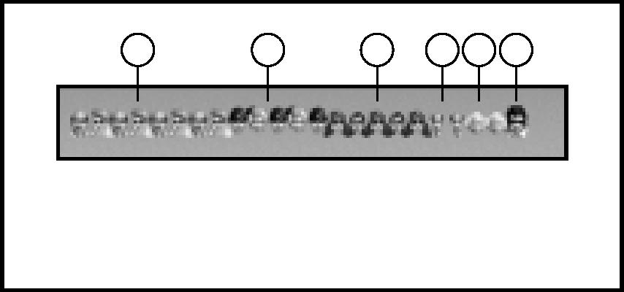

1 Happy Citizens

2 Content Citizens

3 Unhappy Citizens

1 2 3 4 5 6

4 Taxmen

5 Scientists

6 Entertainer

The temperament of your citizens depends on the level of difficulty at which you play. At Chieftain level, your people are so even-tempered that the first six citizens on the POPULATION ROSTER start out content. Each new citizen above this number starts with a bad attitude, and must depend on improvements, luxuries, martial law, and/or Wonders of the World to improve his or her state of mind. The number of citizens who start content decreases by one with each successive level of difficulty, until at Deity level, your people are so temperamental that only one citizen starts out content. The second and subsequent citizens show their unhappiness, and must be cajoled into better humor with any of the management tools at your disposal.

**SPECIAL UNHAPPINESS FACTORS**

**71**

There are two special conditions that cause further unhappiness in some populations. Under a Despotism, and to a progressively lesser degree under other types of government, citizen unhappiness increases with the number of cities. This can lead to very unhappy citizens who must be converted first to unhappy citizens before they can become content.

In Republics and Democracies, each ground or naval unit not in a friendly city or fortress within three squares of a friendly city, and each bomber, Helicopter, or missile unit regardless of where it is located, might create unhappy citizens. You can think of it as units “in the field.” Because of their routine flight training, most air units are always “in the field,” but the protective role of fighters makes them an exception to the rule.

MANAGING
  
YOUR TRADE

In a Republic, the first unit in the field *does not* cause discontent. Each subsequent army in the field creates one unhappy citizen. If your civilization is a Democracy, each unit in the field causes two unhappy citizens. Units with an attack strength of zero (that is, an ADM rating that starts with zero, like Transports and Engineers) do not cause unhappiness in this manner. When a city is in disorder, disbanding distant military units, returning them to their home cities, or changing their home cities can make some unhappy citizens content and might restore the city to order.

**CIVIL DISORDER**

As we mentioned in **City Management Concepts,** cities that don’t maintain a favorable balance of happy people over unhappy people go into civil disorder. Cities in civil disorder produce no tax revenue, technological research, or food surpluses, and the condition suspends production. Prolonged civil disorder might bring down a government, and throw your civilization into Anarchy. A nuclear reactor in a city suffering civil disorder might experience a meltdown due to lax safety controls (see **Nuclear Meltdown**). Keeping a city stable is a very high priority.

A city suffers civil disorder when unhappy people outnumber happy people. Content people and Specialists are ignored in the calculation. When order is restored, the city returns to normal operation the next turn. You can restore order in several ways.

RESTORING ORDER

**72**

You can pay to complete an improvement, such as a Temple, that can convert sufficient unhappy citizens to contentment (or content citizens to happiness) to restore the balance. See **Rush Jobs** for instructions on how to do this.

You can also change the tax rates of your civilization. Increasing the availability of luxuries might convert some content people into happy citizens, allowing them to balance the unhappy populace. See **Trade Rates** for information on economic manipulation.

You can take one or more citizens out of the work force, and make them Specialists. This increases the number of happy people. For information on how to do this, see **Specialists**. When creating Specialists, be careful not to also cause shortages of food or resources that trigger starvation of the population or the scrapping of armies.

If your civilization operates under Anarchy, Despotism, Monarchy, or Communism, you can use martial law to restore order to a city. Up to three military units, each with an attack factor of one or more, can be stationed in a city to enforce martial law. Each military unit makes one unhappy citizen in a city content under the first three types of government. When you are operating under Communism, martial law is doubly effective, and each army makes two citizens content. If you have enough military units to enforce it, and a low enough level of unhappiness, martial law might be enough to restore order.

**WE LOVE THE _____ DAY**

**73**

If a city’s population becomes sufficiently happy, it (not your whole civilization —just this one location) spontaneously holds a celebration in honor of your rule. The people declare a “We Love the (title of the leader) Day” in thanks for the prosperity your management has made possible. While the circumstances that support this celebratory mood continue, the city enjoys certain benefits, depending on your civilization’s type of government. You will see the effects of celebration begin on the first *full turn* that a city celebrates, that is, the turn *after* the party is announced.

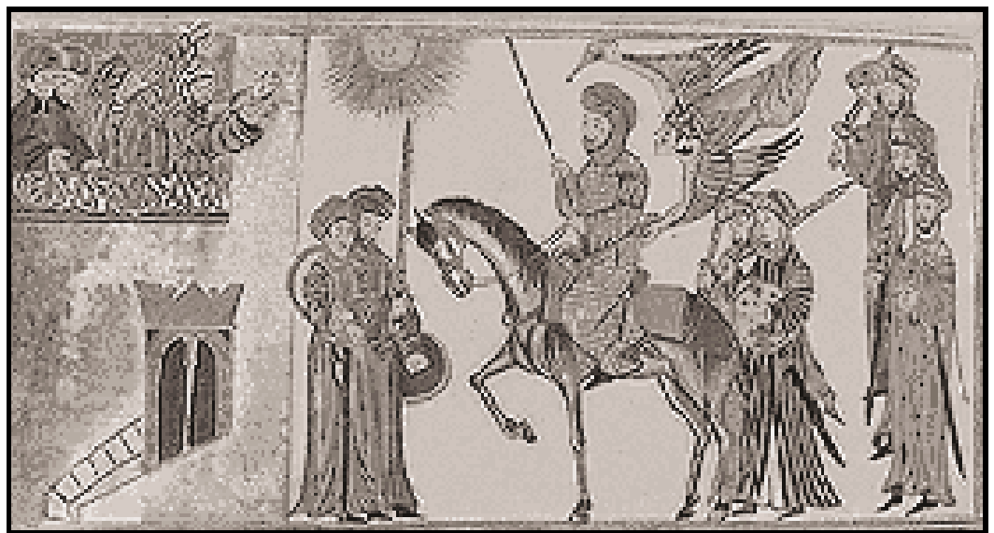

*The people love you!*

MANAGING
  
YOUR TRADE

To trigger a celebration day, a city must fulfill certain conditions: there can be no unhappy citizens in the city, there must be at least as many happy citizens as content citizens, and the POPULATION ROSTER must number at least three citizens. Specialists are considered content citizens for this calculation. For example, a city with five happy citizens, four content citizens, and no unhappy citizens celebrates. A city with ten happy citizens, three content citizens and one unhappy citizen does not.

ANARCHY

The celebration has no effect when your government is in Anarchy. DESPOTISM

The celebrating city collects resources as if its government is a Monarchy (see **Governments**). This can increase the amount of food and raw materials your citizens can produce in certain improved (irrigated and mined) terrain types.

MONARCHY/ COMMUNISM/ FUNDAMENTALISM

**74**

A celebrating city currently ruled by any of these governments collects resources as if its government is a Republic (see **Governments**). This increases the amount of trade your citizens can produce in any terrain that generates trade goods.

REPUBLIC/DEMOCRACY

A city currently ruled by either of these governments increases in population by one point each turn it celebrates, so long as sufficient food is available. This can result in dramatic growth of the city.

|  |  |  |
| --- | --- | --- |
|  |  |  |
|  | TERRAIN &  MOVEMENT |
| **75** |  |

**TERRAIN & MOVEMENT CONCEPTS**

**76**

The game map in ***Civilization II*** is divided into small independent parts, or *terrain squares*, as we mentioned in **City Concepts**. For simplicity, each square consists of a single type of terrain, even though the real world is not as perfectly organized as that. To represent that some types of terrain are easy to walk across and others require slogging through mud or hacking through thick underbrush, your units spend *movement points* to enter each new square. Every unit has an ADM rating (the acronym stands for Attack/Defense/Movement); the M, or third number in the rating, indicates how many movement points it can spend in a turn. You can find out all about units and their ADM ratings under **Military Units**.

Each terrain type has its own *movement point cost* (and they’re all conveniently listed in the TERRAIN CHARTS on the **Poster**). Your Settlers or Engineer units can improve (that is, lower) these movement point costs by laying roads and later railroads in terrain squares (see **Settlers & Engineers** for the lowdown on how they do this). When a unit moves into a new square, it pays that square’s movement point cost. If it has any movement points — or fractions of movement points — left after moving one square, a unit can attempt to move again until it reaches the limit of its movement points. Attacking counts as movement — that is, your units spend movement points to attack. You can read about the details under **Military Units;** what you need to know here is that a unit’s attack strength might be reduced if it has less than a full movement point remaining at the time of combat. You’ll get a message asking if you want to continue with the attack.

The proximity of enemy units or cities can also restrict a unit’s movement options. Units and cities have what in military circles is called a *zone of control;* their influence extends into the eight squares that immediately surround them. Your units cannot move directly from one rival’s zone of control into another’s zone of control unless you have an alliance with the second tribe. This represents a unit’s ability to threaten or pin down enemy troops nearby. When an enemy Legion is nearby waiting to pounce, your troops cannot afford to expose their vulnerable flanks. The blockers don’t have to be units or cities of the same civilization. The **Movement Restriction** diagram should make it clearer, so give it a look-see. Some units (such as Diplomats, Caravans, and all air and naval units) have special abilities that allow them to ignore these restrictions.

**TYPES OF TERRAIN**

**77**

The differences in terrain are deeper than a variety of artwork and colors to make the game map more visually interesting. Each type of terrain has its own economic usefulness, effect on movement, and effect on combat. Detailed information about the terrain types is provided in the TERRAIN CHART on the **Poster,** and from the CIVILOPEDIA.

To get terrain information from the CIVILOPEDIA, click on the CIVILOPEDIA menu, and select the TERRAIN TYPES option. A list of both standard terrain types and their special resources appears. If you don’t recognize the icon for a special resource, click on the standard terrain type to see what special resources are possible.

**A NOTE ABOUT RIVERS**

In ***Civilization II,*** rivers are not a type of terrain unto themselves. Instead, they can flow through any type of terrain. Rivers make movement easier for ground units that follow the line of the river bed either up- or downstream, because each square costs only one-third of a movement point, regardless of the underlying terrain. Settlers and Engineer units cannot build roads across rivers until your tribe discovers the Bridge Building advance. Rivers count as sources of water for the purposes of irrigation. Citizens working terrain through which a river flows gain a bonus arrow icon, representing the ease with which rivers facilitate trade. Finally, a river’s presence enhances the defense bonus of the terrain through which it flows.

TERRAIN &
  
MOVEMENT

**STANDARD TERRAIN SQUARES**

The standard types of terrain can be divided along climactic lines. Here’s a short summary. Glacier and Tundra squares are both cold terrain. Neither produces much in the way of raw materials, and neither can be converted into more profitable terrain. Swamp and Jungle are both wet terrain. Neither is easy to move through, and it costs a considerable investment of time to convert either into more profitable terrain. Plains and Grassland squares are both open terrain. Both are easy to travel across, and when improved, both produce substantial amounts of food as well as other raw materials. Hills and Mountains squares are both vertically challenging. They take some effort to travel across and yield more raw materials when developed by mining. Ocean squares generate substantial amounts of trade, and appropriate types of terrain bordering them can be irrigated. Ground units can move at a rate of one-third of a movement point per square if they follow a riverbed up- or downstream. Desert squares are dry terrain that can be developed for marginal production. Forest squares are difficult to travel through, but yield decent raw materials.

**SPECIAL TERRAIN SQUARES**

**78**

Each standard terrain square can be enhanced by one of two types of special resource. Where special resources appear, they add significantly to the economic value of the terrain. Distinct symbols mark the location of these resources. If your Settlers or Engineer units convert a square containing a special resource icon into another terrain type, the original specialty is lost. If the new terrain type can be enhanced by special resources, it is; if the new terrain is Grassland, it remains a standard terrain. Right now, we’ll give you a brief summary.

Glaciers can be enhanced by *Oil* deposits, representing increased mineral wealth, and therefore yielding extra shields when worked. Alternatively, the presence of *Walruses* indicate the availability of Ivory, with its greatly enhanced trade goods yield.

*Musk Ox* stand in some Tundra squares, indicating excellent food sources or the potential for good grazing; workers in these squares can produce additional food. Other Tundra squares display *Fur,* indicating the high potential for arrows because of desirable trade goods.

Swamp squares can contain *Peat,* whose usefulness as fuel is indicated by the enhanced shield yield, or perhaps *Spice,* exotic flavorings which are prized the world over, and therefore represent bonus yields in both food and arrow icons.

*Gems* shine in Jungle terrain to indicate the presence of precious stones, ivory, spices, salt, or other valuable commodities. These are good trade items and, therefore, the square in which they appear generates substantial arrows. Jungles also have the potential to produce exotic *Fruits* which naturally increase the food output.

*Buffalo* trotting across the Plains represent raw materials on the hoof; workers in these squares generate extra shields. On the other hand, *Grain* represents a particularly fertile piece of open ground, and a rich source of food.

*Coal* deposits, shown as black lump icons in Hills terrain, represent rich locations of coal or metal ores. These areas produce greatly increased shields, especially when mined. On the other hand, some hills are *Wine* country, especially suited for growing grapes. Wine terrain yields greatly increased trade.

*Gold* gleams in Mountains terrain, representing a bonanza of precious metal ore. The value of these deposits produces tremendous trade goods. Alternatively, workers might discover *Iron* deposits in mountainous areas, yielding a substantial number of shields.

*Fish* swimming in Ocean terrain represent the location of underwater banks and reefs where currents and nutrients create excellent fishing grounds. Fishing grounds produce increased amounts of food. On the other hand, *Whales* indicate the bounty of the deeps, and an increase in raw materials and trade goods as well as foodstuffs.

An *Oasis* is a very fertile island in Desert terrain where workers can harvest substantial quantities of food. Conversely, *Oil,* representing the presence of mineral wealth, especially petroleum, can also be found in Desert squares. As they do in Glaciers, Oil squares in Desert terrain yield extra shields when worked.

**79**

A *Pheasant* peers through some Forest terrain. The presence of game indicates excellent food sources available. On the other hand, *Silk* represents a luxurious product of mulberry Forests that brings increased yield from trade goods.

**OPTIMAL CITY SITES**

The economic usefulness of the various terrain types is important when selecting city sites. Citizens work the terrain within a city’s radius to produce the food, raw materials, and trade that the city needs to grow and be productive (see **The City Radius**). Some terrain types are more valuable than others, in that citizens working them produce more resources. Other terrains start out yielding little, and only develop their full potential when they are improved. These squares can be irrigated, mined, or surfaced for increased economic value. Other squares are important because they can be converted into more valuable terrain, as we’ll discuss soon (for instructions on how to irrigate, mine, surface, and convert terrain, see **Settlers & Engineers**). The best city sites offer immediate food, raw material, and trade production, plus the potential for long term development.

**TERRAIN CONVERSION**

TERRAIN &
  
MOVEMENT

When surveying sites for a new city, keep in mind the potential for terrain squares within the city’s radius to be improved. Hills and Mountains squares can be mined so that citizens working them produce increased raw materials. Plains and Grassland squares, whether or not rivers run through them, can be irrigated so that citizens working there produce more food. Swamp and Jungle squares can be cleared to yield Grassland or planted to yield Forest. Forest can be cleared to yield a Plains. Plains and Grassland squares can be retimbered to yield Forest if you need raw materials. An area dense with Jungle and Swamp squares looks barren at first, but has the potential to become a very rich city site.

Improvements are not limited to agricultural effects. Settlers and Engineers also improve terrain by laying roads across terrain squares. Roads allow better access to a city, and therefore, increase the trade goods citizens working some squares produce. Plains, Grassland, and Desert squares all produce trade once penetrated by roads. Railroads eliminate the movement point cost of the terrain across which they are laid and might increase resource production as well. For more information on terrain improvements, see **Settlers & Engineers** — they’re the units that do the work.

**PLANETARY CARETAKING**

**80**

Manipulating terrain to produce the maximum number of shields has a downside, of course. One cost of heedless industrial growth is a gradual polluting and poisoning of the environment. Of the many dangers posed by pollution in the real world, the greatest might be global warming. Theorists believe an unchecked rise in the planet’s atmospheric temperature threatens catastrophic geographic changes including melting polar ice caps, rising sea levels, and parched farmlands. Different threats of poisoning occur if nuclear weapons are detonated or a nuclear reactor melts down.

***Civilization II*** models pollution from industry and nuclear disaster as a balancing factor for growth. As you steer your civilization into the industrial age, you must manage your cities and monitor your terrain to minimize pollution and prevent the disaster of global warming.

**POLLUTION**

Every turn, the game assigns a probability of pollution occurring within the economic radius of each city. The likelihood of this contamination depends on two factors: the number of shields produced (industrial pollution) and the population supported (smog). In some cities, industrial pollution is the major factor in the calculation, and in other cities smog is a bigger hazard. Below a certain level, the chance of pollution is negligible, but as industrial output builds, so does the likelihood of its darker side effects. Smog has no effect on pollution calculations until your civilization acquires the advance of Industrialization.

Smokestacks begin appearing on the CITY DISPLAY in the GENERAL INFORMATION window when the combined pressures of smog and industrial pollution begin to create a significant threat of contamination. The number of stacks roughly indicates the probability each turn of a square within the city radius becoming polluted. For example, a city generating a large number of raw materials each turn (say 20) and inhabited by a large population might show several smokestacks in its CITY DISPLAY. The exact proportion of smokestacks produced by industrial pollution and smog depends on the difficulty level at which you set the game.

Certain city improvements can help the situation. A Nuclear Power Plant, Hydro Power Plant, Solar Plant, or Recycling Center improvement in a city reduces the impact of industrial pollution, in turn decreasing the accumulation of smokestacks. Solar Plants also help prevent global warming by absorbing excess heat in the atmosphere. The Hoover Dam, a modern Wonder of the World, acts as a Hydro Power Plant for all friendly cities. The Mass Transit improvement eliminates smog.

**NUCLEAR CONTAMINATION**

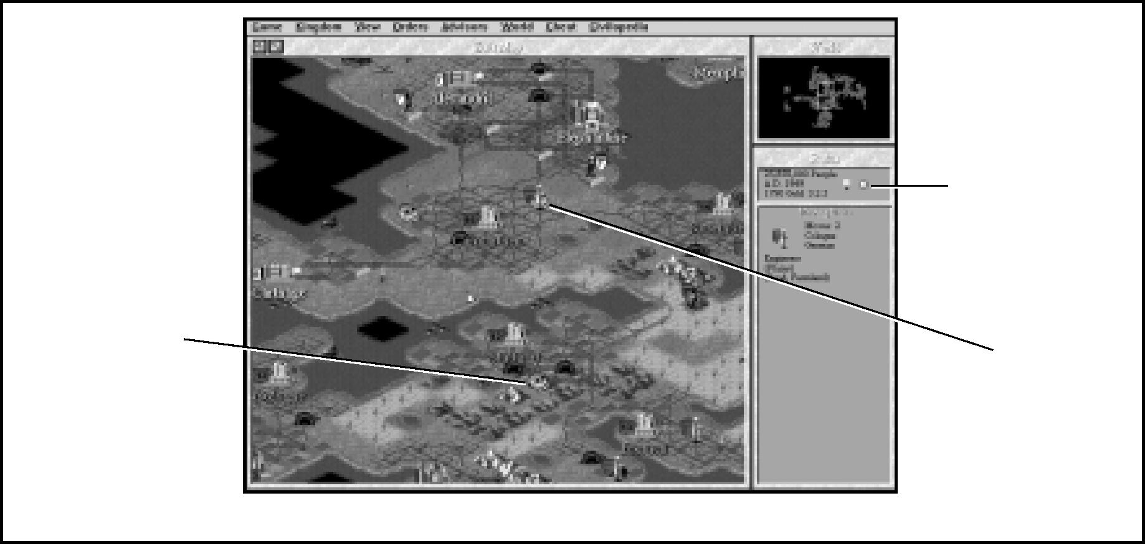

Polluted square

*Pollution is icky!*

Pollution indicator

Engineer Cleaning Up

TERRAIN &
  
MOVEMENT

**81**

The detonation of nuclear weapons or the meltdown of a Nuclear Power Plant can also cause contamination. For game purposes, ***Civilization II*** treats these threats identically to industrial pollution, though in real life their effects might be considerably longer term.

NUCLEAR WEAPONS

A Nuclear unit not only destroys the army or city it targets, but all units stacked with the target, and those in adjacent squares as well. It also pollutes a number of map squares around the impact square. Enemy units’ zones of control (which are discussed under **Movement Restrictions**) might make it impossible for your Settlers or Engineer units to clean up this contamination in a timely fashion, and your rival might not spend the time or manpower. Unchecked pollution significantly raises the risk of a global warming disaster.

NUCLEAR MELTDOWN

If a Nuclear Power Plant melts down, half of the city’s population is destroyed. Additionally, some random number of squares near the city become polluted.

The risk of meltdown always exists when a city which has a Nuclear Power Plant goes into civil disorder. Civilian unrest might result in safety procedures becoming so lax that a catastrophic accident occurs. If you build Nuclear Power Plants in any of your cities, take special care not to allow those cities to go into disorder.

**82**

When your civilization achieves the technological advance of Fusion Power, the risk of meltdown disappears. Your Nuclear Plants automatically convert to fusion-powered facilities once you have achieved this advance.

**POLLUTION’S EFFECTS**

Pollution is represented graphically by a skull on the terrain square in which it occurs. It reduces the production of food, raw materials, and trade to one-half (rounded up) of pre-pollution levels. For example, a square where workers produced four food, one shield, and two trade before pollution blighted the square yields only two food, one shield, and one trade after contamination. Once the terrain is detoxified, workers’ production returns to pre-pollution levels.

Polluted terrain can be detoxified by any Settlers or Engineer unit. The working unit’s shield is marked with a “P” to note it has been ordered to detoxify a polluted square. After four turns of work (an Engineer can clean up in two), the pollution disappears. Adding more Settlers or Engineer units to a polluted square speeds the cleanup. If you use the GOTO CITY order, your city list marks which locations suffer from pollution. Note that a polluted square within the radius overlap of two cities is listed once for each city; if your cities are close together, this might give you an alarming overstatement of the total pollution your civilization suffers.

**MONITORING POLLUTION**

Your environmental advisors inform you immediately when any map square within your territory becomes polluted. A skull appears on the polluted square.

You can monitor the extent of pollution throughout your civilization by watching the pollution indicator, a small icon in the STATUS window. The color of the icon depends on the number of currently polluted terrain squares and the number of turns they have remained contaminated. It indicates the extent of the risk of global warming.

**GLOBAL WARMING**

Global warming might occur at any time that at least nine map squares, anywhere in the world, are polluted. The probability that it will occur increases with the length of time contamination on this scale is left untreated. If polluted terrain is left unattended for too long, environmental damage occurs, as detailed under **Disasters**.

Once an environmental disaster has occurred, the cycle starts over again. The planet achieves equilibrium at the new, higher temperatures. If pollution continues or increases once more to high levels, another bout of environmental problems might occur. This cycle can repeat endlessly if pollution is not controlled.

**83**

**MINOR TRIBES**

Thatch-roofed hut icons scattered about the map of the world indicate the presence of minor tribe villages. These populations are too isolated, too unorganized, or too migratory to develop into major civilizations. Minor tribes react to contact with a range of emotions, from delight to hostility. There is no way to predict a village’s response, but most potential responses are favorable. There is one unique situation: Air units cannot encounter minor tribe villages. Instead, their overflight scares the villagers, and the hut icon vanishes as the tribe abandons their territory in terror.

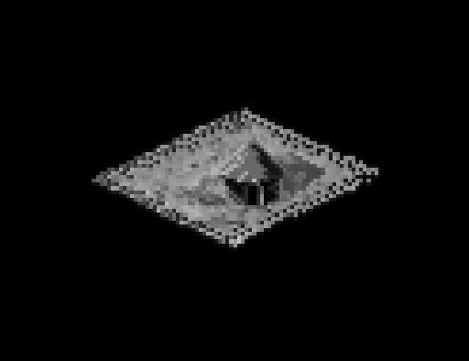

Playtesters and ***Civilization*** fans alike call these hut icons “goody huts.” Here’s what might happen when you move a ground unit onto terrain that a minor tribe occupies.

TERRAIN &
  
MOVEMENT

* Occasionally a minor tribe is sufficiently advanced, yet awed by your emissary, to immediately form a new city and become part of your civilization.
* On the other hand, your unit might have stumbled upon a village which has discovered an advance unknown to your civilization. Graciously, they share their knowledge.
* To placate your emissary unit, a village might give your civilization valuable resources (gold) as a gift. The gift is added to your treasury.
* Your emissary unit stirs up the young bloods in the village with his tales of valor and victory. All the impressionable warriors run off to join your army, creating a new military unit “carrying your colors.”
* Your emissary makes a horrible *faux pas,* and the minor tribe turns vicious. A random number of barbarian units comes boiling out of the terrain squares that adjoin the village. Duck (or run, if you can)!
* Your emissary arrives at a spot rumored to contain a village only to find the inhabitants long gone and the dwellings empty. Nothing occurs.
* Your unit catches up with a particularly peripatetic tribe, and impresses them with his or her goods and possessions. The minor tribe is willing to join your civilization, though not necessarily interested in settling in their present location. The villagers become a Settlers (or Engineer) unit carrying your shield.

**MOVEMENT**

**84**

There are two basic methods of moving units a square or two at a time: by keyboard commands or (if you have enabled mouse movement) by mouse clicks. The keyboard method uses the eight edge keys of the numeric keypad. The s❑ key in the center is inactive; think of it as your unit’s position. The keys surrounding the s❑ represent the points of a compass. For example pressing M sends your unit northwest, while pressing © sends your unit east.

The mouse method involves placing your mouse cursor near the edge of the unit in the direction you want it to travel. When the cursor turns into an arrow pointing in the appropriate direction, click the left mouse button to make the unit move. Note that this method works only if you turn on the MOVE UNITS W/ MOUSE option in GAME OPTIONS. You can also use the GOTO order to send a unit over long distances, as we explain in detail under **GoTo Orders**.

Units can move up to the limit of their movement factors, with a few caveats. The most important exception is that a unit can always move at least one square in a turn, regardless of the movement point cost of the terrain. Are we saying a unit can always move? Not quite. An enemy unit or city’s presence can hamstring any unit with the zone of control restriction, as you’ll see in a moment. There are other, common-sense restrictions on where units can move and where they can’t, which are elaborated under **Movement Restrictions**.

Back to movement factors. A unit with a movement factor greater than one must compare its movement factor with the movement point cost of the terrain square you wish it to enter. The unit pays the movement point cost (subtracts the movement point cost from its remaining movement factor) for each new square it enters, until you choose to stop advancing, or the unit’s movement factor is smaller than the movement point cost of the terrain square. There’s a small chance that a unit can enter a square, even if its movement factor is lower than the movement point cost of the terrain, which is why sometimes Chariots can cross Mountains squares, and sometimes they can’t. When an army is unable to complete a movement order because it doesn’t have enough movement points to proceed, its movement is finished for the turn. The map then centers on the next active unit.

Roads and railroads speed the movement of ground units. They do this by lowering the movement point cost of the terrain over which they are built. Any terrain square with a road across it costs just one-third of a movement point to cross. Any terrain square with a railroad costs no movement points to cross — zero! Cities automatically have roads in their city squares, so entering a city square always costs one-third of a movement point. Once your civilization discovers the Railroad advance, city squares are automatically upgraded to railroads, so your units can slide through them for free.

**THE ACTIVE UNIT**

**85**

How do you know whose turn it is? Every turn, ***Civilization II*** activates each unit in turn by centering the map around the unit and making it blink. You can give orders to each unit as it becomes the active unit (see the **Orders Menu** in **Reference: Screen by Screen**). Five special orders deserve fuller explanations here.

**NO ORDERS**

To skip a unit for the turn, press the SKIP TURN S acebar key or choose the option from the ORDERS menu. Once you’ve skipped a unit’s turn, the troops are on liberty for the day— you can’t recall them to duty again this turn.

**GOTO ORDERS**

To send a unit on a long trek, you have two options. You can click-and-hold on any square on the map until your cursor turns into a crooked “Go” arrow. If the destination square isn’t visible in the MAP window, you can use the ZOOM OUT button to enlarge the area you are viewing, click on the WORLD window to shift your view to another area of the map, or switch to VIEW PIECES mode by pressing the V key or choosing the option from the VIEW menu, and move the cursor with the number pad keys. If you’d rather send a unit to a city, you can press the GOTO G key or choose the option from the ORDERS menu. A screen pops up listing all of your cities; click on the ALL PLAYERS button to see every destination city in the world.

TERRAIN &
  
MOVEMENT

Once a destination is established, the unit automatically “goes to” that square, whether it takes only one turn to complete its orders, or many turns. If the unit is attacked, or an obstruction prevents the unit from completing its journey, it becomes active once again. Ground units cannot travel between continents on a GOTO order.

**WAIT ORDERS**

To skip a unit temporarily, press the WAIT W key or choose that option from the ORDERS menu. This passes you on to the next unit and sends the skipped army to the end of the line. You’ll see this unit again after all the others have had a chance to move.

**PARADROP ORDERS**

Paratroopers that have not moved this turn have the special ability to make paradrops when in a city or Airbase. Press the PARADROP P key or choose the option from the ORDERS menu. Your cursor turns into a parachute. You can make a paradrop in any land square within ten of the origination square, that is not occupied by enemy troops. As you run the mouse over the map, the cursor changes from a parachute to a crossed-out parachute to indicate “illegal” destination squares. Click on a square to make the drop. Paratroopers have one movement point after they drop to attack or change position.

**AIRLIFT ORDERS**

**86**

Once your civilization has discovered the Radio advance, you can build Airport improvements. Once you have two or more Airports, you can airlift one unit per turn into or out of each Airport. Activate a unit in a city, then press the AIRLIFT key © or choose the option from the ORDERS menu. A list of cities with Airports appears, and you can select your destination. Enemy Fighters and Stealth Fighters within range of either the target or destination city have a chance to scramble and interdict the airlift.

**ACTIVATING FORTIFIED AND SLEEPING UNITS**

Fortified and sleeping units do not become the active unit. If you want them to move or change position, you must activate them first. Click the mouse pointer on the square in which fortified or sleeping units are stationed. This opens a box displaying all units in that square. Click again on the icons of all units you wish to activate. Fortified or sleeping units within a city must be activated from within the CITY DISPLAY — see **City Display** for instructions on how to do this. Sleeping units automatically activate when enemy units move into an adjacent square.

**NAVIGATING THE MAP WINDOW**

We’ve talked about moving your units around the map, but there are several tools which allow you to look at different map areas and move around the game world. First, let’s describe the two modes of ***Civilization II***. In MOVE PIECES mode, the active unit blinks, and you can use the number pad keys or cursor arrows to move it across the map. In VIEW PIECES mode, the square-outline cursor blinks, and you can use the number pad keys to move it across the map. You are automatically placed in MOVE PIECES mode at the beginning of each turn, and automatically switched to VIEW PIECES mode when “end of turn” is flashing. Toggle between the modes by pressing the M key (or selecting your choice on the VIEW menu). You cannot switch to MOVE PIECES mode unless there are units still waiting to move.

Of course, you can simply click on a map square to center the MAP window there. If you want to move a long distance, you can use the ZOOM buttons to increase the acreage shown in the window, or click on the WORLD window.

If your cursor is over a unit, stack of units, or city square in VIEW PIECES mode, you can press the ACTIVATE UNIT q❑ key to activate some or all of the units in that square. If there is more than one unit, a pop-up box allows you to choose among them. If the active unit in MOVE PIECES mode happens to be standing in a city, the ACTIVATE UNIT key also works to activate any fellow units in the city, without opening the CITY DISPLAY.

**MOVEMENT RESTRICTIONS**

**87**

Most of the restrictions placed on unit movement are a matter of common sense, as we mentioned earlier. We’re spelling them all out here, in case you try to order a unit somewhere that seems possible and the game won’t let you do it.

**GROUND UNITS**

Ground units (all non-ship and non-air units) normally move only on land. To traverse the wide (or narrow) oceans or even to get across lakes, they must board naval transport. Not all ships take passengers; see **Naval Units** under **Mobile Units** for a list of those that do.

Boarding a ship uses up all a unit’s movement points for the turn and puts it to sleep. If you attempt to move a naval unit into a land square that does not contain a port city, any passengers are offered the option to MAKE LANDFALL and disembark. If a naval unit carrying ground troops makes port, all passengers automatically wake up.

**NAVAL UNITS**

TERRAIN &
  
MOVEMENT

Ships normally move only on the ocean, although they can also sail across inland lakes. Ships cannot navigate rivers, deltas, or swamps in the game, though of course some do in real life. Instead, river navigation is represented by the reduced movement point cost for ground units following riverbeds. City squares that touch a shoreline along one side or at one corner are the only “land” squares that ships can enter— here they make port. Making port costs one movement point.

**AIR UNITS**

Air units can cross both land and sea squares at a cost of one movement point per square, but they must land in a friendly city, at an Airbase, or on a Carrier unit to refuel every turn or two. Though planes can sometimes fly above rival ground units in real life without causing an incident, they are always required to encounter enemy ground units that they overfly in ***Civilization II***. To avoid attacking rival units by accident, carefully guide your planes around them. Air units have the advantage in maneuverability. Neither ground nor ship units can attack air units that appear “next to them” because of the disparate vertical locations. The one exception is the Diplomat or Spy unit’s ability to bribe adjacent units into switching sides. See **Diplomats & Spies** below.

**ZONES OF CONTROL**

**88**

Ground units cannot move directly from one square adjacent to an enemy army or city to another such square. The squares that surround a unit are in that unit’s zone of control — the same holds true for a city. Neither ground troops nor Settlers units can move directly from one rival’s zone of control into another square within a rival’s zone of control. The prohibited square might be adjacent to the first enemy army, to another army (even one from a different civilization), or to any enemy city. Ground units can only move into such a controlled square if a friendly unit or city already occupies the square, or if you have formed an alliance with a rival player (which we’ll explain fully in **Diplomacy**).

Some units have special abilities which allow them to ignore zones of control. Air units have the whole sky in which to maneuver; naval units have the open sea. Diplomats and Spies use social convention and diplomatic immunity with equal aplomb, and Caravans and Freight units can argue neutrality and engineer special deliveries. Partisans use intimate knowledge of the local terrain to good effect. Explorers’ solitary nature and singleness of purpose get them out of tight places, and Engineers’ training includes techniques to infiltrate and bypass enemy positions. The **Movement Restrictions** diagram offers a graphic representation of a unit confronted by enemy zones of control.

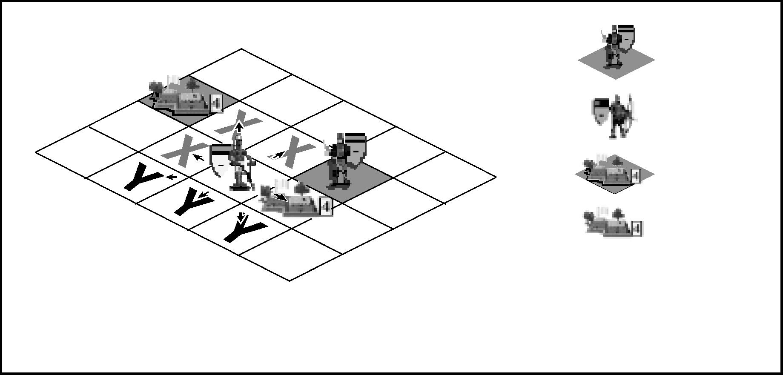

*Movement Restrictions Diagram*

1. ***X*** *moves are OK if those squares already contain an army from your civilization.*
2. *Movement restrictions do not apply to ships, air units, diplomats, and caravans.*

**X**

**Y**

Friendly City

Moves not allowed

Moves allowed

Enemy Army
  
Friendly Army
  
Enemy City



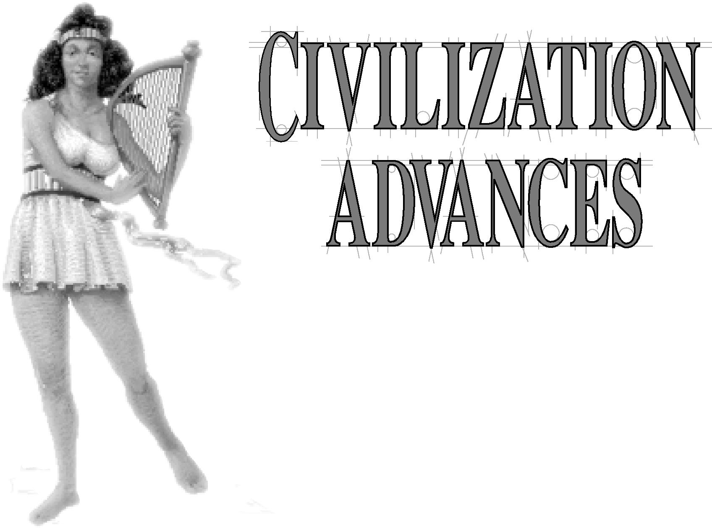

The major dynamic of change throughout the history of civilization has been the continuing advance and accumulation of knowledge. As humankind progressed by fits and starts through the ages, civilizations rose and fell, their success or failure due to what knowledge they acquired and how they employed it.

Those who first acquire new knowledge are often able to employ it to build a more powerful position, but there are many cases of civilizations that obtained some new

invention first, then failed to use it to their advantage. The pace at which a society

develops and implements new knowledge depends on many factors, including its

social organization, economic organization, geographic location,

leadership, and competition.

The concept of progress being not only inevitable, but

even a good thing is a relatively recent phenomenon. Only

in the last several hundred years have we actively studied

history and considered the evidence of the historical record. For most of human history, the pace of progress was so slow as to be

barely detectable but since the Industrial Revolution, the pace of advance and change has dramatically increased. Rapid change is now considered normal. For much of the world, new discoveries are continually expected and are not a surprise.



CWILIZATION
  
ADVANCES

**89**

**THE CONCEPT OF CIVILIZATION ADVANCES**

**90**

As we said in **City Management Concepts,** scientific research is what drives your civilization’s scientific and intellectual growth. The science (beaker icons) each city generates every turn represents a percentage of the total trade, that city brings in. You can adjust the amount of science generated with the TAX RATE option in the KINGDOM menu. A low science ratio generates advances slowly; a high ratio generates them more quickly.

You want to accumulate research, in the form of beakers, to gain advances, or new technologies. Each new advance allows your civilization to build new units or city improvements; sometimes a new advance makes possible the construction of a new Wonder of the World. Each new civilization advance also opens up a path to researching further technologies. You could look at the connections between advances as a flow chart (see the **Poster** for an example), as a web, or as a tree. The important concept is that each technology is a building block that allows research into further advances. You can even research into the realms of science fiction; each futuristic advance you discover adds bonus points to your final score, as we’ll explain in **Future Technology,** coming right up.

Accumulated research isn’t the only way to gain advances. Contact with a minor tribe might also net you a new civilization advance — see **Minor Tribes** for all the possible outcomes of an encounter. Finally, parley with other civilizations can result in an option to exchange technologies, and war offers the opportunity to wrest them by force from cities you subjugate. We’ll give you the full details under **Diplomacy**.

The scientific research performed in each city you own is totaled in the SCIENCE ADVISOR’s Report (see **The Advisor Menu** in **Reference: Screen by Screen** for more about the Science Advisor and his duties). Each new advance that your civilization discovers “costs” a certain amount of science (accumulation of beakers). As time progresses, new advances require more funding to research. The SCIENCE ADVISOR’s Report also lists the technologies you have already discovered or been given, and the current advance your scientists are researching.

**CLIMBING THE TECHNOLOGY TREE**

**91**

Once your civilization begins to accumulate scientific research, your Science Advisor asks you to choose a new civilization advance to research. Before making your choice, you can immediately get help concerning the available technologies. Press the GOAL button to see a list of all the advances in the game. Select the one you’re most interested in pursuing, and click OK to find out which of the options you now have will further your research toward your goal. A message informs you if none of the options is suitable. Technologies you should be able to research but that are not on the current list of possibilities eventually show up (at a later choice-point). Once you have chosen a direction for your research, you cannot change your mind. Your scientists pursue that topic until they learn the new civilization advance. If you are unfamiliar with the advantages of a particular advance, highlight it and click on the HELP button to see the CIVILOPEDIA entry.

Advances are divided into five broad categories: Military, Economic, Social, Academic, and Applied. The icons in front of each advance show which category each advance belongs to. They can help you decide which advance will further your general strategy if you are, for instance, following a militaristic path, rather than an economic one. These icons also appear in the diplomatic screens, to help summarize the technology paths of your opponents.

When research is complete, your chief investigator announces the discovery. The CIVILOPEDIA screen appears detailing the impact of the advance, including any new units, city improvements, and Wonders that have become available. The PRODUCTION menus in each CITY DISPLAY are immediately revised to include these new items wherever they are appropriate (for instance, inland cities can never build ships, so ship units never appear on their PRODUCTION menus, even if you have discovered Navigation or later seafaring advances).

As each new advance is acquired, your advisor appears again to ask for a new topic to research. The list of choices is updated with each new discovery to reflect your growing knowledge base. Technologies you acquire through means other than research (see **Diplomats & Spies** and **Minor Tribes** for details) no longer appear on the list of choices — you’ve already discovered them. If by chance you’re given the civilization advance your scientists are currently researching, your Science Advisor immediately switches the research effort to a new topic of your choice —the accumulated beakers that represent research into the gift advance are transferred to the new topic.

CWILIZATION
  
ADVANCES

**THE POSTER**

**92**

The **Poster** contains a graphic technology tree, or flowchart, that lists every civilization advance in ***Civilization II***. For easier reference, advances are subdivided into the same four ages as Wonders of the World. The age of your civilization does not limit the advances you can research in any way.

Each entry on the chart gives the name of the advance and any new units, improvements, Wonders, or spaceship parts your civilization can now build as a result of this discovery. Some advances also allow your Settlers or Engineer units to undertake new orders.

Many technologies are the synergy of two diverse threads of inquiry. As a result, a second prerequisite advance might be listed in parentheses below the name of the current advance. By following the arrows along the chart, you can see that Alphabet leads to Mapmaking. By reading the second prerequisites, you can see that Mapmaking (along with Astronomy) leads to Navigation.

You can use this flowchart as a quick reference to what you want to discover next, or to plan an extensive research effort that culminates in an important technology like Railroad or Nuclear Fission. It can also remind you of advances you are ignoring.

**FUTURE TECHNOLOGY**

After your scientists discover the Fusion Power and Recycling advances, they can begin researching futuristic advances. These not-yet-imagined civilization advances are collectively known as “Future Tech;” when your civilization accumulates enough scientific research (beakers) to finish one unit of Future Tech, you can research another. Each Future Tech you discover adds five points to your final score (see **Scoring** for other ways to boost your final total).

**SPECIAL ADVANCE EFFECTS**

**93**

A number of the advances in ***Civilization II*** have effects independent of the new units and improvements you can build. We’ll summarize these effects here. Each advance’s CIVILOPEDIA entry reminds you of these effects.

* Achieving the Corporation advance allows you to focus a city’s production on revenue. The discovery of the Corporation advance allows your citizens to “build” the Capitalization improvement, and market a city’s research to produce high-tech consumer goods that generate tax income.
* The discovery of the Democracy advance allows each Courthouse improvement to make one content citizen happy.
* Once your civilization discovers the Electronics advance, your Colosseums can make four unhappy people content in each city, not just three.
* The discovery of Fusion Power eliminates the possibility of a meltdown in your Nuclear Power Plants. In addition, it gives the Thrust Components of your spaceship 25 percent more power.
* Both Navigation and Seafaring reduce the chance of your Trireme units being lost at sea.
* Once your culture has embraced the Nuclear Power advance, all of your Naval units gain one extra movement point.
* If you discover the Philosophy advance before any other civilization has done so, you earn a “free” advance.
* Once your civilization has achieved the Railroad advance, all your city squares are automatically upgraded from roads to railroads. It no longer costs any movement points to enter cities.

CWILIZATION
  
ADVANCES

* Once your civilization has achieved the Refrigeration advance, all your city squares are automatically upgraded from irrigated land to farmland, if the terrain is suitable. Once you build the Supermarket improvement, your workers can harvest 50 percent more food from these spaces.
* The discovery of Theology makes your Cathedrals more influential. Instead of
    
  making three unhappy people per city content, a Cathedral now relieves four.

|  |  |
| --- | --- |
| There is one disadvantageous special effect. Once you discover the advance of Communism, the effect of the Cathedral improvement (which discovering the Monotheism advance allows you to build) is lessened. Instead of making three unhappy people per city content, a Cathedral now only relieves two.  If your culture has discovered both Theology and Communism, the special effects cancel each other.  **94** |  |

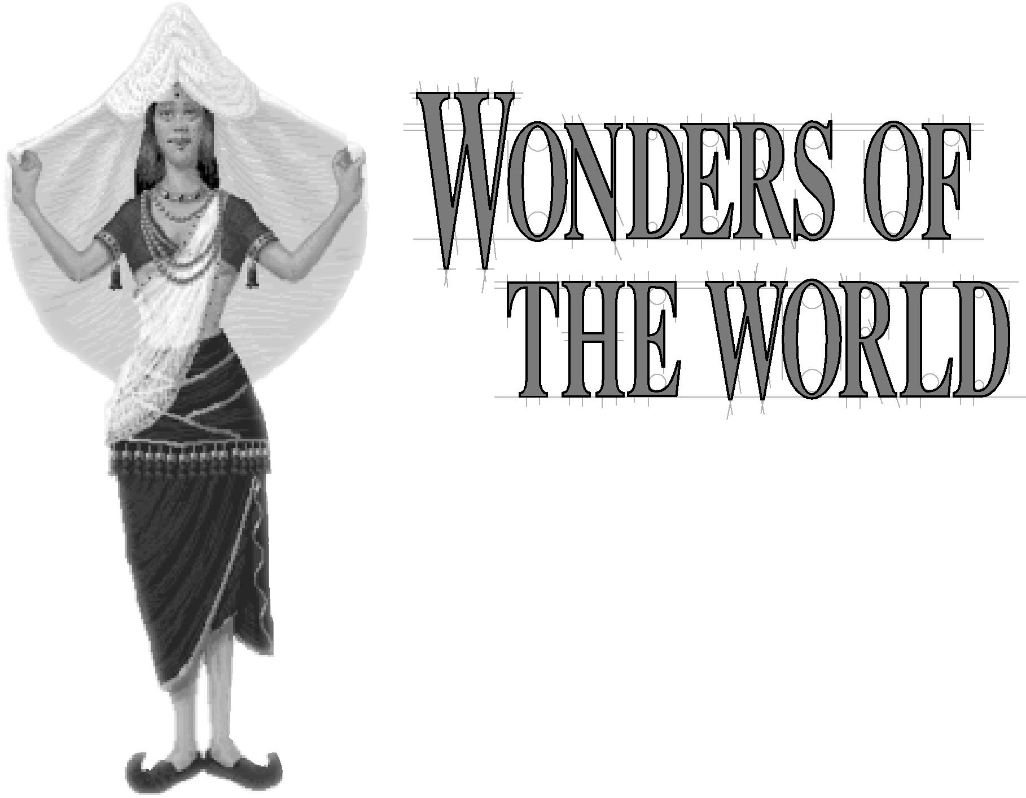A Wonder of the World is a dramatic, awe-inspiring accomplishment. It is typically a great achievement of engineering, science, or the arts, representing a milestone in the history of humankind. As your civilization progresses through the years, certain advances make building Wonders of the World possible. Twenty-eight Wonders are included in ***Civilization II,*** seven each representing the four great epochs of civilization: the Ancient World, the Renaissance (including the High Middle Ages), the Industrial Revolution, and the Modern World (present and future). These Wonders are the extraordinary monuments of a civilization, bringing everlasting glory and other benefits to their owners.

WONDERS OF
  
THE WORLD

**95**

|  |
| --- |
| **THE CONCEPT OF WONDERS**  Wonders of the World are like extraordinary city improvements, in that they are structures (or achievements) that your civilization can undertake to “build.” Unlike city improvements, *each Wonder is unique, existing only in the city where it is constructed.* Each one confers a specific, unique benefit on the civilization that owns it (you can find the specifics in the CIVILOPEDIA listing for each Wonder). If one of your cities is captured by a rival power, and you had built a Wonder there, that Wonder no longer benefits your civilization. Instead, its bonuses now apply to the conquering civilization. The same holds true if your units capture a city containing a Wonder from a rival player.  *If a Wonder is destroyed by the decimation of the city in which it stood, it can never be rebuilt*. Its benefits are lost to the world forever. Further, some of the glories of the ancient and Renaissance Wonders dim over time. Objects and accomplishments that awed the ancients lose their luster for people of the Modern Age*. The achievement of later advances can negate the benefits of older Wonders*, regardless of whether your civilization or another discovers the canceling advance. |

**CONSTRUCTING WONDERS**

**96**

You can build a Wonder only if you have discovered the advance that makes it possible, and if it does not already exist somewhere else in the world (if it exists in another city, it won’t appear as an option on your PRODUCTION menu). However, you can start construction of a Wonder even if another civilization is working on the same project—you just race to see who gets done first. A message warns you if another civilization’s production of a Wonder is imminent.

If you are building a Wonder in one of your cities and the same Wonder is completed elsewhere before you finish, you must convert your production to something else. Any excess shields you have accumulated beyond the number required to construct your new project are lost, so be careful what you choose. As you click on each potential project, you see a graphic representation of the shortfall or excess of shields you currently have with respect to the new project’s requirements.

Wonders are not destroyed when an enemy captures the city in which they exist. However, if a city possessing a Wonder is destroyed (that is, if its population is reduced to zero by siege or bombardment), that Wonder is lost forever and cannot be rebuilt.

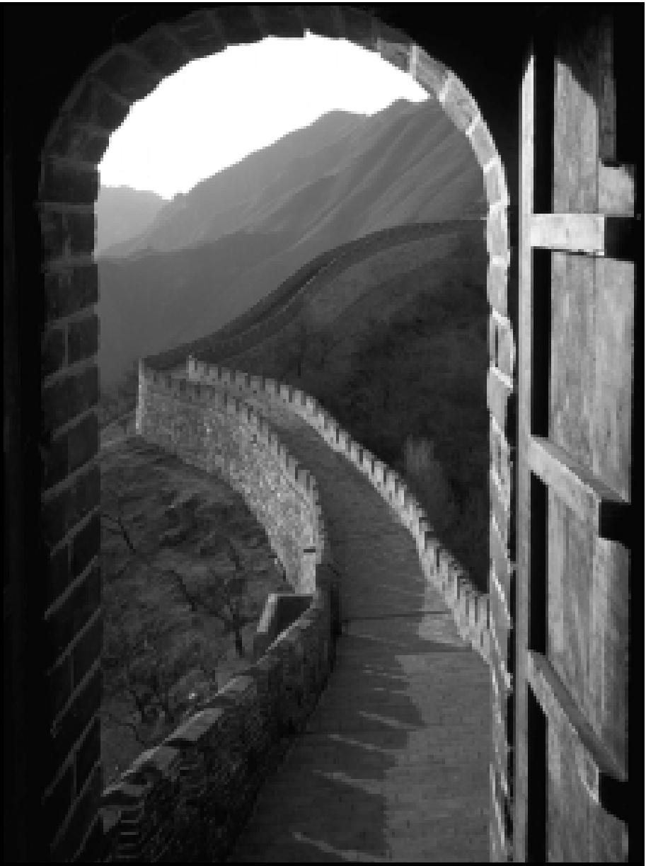

Wonders of the World are often long-term projects (as befits their magnificence). If you want to accomplish construction of a Wonder faster than the city that is building it can generate shields, you have several options. You can divert trade goods into the Wonder’s coffers by moving a Caravan or Freight unit into the city of construction and accepting the choice HELP BUILD WONDER— see **Caravans & Freight** for details about Caravan interactions. You can also spend cash directly from your treasury. Click the BUY button at the top of the PRODUCTION menu; if you have enough cash on hand to purchase the Wonder, you can choose to pay, and the Wonder will be completed next turn. In addition, you can disband troops currently in the city that is constructing the Wonder. Each disbanded unit contributes shields equal to one-half its construction cost directly to the RESOURCE BOX, representing the reallocation of support from the unit to the construction.

WONDERS OF
  
THE WORLD

**97**

Wonders can be built in any city and more than one may be built in the same city. Each Wonder has both specific and general benefits. You can read about the specific benefits in the appropriate CIVILOPEDIA entry. The glory that accrues to your civilization for possessing a Wonder is one of the general benefits conferred by such great works; more importantly, this glory continues to accrue even if new advances make the Wonder’s specific benefit obsolete. In addition, each Wonder that your civilization possesses adds to your ***Civilization II*** score. The presence of Wonders is significant to the calculations determining the top five cities in the world. Further, the presence of Wonders influences historians, such as Gibbon, who periodically rate the world’s civilizations. Finally, Wonders also sway your people to improve your throne room (see **Throne Room** for the particulars).

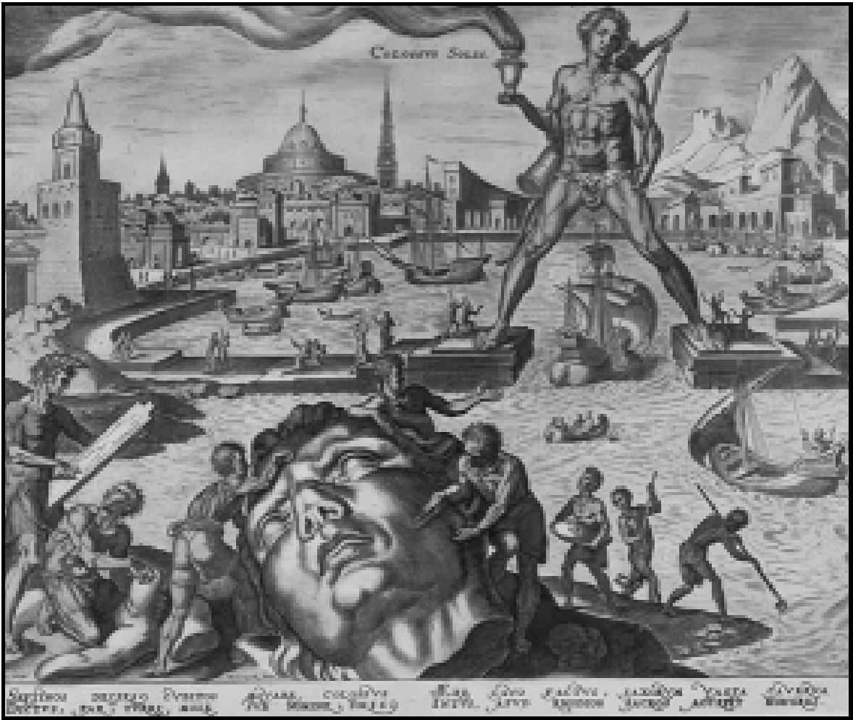

**98**

UNITS

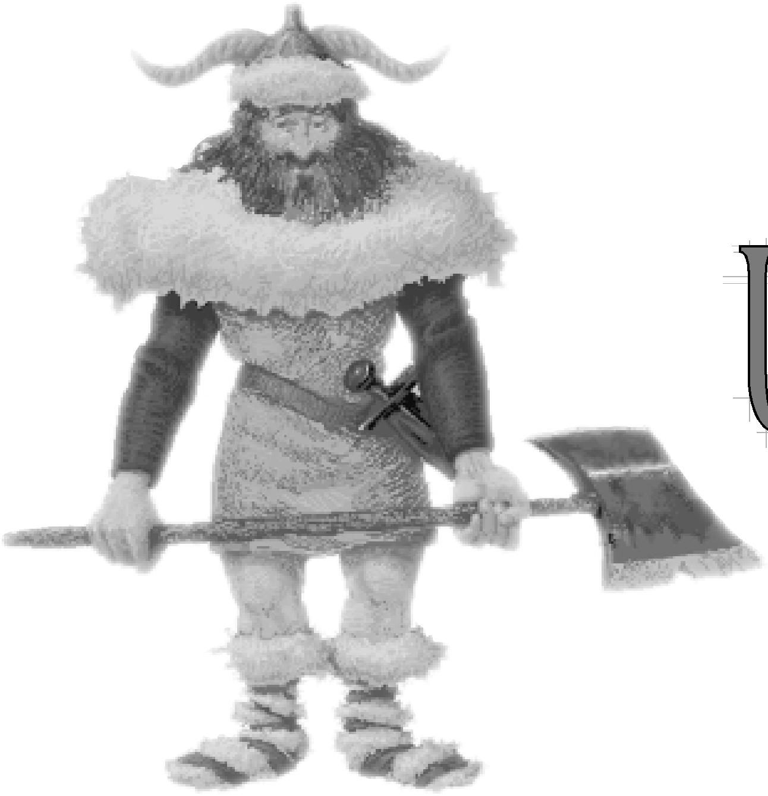



Units are groups of citizens, soldiers, and

**99**

envoys that can move around the world of

***Civilization II*** and interact with other units and

civilizations. Some non-combat units, like Caravans, Explorers, and Settlers, have special functions which are explained separately.

**UNIT CONCEPTS**

**100**

Units are the pieces you move around on the map in ***Civilization II***. Each civilization’s units carry a different color shield. Units carrying red shields are always barbarians.

Units can be divided into types according to the way they move: *ground* (or land) units, *air* units, and *naval* (or sea) units. Each unit has statistics for attack strength, defense strength, and movement points. These stats are listed in a shorthand, code-like set of numbers, which we’ve already mentioned is called the ADM — this stands for Attack/Defense/Movement. You can find each unit’s ADM numbers in the CIVILOPEDIA. In addition, each unit — even non-combat units — has statistics for hit points and firepower, which are also found in the CIVILOPEDIA. The strength bar at the top of a unit’s shield indicates how many hit points that unit currently has, both by its length and by its color.

*Attack strength shows the likelihood of inflicting damage when attacking an opponent.* Units with a high attack strength are useful for offensives in which they are attacking.

*Defense strength represents the ability of a unit to defend itself when attacked; it is the likelihood that damage will be inflicted on an attacking unit.* Units with high defense strength are useful for defending cities and other positions against enemy troops. The terrain on which a unit stands can increase its defensive strength, as you’ll find in **Terrain & Movement**.

*Movement points indicate how far a unit can travel* — or how many times a unit can attack— in a turn; they’re explained in detail in **Terrain & Movement**, too.

*Hit points indicate how much damage a unit can withstand before it is destroyed.* Units with a greater number of hit points can absorb more damage in combat. A green strength bar indicates that a unit has more than two-thirds of its hit points remaining, a yellow strength bar means the unit has between one-third and two-thirds of its hit points, and a red strength bar show that a unit has less than one-third of its total hit points remaining. Hit points can be restored by skipping turns, especially in cities with repair facilities.

*Firepower indicates how much damage a unit can inflict in a round of combat.* Units with a high firepower pack a powerful wallop.

A unit’s status is important when you want to give it orders. Units can be on *active status,* which means they blink each time they become the active unit. Units on *sleep status* remain inactive until an enemy unit comes within one square of them. At this point, they “wake up” and become active. Units on *fortified status* are also inactive (their status is indicated by the letter “F” on the unit’s shield, and by the brown “entrenchment” icon which appears around the base of the unit— in fact, they are entrenched in a defensive posture. They remain inactive even if rival units approach them. Clicking on either a sleeping or fortified unit allows you to change its status to active. When the unit becomes the active unit, you can give it new orders.

Every unit has an *observation factor*. Most units can only “see” units and objects on the edges of the terrain squares directly adjacent to their own. Early in the game, when most of the map is black, the limits of this observation area are obvious, as the blackness rolls back only so far with each move a unit makes. Even after you have explored a continent, barbarians and rival units can appear “out of nowhere” because they are lingering outside the limits of your units’ observation.

UNITS

**101**

Some advanced units have greater observation factors. They can “see” into a second square in all directions, which makes them useful for monitoring rival’s movements and anticipating surprise attacks. Exceptional observation factors are noted in unit descriptions in the CIVILOPEDIA.

**MILITARY UNITS**

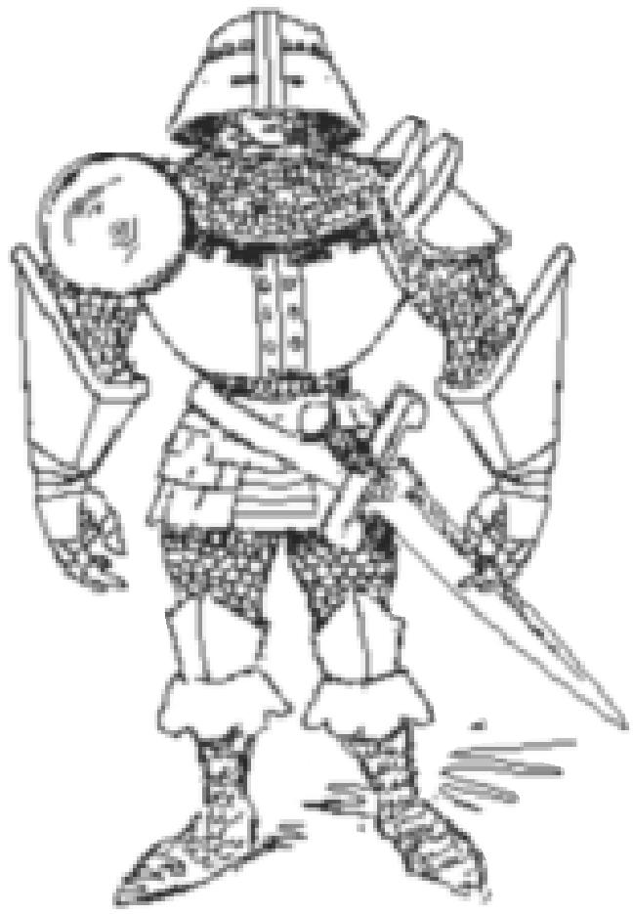

Through the years, the majority of your time is spent moving and positioning armies. A strong military is the best defense against rivals and barbarians.

Military units are also the eyes of your civilization, exploring the world as

they move. Finally, they can serve you offensively by defeating the armies

of your rivals and capturing their cities.

Armies can be ground units (Legions, Cannons, and Armor, for example), naval units (Triremes, Ironclads, Battleships, etc.), or air units (Fighters, Bombers, and Nuclear units). Several non-combat units need further explanation, so they’re discussed in detail a little later. All units, whether they are combat or non-combat oriented, are described in the

MILITARY UNITS option of the CIVILOPEDIA.

**GROUND UNITS**

The majority of ***Civilization II***’s units are ground units. These armies

move over the map terrain square by terrain square. They spend

movement points according to the type of terrain they are entering,

observe movement restrictions like zones of control, and attack rival

units when you move them into a square containing an enemy army. Most ground units have an observation of one square.

PILLAGE

Armies can strip the countryside through which they roam of any improvements any Settlers or Engineer units have built, tearing up roads, trampling crops, and collapsing mines. The occupying army destroys your choice of one improvement each time you press the 8ni@ and © keys simultaneously, or choose PILLAGE from the ORDERS menu. It takes one turn to pillage one improvement.

**AIR UNITS**

**102**

Air units operate under some special movement rules. These units can cross any terrain square at a cost of one movement point per square. Because they are airborne, they get no bonus for crossing squares improved by roads or railroads. All air units except missiles have an observation range of two squares in any terrain.

Most air units must end their movement in a friendly city with an airport, at an Airbase, or on a Carrier unit, as these are the only areas where they can safely land. Bombers and Stealth Bombers must land for refueling every second turn, giving them effective ranges of 16 (8 out and 8 back) and 24 (12 out and 12 back), respectively. Bombers and Stealth Bombers can only attack once, regardless of their remaining movement points. In addition, attacking uses all a unit’s remaining movement points for the turn. Therefore, if you attack during a Bomber or Stealth Bomber’s return flight, it does not have enough movement points to return home safely, and it crashes and disappears. Fighters and Stealth Fighters can attack targets as many times as they have movement points. However, be sure you save enough movement after the attack to return to a landing area, or your pilots kamikaze!

Both missile units are one-shot attackers; the icons represent missiles that are spent in the aggression. If you have miscounted the number of squares to your destination, or another unit’s movement or position prevents a missile unit from reaching a target city or unit, you can attempt to return the missile to a friendly city or Airbase, or to a Submarine or Carrier unit. If your missile gets stranded — that is, there is no target unit or city within reach, and no safe landing area —the missile is a dud that falls to earth harmlessly. It disappears from the game.

If a city is the target of a Cruise missile attack, the strongest military unit defends against it (the unit in that city with the largest defense factor). There is no collateral damage to city improvements from Cruise missile attacks. If a city is the target of a Nuclear missile attack, half of the population is destroyed. All military units in and adjacent to the target square are destroyed as well, regardless of the civilization to which they belong. If a military unit or stack of units is the target, all units in the stack are destroyed. In addition to the loss of units, all land terrain squares adjacent to the impact square become polluted.

Helicopters are unique air units in that they don’t need to return to a base for refueling, giving them an unlimited movement range similar to a ground unit. However, every turn a Helicopter starts in the field —not taking off from a friendly city, Airbase or Carrier — it suffers a small amount of damage. Eventually, it must return to a friendly city or Airbase for repairs. A Helicopter can only make one attack per turn; attacking uses all remaining movement points for that turn.

**NAVAL UNITS**

UNITS

**103**

Naval units also adhere to some special rules. Some naval units have the capacity to carry passengers —ground units. These include Triremes, Caravels, Galleons, Frigates, and Transports. Carriers can only transport air units. Submarines can only transport missile units. When two ships occupy the same square, the one that leaves first takes up to its carrying capacity of passenger units with it.

Most naval units can conduct shore bombardments— that is, they can attack units standing on the coastal squares of continents and islands. Because of the high degree of inaccuracy, the firepower of both the ship and its target is reduced to one when a ship bombards a unit, city, or stack on shore. Submarine and Transport units cannot conduct shore bombardments at all.

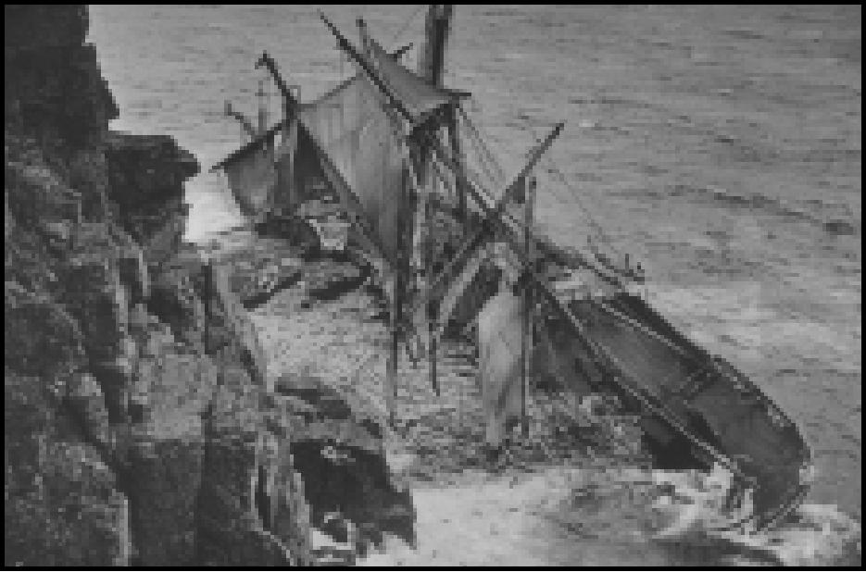

Battleships, Carriers, Cruisers, Destroyers, and Submarines have enhanced observation ranges at sea. Each can “see” enemy ships and planes from two ocean squares away. Rival Submarine units are the only exception to this rule, as their ability to travel underwater camouflages them from most units’ view (it likewise conceals your Subs from your enemies), unless the Submarine is attacking the observing unit. Destroyers, Cruisers, AEGIS Cruisers, and Helicopters can all spot Submarines if they are adjacent to them. Note that Submarines cannot spot rival Submarines!

**COMBAT**

Combat occurs when a unit attempts to enter a map square occupied by a unit or city of another civilization — unless the unit is a Diplomat or Spy, in which case it can offer bribes to units or conduct a variety of business in cities — or unless the unit is a Caravan or Freight unit, in which case it can establish a trade route when it enters a city. Everybody else just fights. Battles are immediately resolved.

Most battles result in the destruction of one army or the other. When more than one unit occupies the defender’s square, the unit with the highest defensive strength (as determined by comparing the second digit in the units’ ADM numbers, and making allowance for veteran status) defends. If it loses, then all other armies stacked with it are destroyed as well. However, stacked units taking advantage of Fortress improvements or taking cover in city squares are destroyed one at a time.

**THE EFFECT OF DAMAGE**

**104**

Successful attackers which have movement points remaining after combat can continue moving—and even continue attacking— normally, if they choose. However, successful attackers often sustain damage in each battle. As a unit is damaged, its strength bar gets shorter, and eventually changes color. Both the length of the strength bar and the color are significant. When a unit is reduced to approximately two-thirds of its full strength, the strength bar changes from green to yellow. When a unit’s hit points are reduced to around one-third of its full strength, the bar changes from yellow to red.

In addition to losing strength, damaged units also lose mobility. A unit’s damage is factored into its movement allowance, so a unit which has sustained damage of 30 percent only has 70 percent of its movement points. For example, if the damaged unit normally had three movement points, damage of 30 percent would reduce its movement to two (even though it would still have a green strength bar). There are two important exceptions to this rule: Naval units are never reduced below two movement points per turn, and air units do not suffer reduced movement at all.

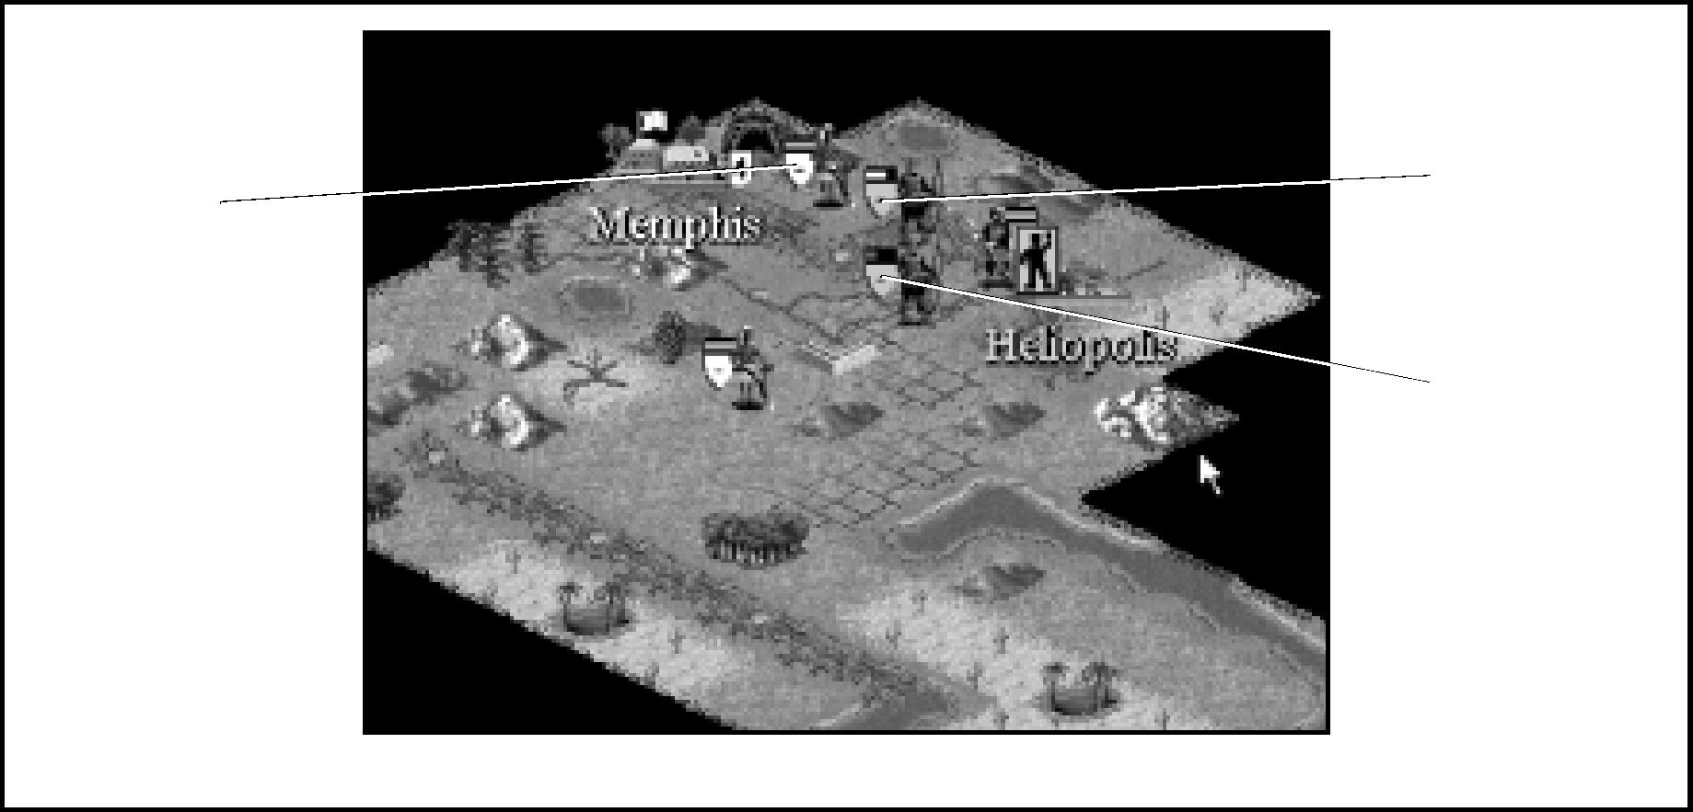

No Damage

*Different colored strength bars indicate different levels of hurt.*

Critical Damage

Partial Damage

**CALCULATING THE WINNER**

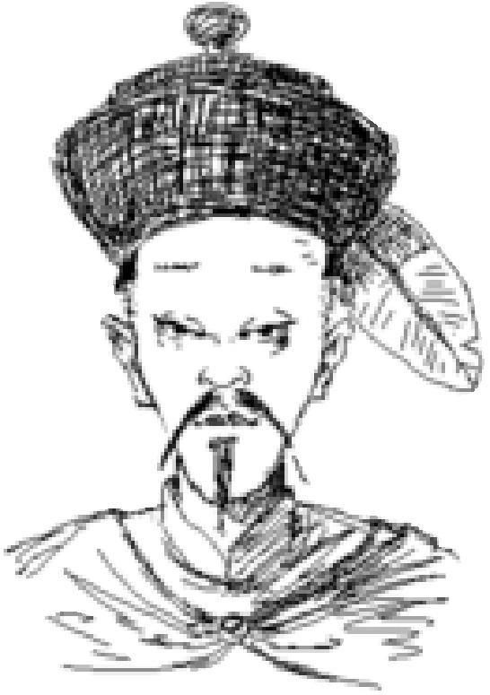

**105**

Combat in ***Civilization II*** is essentially like a rapid-fire boxing match. Units fight one-on-one in rounds, with damage equal to the firepower of the winner being subtracted from the hit points of the loser of each round. When one unit loses all its hit points, it is destroyed. If the loser is defending a stack of units and they are not inside a Fortress or a city, the whole stack is destroyed.

UNITS

The important factors in combat are the attack and defense strengths of the combatants as well as their hit points and firepower; the presence of veteran units on either side; the terrain occupied by the defender; and any defensive improvements in the square. In addition to considering all of these factors, combat also includes an element of chance. Imagine that sometimes, a unit just gets lucky. We don’t want to drag you through lots of heavy arithmetic for each combination of factors, but the calculations for each round of combat can be boiled down to a simple comparison.

The total modified attack and defense factors are combined and the probability of either side winning is approximately the ratio of each side’s factor compared to this total. For example, if an Elephant (attack factor 4) attacks a Phalanx (defense factor 2), the total of the factors is 6 (4 + 2). The Elephant has about a 66 percent chance of winning (4 out of 6) and the Phalanx about a 33 percent chance (2 out of 6).

Both the Elephant and the Phalanx have ten hit points and a firepower of one, so the battle goes between ten and nineteen rounds, until one or the other unit is reduced to zero hit points. It is possible for one opponent to win every round and take no damage at all,

and it is possible for the opponents to trade damage for damage until even the

eventual winner is badly beaten up. Most combats fall somewhere in the middle.

**ADDING IN ADJUSTMENTS**

How do those adjustments for veteran status and terrain and so on work? They’re added into each factor they affect before the total is determined. For instance, if both units are veterans, each gets a 50 percent bonus to attack and defense, giving the Elephant an attack factor of 6 (4 + 2) and the Phalanx a defense factor of 3 (2 + 1). Of course, modifying each unit’s factors also changes the total: Instead of 6, it is 9 (the total of each modified factor, 6 + 3). Now the odds are close to 6 out of 9 for the Elephant and about 3 out of 9 for the Phalanx.

If both are veterans and the Phalanx is behind City Walls (which triples a

unit’s defense factor, making the veteran Phalanx a 9), the odds are about 6 out of 15 for the Elephant and close to 9 out of 15 for the Phalanx. Though the adjustments change the odds of each unit winning a single round, they have no affect on the total number of rounds or on the amount of damage inflicted.

There are a number of special combat situations, which have special rules, detailed below.

**106**

AIR BATTLES

Only Fighters and Stealth Fighters can attack Bomber or Stealth Bomber units. In fact, Bombers and Stealth Bombers prevent enemy units (other than Fighters and Stealth Fighters) from even entering, much less attacking, the square they occupy.

When a Fighter or Stealth Fighter attacks a Helicopter unit, the Helicopter’s disadvantage is represented by reducing its firepower to one and reducing its defense factor by 50 percent.

When a Fighter or Stealth Fighter is stationed in a city that is attacked by a Bomber or Stealth Bomber, the defending units scramble, gaining a defense factor four times their normal value. However, they gain no additional protection from SAM Missile Batteries (because the SAMs don’t want to down their own planes).

AIR DEFENSE

When an AEGIS Cruiser is attacked by air units, it gains defense bonuses: The defense factor is tripled against plane or Helicopter attacks, and it is increased five times against missile attacks.

CITY ATTACKS

A successful ground attack on a city destroys only one defending unit at a time. However, each successful attack also reduces the population of the city by one point unless the city is protected by City Walls. Population loss does not result from naval or air attack, but is caused by a Nuclear strike.

CITY DEFENSES

The City Walls improvement triples the defense strength of units within against all ground units except Howitzers, and it protects a city’s population from reduction. The Coastal Fortress doubles the defense strength of all units within a city against shore bombardments by enemy ships. The SAM Missile Battery doubles the defense strength of all units within the city against all air units except Nuclear missiles. See **Nuclear Attacks** for the scoop on SDI Defense improvements.

FORTRESSES

UNITS

**107**

Units within a Fortress gain significant advantages. A unit stationed within a Fortress doubles its defensive strength, and stacked units are destroyed one at a time. Settlers or Engineer units can build Fortresses on any terrain square (except a city square) once your civilization has discovered the Construction advance; see **Settlers & Engineers** for the complete scoop.

NUCLEAR ATTACKS

Nuclear attacks occur when a Nuclear unit attempts to enter a square occupied by enemy units or an enemy city. A Spy unit can make a suicide bomber attack by smuggling a Nuclear unit into an enemy city, regardless of the presence of an SDI Defense city improvement. In any case, all units in the target square and adjacent squares are destroyed, regardless of their cultural allegiance (in other words, both theirs and yours). In addition, a bombed city loses half of its population. The defense against most nuclear attacks is the SDI Defense city improvement.

An SDI Defense improvement is like an umbrella that extends three squares from a city in any direction. The city and all units and improvements within this radius (including Airports, Fortresses, and other city squares) are protected from all effects of a direct Nuclear missile attack, other than the suicidal bomber Spy mentioned previously.

PEARL HARBOR

When air units or ground units attack ships in port (naval units defend a city against air units), the attackers’ firepower is doubled against the defending units and the defender’s firepower is reduced to one, to represent the defenders’ vulnerability. Air units also pick off city defenders one at a time, except for Nuclear missiles (see **Nuclear Attacks,** above).

SHORE BOMBARDMENTS

Other than Submarines, any naval units with an attack factor greater than zero can attack enemy units on adjacent land squares (they are conducting shore bombardments). Cities along the coastline are vulnerable to shore bombardments, too. Naval units can defend the cities they occupy against attack, though their firepower is reduced to one because of their limited maneuverability.

**CARAVANS & FREIGHT**

**108**

Caravan units represent shipments of trade goods and materials. Though the icon remains a camel, as history progresses, your Caravan units are stand-ins for the continuum of trade vehicles from camel caravans to wagon trains. They can be used to establish trade routes between cities or to transfer resources for the construction of Wonders of the World. Caravans become available once you have achieved the advance of Trade.

Once your civilization has discovered The Corporation, the Freight unit replaces the Caravan unit on the PRODUCTION menu. Freight units have two movement points a turn. They represent the modern movement of goods and materials by truck convoys and cargo containers.

**TRADE ROUTES**

A Caravan or Freight unit can establish a trade route by entering any city, even a rival’s city. Your treasury gains an immediate cash payment for delivery of the first load of goods, and your research scientists gain an immediate bonus for cultural exchange of an equal amount of science (beakers). The home city of the Caravan or Freight unit gains an increase in the trade generated each turn, which represents a continuing economic relationship. A listing in the GENERAL INFORMATION window shows the cities with which trade routes have been established, and the amount of bonus trade generated every turn. The bonus is added to the total amount of trade your city produces, so that indirectly this boosts your research, tax, and luxury production in that city.

Each city can have up to three functioning trade routes, one for each commodity the city produces. As each route is established, the commodity traded on that route is enclosed in parentheses, to indicate a successful deal. Thereafter, when a Caravan is completed, loads of that commodity are no longer available. Food loads are always available.

The amount of trade generated by a trade route depends greatly on supply and demand, and partly on the size of the two cities. Bigger cities generate more trade. Trade with a city from another civilization is of greater value than trade with friendly cities. The farther apart the two cities are, the greater the bonus for trading between them. Trade bonuses also increase when the cities are on different continents. If you capture a rival city with whom you were previously trading, the trade route remains active. However, the amount of trade it generates is reduced, because items which were once exotic imports have become domestic commodities.

Caravans and Freight can enter any city they can reach. They are not hampered by movement restrictions like zones of control, but their ADM numbers are low enough that they might find it difficult to smuggle goods into an enemy city without being destroyed. Caravan and Freight units can take advantage of naval transport to trade overseas (you can load them aboard any ship that carries units), and they can disembark into a city directly from a ship.

SUPPLY & DEMAND

UNITS

**109**

Each city in the game can supply three commodities because of their local abundance. Similarly, each demands three other commodities, which are locally in short supply. While a Caravan or Freight unit can deliver goods to any city, it gains the largest profits from delivering a commodity to a community that demands it. You can check the marketplace wisdom by clicking the SUPPLY & DEMAND button at the bottom of the TRADE ADVISOR’s Report. A list of commodities appears. Choose the commodity in which you’re interested, then click OK. A second list shows all known cities that supply the item and all known cities that demand it. The list is updated to reflect your exploration and contact with other cultures.

FOOD CARAVANS

A fourth and always available option for trade goods is food. You can transfer one food per turn to another city by sending a load of food from a city with a surplus to a city that needs help. A needy city can be on the receiving end of more than one food route. Once a food route is established, it cannot be countermanded. It is automatically canceled, however, if the sending city runs out of food for its own people.

**BUILDING WONDERS**

A Caravan or Freight unit can contribute shields equal to its construction cost to any Wonder of the World you are undertaking. Simply move your Caravan or Freight unit into the city in which construction of a Wonder is underway. A dialog box offers you the choice of contributing to the construction. If you decide to help build the Wonder, your Caravan or Freight unit disappears and its worth is added to the production of the Wonder, speeding its completion. If you divert goods to help build a Wonder, they are still available later to establish a trade route.

**DIPLOMATS & SPIES**

**110**

Diplomats are unique units that can act as ambassadors, envoys, secret agents, and saboteurs. They can open contacts with other civilizations and establish embassies to gather information about your rivals. They can steal information and otherwise disrupt your rivals. They can bribe enemy armies. Stationing Diplomat or Spy units in your own cities reduces the effectiveness of enemy Diplomats and Spies. When your civilization obtains the advance of Writing, you can build Diplomats.

Be aware that enemy Diplomats can use all the same techniques against your civilization as you use against theirs.

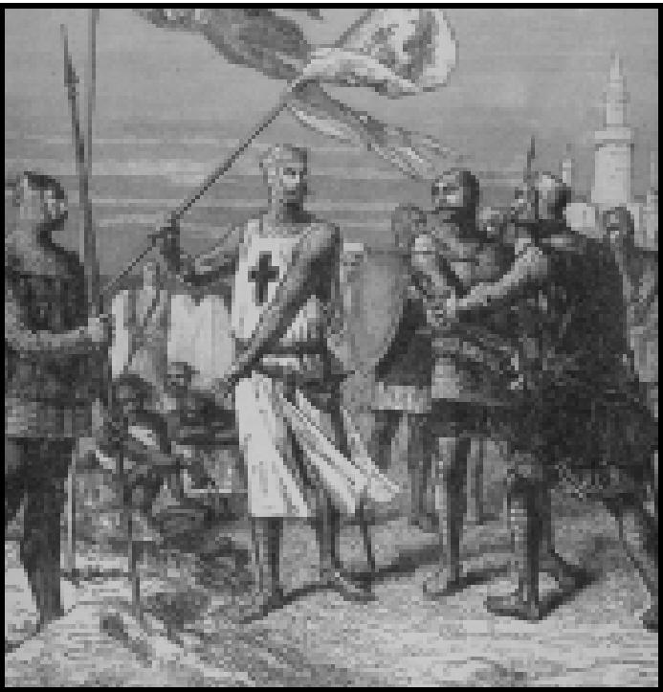

Once your civilization has developed the Espionage advance, the Spy unit replaces the Diplomat unit on the PRODUCTION menu. A Spy is superior to a Diplomat in several ways. Her greater sophistication and more elaborate training allows her to choose a specific technology or target improvement when entering a city intent on mischief. In addition, she can travel more rapidly, moving up to three squares a turn, regardless of the terrain. A Spy has an observation range of two squares in every direction. When a Spy successfully completes a mission, she has a chance of escaping and returning to the nearest friendly city. The easier the mission, the greater the chance that she will escape. For instance, stealing a random civilization advance is easier than stealing a specific one. Finally, Spies have the unique ability to plant nuclear devices in enemy cities, as we’ll explain in **Entering Enemy Cities**.

**BRIBING ENEMY UNITS**

You might convince an enemy unit to defect and join your civilization. Only units of civilizations governed by Democracy are completely immune to bribery.

In game terms, simply move a Diplomat or Spy into a square occupied by a single enemy unit (neither Diplomats nor Spies can bribe units that are stacked together). A dialog box appears, showing how much gold the unit demands to defect. If the unit is immune to bribery, a dialog box will remind you of this condition.

The farther a unit is from its capital, the less gold is required. If you accept, the gold is deducted from your treasury and the army switches sides (becomes your color). The Diplomat or Spy survives the discussion regardless of his or her success in negotiating; however, if you do not choose to pay the bribe, the enemy unit might attack your negotiator later. Diplomats and Spies can bribe naval and air units as long as these are not stacked with other units.

The nearest friendly city becomes the home city for a newly bribed unit (see **Unit Roster** for information on this point).

**COUNTERESPIONAGE**

UNITS

**111**

Diplomats and Spies stationed in friendly cities have a chance to thwart “steal technology” attempts by enemy Diplomats and Spies. Each Diplomat has a 20 percent chance to do so per attempt. Spies have a 40 percent chance; veteran Spies have a 60 percent chance of catching their fellow envoys. Getting caught ends the interloper’s turn.

**ENTERING ENEMY CITIES**

Diplomats and Spies can slip past enemy armies without pausing to observe zones of control, using superior powers of persuasion and/or diplomatic immunity as a shield. Diplomats and Spies are also subject to *deportation* (a special form of “attack”) even from civilizations with which they are not at war. Any military unit can “attack” a Diplomat or Spy from a civilization with which it is at peace, provided that the envoy is nearer to a city of the military unit’s culture than to one of its own cities. The offending envoy is returned to friendly territory. Diplomats and Spies can travel overseas in ships as do other ground units.

Diplomats and Spies are two of only four units that can enter defended enemy cities (Caravans and Freight are the other two). A menu listing the tasks a Diplomat or Spy can perform appears whenever you send your envoy on an urban mission. If, after you’ve

looked over your choices, you decide not to take any action, click the CANCEL button to

back out of the menu. Each task is fully explained below.

**INTERNATIONAL INCIDENTS**

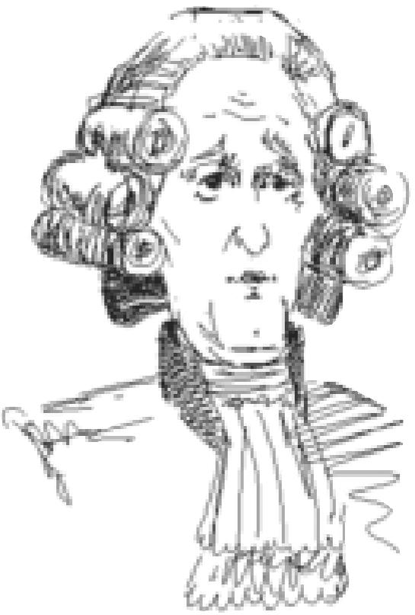

Whenever a Diplomat or Spy *successfully* steals technology, sabotages a city improvement, poisons the water supply, or incites a revolt in a city of a

civilization with whom you have signed a treaty, an international incident

almost inevitably occurs. Your victim is likely to treat your treachery as an

act of war, although a victim with whom you are allied may sometimes

choose to disregard your act. In addition, if you are governing your civilization as a Republic or Democracy, there might be domestic repercussions as well. Your government may collapse into Anarchy when the scandal reaches the Senate floor.

Do not confuse international incidents with a Spy’s ability to escape unharmed after a mission —the two events are completely independent. The only times when incidents do not occur are when you are already at war with your victim and when the Diplomat or Spy fails in its mission.

INVESTIGATE CITY

**112**

Your Diplomat or Spy unit gathers information about the rival city’s production and development. In game terms, this option shows you the enemy’s CITY DISPLAY. You can examine what armies are defending the city and what improvements have been built there. When you exit the CITY DISPLAY, you return to the MAP window. Your Diplomat has been eliminated, or your Spy has been charged one-third of a movement point for her efforts. There is no possibility that your envoy is detected. Until the end of the turn, you may click on the city again at any time to review the knowledge you have gained.

ESTABLISH EMBASSY

Your Diplomat or Spy unit establishes official contact with the rival civilization, setting up an office in the city to which you sent him or her. If you sent a Diplomat, he stays there to head the office, so the icon disappears; if you sent a Spy, she has been charged one-third of a movement point for her efforts. There is no possibility of international embarrassment. In game terms, you can access information about your rival’s type of government, treasury, number of armies, the name of its capital city, treaties with other civilizations, diplomatic states, and technological advances whenever you look at your FOREIGN MINISTER’s Report (see **Advisors** for the complete scoop). It is only necessary to establish an embassy once with any particular civilization.

STEAL ADVANCE

Your Diplomat or Spy attempts to steal one civilization advance from a rival civilization. In game terms, a Diplomat can only confiscate one advance per city. A Spy can make more than one attempt per city, although her chance of capture increases with every additional mission. If you send a Spy, she has the option to try the more difficult task of filching a specific advance from the list of unique technologies your rival has.

Even if he succeeds, a Diplomat disappears in the process (his cover is blown). If she evades capture, a Spy returns to the closest friendly city, and is promoted to veteran status for her work. While veteran status cannot improve her ADM rating of zero defense, it does increase her chances of escaping detection on later missions.

If you have already stolen a civilization advance from this particular city, or if the enemy civilization has discovered no technology worth stealing, and your envoy is undetected, a Diplomat unit loses its turn but is not destroyed. If the enemy civilization has discovered no technology worth stealing, a Spy remains empty-handed. The only way a Spy can fail to steal an advance is if she has opted to confiscate a particular technology.

INDUSTRIAL SABOTAGE

UNITS

**113**

Carefully maneuvering in the back streets, your envoy manages to infiltrate some critical city organization or defense. In game terms, your Diplomat or Spy destroys either whatever item the rival city currently has under production, or one of the rival city’s existing improvements — the item targeted is a matter of random chance. If you send a Spy, she has the option to try the more difficult task of destroying a specific target from the list of existing improvements that city has.

Regardless of his success, a Diplomat is lost in the effort (think mad, suicidal bombers if it helps). If your Spy is not captured, she returns to the closest friendly city, and is promoted to veteran status for her work. While veteran status cannot improve her ADM rating of zero defense, it does increase her chances of escaping detection on later missions. The only way a Spy can fail to complete her sabotage is if you have opted to destroy a particular improvement.

If your envoy destroys a critical improvement, it might throw the city into unrest (Temple, Cathedral), weaken its defenses (City Walls, Coastal Fortress), or cut its production (Factory, Solar Plant). Diplomats and Spies never destroy Wonders of the World.

INCITE A REVOLT

Your Diplomat or Spy contacts dissidents within a city and provides the necessary means for them to overthrow their current regime. In game terms, for a suitable payment, the city revolts and joins your civilization. The amount needed to finance a revolt depends on the size of the city and its proximity to the enemy civilization’s capital. If you wish to avoid an international incident, you must subvert the city by paying double the listed amount, as the dialog box warns.

Enemy capitals never agree to revolt, and neither do cities in a Democracy. Cities with Courthouses cost twice as much to bribe. Cities under Communism tend to remain expensive to bribe even when they are situated far from their capital. Also, it costs less to push a city already in civil disorder into open revolt than it does to undermine a contented city.

A Diplomat is lost in a successful revolt (he stays to organize the new government). A Spy returns to the closest friendly city if she is not captured, after appointing a new city government. A successful Spy is promoted to veteran status.

If you don’t have enough cash to finance the project, your envoy doesn’t even attempt to incite the natives. He or she escapes outside the city if you refuse to pay the cost.

If the overthrow is successful, all units within one square of the revolting city that belong to that rival civilization also revolt and join your regime. All other rival units who counted that city as home are disbanded. All existing city improvements except Temples and Cathedrals remain intact.

POISON THE WATER SUPPLY

**114**

Only Spies can attempt to weaken the resistance of a rival city by poisoning the water supply. In game terms, a successful attempt reduces the target city’s population by one point. If your Spy is successful and undetected, she discards her environment suit and returns to the closest friendly city for promotion to veteran status.

PLANT NUCLEAR DEVICE

Only Spies can attempt to plant nuclear devices in rival cities. In game terms, this is the only way to nuke a city protected by the SDI Defense improvement. This is the most difficult mission to accomplish, and the likelihood of capture is high. Furthermore, there is the possibility that your Spy will be caught red-handed, causing a major international incident. If this happens, every civilization in the world will declare war on you, appalled by your atrocity (unless you have a Fundamentalist government).

**SETTLERS & ENGINEERS**

Settlers are groups of your most resourceful and adventurous citizens. As independent pioneers, they perform two critical functions for your civilization; they found new cities and they serve as civil engineers, improving the terrain for your empire’s benefit. After your civilization develops the Explosives advance, the Engineer unit replaces the Settlers unit on the PRODUCTION menu. These industrial-era citizens have better training and better equipment than your basic Settlers unit. Engineers can accomplish all the same tasks as Settlers can, and they can perform them twice as quickly. In addition, Engineers have the unique ability to Transform formerly unimprovable terrain like Desert, Glacier, and Mountains squares.

Your civilization produces Settlers and Engineers in the same manner as it does any other unit, with one caveat. When one of these units is completed, the population of the city that produced it is reduced by one point (one citizen on the POPULATION ROSTER), representing the emigration of these pioneers. If a city has only one population point when it completes the task of building a Settlers or Engineer unit, the city disappears when its population is absorbed into the new unit. This is one of the only ways to eliminate a city that is in a poor or inconvenient location.

**FOUNDING NEW CITIES & INCREASING EXISTING ONES**

UNITS

**115**

To found a new city, move a Settlers or Engineer unit to the desired location and press the BUILD M key, or choose BUILD NEW CITY from the ORDERS menu. The unit disappears as the people it represents become the first population point of the new city.

The ADD TO CITY order can be used to increase the size of an existing city with less than ten population points. Move a Settlers or Engineer unit into an existing city and press the BUILD © key or choose ADD TO CITY from the ORDERS menu. The unit is absorbed into the city, adding one point to its population.

**MAKING IMPROVEMENTS**

Settlers, and later Engineers, can make a number of agricultural and industrial improvements to your civilization’s topography. Each task takes a certain number of turns to complete, depending on the terrain being improved. Some improvements can only be undertaken after your civilization has acquired certain technologies. Engineers, being better trained and equipped, can accomplish tasks twice as fast as Settlers. Engineers are also the only units that can Transform terrain. Teamwork makes these units work faster. You can combine Settlers and/or Engineers to accomplish tasks more rapidly. For example, two Settlers units work twice as rapidly as one, and three can accomplish a task in one-third the standard time. One Settlers unit and an Engineer can also accomplish a task in one-third the standard time, since the Engineer naturally works faster than the Settlers.

There is no limit to the number of times your Settlers or Engineers can build new improvements on any given terrain square — if the changing needs of your civilization demand clearing, irrigation, reforestation, clearing, pollution clean-up (detoxification), and reforestation in succession, the land can take it. If an option is grayed out on the ORDERS menu, that task cannot be accomplished at this time. Perhaps undertaking another improvement will make the desired option available in the future. For instance, a Plains square surrounded by Forest has no access to water and cannot be irrigated. You’ll need to clear at least one of the adjacent Forests (one that shares a side with the target square) and irrigate it, before irrigation becomes available to the target square.

We’ve extracted all the variations into a table which lists the task, the shortcut key, the required advance, if any, and the terrain types which benefit from this improvement. Full explanations of each activity appear after the table.

**116**

|  |  |  |  |
| --- | --- | --- | --- |
| **TASK** | **SHORTCUT KEY** | **REQUIRED ADVANCE** | **TERRAINS THAT BENEFIT** |
| Irrigate | I | — | Desert, Grassland, Hills, Plains, River |
| Clear | I | — | Forest, Jungle, Swamp |
| Build Farm | I | Refrigeration | Any Irrigated Land Square |
| Build Fortress | F | Construction | Any Land Square |
| Mine | M | — | Desert, Hills, Mountains |
| Reforest | M | — | Grassland, Jungle, Plains, Swamp |
| Clean up | P | — | Any Polluted Land Square |
| Build Road | R | — | Any Land Square |
| Build Railroad | R | Railroad | Any Road Square |
| Transform | O | Explosives | Any Land Square |
| Build Airbase | E | Radio | Any Land Square |

IRRIGATE

Depending on the form of government employed by your civilization, irrigation can improve the agricultural production of a city’s relatively level terrain. A suitable square can be irrigated if it shares one side with a source of water (Ocean square or terrain with a river running through it) or another irrigated square (diagonal doesn’t count). Although your city square might be irrigated when the city is founded, it does not count as a source of water for further irrigation. Sometimes you might find it necessary to irrigate squares to which your city has no access, in order to extend irrigation into squares the city uses. When your Settlers or Engineer unit is positioned in the appropriate terrain square, choose the BUILD IRRIGATION option on the ORDERS menu or press the I key.

CLEAR

Clearing terrain improves the movement point cost of dense terrain (although it eliminates the defensive bonus), and provides land suitable to further improvement through irrigation or reforestation. Sometimes a terrain square might need to be cleared to allow for irrigation access, and later reforested to restore valuable resources. When your Settlers or Engineer unit is positioned in the appropriate terrain square, choose the CHANGE TO GRASSLAND (sometimes CHANGE TO PLAINS) option on the ORDERS menu or press the I key.

BUILD FARM

UNITS

**117**

Planting market gardens and other high-yield farmland is the post-industrial farmer’s task. Once your civilization has discovered the Refrigeration advance, Settlers or Engineer units can intensify the food output of irrigated land by another 50 percent in cities that build the Supermarket improvement. When your Settlers or Engineer unit is positioned in the appropriate terrain square, choose the IMPROVE FARMLAND option on the ORDERS menu or press the [D key.

BUILD FORTRESS

Building Fortresses can be essential for defense of terrain that is not a city site. Fortresses provide a defensive bonus to rural or frontier units in the same way the City Walls improvement benefits urban defensive units (see **Combat** for the full details). In addition, representative governments can station troops in Fortresses that are within three squares of a friendly city without incurring a field service penalty (see **Happiness & Civil Disorder** for complete details). Once your tribe has discovered the Construction advance, this option becomes available in the ORDERS menu. When your Settlers or Engineer unit is positioned in the appropriate terrain square, choose the BUILD FORTRESS option or press the ❑F key.

MINE

Mining terrain allows full utilization of the natural resources present. It is especially useful in special terrain like Coal and Gold. When your Settlers or Engineer unit is positioned in the appropriate terrain square, choose the BUILD MINE option on the ORDERS menu or press the **M❑** key.

REFOREST

Reforestation improves the shield production of most terrain (though it increases the movement point cost of open terrain if there is no road or railroad through the square). Reforesting Plains and Grassland squares also improves their defensive bonus. When your Settlers or Engineer unit is positioned in the appropriate terrain square, choose the CHANGE TO FOREST option on the ORDERS menu or press the **M❑** key.

CLEAN UP POLLUTION

Detoxifying squares by cleaning up the pollution there restores the full (pre-pollution) production capacity to the affected squares. A long-term benefit of clean-up is the reduced chance of global warming, which might otherwise occur (see **Terrain & Movement** for details). Both industrial pollution and nuclear contamination can be eliminated by clean-up efforts. When your Settlers or Engineer unit is positioned in the appropriate terrain square, choose the CLEAN UP POLLUTION option on the ORDERS menu or press the © key.

BUILD ROAD

**118**

Building roads across terrain reduces the movement point cost of that square by one-third, provided that the moving unit enters from an adjacent road square. Depending on the form of government under which you civilization operates, it can also improve the trade production of the square. Roads are the foundations for railroads. When your Settlers or Engineer unit is positioned in the appropriate terrain square, choose the BUILD ROAD option on the ORDERS menu or press the ® key.

BUILD RAILROAD

Laying track across terrain eliminates the movement point cost of that square providing the moving unit enters from an adjacent railroad square. Railroads also increase shield production by 50 percent, rounded down. You can only build railroads where you have already built roads. When your Settlers or Engineer unit is positioned in the appropriate terrain square, choose the BUILD RAILROAD option on the ORDERS menu or press the ® key.

TRANSFORM

Modern equipment and engineering techniques allow workers to transform even the most inhospitable land into a productive terrain. Once your civilization has discovered the Explosives advance, this option becomes available to your Engineer units. When your Engineer unit is positioned in the appropriate terrain square, choose the TRANSFORM option on the ORDERS menu or press the p❑ key.

BUILD AIRBASE

Building rural airbases allows your air units more flexibility in their flight plans and enables them to patrol a greater area. Once your civilization has discovered the Radio advance, this option becomes available on the ORDER menu. When your Settlers or Engineer unit is positioned in the appropriate terrain square, choose the BUILD AIRBASE option or press the E key.

**EXPLORERS**

UNITS

Explorers are non-combat units that can treat all terrain as roads. Their bravery and resourcefulness makes them ideal for opening up new continents and discovering the far reaches of a landmass quickly. Explorers can ignore enemy units’ zones of control; however, for diplomatic purposes (peace treaties and alliances) your rivals consider Explorers as dangerous as they do combat units.

**BARBARIANS**

Barbarians are small tribes of raiders that are not part of any opposing civilization. They always carry red shields. You can set the likelihood and frequency of barbarian attacks in the initial game choices you make. You might encounter them periodically as your civilization begins to expand and grow. They sometimes invade from the sea; other times they arise suddenly in unsettled parts of any continent. Barbarians might attempt to capture or destroy your cities, and pillage your fields and mines. Most barbarian tribes are accompanied by a leader.

Because barbarians can appear along any coast or in any unsettled area, it is important to defend your cities with at least one military unit. Barbarians (and rival armies) can walk

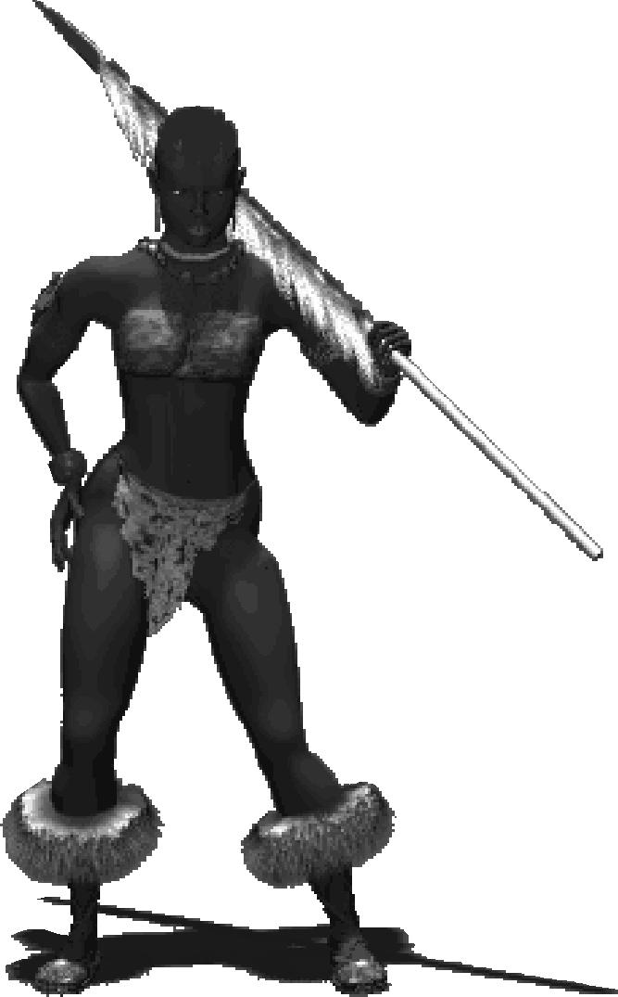

right into an undefended city, capturing it with only minor bloodshed (the captured

city loses one population point, just as any city taken by force does — see

**Capturing Cities** under **Cities** for the gory details).

Even if barbarians capture a city or several cities, they do not become a

rival civilization —that is, they do not join the space race, or negotiate

treaties, or earn rank in historians’ reckonings. Sea raiders can be fought on land or engaged at sea in their ships. Land barbarians arise in areas that are outside the radius of a city. As time passes, they appear at even farther distances from civilization. Thus, expanding your network of cities over a continent eventually removes the threat of land barbarians, because the entire area has become more or less civilized by your urban presence.

*Zulu Warrior*

**119**

**RANSOMING BARBARIAN LEADERS**

**120**

When you attack and destroy stacked barbarian units, the leader units fall with their troops and are also destroyed. However, if a barbarian leader stands alone in a square, and your army wins an attack against him, he is captured. His compatriots immediately give you gold to ransom him back—the amount they pay is based on the barbarian level you chose in game setup. Barbarian leaders who have lost their armies attempt to escape. If not captured in a few turns, they disappear.

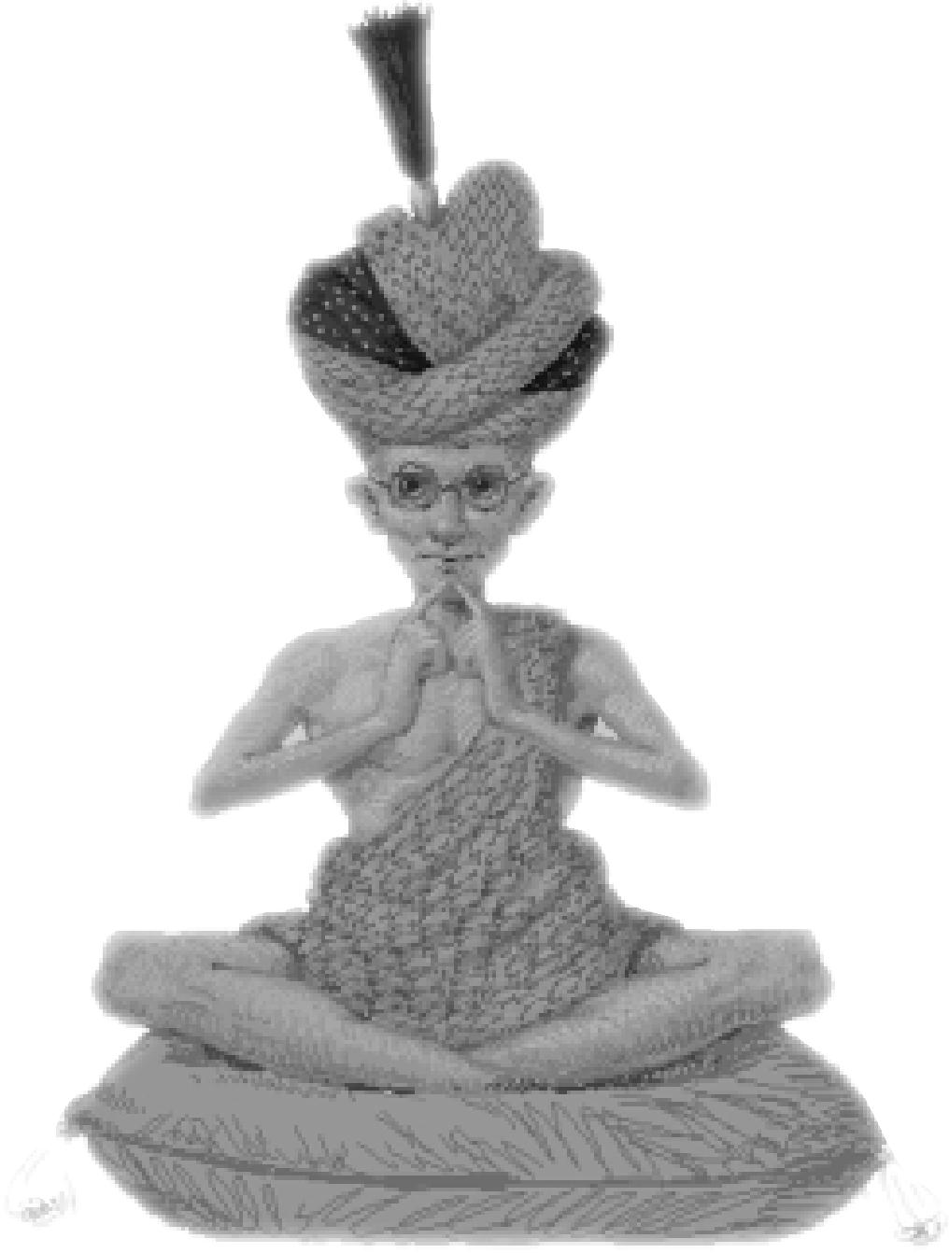

**121**

|  |  |
| --- | --- |
|  | DIPLOMACY |
|  |
| Other cultures share your world in ***Civilization II***. If your attitude is expansionist and your home continent is large, you might seek out —  and find —your rivals early in the game. If you concentrate on  perfecting your own cities or find yourself limited by a small  continent, it might be centuries before you encounter other  players. Whether you opt for peaceful communications or  aggressive action depends on your style. |  |

**CONCEPTS OF DIPLOMACY**

Eventually, no matter how isolated your location or how isolationist your policies, you will have contact with rival civilizations. Choosing to meet with a rival allows you to explore the intricacies of negotiation.

Every AI opponent has an *attitude* that he or she presents to negotiators. Your rivals’ attitudes can range from friendly to inimical. You can tell what attitude a leader has by watching the body language of the emissary after he or she stops speaking and by observing the titles of the dialog boxes during negotiations. A ruler’s personality affects his or her attitude. Your rivals’ attitudes can change over time, depending on your rank in the game, the current balance of power, the gifts you offer them, and your *reputation* for keeping your word in negotiations: Every time you go back on your word, international observers notice and remember.

Diplomatic negotiations can result in five different states: *alliance, peace, cease-fire, neutrality* or *war*. A rival might demand money or civilization advances (the reverse is also true —you can demand money or civilization advances from rival rulers). In addition, negotiations can include requests to share maps and instructions to withdraw trespassing troops. A player might even ask you to declare war on a third party. All negotiations progress through a series of screens, each with a variety of pre-set options.

Establishing embassies in your rivals’ cities allows you to increase your negotiating power. By checking your FOREIGN MINISTER’s reports, you can see whether, for example, the bellicose Indians have the city base to back up their threats, or whether they are just bluffing. You’ll have a better idea of when to back down and when to press for concessions.

**YOUR RIVAL’S ANTECHAMBERS**When you meet with an emissary of a rival ruler, the decor
  
of his antechamber can tell you much about the relative
  
size and type of government employed by the enemy
  
civilization. One alcove displays icons relating to the
  
military might of your rival, the other icons represent his
  
or her knowledge and advancement. Decorative details
  
indicate what type of government is in power.

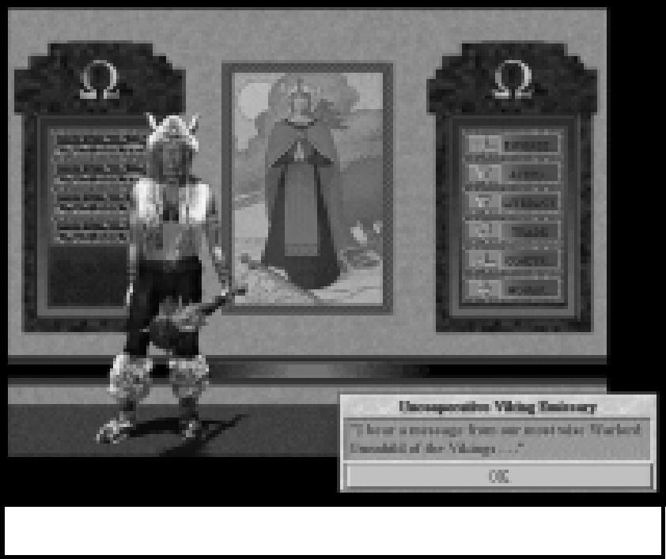

*A herald in the antechambers.*

**122**

**CONDUCTING DIPLOMACY WITH
  
COMPUTER OPPONENTS**

**123**

Diplomacy is conducted face to face with one rival emissary at a time. An opponent can contact you any time after units from each of your civilizations have met, and the reverse is also true. You can contact an opponent any time after your units have been adjacent to his or hers. Just select the SEND EMISSARY option from the FOREIGN MINISTER’s report in the ADVISORS menu.

In game terms, once you choose the SEND EMISSARY option, a dialog box opens, offering you several responses from which to select your intent. The form of government under which your civilization currently operates can influence the choices you have; see **Governments** for the details.

DIPLOMACY

Establishing embassies with other civilizations can be a very useful preparation for negotiations. Your FOREIGN MINISTER collects information from all of your embassies. From him you can learn important facts about your opponents, including the personalities of their leaders, their diplomatic states with respect to all civilizations with whom they have contact, the number and names of their cities, the extent of their technological advances, their current research project, and the amount in their treasury. This information is not available for civilizations with which you have not established an embassy.

**MOOD AND PERSONALITY**

The tone and result of any negotiations are greatly influenced by the mood of your rival. The opposing leader might be antagonistic, obsequious, or somewhere in between. This mood depends on the leader’s personality and how your two civilizations compare to each other and to the rest of the world. You might pick up cues about a rival’s mood from the body language of the emissary.

A rival leader’s personality might be aggressive, rational or neutral. Aggressive leaders are more likely to lean toward war or demand high payments for peace. Rational leaders are more likely to offer peace and might only be bluffing when asking for payment. If you have broken previous peace agreements with any civilization, your perfidy is remembered and influences all rivals’ degree of antagonism.

If you are the largest, most powerful, and richest civilization in the world, all rivals are likely to be very demanding or antagonistic. However, if a particular opponent is puny in comparison to your might, his or her natural tendency to belligerence might be overridden. A civilization threatened with extinction is more interested in survival.

Leaders with whom you are allied tend to become jealous as your civilization grows larger and more powerful; they expect to be appeased with gifts of cash or knowledge. On the other hand, allies who leap ahead of you may be generous when asked to share their good fortune.

**REPUTATION**

**124**

Your reputation is based not on how peaceful or how warlike you are toward your neighbors, but on how often you keep your word. Breaking alliances or treaties can blacken your reputation in the international community. Savagely sacking the city of a treaty partner with Legions, or breaking a cease-fire to bombard your opponent’s city by Stealth Bomber are acts likely to be deplored throughout the known world. The actions of your Diplomats and Spies can also damage your standing. Your computer opponents learn from your actions and adjust theirs to fit their expectations. If you habitually break treaties, other leaders will have no qualms about doing the same to you. It is important to note that the most severe censure is reserved for the ringleaders in group actions. If you break your word because you were “incited” by another player, the diplomatic penalty is drastically reduced. For example, if you have signed a treaty with the Romans, and the Greek emissary asks you to declare war on your erstwhile friends, it is a chance for you to break your treaty with the Romans at a much-lessened penalty than if *you* had been the principle figure of treachery.

Over long periods of time, if you mend your ways by keeping your word to other rulers, the black marks on your reputation can be partially erased and your honor somewhat redeemed. If you build the Eiffel Tower Wonder, the process of character redemption is speeded by a “lump sum” 25 percent shift in your favor, followed by a more rapid recovery over time. Only through the effect of the Eiffel Tower can a player who has broken his word regain a spotless reputation.

Finally, your reputation matters on the domestic front, too. When you choose to govern your civilization as a Republic or Democracy, your Senate pays careful attention to your conduct in foreign affairs. They can, for instance, force you to sign a cease-fire or peace agreement. They are also vigilant in trying to force you to keep your agreements. If they catch you circumventing their oversight by intentionally provoking an enemy (by refusing to leave enemy territory during a peace treaty, for instance, or if a Diplomat or Spy causes an international incident), your government is likely to collapse into Anarchy because of the scandal.

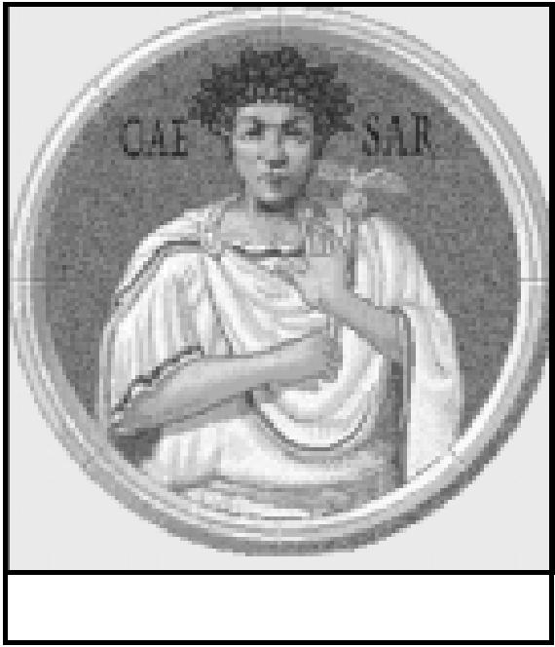

*Julius Caesar*

**THE FIVE DIPLOMATIC STATES**

**125**

In ***Civilization,*** all negotiations ended with an offer of peace or a declaration of war. In ***Civilization II,*** however, there are finer gradations of posture, or diplomatic state, than just these two options. The relationship between two cultures can be expressed as one of five different states: alliance, peace, cease-fire, neutrality, or war. Each has repercussions in the movement and position of armies and other units, as well as on the international reputation of the participants. A short description of each state follows.

**ALLIANCE**

DIPLOMACY

In an alliance, you and your ally agree to full (or almost full) cooperation against your common enemies. This shared purpose and trust manifests in a relaxation of restrictions. You can freely enter each others’ territories, ignoring zones of control, although you cannot stack your units with those of your ally or actually enter each others’ city spaces. If you have convinced a weaker power to ally with you, that ruler will expect occasional awards for his or her faithful service. Your ally also expects your military assistance if he or she is attacked.

Because an alliance involves a great deal of trust and cooperation, it is more difficult to cancel than other types of agreement. You cannot simply back-stab an ally by attacking him or her, but must first cancel your agreement during diplomatic negotiations. All units nearer to one of your former ally’s cities than to one of your own are returned from the field to the closest friendly city. The reverse is also true: your former ally’s armies are returned to his or her territory at the same time.

Breaking an alliance, for any reason, is remembered as a major transgression by all of the computer-controlled players. If you unilaterally cancel an alliance, your reputation suffers a “black mark” that is only very slowly erased by time. To cancel an alliance without receiving a black mark, you must maneuver your ally into terminating the agreement for you.

**PEACE**

A peace treaty is in theory a permanent arrangement, in which you and your rival agree not to attack each other or even enter the other’s territory with military units. In ***Civilization II*** a ruler’s territory encompasses any space within the radii of his or her cities. Units that violate this agreement may be asked to leave — and their failure to do so immediately can be considered a treaty violation, even if circumstances (like opposing units’ zones of control) render the trespassing unit temporarily immobile.

Since it is a degree less cooperative than an alliance, there is no barrier that prevents you from breaking a peace treaty at any time — other than your concern for your reputation. Breaking a peace treaty is a serious matter, and your ruthlessness is long remembered by all other cultures, not merely the one you double-crossed. If you wish to avoid the black mark on your reputation, you can try taunting the other leader into declaring war on you. If he or she falls for the maneuver, you reputation remains spotless, though your military preparedness might suffer as your armies absorb his or her first strike.

**126**

Peace treaties are most useful when you want a long period of quiet on a particular border, since their recognition of territorial borders keeps enemy units from harassing you and fortifying near your cities. By the same token, they impede you from entrenching your units in your treaty-partner’s territory.

**CEASE-FIRE**

A cease-fire is an agreement with a former enemy to end a war. Your enemy might agree to a cease-fire because he or she wants to make peace, is tired of fighting, or simply wants to get some breathing space before attacking you again. Once a cease-fire is signed, your former enemy ceases attacking your units and cities for approximately 16 turns.

Although a cease-fire enjoins you from attacking your former enemy, there are no territorial restrictions on where you may move your units — you can remain in your fortified positions, even adjacent to enemy cities. Of course, maintaining military units near enemy cities is considered a sign of bad faith and will lead to friction in the future.

Unlike a peace treaty, a cease-fire is only a temporary agreement whose effects dwindle with time. Once the cease-fire expires, your civilizations remain in a state of neutrality (described below) until some other negotiation or aggression takes place. A cease-fire is automatically extended for an additional 16 turns or so whenever tribute is paid by either side. A message informs you when a cease-fire you have signed expires. Violating a cease­fire is an act of treachery that is remembered internationally, and that blackens your reputation.

**NEUTRALITY**

**127**

This state represents not so much an agreement as a wary agreement to disagree — you are not openly at war with an enemy, but you have no formal connection, either. The lack of binding paperwork means that you can freely start a war at any time simply by attacking an enemy unit or city. On the other hand, you might also send an emissary to start negotiating a peace treaty or even an alliance with a neutral rival.

Territory is considered important while cultures maintain a neutral stance, and refusing to remove a unit that has entered the opponent’s territory might be enough provocation for a declaration of war. The expulsion of your Diplomat or Spy from an opponent’s territory is not in itself a contravention of neutrality.

DIPLOMACY

**WAR**

This diplomatic state represents the likelihood of open hostilities at any point in which your units contact your opponent’s units. However, there are times when you might enter or remain in a state of war without the exchange of gunfire, as when continents separate your main forces from the enemy’s.

Wars can start for innumerable reasons, ranging from self defense to greed and conquest. War might be openly declared after a breakdown in negotiations or in return for offenses rendered by ill-placed troops, or it can start with a sudden sneak attack. Civilizations at war with yours might drag their neighbors into the conflict, too, by activating alliances (paying their allies to assist them in the attack).

Once you are at war with another civilization, that ruler considers you a hated enemy unless and until you sign a cease-fire or other, more permanent, agreement. You must make up separately with each opponent (even those allied with a civilization with whom you have already negotiated). If, for instance, the Vikings and the Sioux were allies in a war against you, you must negotiate one agreement to end hostilities with the Vikings and a separate one to placate the Sioux.

**NEGOTIATIONS**

To begin negotiations with another ruler, simply pull down the FOREIGN MINISTER’s report from the ADVISOR menu, and click the SEND EMISSARY button. The options available to you depend on your current diplomatic state and the attitude of your rival. If you send too many emissaries, a leader can get annoyed and refuse to speak to you. Wait a few turns for his or her impatience to wear off, then try again.

|  |  |
| --- | --- |
| If you are at war with a rival, he or she might make a demand that you must satisfy if you wish to progress in your negotiations or might even refuse to meet with you. If you are in a state of neutrality or better and have not exhausted your welcome, you progress to the DIPLOMACY menu. Again, the options available to you depend on your current diplomatic state. We’ve prepared several tables to clarify your choices. The table below displays the gist of your emissary’s polished phrases, the states in which he or she is allowed to offer such remarks, and the opponent’s probable response. Most results are self explanatory; the two which direct you to other menus are expanded on below. |  |

**DIPLOMACY MENU**

**DIPLOMATIC OPTION WHEN OFFERED RESULT**

“Consider this discussion complete.” always except war end conversation

“Suggest a permanent strategic alliance.” peace possibly sign alliance, might ask

for concession

“Suggest a permanent peace treaty.” cease-fire/neutral possibly sign peace treaty, might

ask for concession

“Request a gift from you, our gracious allies.” allied possibly receive gift, but possibly

lower ally’s esteem

“Demand tribute for our patience.” peace/cease-fire possibly receive tribute,

/neutral possibly declare war, possibly

no reaction

“Insist that you withdraw your troops.” peace possibly withdraw, possibly

declare war

“Cancel this worthless alliance.” allied end alliance, get black mark

“Have a proposal to make...” always except war go to PROPOSAL menu

“Wish to offer you a gift...” always except war go to GIFT menu

**128**

**“HAVE A PROPOSAL TO MAKE...”**

**129**

Once you have your rival’s ear, you can make a variety of suggestions. Common sense tells you that the better an opponent likes you, the more likely he or she is to agree to your proposal. Opponents also take your relative standing in the game into account. They are more likely to be magnanimous if you are far behind than if you are the pre-eminent power in the world. The following table gives the gist of your emissary’s remarks and the rival’s likely response.

PROPOSAL MENU

DIPLOMACY

**COMMENT RESULT**

Never mind Return to DIPLOMACY menu

Ask to exchange knowledge Possibly exchange advance, possibly receive as a gift or for a fee

Ask to declare war against an enemy Demand bribe of gold or knowledge to attack an enemy

Ask to share world maps Possibly exchange maps

**Exchanging Knowledge:** Civilizations that are not extremely antagonistic might accept an offer to trade civilization advances. They negotiate by requesting a particular advance from you. Your options include accepting the deal as offered, vetoing the exchange, or offering an alternative advance instead of the one they requested. They, in turn, can accept or decline your revised offer. Sometimes an opponent thinks less of you for offering lesser alternatives. You may continue trading as many technologies as you possess, provided the other party is interested. Occasionally, you might be offered an advance as a gift or for a monetary fee.

**Declaring War:** Civilizations who see an advantage in changing the balance of power might be persuaded to declare war on a mutual enemy. They usually request a cash payment for their trouble, but might demand two advances in lieu of gold.

**Exchanging Maps:** Civilizations might agree to exchange knowledge of the world in the form of accurate maps of territory they have explored. If they accept, the darkness is rolled back in your MAP window to represent their information.

**“HAVE A GIFT TO OFFER...”**

**130**

Sometimes rivals appreciate a tangible result more than mere flowery words. If you’d like to improve an opponent’s attitude toward you, you have the option of offering a gift. Several categories of persuasion are available: knowledge, money, and troops.

GIFT MENU

**COMMENT RESULT**

Never mind Return to DIPLOMACY menu

Offer knowledge Give knowledge, improve attitude

Offer money The more money, the better the attitude

Offer military unit Transfer military unit

**Offer Knowledge:** You can agree to offer knowledge to cement a better relationship. Your rival suggests an advance they are interested in. You can agree to that choice, change your mind about the exchange, or make a counter-offer. Your rival’s opinion of you improves with each gift you make.

**Offer Money:** You can attempt to offer a gift of cash to placate your rival. A dialog box lists your three levels of generosity. If you change your mind, the NEVER MIND option is always available. Your rival’s opinion of you always climbs if you give him or her gold.

**Offer Military Unit:** You can attempt to offer one of your existing military units to bolster a friend’s army and encourage his or her good opinion. If the leader feels your technology is superior, a list of your cities appears. Choose one to see the roster of units stationed there. Click on a unit to send. That unit becomes part of the other civilization’s army, and no longer draws support from your city.

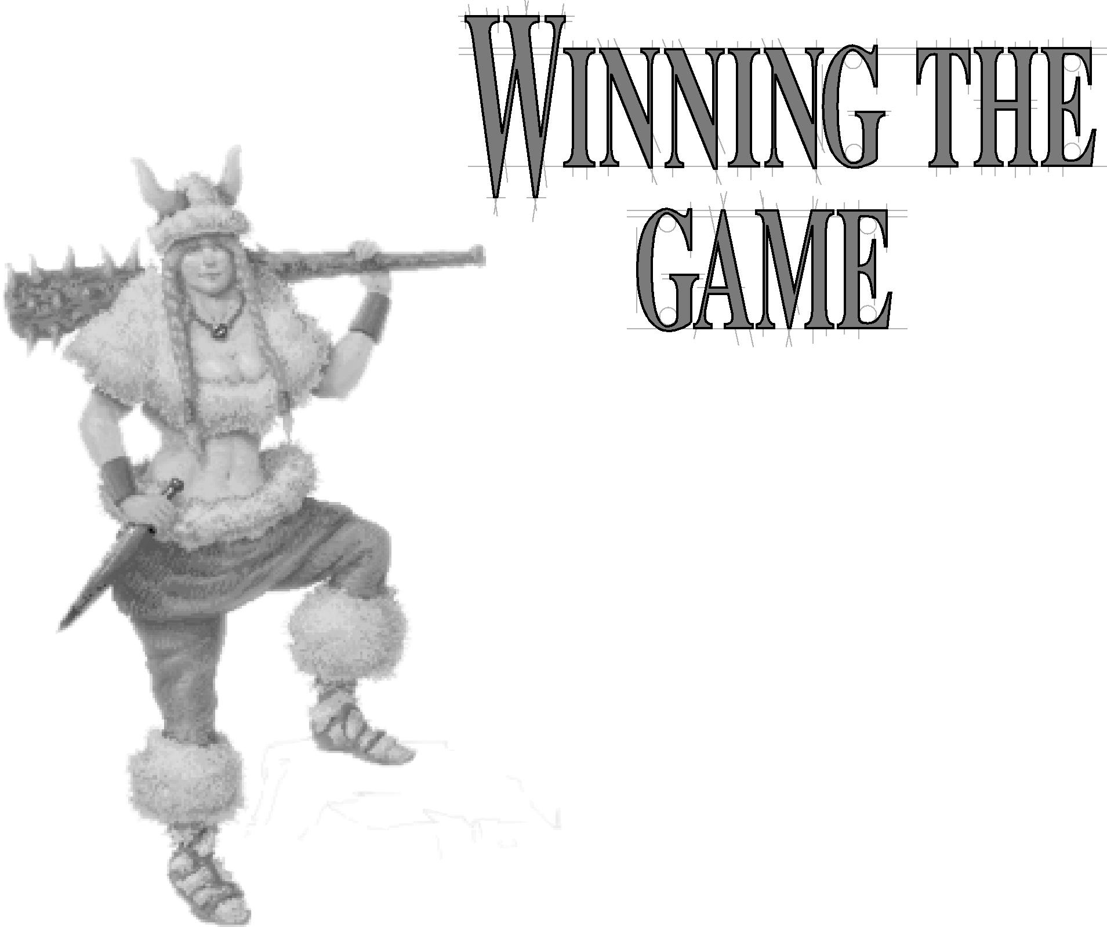As we explained in the Introduction, there are two ways to win
  
***Civilization II***. You can either beat the other civilizations into space by being
  
the first to successfully colonize a distant system, or conquer all the other

WINNING
  
THE GAME

**131**

civilizations in the game.

**THE SPACE RACE**

The environmental pressures of growing populations in the modern world are forcing humans to look into space for resources and room to live. The question is not whether humans will travel to the stars, but when. The final act of stewardship you can perform for your civilization

is to ensure that they lead this exodus.

The history of your civilization ends when either you or one of your rivals reaches a nearby star system with colonists. If your spaceship is the first to arrive, you receive a bonus to your civilization score in recognition

of this final accomplishment. Regardless of how many colonists your spaceship is carrying or how fast it is, if a

rival makes planetfall first, you receive no bonus.

No civilization can undertake spaceship component construction until one civilization has built the Apollo Program Wonder. Thereafter, the race is on and any civilization that has acquired the necessary advances can begin building the parts of a spaceship.

Spaceships are in many ways a one-shot deal. Each civilization, including yours, can build only one spaceship at a time. Restrictions prevent you from building a second, back­up ship once you launch the first. Once launched, ships cannot be recalled or turned around. You can construct a second spaceship only if your current ship explodes in space or if your capital city is captured while your spaceship is under construction (the conquerors burn it on the launch pad).

**132**

**SPACESHIPS**

The purpose of your spaceship is to carry as many colonists as possible to another star system. At a minimum, it must provide living space for colonists, life support, energy sources, propulsion power, and fuel for the engines. Spending more time constructing additional components can result in a faster voyage and a higher colonist survival rate.

As each new component is completed, the SPACESHIP display appears, showing where the component is positioned and updating the statistics and specifications. All spaceships have the same characteristics: population, food, energy, mass, fuel, flight time, and probability of success. We’ll explain each in turn.

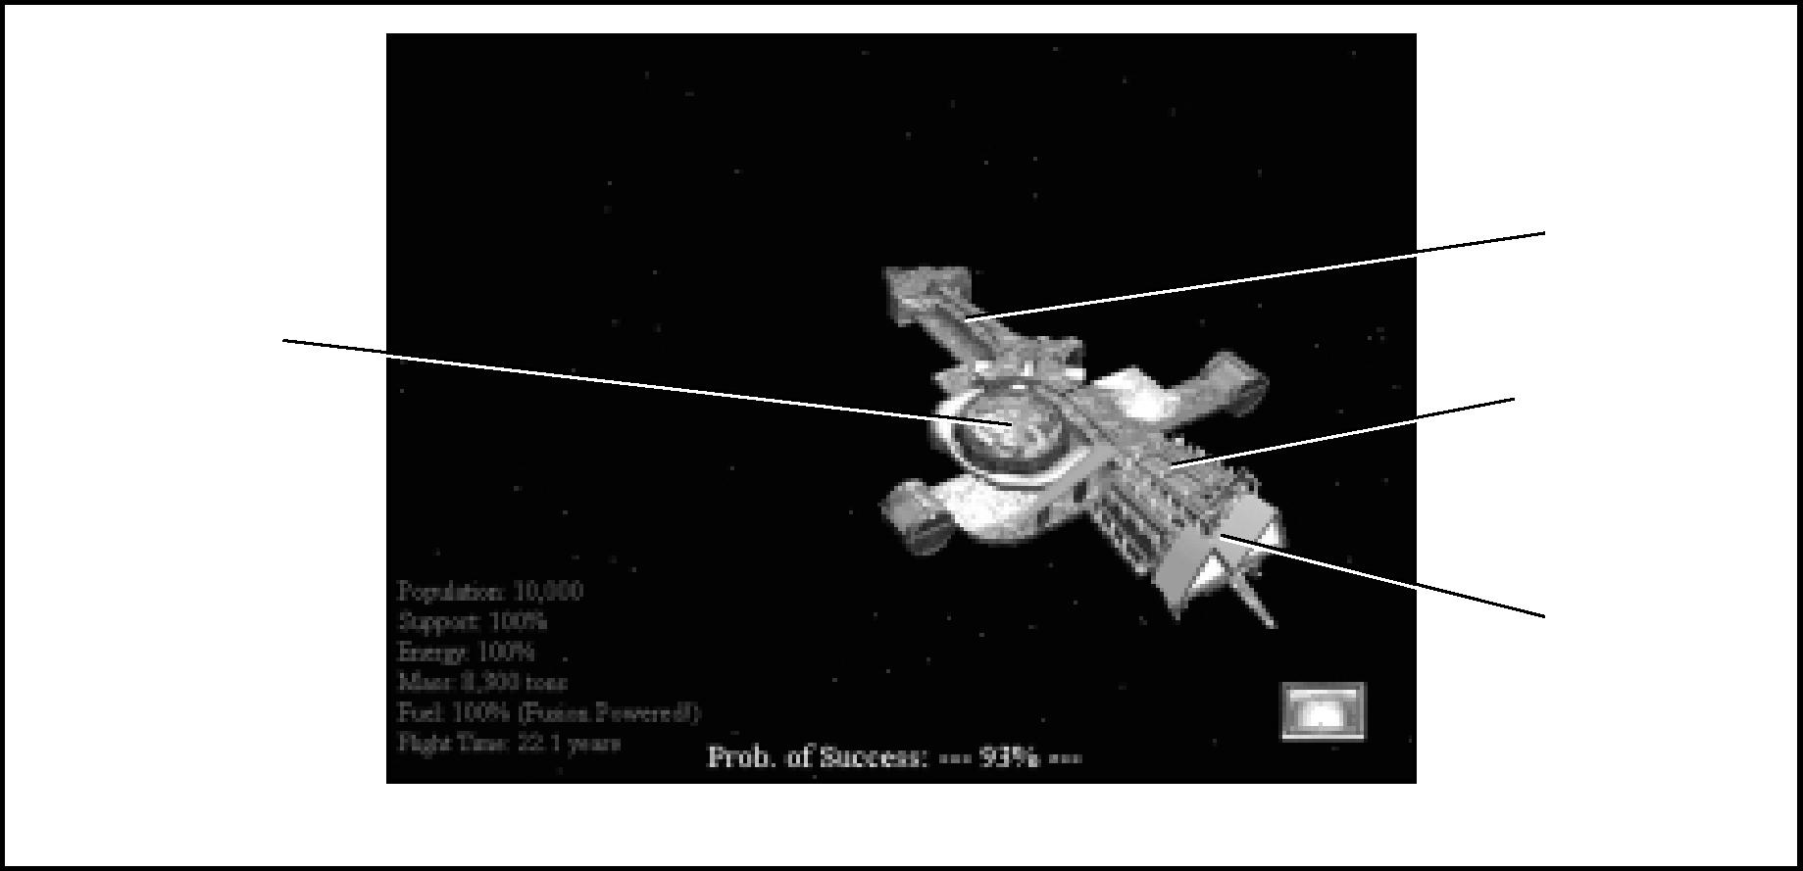

Habitat Module

*Your Spaceship*

Fuel Component

Structural Component

Propulsion Component

**POPULATION**

**133**

This figure represents the number of pioneers the spaceship is outfitted to carry. The more citizens it carries to the new planet, the higher your bonus.

**SUPPORT**

This figure shows what percentage of accommodations on the ship is currently serviced by life support: air, nutrient, and waste systems. Pioneers not provided with life support cannot survive the voyage.

**ENERGY**

This figure indicates what percentage of the energy required by habitation and life support modules is currently being provided. If sufficient energy is not available to power life support and habitation, the probability of success will be very low.

**MASS**

WINNING
  
THE GAME

All of the components, modules, and structures add to the mass of your spaceship. The greater the mass, the more power is required from propulsion parts to move it.

**FUEL**

This figure indicates what percentage of the fuel your propulsion units require is currently aboard. If insufficient fuel is provided, the propulsion components aboard cannot work to their maximum power and the ship cannot attain its best possible speed.

**FLIGHT TIME**

This calculation indicates the number of years required for your spaceship to reach the nearest star, based on the ship’s current mass and engine power. Adding more engines and fuel reduces flight time.

**PROBABILITY OF SUCCESS**

This figure incorporates all the other data (including the amount of food and energy available and the estimated flight time) in an estimate of the approximate percentage of colonists who are expected to survive the voyage. The faster the flight, the higher the expected survival rate.

**SPACE SHIP LAUNCH**

**134**

To send your spaceship on its voyage, click on the LAUNCH button. You cannot retrieve a spaceship once it has been launched.

**CONSTRUCTION**

Your spaceship is such a large undertaking that it cannot be built whole cloth the way improvements are built—it is, instead, constructed of parts. There are three types of spaceship parts: components, modules, and structures, each of which we describe in detail below. You must achieve a new civilization advance to make each type of part available for construction. However, the delivery of spaceship parts to your capital city is handled automatically as each part is completed.

Though you can construct parts in any order, and most likely will have multiple parts under production simultaneously, all modules and components must eventually be connected to structural parts if you want them to function. Unconnected modules or components are emphasized to signal that they are not working. Once sufficient structural parts have been added to provide supply and support lines, the problem disappears.

**COMPONENTS**

To build spaceship components you must have achieved the technological advance of PLASTICS. You can then build components at a cost of 160 shields each. There are two kinds of components, propulsion and fuel. As each component is completed, you choose which type has been built.

**Propulsion Components:** These parts are the engines that provide the power for space flight. More engines mean the ship travels faster, reaches its destination sooner, and has a higher probability of a successful mission.

**Fuel Components:** These parts provide fuel for the propulsion units. In order for the propulsion units to perform at maximum levels, you must provide one fuel component for each propulsion component.

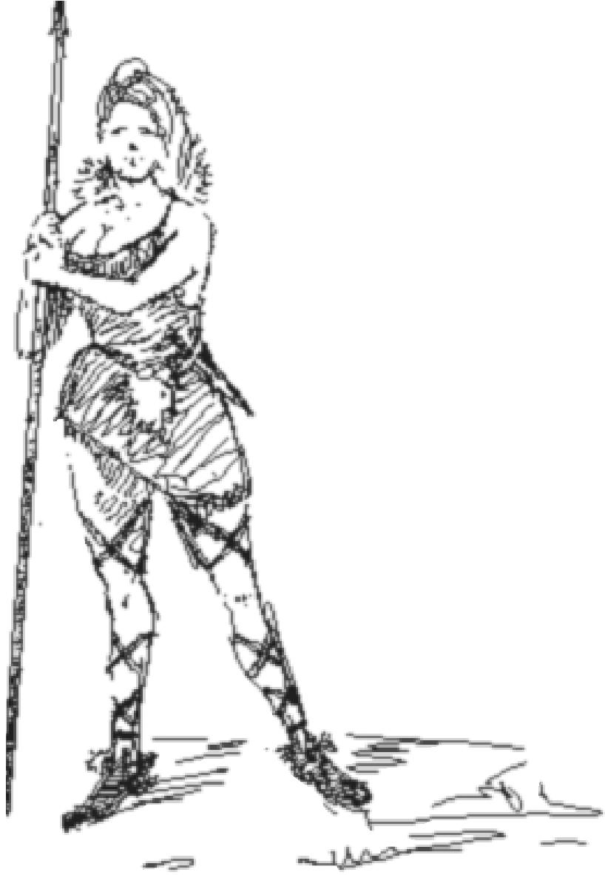**MODULES**

**135**

Spaceship modules require the advance of Superconductor and cost 320 shields each to build. They exist in three types: habitation, life support, and solar panels. As each module is completed, you choose which type it is and add it to your ship.

**Habitation Module:** Each habitation module provides living space, community services, and recreational facilities for 10,000 colonists.

**Life Support Module:** Each life support module provides the food and other requirements for the 10,000 colonists carried in one habitation module. Colonists carried in a habitation module that doesn’t receive life support have a very low probability of surviving.

**Solar Panel Module:** Each solar panel module provides enough energy to power two of the other types of module. Modules that don’t receive power cannot function properly.

**STRUCTURAL SUPPORT**

WINNING
  
THE GAME

Structural units require the advance of Space Flight and cost 80 shields each to build. You must build sufficient structural units to connect the components and modules together. Parts that are not connected do not work and provide no benefit to the ship.

**CONQUERING THE WORLD**

When striving to win this way, aggressiveness helps. Your object is to take over any and all rival civilizations. Note that if you vanquish other civilizations early enough in the game, some new tribe might develop a Settlers unit and found a civilization using the color originally assigned to the vanquished culture. In this way, some civilizations “re-start.” Eventually, if you’re lucky, you might be able to subjugate the entire world. If at any time you control the only settled civilization, you win, and the End Game sequence proclaims you the ruler of the world.

**BLOODLUST OPTION**

If you prefer to eschew space exploration altogether, you can choose an optional rule at the initial setup of the game that disables the

spaceship building sequences. Although you can still achieve,

say, the Space Flight and Plastics advances, the spaceship parts remain grayed out on any menus on which they appear, and you remain planetbound. Thus, your only possible method of victory is total world domination.

**SCORING**

Completing a ***Civilization II*** game can take many hours, especially if you are playing at one of the tougher levels of competition. There are several ways to get a general idea of how you’re doing along the way.

**THRONE ROOM**

As your civilization achieves certain milestones, some of which are keyed to numbers and sizes of cities, attitude of population, and civilization advances, your citizens spontaneously show their approval — first by building and subsequently by offering to make additions to your THRONE ROOM. Periodic reports notify you of these events.

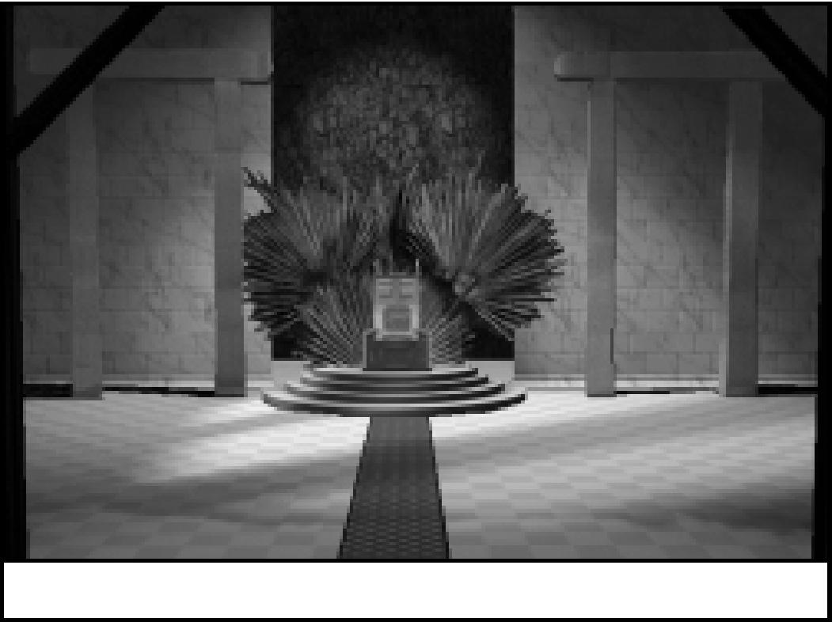

*A typical throne room*

Do you have to take the time to direct the additions to your throne room? No. If you choose to, you can completely ignore it with no repercussions. Turn off THRONE ROOM on the GRAPHICS OPTIONS menu, and

you won’t even know it’s there.

However if, like most of us, you enjoy making improvements to your seat of power, click once to see the schematic overlay. The colored elements of the

overlay represent areas that you can

**136**

change. Each element has four different looks, representing the increasing decorative sophistication of your people. Once you have indulged your tastes in interior decor to their fullest, your people update the various *objects d’art* scattered about your chamber. You can view the current state of your throne room at any time by selecting the VIEW THRONE ROOM option from the VIEW menu.

**DEMOGRAPHICS**

**137**

This option, available on the WORLD menu, provides a number of real world statistics about your civilization’s health, growth, economic, and military status. Each measure shows both an actual value and your rank among the world’s civilizations. If you have established an embassy with the nation that is top-ranked in a particular measure, your rival’s achievement is listed along with your own ranking. You can use the DEMOGRAPHICS report to compare your performance with that of your rivals and to determine what areas of your civilization need the most immediate attention.

**CIVILIZATION SCORE**

|  |  |  |
| --- | --- | --- |
|  | If you’re the type who prefers the concreteness of numbers, choose the  CIVILIZATION SCORE option from the WORLD  menu for a numerical representation of your progress. ***Civilization II*** keeps a running total of the points you’ve earned for population size and various achievements. It also keeps track of penalties for pollution and other negatives. This chart covers basic scoring: |  |
| WINNING  THE GAME |
|  |  |

Each happy citizen 2

**CONDITION POINTS SCORED**

**138**

Each content citizen 1

Each Wonder of the World that you possess 20

Each turn of world peace (no wars or combat) 3

Each futuristic advance 5

Each map square currently polluted -10

When you reach the end of the game (in 2020 AD), this total becomes the basis of your score. However, the level of barbarian aggression you chose affects the final tally. The lowest level of activity (none) results in -50 points, the next higher level -25, and the normal level causes no change. Playing at the highest level of barbarian villainy adds 50 points to your final score.

The basic scoring goal — a challenging one — is to score 1,000 points or more. Of course, there are ways to score even higher, but they involve winning the game before time runs out.

If you conquer the world before the last year of the game (2020 AD), ***Civilization II*** calculates an alternate score, based on the number of rivals you’ve squelched and the speed with which you moved. You can earn up to 1,000 points for conquered cultures, and nearly as much for speed. ***Civilization II*** compares this alternate score to your running total and awards you the higher point value of the two.

If you successfully settle the stars, you earn a bonus based on the number of colonists to reach Alpha Centauri. This bonus is added to your running total score when you complete your mission.

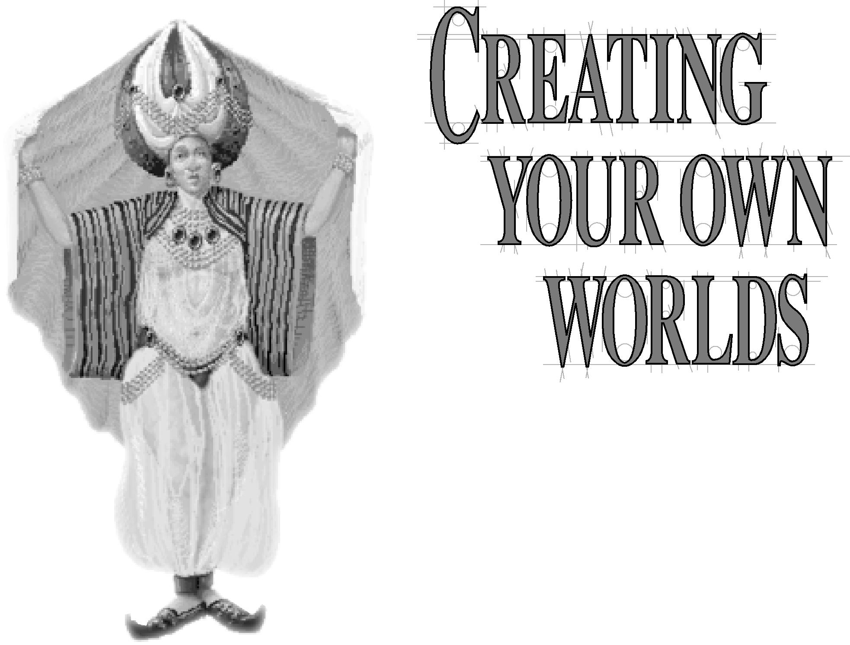***Civilization II*** offers a number of options to keep the worlds you civilize fresh. Undoubtedly, the most powerful of these is the MAP EDITOR. With this tool, you can create your own worlds, determine the size and shape of the

CREATING YOUR
  
OWN WORLDS

**139**

continents, the type and extent of the terrain, and the starting locations of all

the civilizations in the game.

You can literally create any world you like. However, it is possible for a

custom-drawn map to violate the map conventions that ***Civilization II*** needs

to run a successful game. Therefore, it is important that you, as map designer,

include a sufficient combination of Plains and Grassland squares for every civilization to have at least one potential city site. The world also must have at least one ocean and preferably more than one continent. An “illegal” map will lower the quality of your game by forcing your computer opponents to play at a significant disadvantage — and hence pose a much less interesting challenge.

To begin using the MAP EDITOR, double-click the MAP EDITOR icon in the Windows program group to which you assigned ***Civilization II***. Once you’re in the program, you have a couple of screens, a tool box, and a few menus that let you create your own worlds. Each of these components is described below.

**YOUR TOOLS**

**140**

The main features of the MAP EDITOR are the TOOLBAR and three display areas: the MAP, WORLD, and STATUS windows. In brief, the TOOLBOX holds your terrain type “brushes,” the tools you use to place squares into the MAP window. The WORLD window allows you to quickly center the MAP window around any place on the planet you’re creating. The STATUS window shows you the brush you are currently using, its position in the MAP window, and the dimensions of the map.

**THE TOOLBOX**

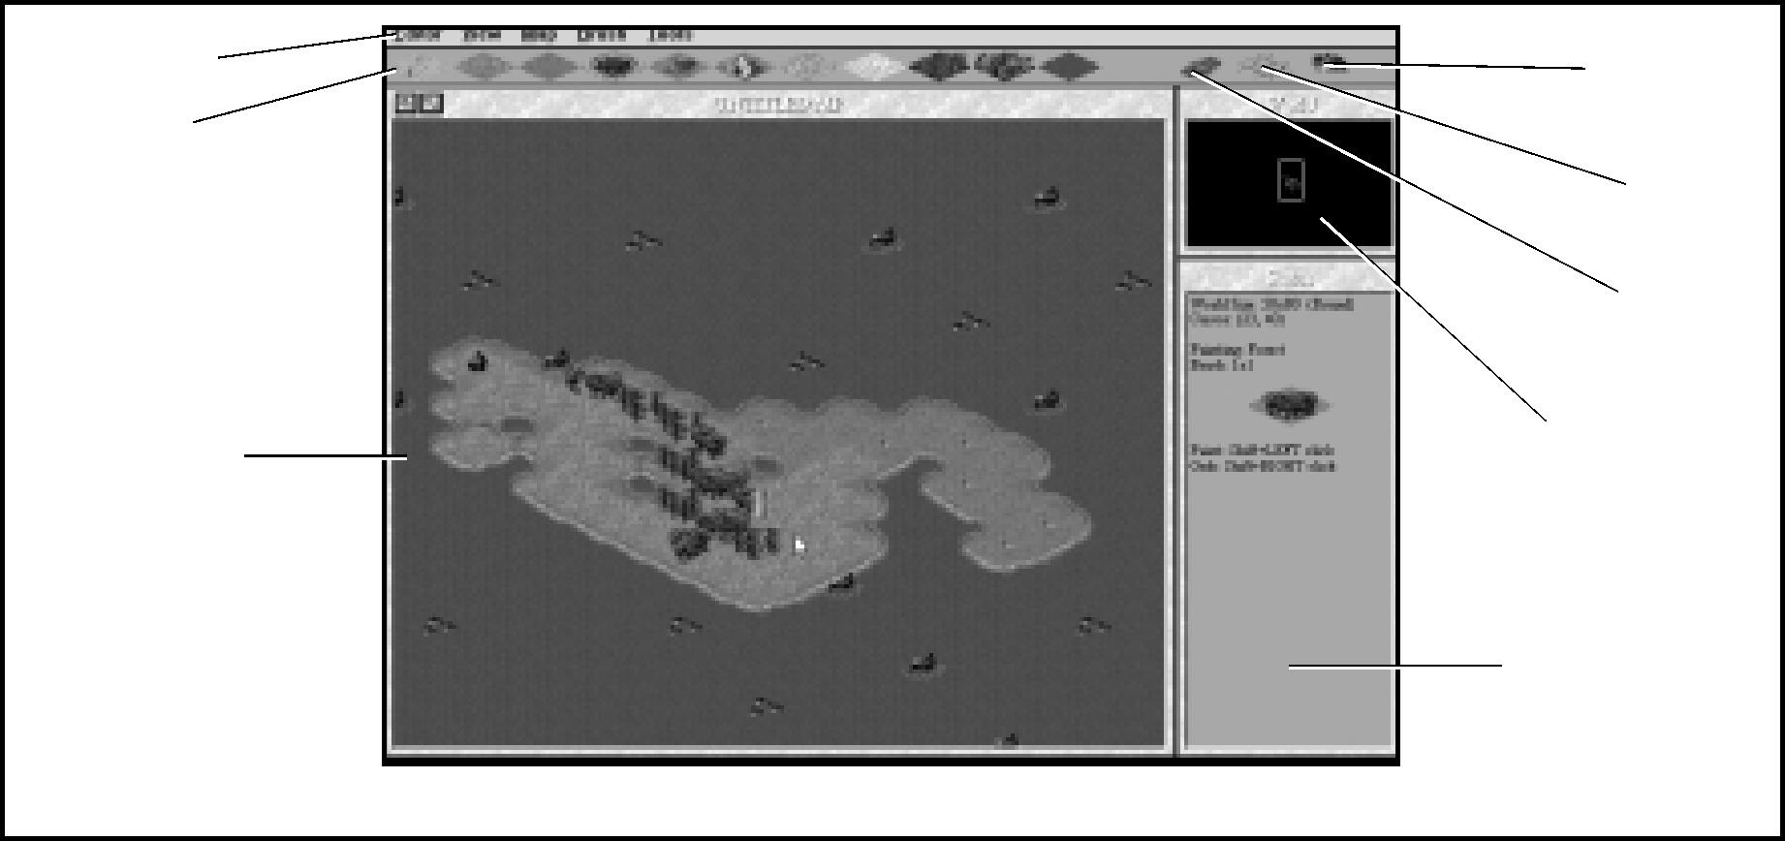

Menu Bar ToolBar

Map Window

*The Map Editor*

Status window

World Map

Special

City River

The TOOLBOX contains all the basic types of terrain available in ***Civilization II,*** plus three special icons: River, City, and Special. When you select one of these icons, it becomes your brush, and you can then use the brush cursor to place that terrain (or river or city) onto the world. When you use the CITY icon, you can set the starting locations for some or all of the game civilizations.

**Placing Terrain**: Click on the terrain type you want to “load” your brush. Then, hold down the *s* key and click anywhere on the map (even atop existing terrain) to place that type of terrain square there. To place larger areas, you can choose a larger brush size (see below) or drag the cursor while you hold down both the *s* key and the left mouse button.

**141**

**Placing Rivers:** To place rivers onto the map, first click the RIVER icon. Once your brush is “loaded,” you can lay rivers in the same way as you do terrain. Note that you can also *remove* rivers by holding down the *s* key and right-clicking on a location. You can *s*-right-click-and-drag to remove a long length of river.

**Placing Starting Locations:** To place a city square on the map, click the CITY icon. When your brush has thus been loaded, you can place cities in the same way as you do terrain or rivers. As soon as you place a city, you are prompted to choose which civilization will start at that location when the game begins. Civilizations that already have starting locations are noted in parentheses. Note that you can *remove* a city by holding down the *s* key and right-clicking on a location, or simply by placing that civilization in a different location. If you place starting locations for some civilizations but not others, ***Civilization II*** will decide where to place the unassigned ones. When you load a map you have created (to use in a game), you will always have the option to ignore the pre-set city locations and use random locations instead.

**Multi-terrain Brushes:** You might find it convenient to paint your map with a brush that contains more than one type of terrain. To do so, you use the Special brush, which operates like the cut-and-paste functions of many applications. First, lay down an area of terrain squares on the map that is exactly the size and the types that you wish to have fill your brush. Next, select a multi-square brush of the same size as this area (multi-square brushes are described below). Click the Special icon on the TOOLBOX. Finally, hold down the *s* key and right-click on the terrain area (you can use any existing map section). This “grabs” that terrain and uses it to fill your brush. Click anywhere with the brush to place an area of terrain that is an exact copy of the area you “grabbed.”

CREATING YOUR
  
OWN WORLDS

**MAP WINDOW**

**142**

The MAP window is the one you’ll use the most, the one in which you actually place terrain squares. This is where you build your world. Clicking anywhere in this window centers the map at the location you clicked (the cursor location). The MAP window can also be sized, like most windows; click-and-drag a side or corner of the frame to the dimensions you like. A large MAP window is most useful for creating detailed continents.

To paint using the current brush, hold down the 3nift key while you click or click-and-drag.

To remove rivers or cities from squares, hold down the shift key and right-click.

If the current cursor location is a basic terrain, without a city or river, you can select that type of terrain as your brush without recourse to the TOOLBOX. Hold the 3hi@ key and right-click on the spot.

**WORLD WINDOW**

This window shows the entire map of your world in miniature. Click anywhere in the WORLD window to center the MAP window on the spot you clicked.

**STATUS WINDOW**

The STATUS window is a convenient quick reference. It shows the dimensions of your map, the current cursor location, and the current brush.

**THE MENUS**

The MENU BAR (along the top of the screen) provides access to the following menus. Each option on each menu is described briefly.

**EDITOR MENU**

This menu contains options for loading and saving maps.

**New Map:** This option creates a new, blank map into which you can place terrain.

**Load Map:** This option allows you to load a previously created map. This can be a map you have made or one from a saved game.

**Save Map:** This option allows you save the map you are currently editing. If you have not already named it, you will be prompted for a name.

**Save Map As:** This option allows you to save the current map under a new name. **Quit:** Choose this option to stop using the MAP EDITOR and return to Windows.

**VIEW MENU**

**143**

This menu contains options that let you adjust the amount of detail you see and the location of your windows.

**Zoom In** Z**:** This option enlarges the view by one level, lessening the amount of the world you can see.

**Zoom Out** X**:** This option constricts the view one level, increasing the amount of area you see.

**Max Zoom In** (  **Ctri**) Z)**:** This option zooms the view in to maximum magnification. **Standard Zoom** (3hift Z)**:** This option resets the zoom to the default level.

**Medium Zoom Out** ( shift X)**:** This option sets the zoom at a level roughly midway between the default and the maximum.

**Max Zoom Out** (  **Ctri**) X)**:** This option zooms the view out to see the maximum area.

**Arrange Windows:** This option cleans up the desktop, returning the windows to their starting configuration.

**Center View** C**:** This option centers the MAP window on the current cursor location.

**MAP MENU**

This menu contains options to get your map started, to check your map when it’s done, and to help you recover from mistakes.

**Generate Random Map** R**:** This option creates a world in the same way as the map generator does when you start a new game. You will be asked all the world customization questions that ***Civilization II*** normally asks.

CREATING YOUR
  
OWN WORLDS

**Generate Blank Map** B**:** Choose this option to generate an ocean world, a map filled with water, as your blank canvas.

**Set World Shape** H**:** This option allows you to select a flat or round world, which determines whether or not units will be able to cross from the western edge of the map to the eastern (think of it as the International Date Line, if you will), and back.

**Analyze Map** N**:** This option searches for potential problem areas in your map. This is especially useful for avoiding “illegal” maps.

**Undo Last Change** U**:** This option cancels the last edit you made to your world.

**BRUSH MENU**

**144**

The items in this menu allow you to change the characteristics of the brush you use to insert terrain on your map. The brush can be various sizes and shapes, giving you the flexibility to quickly and easily create the worlds you want.

**1x1** K]**:** This option sets the size of the brush to a single terrain square.

**3x3** 2**:** This option gives you a brush that is 3 squares by 3 squares (it looks like a 3x3 diamond). Selecting a terrain type from the TOOLBOX to use with this brush allows you to create 3x3 blocks of that terrain type.

**5x5** a]**:** This option sets the brush size to 5 squares by 5 squares.

**Cross** H]**:** This option gives you a cross-shaped brush to work with. This brush is the same as the 3x3 brush, but with the top, bottom, and side squares (all four corners) lopped off.

**City Radius** a]**:** This option allows you to paint with a brush the same shape as a CITY

RADIUS.

**TOOLS MENU**

The tools in this menu add some special controls to fine-tune your map building.

**Coastline Protect** [p)**:** This option locks all ocean squares into place, allowing no changes to oceans until you toggle the option off again. This makes it easy to fill in terrain without worrying about overwriting oceans and changing your coastline by mistake.

*Warning:* If you start a new map (containing only ocean) and you have COASTLINE PROTECT turned on, you will not be able to paint any terrain onto your world. Be sure this option is turned off when you start a new map.

**Autoscroll During Paint** A**:** When turned on, this option causes the MAP window to automatically scroll in an attempt to follow your brush (the cursor) as you paint. This might slow the program significantly on some computer systems.

**Set Resource Seed** S**:** The pattern of SPECIAL RESOURCES that is scattered over the map is determined (in a manner too complex to describe here) by a number generated when the game creates a map. The MAP EDITOR allows you to set this number and see its effects immediately. You do this by simply entering any number you choose into this option’s dialog box. Click OK to see the effects of your number.

If you set the value to “1,” the pattern of resources will be random. (Note that, even if you set a number other than “1,” when you load this map to use in a game, you are still given the option of using a random pattern.)

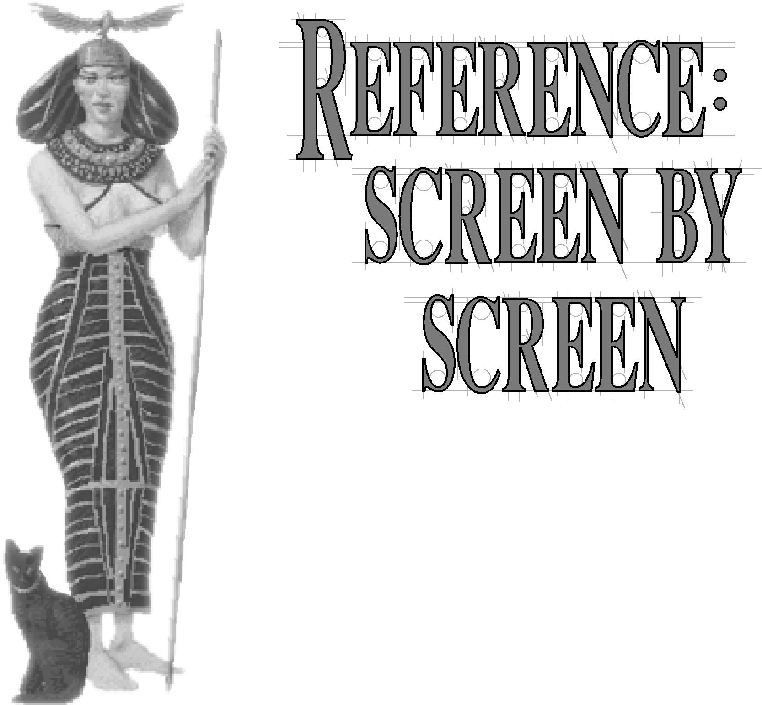This section details each of the menus and major screens in the game and the parts and options of each. Refer to the body of the manual for the whys and wherefores (all we’re discussing here is the how-to). The screens are covered alphabetically, for ease of reference.

**145**

**THE CITY DISPLAY**

You can direct the operation of each city from the CITY DISPLAY. Here, you assign citizens to work in the surrounding fields, mines, forests, and fishing grounds. This display collects in one place all the critical information concerning the pictured city’s status, including how many shields it produces; how much food and trade income it is

REFERENCE: SCREEN
  
BY SCREEN

generating; what it is producing and how close the item is to completion; the happiness of the population; who is defending the city; and what improvements you’ve already built.

You can open the CITY DISPLAY in many ways.

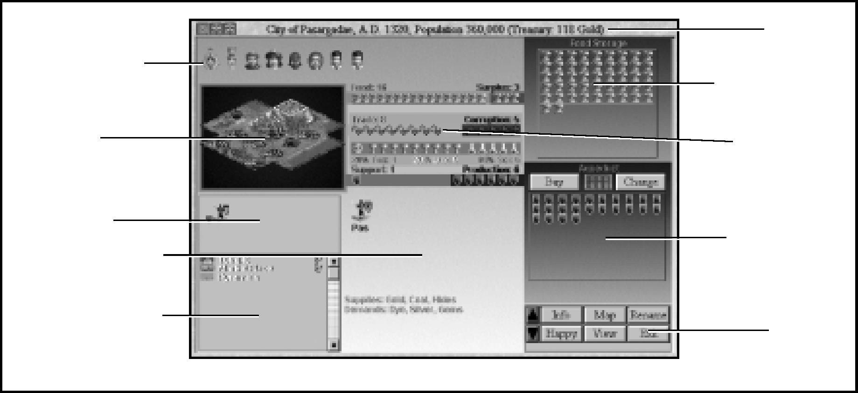

General Information Roster

Population Roster

Resource Map

Unit Roster

Improvement Roster

*The City Display*

Food Storage Box

Production Box

Resource Bars

Title Bar

Buttons

**146**

* Position the cursor over a city in the MAP window, then click on that city.
* Pull down the KINGDOM menu and choose FIND CITY, then select the city you want.
* Position the cursor or the current active unit on a city, then press Enter .
* Double-click on any city name in the CITY STATUS report.
* Double-click on any city name in the ATTITUDE ADVISOR’s report.

You can close the CITY DISPLAY by clicking the EXIT button or the button in the top

left-hand corner of the window. If you have the ENTER KEY CLOSES CITY SCREEN option (one of the GAME OPTIONS accessible through the GAME menu) enabled, you can just press Enter .

***Civilization II*** has a CITY DISPLAY that is similar to, but not the same as, those in past ***Civilization*** games. Those of you familiar with ***Civilization*** or ***CivNet*** should take the time to learn the differences. We’ll discuss each section of the display in turn.

Two important new features are the ZOOM buttons in the top left-hand corner of the window frame. You can click on to contract the CITY DISPLAY and to expand it again.





**TITLE BAR**

Along the top of the display is the TITLE BAR. The name of the city, the current date, the total population of this city, and the amount you have in your treasury are noted here.

**POPULATION ROSTER**

Near the top of the display are icons representing the city’s population. Each citizen icon in the POPULATION ROSTER represents one population point. (Note that each population point represents a different number of citizens as the game progresses; the actual population is listed in the TITLE BAR.) In addition to the usual workers, a city can support three different types of Specialists.

Citizen icons can be happy, content, unhappy or very unhappy. If the number of unhappy people exceeds the number of happy people (with content people and Specialists ignored), that city goes into civil disorder (see **Civil Disorder** for details).

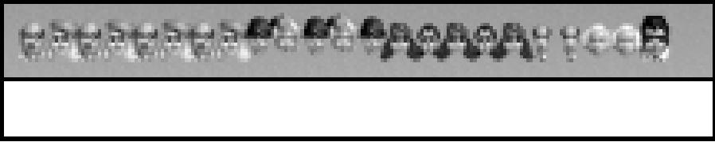

*Population Roster*

SPECIALISTS

**147**

Citizens who are not working in the city radius are Specialists. For an example, click on a productive city radius square; the workers there become Entertainers (one citizen in the POPULATION ROSTER is replaced by an entertainer icon). Specialists no longer directly contribute to the resources a city generates. However, they might be useful in adjusting the amount of luxuries, taxes, and research the city generates. Specialists do consume food like other citizens. There are three types of Specialists: Entertainers, Scientists, and Taxmen. Cities must have a population base of five or more to support Taxmen

or Scientists.

|  |  |  |  |
| --- | --- | --- | --- |
|  | | **Entertainers:** Citizens removed from the work force immediately become Entertainers. Each Entertainer adds two Luxury icons to the tally in the APPORTIONMENT bar. These additional luxuries are added before the effects of improvements such as Marketplaces and Banks are calculated. Creating Entertainers has the result of creating more luxuries, thus making more citizens happy. | REFERENCE: SCREEN  BY SCREEN |
| *“The King”* |  |  |
|  |  |  |  |

**Taxmen:** Click on an Entertainer icon in the POPULATION ROSTER to put him to work as a Taxman. Each Taxman adds three Tax icons to the APPORTIONMENT bar (instead of the two Luxuries the Entertainer used to generate). No tax collection is made if a city is in civil disorder (see **Civil Disorder** for details).

**148**

**Scientists:** Click on a Taxman icon to create a Scientist. Each Scientist adds three Science icons to the total in the APPORTIONMENT bar (instead of the taxes the Taxman used to generate). This additional research is added before the effects of improvements such as Libraries and Universities are calculated. As with Taxmen, Scientists are only useful if your city is not in civil disorder.

Click on a Scientist icon to return it to Entertainer status.

|  |  |  |  |
| --- | --- | --- | --- |
| **FOOD STORAGE BOX**  Any surplus food generated by your city each turn accumulates in this box. The capacity of the box expands as the city’s population increases. When the box overflows, your city’s population grows by one point, and a new citizen is added to the POPULATION ROSTER. The FOOD STORAGE BOX empties and begins to fill again the next turn.  If one of your cities is not producing enough food to feed its population, the shortage is subtracted from the reserve in the FOOD STORAGE BOX. If the box is empty and the city still has a food shortfall, any Settlers or Engineer units which draw food from its stores are disbanded, one per turn, until the shortfall is corrected. If there are no settlers or Engineers, or if a shortfall still exists after they are lost, the city loses one point of population, each turn to starvation, until an equilibrium is reached.  The Granary improvement has the effect of speeding population growth. When a city has a Granary, the FOOD STORAGE BOX only half empties when it overflows and creates more people. The box empties only to the granary line. |  | | |
|  | *Food Storage box* |  |
|  |  |  |

**THE RESOURCE BARS**

**149**

The RESOURCE bars compile all the resources generated by the city’s workers each turn. Food, shields, and trade goods are collected each turn from the CITY RADIUS squares being worked by citizens. The amount of any particular resource collected might be modified by the presence of a certain improvement in the city, the form of government you choose, or by your ownership of a certain Wonder (see **City Improvements** for details).

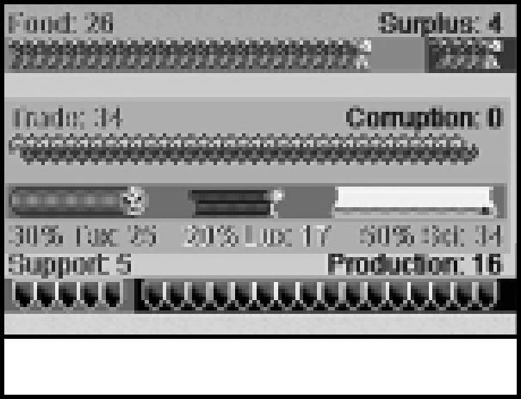

*Resource Bars*

FOOD

The top bar represents the state of the city’s food harvest each turn. Each population point (citizen icon) in your city consumes two units of food each turn. Also, some units consume food as part of their support needs. Any surplus or shortfall is noted on the right side of the bar. Excess accumulates in the FOOD STORAGE BOX.

TRADE

The center area contains the TRADE bar and the APPORTIONMENT bar. Together, these represent the state and disbursal of the city’s trade income each turn. The TRADE bar lists the total trade goods produced on the left, including any derived from TRADE routes. Depending on your type of government and each city’s distance from your capital, some portion of the arrow icons might be lost as corruption; this is noted on the right side of the bar.

The APPORTIONMENT bar notes how the income from these trade goods is divided into taxes (gold), luxuries (goblets), and research funding (beakers). These numbers depend on your trade rates (see **Kingdom Menu** for details) and the assignment of the city’s Specialists. The apportionment is figured after the losses to corruption have been subtracted.

SHIELDS

The bottom bar represents the state of the city’s production each turn. Depending on the form of government under which your civilization operates, some of the shield icons generated each turn might be required to maintain units that a city has previously built. Support requirements are noted on the left side of the bar. Any production capacity lost to waste is noted in the center of the bar. Production is indicated on the right side of the bar and accumulates toward what the city is building in the PRODUCTION BOX.

REFERENCE: SCREEN
  
BY SCREEN

If the city’s industrial capacity is not sufficient to maintain the existing units, the shortage is indicated. If your turn ends and there is such a shortage, enough units are disbanded to make up the difference, beginning with the ones farthest from the city.

**RESOURCE MAP**

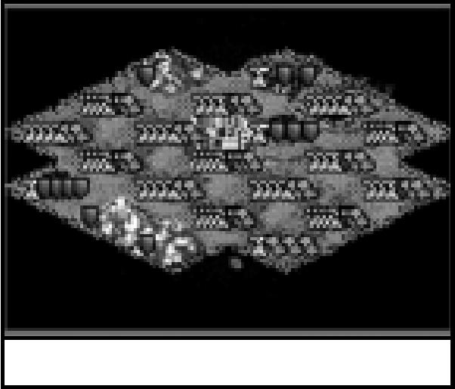

*Resource Map*

Immediately below the POPULATION ROSTER is a detail map showing all of the discovered terrain squares within a city’s radius. The city square itself is always under production. For each population point (each citizen in the roster), you can work one additional square. The maximum number of squares a city can work is the number of citizens plus one or twenty-one, whichever is smaller. Note that it is possible to have more citizens than there are squares to work.

Depending on the type of terrain in a map square, citizens working there can produce food, production shields, and/or trade goods. Most squares produce a combination of several resources. Clicking on any square under production (except the city square, which remains permanently under production) temporarily takes that citizen off work. Click on an unoccupied square to put the citizen back to work in a new place. You can move people from one square to another however you wish to change the mix of resources the city is harvesting. Citizens removed from work are temporarily converted into Specialists.

When the city population increases, each new citizen is automatically assigned an area to develop. You might want to review the map of a city that has just increased in size to be certain that workers have been placed as you wish.

**PRODUCTION BOX**

**150**

Below your FOOD STORAGE BOX is the PRODUCTION BOX. Any production (shield icons) generated by your city each turn accumulates in this box. The capacity of the PRODUCTION BOX changes to reflect the cost of the unit, improvement, or Wonder currently under construction. When the box is full, the item is complete. The box empties, and the new item is ready for use. The item being built is noted at the top. The items available for building depend on the advances your civilization has achieved.

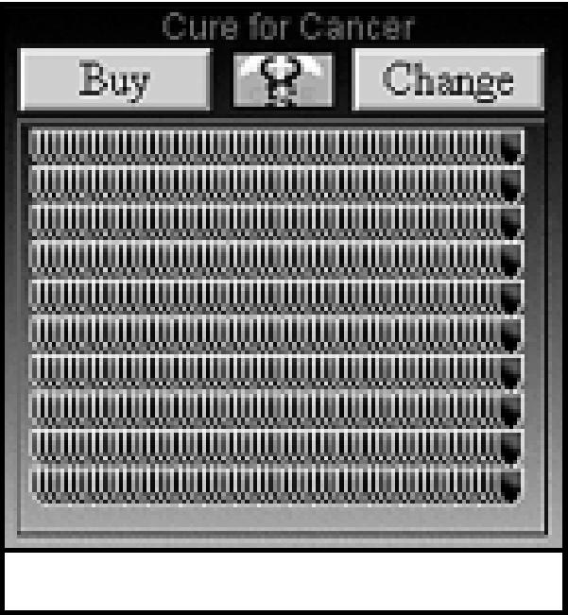

*Production Box*

When the discovery of a new advance makes available a unit that supercedes units currently being built, your production is automatically upgraded to the new unit. If you are building a Wonder and another civilization completes it before you can, you are reminded that you must change production in that location.

Some Wonders on the PRODUCTION menu might be marked with an asterisk (*) before their name. This indicates that the Wonder’s special ability has been made obsolete by someone’s discovery (not necessarily yours) of the terminating advance. You may still build obsolete Wonders to gain points toward your final score (see **Scoring** for details).

**151**

CHANGE

You can use the CHANGE button to switch production to another item at any time before the production of the existing item is completed. If you have already accumulated sufficient shields to construct the new item, any excess is lost, and the item is immediately completed. Otherwise, the accumulated shield icons roll over toward the new item. Note, however, that changing the production assignment often results in a significant loss of efficiency, which is reflected as a loss of accumulated shields.

This button changes to AUTO OFF if you set the city to automatic production mode. BUY

You can speed the completion of an item by clicking the BUY button. A dialog box shows how large a cash outlay the rush job requires (see Rush Jobs for why you might choose this option). If you have sufficient funds in your treasury, you are given the option to buy the item outright.

PRODUCTION MENU BUTTON

These buttons are not in the PRODUCTION BOX, but rather on the PRODUCTION menu from which you choose the next item you wish constructed.

**Auto:** This button allows you to hand the city’s production choices off to your advisors (you get to choose the Military Advisor, the Domestic Advisor, or both) each option causes your cities to be run using a different philosophy). The game automatically decides what to build next after each item is completed. To take back the responsibility for these decisions, click the AUTO OFF button in the PRODUCTION BOX.

**Help:** The Help button calls up the CIVILOPEDIA entry for whatever item is highlighted.

**Cheat:** When the CHEAT menu is enabled this button allows you to select a unit improvement or Wonder from the PRODUCTION menu and build it instantaneously, without interrupting your regular production in any way.

REFERENCE: SCREEN
  
BY SCREEN

**UNIT ROSTER**

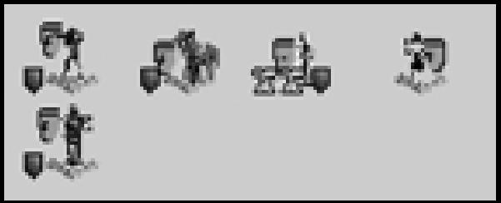

*Unit Roster*

**152**

Below the RESOURCE MAP is the UNIT ROSTER. This shows all of the units that call this city home. The status of each unit (fortified, veteran, or whatever) is indicated on the unit’s shield . Food and shield icons below these units indicate any resources required by each as support. The amount and type of support that units need depends on your civilization’s chosen form of government (see **Types of Government**). Additionally, if your civilization operates a Democracy or a Republic, armies on foreign duty whose absence is causing unhappiness are noted. If the city does not generate enough resources to maintain all of the supported units, units left unsupported are disbanded, beginning with those farthest from the city. Click on any unit icon for its exact location. The SUPPORTED UNIT INFORMATION window that opens also gives you a few useful options:

* No changes
* Center map on unit
* Center map on unit and close city screen
* Order unit to return home
* Disband Unit

These are all exactly what they sound like.

**IMPROVEMENT ROSTER**

Below the UNIT ROSTER is a list of all of the existing improvements and Wonders of the World in the city. Each entry in the list includes the item’s icon and name. If the improvement is one you can sell, there is a gold icon next to the listing. Click on the listing to sell the improvement. (You can not sell Wonders.) Improvements are added to the roster as they are completed. Any improvements destroyed by disaster or bombardment are removed from the list, as are any improvements you sell. Note that Wonders will remain on the roster even after their special ability has become obsolete.

**GENERAL INFORMATION BOX**

What information is in the box in the bottom center of the CITY DISPLAY depends on what you want to see. Three of the buttons in the bottom right-hand corner of the display control this area.

CITY INFO CHART

**153**

Click the INFO button to view this chart. (This is the default display the first time you open the CITY DISPLAY.) Every unit currently in the city is represented by its icon. The three-letter abbreviation of the name of its home city appears under each unit. You can click on any of these units to give it orders. The orders available in the UNIT INFORMATION window are:

* No changes

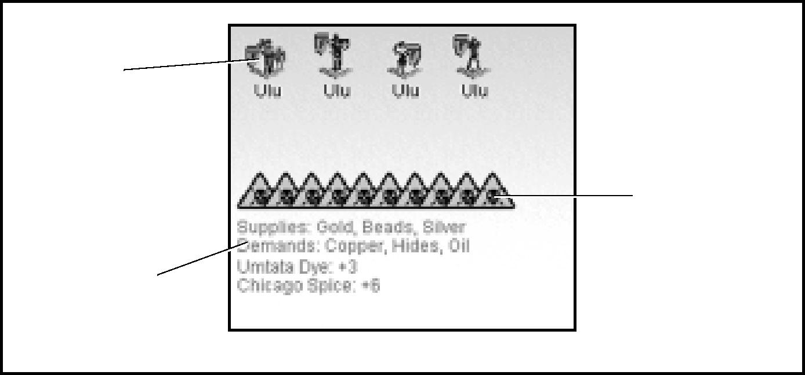

Trade Routes

Unit Info

*City Info in the General Information Box*

Pollution Threat

* Clear orders
* Sleep / Board next ship
* Disband
* Activate Unit
* Activate Unit and close City Display
    
  Each does exactly what it sounds like it does.

Once your civilization has discovered the Trade advance this area lists items in demand, and items the city can supply. It also summarizes the income from trade routes if you have any. A city can have up to three trade routes in operation at any time. Each destination city is listed, along with the commodity traded and the income generated each turn.

REFERENCE: SCREEN
  
BY SCREEN

The threat of pollution as a result of the industrial production and smog in the city is represented by cautionary triangles marked with skull-and-cross bones. The more of these that appear in the GENERAL INFORMATION box, the greater is the likelihood a random terrain square within the city radius will become polluted this turn.

HAPPINESS CHART

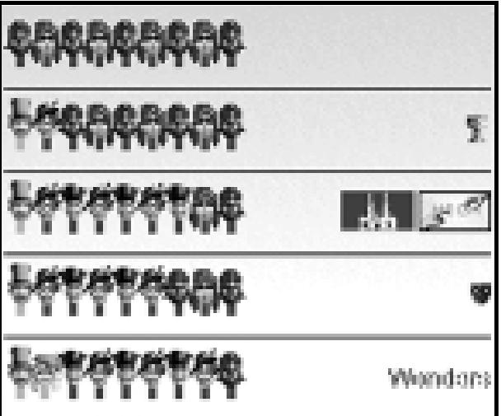

*Happiness Chart in the General Information Box*

**154**

Click the HAPPY button to see this chart. The HAPPINESS chart breaks down the factors affecting the happiness of a city’s population into a series of citizen icon representations. Each row encompasses the effects of the previous row and adds the results of specific measures.

The first row shows the natural happiness of a city’s population before any adjustments. The number of content citizens is determined by the difficulty level at which you are playing.

The second row shows the effect luxuries have in the city, if any. Every two units of luxuries make one content person happy or one unhappy person content. Note that contented persons are made happy before unhappy persons are made content.

The third row adds in the benefits of city improvements like Temples, Cathedrals, and Colosseums.

The fourth row adds in the effects of martial law and field duty. Any units imposing martial law are shown in this row. Under a Republic or a Democracy, martial law does not work, and this row instead displays any unhappiness generated by having units in the field.

The fifth row adds in the effects of any Wonders of the World, whether in this city or elsewhere, that influence the population’s happiness. Additionally, the fifth row reflects the attitudes shown in the POPULATION ROSTER, since all of the adjustments have been factored in.

|  |  |  |  |
| --- | --- | --- | --- |
| FOREIGN SERVICE MAP  Click the MAP button to see a miniature map of the world. The city location is noted on this map, and so are the locations of all of this city’s units assigned to foreign service. |  | | |
|  |  |  |  |
|  |  | *Foreign Service Map in the General Information Box* |  |

**THE BUTTONS**

**155**

In the bottom right-hand corner are two arrows and a few buttons. Here’s what each does:
  
The arrow buttons allow you to scroll through your cities one at a time, in alphabetical order. These buttons are not active when the CITY DISPLAY pops up in response to a report.

* INFO changes the display in the GENERAL INFORMATION box to the CITY INFO chart.
* HAPPY changes the display in the GENERAL INFORMATION box to the Happiness chart.
* MAP changes the display in the GENERAL INFORMATION box to the FOREIGN SERVICE MAP.
* VIEW shows you a view of the city as seen from the air.
* RENAME allows you to change the name of the city.
* EXIT closes the CITY DISPLAY.

**THE MENU BAR**

As is usual in Windows applications, a menu bar spans the top of the ***Civilization II***

window. There are eight menus: GAME, KINGDOM, VIEW, ORDERS, ADVISORS, WORLD, CHEAT, and CIVILOPEDIA. You can open any menu by clicking on its name or by holding *a* and pressing whichever letter in the menu name is underlined. Having opened a menu, double-click on any option to activate it or use the arrow keys to move the highlight to that option, then press *e*. Most options also have a shortcut key, which is noted next to the option on the menu. Even when the menu is not open, you can use the shortcut to activate an option. Any option which is grayed out is currently unavailable.

**GAME**



*The Menu Bar*

The options on this menu are what we call “meta-game functions”; that is, they affect the game as a whole.

GAME OPTIONS *c* Q

REFERENCE: SCREEN
  
BY SCREEN

This option calls up a checklist of other options. Each of these is a toggle; those with checked boxes are currently “on,” and those with empty boxes are “off.” Click on an option to toggle it on or off. Note that some options, such as TUTORIAL HELP, might affect game speed. When you have these options set as you want them, click OK to return to the game. If you change your mind and wish to discard your changes, click on CANCEL instead.

**Sound Effects:** includes battle noises, message alerts, and construction sounds. If you want to hear the audio cues that ***Civilization II*** provides, make sure this box is checked.

**156**

**Always wait at end of turn:** guarantees that your turn will not end until you press Enter . If this option is not checked, you need only press Enter to end a turn when you have no active units to move.

**Autosave each turn:** automatically saves your game every turn and backs it up to a save file every four turns. If something dreadful happens and you need to restart the game, you can use one of these backup files just as you would any saved game.

**Show enemy moves:** makes the progress of any enemy units within observation range of your units and cities visible. When this option is not checked, you see only those enemy moves which result in combat with your units.

**No pause after enemy moves:** normally, ***Civilization II*** pauses briefly after each enemy unit moves. This gives you time to actually see every enemy move. If you turn this option on, there is no pause; enemy units will move as quickly as possible.

**Fast piece slide:** increases the speed at which all units move from square to square. Checking this option will speed up the game, but might make some unit movements difficult to follow.

**Instant advice:** when turned on, this option allows your Advisors to provide helpful hints whenever they have an opinion to proffer. Otherwise, they’ll keep silent until you ask for their input.

**Tutorial help:** when active, provides even more advice for novice players.

**Move units w/ mouse** (**cursor arrows**)**:** As in the original ***Civilization,*** in ***Civilization II*** you use the keyboard controls (specifically, the numeric keypad) to move your units. If you would rather use the mouse-and-keyboard method introduced in ***CivNet,*** turn this option on. You will then be able to position the mouse just to the side (or top or bottom) of the active unit (the cursor will change to reflect the fact that you are giving movement orders) and click to have the unit move in that direction. The keyboard controls remain active regardless.

**ENTER key closes City screen:** when this option is checked, the CITY DISPLAY closes any time you press Enter . Otherwise, the CITY DISPLAY remains visible at all times once opened, unless you click the ExIT button to close it. Note that turning this option on removes your ability to use Enter (when the viewing cursor is on a city) to open the

CITY DISPLAY.

GRAPHIC OPTIONS Ctrs

**157**

This option also opens a checklist of other options. Each is a toggle; those with checked boxes are “on,” and those with empty boxes are “off.” Click on an option to toggle it on or off. Note that some options, such as CITY ANIMATIONS, might affect game speed. When you have these options set as you want them, click OK to return to the game. If you change your mind and wish to discard your changes, click CANCEL instead.

**Throne Room:** you will not be notified of the spontaneous improvements to your

THRONE ROOM that your citizens offer unless you have this option turned on.

**Diplomacy Screen:** when this option is checked, diplomatic discussions take place on the full DIPLOMACY SCREEN, with a portrait, military and technical information, and perhaps the animated herald (see the next option). If you turn this off, diplomacy is a spartan matter carried on in text boxes.

**Animated Heralds:** whenever you make contact with a representative of another civilization, the communication will include an animated Herald unless this option is turned off.

**City Animations:** every time a city completes an improvement, you’ll visit that city to view the building. Turn this off if you’d rather send an assistant to cut the ribbon at the opening ceremonies.

**Town Council:** an animated Town Council will convene occasionally to offer you advice. If you’d rather not listen to them, turn this option off. You can still ask them for advice using the TOWN COUNCIL option on the ADVISORS menu.

**Large Video Windows:** if you are playing on a high-performance system, you might want to watch each Wonder of the World video in the LARGE VIDEO window. Check this to do so. Otherwise, the video will appear in the standard window.

CITY REPORT OPTIONS Ctrs Q

This option also opens a checklist of other options. Each toggles reporting of an aspect of city information. Those with checked boxes are “on,” and those with empty boxes are “off.” Click on an option to toggle it on or off. Note that some options might affect game speed. When you have these options set as you want them, click OK to return to the game. If you change your mind and wish to discard your changes, click CANCEL instead.

**Warn when city growth halted** (**Aqueduct/Sewer System**)**:** when one of your cities reaches the maximum population that its current infrastructure can support, you will receive a warning of the situation only if this option is checked.

REFERENCE: SCREEN
  
BY SCREEN

**Show city improvements built:** when on, this notifies you of the completion of any improvement to a city. This is especially useful when you have a city in automatic production mode.

**Show non-combat units built:** if on, this notifies you when a city has completed production of a non-combatant unit (a Diplomat, for instance). This is especially useful when you have a city in automatic production mode.

**158**

**Show invalid build instructions:** if you assign a production order to a city that is not valid (building a Wonder of the World that another city has already completed, for example) you will not receive notification of the problem unless this option is turned on. This is especially helpful when you have cities set in automatic production mode.

**Announce cities in disorder:** when this is on, you will be notified of any city that goes into civil disorder.

**Announce order restored in city:** if this is checked, you will be notified when any city in disorder has been calmed.

**Announce “We Love The King Day”:** if the citizens of a city are particularly happy with your rule, they have a celebration in your honor. You won’t know about it unless this option is turned on.

**Warn when food dangerously low:** cities running at a harvest deficit can quickly deplete their stores of food. You will be warned of the impending starvation of your people only if this option is checked.

**Warn when new pollution occurs:** industrial civilizations often produce waste products that are unfriendly to the environment. News of ecological damage will only reach your ears if this option is turned on.

**Warn when changing production will cost shields:** changing the production assignment of a city when it has not completed its previous assignment often results in a substantial loss of production efficiency and accumulated shields. Unless this option is checked, you will not be notified or have the option to verify your orders when this is the case; you will simply have the penalty deducted.

SAVE GAME Ctrs

Use this option to save your game. ***Civilization II*** suggests a name for the save file, but you can type in any name you like (as long as it is eight characters or less). The default extension for saved games is .SAV. The only limit on the number of saved games you can have is the capacity of your hard disk.

LOAD GAME i ❑Q

Use this option to load a game saved previously (including autosaved games). Select one of the files listed in the window, then click OK.

RETIRE *c*

**159**

Retiring is one way of ending your game. When you retire, the game shows you how your civilization did in comparison to the others (which it does not do if you simply quit). The closing displays are exactly the same as if the game had come to a conclusion on its own. First, of course, you must confirm that you want to retire.

QUIT *c* N

Choose this option if you just want to exit the game without all the closing displays. You have a chance to confirm or cancel quitting.

**KINGDOM**

This menu includes options that affect not just one city, but your entire civilization. TAX RATE *s ❑T*

|  |  |  |  |  |
| --- | --- | --- | --- | --- |
|  | | | Choose this option to adjust the proportion of taxes (gold icons) to science (beaker icons) to luxuries (goblet icons) that each city generates each turn. As the percentage of any one of these increases, the percentage of one or both of the others must decrease.  VIEW THRONE ROOM *s*H  As you progress through the game, your achievements and skill in management are acknowledged periodically by your people. The citizens express their favor by spontaneously adding to the grandeur of your THRONE ROOM, which is located in your PALACE, which is in your capital city. (If you want to, you can relocate your THRONE ROOM and capital by constructing a new PALACE in any city you control.) This option allows you to take a look at the status of the chamber from which you rule. |  |
| REFERENCE: SCREEN  BY SCREEN |
|  | *Setting the Tax Rates* |  |
|  |  |  |

FIND CITY shift C

**160**

Select this to choose from a list of all your cities. The MAP window will center on the city you pick.

REVOLUTION shift R

Choose this option when you want to switch forms of government. You must have acquired specific technological advances to choose a type of government other than Despotism. Usually, a revolution brings on a period of Anarchy. This can last for several turns. Eventually, you’ll receive notification that your citizens are ready to choose a new type of government. All the options available to you are listed. Click on your choice.

Note that once the period of Anarchy ends and you have chosen a new government, you can use this option for the rest of that turn to freely switch your form of government without provoking further Anarchy.

**VIEW**

This menu includes options that affect the views in the various game windows. MOVE PIECES V

Use this option to switch the MAP window from VIEW PIECES mode into MOVE PIECE mode. The current active unit will be centered in the MAP window, blinking.

VIEW PIECES V

Use this option to switch the MAP window from MOVE PIECE mode into VIEW PIECES mode. The terrain cursor unit will be centered in the MAP window, blinking. You can use the keys on the numeric keypad to move this cursor just as you would a unit.

ZOOM IN Z

This option incrementally increases the size of the map squares shown in the current MAP window. This option functions in the same way as the button in the upper left-hand corner of each window.



ZOOM OUT X

This incrementally decreases the size of the map squares shown in the current MAP window. This option functions in the same way as the button in the upper left-hand corner of each window.



MAX ZOOM IN ii z❑

**161**

This option automatically zooms in to the maximum size map square in the current MAP window.

STANDARD ZOOM Shi@ z❑

This option resets the square size in the current MAP window to the default size. MEDIUM ZOOM OUT Shi@x❑

This option zooms to a medium size map square in the current MAP window, a size that we have found useful.

MAX ZOOM OUT ii x❑

This option automatically zooms out to the minimum size map square in the current MAP window, showing the entire known world.

SHOW MAP GRID ii G

Select this to superimpose a grid on the map in the MAP window. This can help novice players become familiar with the isometric movement system used in ***Civilization II***.

ARRANGE WINDOWS

This option returns the screen to its original configuration. Only the MAP window, the STATUS window, and the WORLD window remain open.

SHOW HIDDEN TERRAIN ff)

Use this to temporarily remove the improvement graphics from all terrain, so that you can clearly view the terrain underneath.

CENTER VIEW ~

This option automatically centers the current MAP window on the current active unit. If there is no current active unit, nothing happens.

REFERENCE: SCREEN
  
BY SCREEN

**ORDERS**

**162**

This menu lists the orders you can give the current active unit. Note that orders that are not appropriate for the active unit, or not currently available, are grayed out (or not listed). Some options have different results (and different text) depending on what type of terrain the unit is standing on.

BUILD NEW CITY/JOIN CITY

This option tells a Settlers or Engineer unit to create a new city where it stands. If the unit stands in an existing city with fewer than eight population points, the option reads JOIN CITY instead, and the unit adds itself to the city as a population point.

BUILD ROAD/RAILROAD

This option tells a Settlers or Engineer unit to build roads across the square in which it stands. If you have discovered the Railroads advance, the option might read BUILD RAILROAD. In this case, your unit can improve existing roads to railroads.

BUILD IRRIGATION/CHANGE TO... [D

Use this option to order a Settlers or Engineer unit to irrigate the square in which it stands. If the introduction of agriculture requires or will cause the square to change type, the option will read CHANGE TO instead, followed by the type of terrain that will result. For example, if your unit is on a Forest square, the option might read CHANGE TO PLAINS. These alternate orders tell the unit to enact the change. Note that this change does *not* include irrigation; you can only do that once the terrain is suitable. For details on which terrain types can be transformed to which others, please refer to the **Poster**. If your unit stands in a square that will not benefit from irrigation, the option will be grayed out.

BUILD MINES/CHANGE TO... M❑

Use this option to order a Settlers or Engineer unit to mine the square in which it stands. If the introduction of mining requires or will cause the square to change its type, the option will read CHANGE TO instead, followed by the type of terrain that will result. For example, if your unit is on a Grassland square, the option reads CHANGE TO FOREST. These alternate orders tell the unit to enact the change. Note that this change is in place of the mining. For details on which terrain types can be transformed to which others, please refer to the **Poster**. If your unit stands in a square that will not benefit from mining, the option will be grayed out.

TRANSFORM TO... O

**163**

This option tells an Engineer unit to drastically change the terrain type of the square in which it stands. For example, if your unit stands in a Mountains square, the option reads TRANSFORM TO HILLS, and it orders the unit to do exactly that. For details on which terrain types can be transformed to which others, please refer to the **Poster**.

BUILD AIRBASE E

This orders a Settlers or Engineer unit to build a military Airbase (not an airport) in the square it occupies. Once it is built, your air units can land for fuel and repairs at the Airbase.

BUILD FORTRESS F

This orders a Settlers or Engineer unit to build defensive fortifications in the square it occupies. Once it is built, your units can occupy the Fortress to enhance their defensive capabilities.

CLEAN UP POLLUTION P

Use this option to order a Settlers or Engineer unit to detoxify a polluted square. PILLAGE Shi@ P

This option tells a unit to wreak havoc on the square it occupies, which could mean collapsing mines, destroying irrigation, ripping up roads, or other destruction.

UNLOAD U

Give this order to a ship to activate all its passenger units, allowing them to move ashore or onto another ship. The ship must be adjacent to a land square, a city square, or another friendly ship. You can also click on the ship to bring up a box showing all of the shipboard units, then click on each one that you want to unload.

GOTOG

This option allows you to send a unit directly to one of your cities. Select a city from the list (only those which the unit can reach on its own will be listed), and the unit will go there without further orders. (Note: the original function of this order, sending a unit to a destination square, is now a mouse function. Click-and-hold on the square to which you want the current active unit to go until the mouse cursor changes to a “GoTo” arrow, and the unit proceeds to the selected square without further orders.)

REFERENCE: SCREEN
  
BY SCREEN

PARADROP P

**164**

This movement order is available only to Paratrooper units currently located in an Airbase or a city with an Airport. Choose any unoccupied square no more than ten squares distant from the unit’s current location. The unit will move immediately to that square. This order uses all but one of the Paratrooper’s movement points for that turn.

AIRLIFT L

Use this order to move a unit that has not yet moved this turn from any of your cities served by an Airport to any other (friendly) city with an Airport. This travel uses all of the unit’s movement points for that turn. Only one unit may be airlifted from or into each city per turn.

SET HOME CITY H

Use this option to reassign a unit to a specific city for support. In order to be reassigned a unit must be in a city other than the one it currently calls home. If the unit is not in a city, this order causes the unit to move directly to the nearest city under your control.

FORTIFY F

Select this option to order a military unit to dig in and fortify itself in the square in which it stands. This enhances the defensive capabilities of the unit for as long as it remains fortified.

SLEEP M

When you order a unit to sleep, that unit is assigned the task of remaining in the square it occupies. The unit maintains this posture until you wake it (activate it) or an enemy unit approaches an adjacent square. You can click on a sleeping unit and give the ACTIVATE UNIT order at any time to wake it and return it to active status. Units boarding a ship to undertake naval transport automatically assume sleeping status when they ship out.

DISBAND Shi@ Fp

This order allows you to dismiss a unit from active duty. The unit disappears completely and irrevocably, so be careful when invoking this option. If you disband a unit in a city square, one half of the units construction cost is immediately added to the PRODUCTION BOx in that city. This represents the redistribution of support and retraining of soldiers.

ACTIVATE UNIT A

This orders the unit at the cursor location to become active. If there is more than one unit in that square, you can select which unit you want to activate.

WAIT w❑

REFERENCE: SCREEN
  
BY SCREEN

**165**

Use this to order the current active unit to wait for orders until you have given every other active unit something to do. Note that if you give another unit the WAIT order, that unit will get in line behind the first unit you ordered to wait, and so forth.

SKIP TURN S acebar

Use this order to pass over a unit for a turn. The unit takes no action, but will repair itself somewhat if it has been damaged.

**ADVISORS**

These options all provide reports on the overall picture of your civilization’s strengths and progress.

TOWN COUNCIL Ctrs ❑r

The TOWN COUNCIL is a video-animated meeting of all your advisors. In it, you can ask one or all of them for advice on your current situation.

CITY STATUS Ft

This report lists vital statistics for all the cities in your empire, in the order in which they were founded. This information includes how many of each resource type (food, production, and trade) each is collecting, what each city is building, and how close it is to finishing that assignment. You can double-click on any of the listed names to open the CITY DISPLAY for that city.

DEFENSE MINISTER F2

The DEFENSE MINISTER reports on your military assets. This includes information on every one
  
of your existing units, plus statistics on past performance in battle and casualties to date.

FOREIGN MINISTER F3

**166**

This report is a summary of everything you know about the other civilizations with whom you have made contact. This report includes thumbnail sketches of each (the name and title of the leader, your current diplomatic status with them, and their leader’s current attitude toward you). If you have an embassy with a civilization, you also find out how much gold they have in their treasury.

You can double-click on any of the leaders (or the SEND EMISSARY button) to begin negotiations with that ruler immediately.

If you have established an embassy with a particular civilization, clicking CHECK INTELLIGENCE opens the INTELLIGENCE REPORT, which gives you further details, including a complete list of their cities and notice of which Wonders (if any) they are attempting to build.

|  |  |  |  |
| --- | --- | --- | --- |
| ATTITUDE ADVISOR F4  This advisor summarizes the relative happiness of your citizens. For each city, this report details the base status of its population (happy, content, unhappy, and specialist citizens) and the effects of any influences (Temple improvements, for example) which, directly or indirectly, modify the happiness of the people. If any city is about to go into civil disorder (next turn) or will remain in civil disorder unless you do something, that city will be clearly marked. Double-click on any of the listed city names to open the CITY DISPLAY for that burg. |  | | |
|  |  | *Attitude Advisor Report* |  |

TRADE ADVISOR a]

REFERENCE: SCREEN
  
BY SCREEN

**167**

Your Trade Advisor reports on the percentages of trade you have earmarked for luxuries, tax revenue, and scientific research funding in each city. In addition, this report covers those improvements to your cities which require maintenance payments. Comparing your total tax revenue (income) with your maintenance cost total (expenses), you can see whether the treasury of your civilization is increasing each turn, shrinking, or remaining the same. If your treasury is shrinking, this might be a good time to increase taxes or adjust individual cities to produce higher revenue. In an emergency, you might wish to sell an improvement to raise cash. In addition, your trade Advisor keeps tabs on the market for every trade cargo in the game. Click the SUPPLY AND DEMAND button to see a list of Commodities. Click on the commodity in which you are interested, to see a list of cities interested in that cargo. The OK button lets you choose another cargo and the CANCEL button returns you to the TRADE ADVISORS Report.

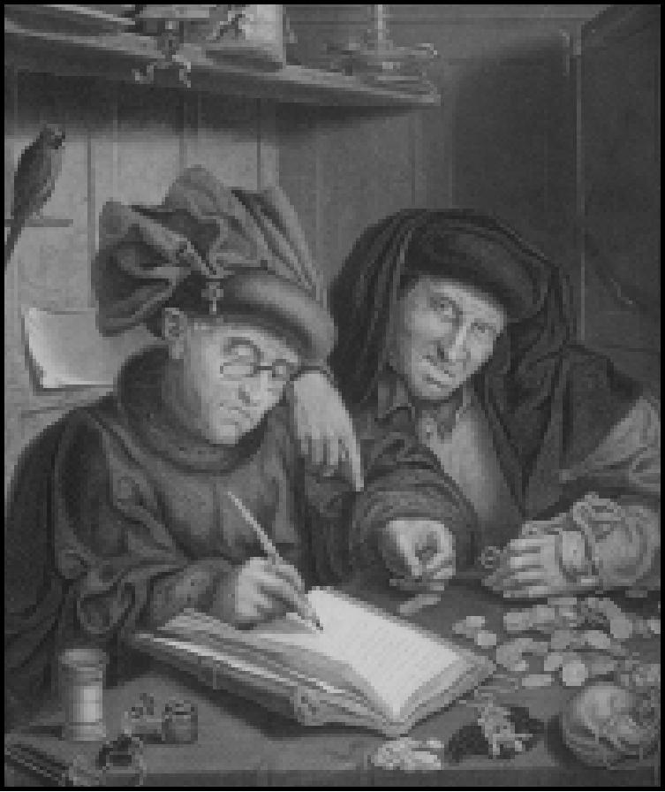

SCIENCE ADVISOR a]

Your Science Advisor keeps a record of the advances your civilization has already achieved and the progress of your scientists toward the next advance. (Advances that your civilization was the first to learn appear in white type.)

Click the **Goal** button to see the entire list of advances and help options that are available.

Note that it is possible to continue making advances beyond the list that defines civilization up to the end of the twentieth century. These continuing advances are called FUTURE TECH, and each one you acquire adds to your civilization score.

**WORLD**

**168**

This menu allows you to view statistics comparing the progress of the world’s civilizations. WONDERS OF THE WORLD n

This option shows the icon for each Wonder that has been built and identifies both its location and the culture that (currently) owns it. If a Wonder was built but has since been destroyed, that fact is also noted.

|  |  |  |  |
| --- | --- | --- | --- |
| TOP 5 CITIES Fa  This option brings up important statistics about the top five cities in the world, including their population size and citizens’ attitudes, the culture to which they belong, and any Wonders present. City rank is determined on the basis of the number of happy citizens, content citizens, and Wonders of the World there. This list might even contain information on places you didn’t know existed (your civilization has yet to discover them).  CIVILIZATION SCORE Fs  Use this option to find out your score so far. This is based on the total number of citizens in your entire civilization, Wonders you have built, bonuses for various measures like world peace, and similar penalties for negatives like pollution. If you have enabled Cheat Mode during your game it is noted in your score. |  | | |
|  | *Top 5 Cities* |  |
|  |  |  |

DEMOGRAPHICS

This option shows you a list of demographic statistics and the ranking of your civilization for each measure mentioned. If you have diplomatic relations with civilizations whose rank in a particular category is higher than yours, that culture’s statistics are listed as well.

**169**

|  |  |  |  |
| --- | --- | --- | --- |
|  | SPACESHIPS F |  | When you contact your space advisors, they report the progress of any spaceship under construction. Select from the menu the civilization whose spaceship you wish to examine. Your advisors present a picture of the construction accomplished to date and their assessment of what the craft can carry, its estimated flight time, and its probability of success.  The space race begins once the Apollo Program Wonder of the World has been constructed. Thereafter, any civilization that has the required technologies can begin building parts of a spaceship.  Once the space race begins, it is important to maintain a watch on the spaceships of your rivals. You need to assess when they are likely to launch so that you can plan the size of your own ship and its launch date. If you conclude that your ship construction is too far behind to catch up, it might be necessary to mount a military campaign to capture the enemy capital. Capturing an enemy capital destroys a spaceship, whether it is under construction or already launched. |
|  | | |
|  | *Apollo Program* |  |
|  |  |  |

**CHEAT**

This menu contains options designed as crutches for those of you too loathsome and pathetic to be able to win on your own. PIo, seriously, these are aimed at novice players who might want (or need) a head start, so that they can jump the learning curve” and enjoy some of the more advanced portions of ***Civilization II.*** More experienced players might want to use these to cut out some aspect of the game that they find less than fun, so as to enjoy the rest that much more. Whatever your reasons for cheating, remember that using this menu goes on your permanent record.

TOGGLE CHEAT MODE *Ctrs* ❑Q

Use this to toggle CHEAT MODE on and off. You cannot use any of the other options on this menu unless this one has been enabled. Once you use this option, *even if you never actually use any of the other cheat options*, the fact that you have cheated is noted permanently on your civilization score.

REFERENCE: SCREEN
  
BY SCREEN

CREATE UNIT *s* 1

**170**

This option creates a new unit at the current cursor location. You can generate any type of unit that you can currently build, or use the buttons at the bottom of the window to select from lists of Obsolete or Advanced units. Other buttons determine whether or not the created unit is a veteran and which civilization has control of that unit.

REVEAL MAP *s* 2

Use this to view the map of any civilization (what they have discovered to date), or to have the entire world revealed to you.

SET HUMAN PLAYER *s* 3

This option allows you to abandon your rule and take control of whichever civilization you
  
would prefer to run. You can also abdicate completely and watch the game play against itself.

SET GAME YEAR *s* 4

Use this to turn the calendar forward or back to whatever game year you like. You will be prompted to enter a number of “Turns Elapsed.” This is the game’s way of expressing years. There are several different time scales for years versus turns, depending on the difficulty level and how far the game has progressed. It might help to know that there are 550 turns in a Chieftain level game, 500 in Prince level, 450 at King level, and 400 at both the Emperor and Deity levels. After these turns, there is always a grace period of twenty years between the last turn (2000 A.D.) and the end of the game (2020 A.D.). Nothing but the year (neither your civilization nor any of your opponent’s) will be affected.

KILL CIVILIZATION *s* 5

You can completely eliminate any civilization, including your own, with this option. TECHNOLOGY ADVANCE *s* Fs

This option allows you to immediately confer on any civilization (including your own, of course) whatever advance they are currently researching.

DISCOVER ALL TECHNOLOGIES *c s* Fs

This option is a double-edged sword. The first time you use it on any civilization, it confers knowledge of every possible advance (excepting only Future Tech). If, however, you use it on the same civilization twice, the second application *takes away every advance*, even those discovered honestly.

FORCE GOVERNMENT Shi@ F7

**171**

Use this to change the government of any civilization to the type you wish it to be, whether or not that form of government has been discovered.

CHANGE TERRAIN AT CURSOR snip Fa

This option gives you the ability to instantly determine the improvements made to the square that is the current cursor location. You can add or remove any improvements appropriate to the type of terrain.

DESTROY ALL UNITS AT CURSOR Ctrl Shin Fp

This quite simple destroys any units at the current cursor location. CHANGE MONEY Shi@ Fs

Use this to specify the amount of funds in the treasury of any civilization. SAVE AS SCENARIO

This allows you to save the current game situation as a scenario file. **CIVILOPEDIA**

The CIVILOPEDIA is an on-line encyclopedia of ***Civilization II***. The entries under each topic appear alphabetically, and each includes detailed information about the item, its historical importance, and its significance in the game.

CIVILIZATION ADVANCES

This option focuses on the advances. The CIVILOPEDIA entry describing each advance automatically appears when you acquire that advance.

CITY IMPROVEMENTS

This option culls the list to include only the structures you can build in a city to improve its working.

REFERENCE: SCREEN
  
BY SCREEN

WONDERS OF THE WORLD

To narrow your choices down to information about the various Wonders, use this option.

MILITARY UNITS

**172**

The title of this topic might be slightly misleading, as ***Civilization II*** considers all units to be military, even Diplomats, Caravans, and Settlers.

GOVERNMENTS

If you want information on the various forms of government, this is the place.

TERRAIN TYPES

This option provides the entries for each type of terrain square and special resource that exists in ***Civilization II***.

GAME CONCEPTS

This option includes all the information not covered under any of the other focused topic lists, including things like Pollution, Disbanding, and Fortresses.

SEARCH CIVILOPEDIA

This option lets you choose from every topic in the CIVILOPEDIA (for those times when you’re not sure what type of item you’re looking for).

**THE STATUS WINDOW**

The information displayed in this window helps you keep abreast of the status of your civilization and your turn. Note that you can click anywhere in this window to toggle the MAP window between VIEW PIECES mode and MOVE PIECES mode.

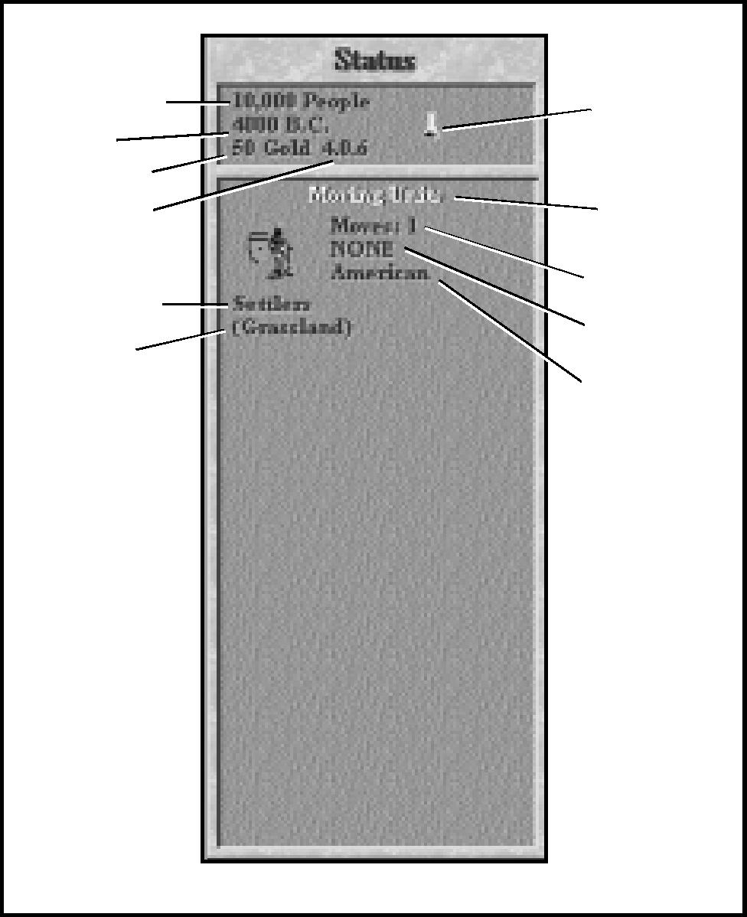

Population Date

Treasury

Tax Rate

Unit Type Terrain

*The Status window*

Movement
  
Home City

Nationality

Research Indicator

Map
  
Window
  
Mode

**173**

**WORLD PEACE BAR**

At the top of this window is a bar indicating the accumulated turns of world peace. World peace is a situation in which *no* civilizations are at war. Each turn of peace adds to your civilization score. (This bar might not become visible for quite a while, if ever.)

**SUMMARY BOX**

Below the peace bar is a quick reference box summarizing data you’ll find useful during the game.

POPULATION

This figure reports the current size of your civilization’s population.

DATE

The date is reported in years B.C. or A.D. A normal game begins in 4000 B.C. Each turn represents the passing of a period of years. Depending on the current date, turns might be 1 year, 2, 5, 10, 20, 25, or 50 years long.

REFERENCE: SCREEN
  
BY SCREEN

TREASURY

**174**

This figure reports the amount of gold currently in your treasury. If it increases each turn, you’ve got a surplus; if it decreases each turn, you’re operating at a deficit.

TRADE BALANCE

The figures that appear here represent the percentages you’ve set for the spending of your trade income. They are, in order: taxes, luxuries, and research. (Note: multiply the number shown by 10 to get the actual percentage.) Each of these three by-products of trade has its benefits. As time passes and cities grow, you might have to adjust the trade rates to provide a minimum amount of taxes and science research while providing more luxuries to keep the population sufficiently happy. To adjust trade rates, pull down the KINGDOM menu and select the TAX RATE option.

SCIENTIFIC RESEARCH

The research indicator is a graphic representation of your progress toward the next advance. The beaker notes your progress, and it changes as you get closer to your current research goal. Once the new discovery is reported and your scientists are sent off to study something else, this indicator is reset.

ENVIRONMENT

If there is any danger of global warming, the environment indicator graphically represents the extent of this risk. With the first case of pollution, the sun icon appears, at its lowest setting. If pollution continues, the sun changes to indicate the “progress” of pollution. If pollution is not brought under control when the indicator is at its highest, the planet suffers a bout of global warming, then the indicator reverts to a setting that reflects the new equilibrium.

Pollution and environmental problems can also be caused by nuclear reactor meltdowns and fallout from nuclear weapons. For more information on pollution and global warming, see **Planetary Caretaking**.

**ACTIVE UNIT/LOCATION BOX**

REFERENCE: SCREEN
  
BY SCREEN

**175**

Below the SUMMARY BOX is an area dedicated to information on the current cursor location. This is normally the current active unit, but might also be a terrain square you have selected. Note that for the purposes of this information box, cities are ignored. The following information is included, not necessarily in this order.

MODE

Whether the MAP window is in VIEW PIECES or MOVE PIECES mode is noted.

ICONS

If there are any units at the current location, each will be represented by its icon. These icons
  
are complete with the colored shield denoting nationality and the bar showing damage status.

NATIONALITY

If there are any rival units at the current location or if you are viewing a unit, rather than a terrain square, the name of the civilization to which each unit belongs is displayed.

HOME CITY

If there are any of your units at the current location, the name of the city from which each unit derives support is displayed. This is normally the city where the unit was built. You can transfer a unit to another city by moving it there and using the SET HOME CITY order. This can be useful when one of your cities is threatened with capture, since all units supported by a captured city are destroyed.

UNIT TYPE

If there are any units at the current location, the type of each unit is displayed. For your units, the box also tells you whether or not it is a veteran unit.

MOVEMENT

**176**

If there are any of your units at the location, the number of movement points the active unit has remaining are noted. (If you are finished moving a unit, but it still has movement left, use the SKIP TURN order to end that unit’s movement for the turn.)

Note that points are shown as fractions when the unit is moving along a road (roads triple movement, making fractional movement points necessary). The fraction indicates the lowered attack strength as well as the use of movement points. For example, a unit that begins with 1 movement point and moves one square along a road would show 2/3 movement points remaining, which also equates to 2/3 attack strength.

Also remember that units beginning on a square containing a railroad and moving along the railroad spend no movement points until they leave the railroad.

TERRAIN

This is the terrain type of the square. This terrain report disregards the presence of a city, but does mention other improvements such as irrigation, roads, and railroads. If there are special resources available at that site, they are also noted.

**THE MAP WINDOW**

**177**

The MAP window is the isometric map, the window in which you view and move your active units. The area shown in this window is the section of the world outlined on the map in the WORLD window. You can move and re-size the MAP window just as you would any other window. (Note that, if you open so many reports, displays, and messages that you bury the MAP window, you can always close them all and bring it to the front of the heap by choosing

ARRANGE WINDOWS from the VIEW menu.)

**MULTIPLE WINDOWS**

If, for some reason, you would like to have more than one MAP window open (to keep an eye on an especially valuable piece of real estate, for example), you can do so. Right-click anywhere in the WORLD window. The new window acts just like the default one, except that you have an additional button in the top left-hand corner. You can use this button to cycle through the viewing modes for that window. The modes are: View Friendly Units, View Enemy Units, View All Units, and Static View (which centers on the map square you choose and stays there).

**ZOOM BUTTONS**



In the upper left-hand corner of the window frame are Zoom In and Zoom Out



buttons. Use these to customize the size of your map view. There are sixteen levels of adjustment. You can also use any of the ZOOM options on the VIEW menu.

**MOVING THE VIEW**

To reposition the MAP window so that it shows a different section of the game map, simply click on any map square in the window. ***Civilization II*** redraws the map, centering on the square you selected. If you want to center on a square that is not presently in the window, you can also click on a location in the WORLD window to center there.

**CENTERING ON A CITY**

Use the FIND CITY option on the KINGDOM menu to center the map on any known city, regardless of where or whose it is.

REFERENCE: SCREEN
  
BY SCREEN

**CENTERING ON A UNIT**

To center the view on a particular one of your units, open the CITY DISPLAY for that unit’s home city. In the UNITS ROSTER, click on the icon for that unit. Use the CENTER MAP ON UNIT option to center the MAP window on the unit.

**WORLD WINDOW**

|  |  |
| --- | --- |
| This window shows a map of the entire known world. It is centered on the part of the world shown in the MAP window. The rectangle delineates the edges of that view. You can use the WORLD window to move around the MAP window more rapidly. Click on a location in the WORLD window, and both windows shift to center on that position. |  |

**178**

**DESIGNERS’ NOTES**

DESIGNERS'
  
NOTES

**179**

Opportunities like this don’t come along every day. After all, games as much fun as ***Civilization*** — and as successful as ***Civilization*** — are few and far between. And a game of that caliber whose appeal is wide enough, whose subject matter is broad enough, and whose structure is open enough to lend itself so easily to such a major expansion and overhaul is a rare gem indeed. But by summer of 1994 it was clear that ***Civilization II*** was an idea whose time had come, and boy were we excited about it!

Of course, the biggest potential pitfall in working on a game like this is that none of us wanted to go down in history as “the guys who broke ***Civilization***!” ***Civilization*** is about as complex and finely balanced as games get, and any misstep would quickly throw that magical pacing out of kilter. So just throwing in the kitchen sink wasn’t going to cut it. Every addition or change needed to be carefully weighed to make sure it wasn’t doing more harm than good. On the other hand, we knew we wanted this to be a lot more than a simple facelift — this was our big chance to take our favorite game and make it better than ever.

So we got our “fun experts” together and began the mammoth task of sorting through ideas. And there were *plenty* of ideas. In the years since ***Civilization*** first appeared, we have received literally thousands of letters, phone calls, and e-mail messages offering suggestions for improvements, additions, and sequels. Everything from quick notes detailing pet peeves to full-scale design documents offering to remake the game from top to bottom. Some ambitious folks on the Internet even compiled a most helpful database of “***Civ II*** proposals.” And once we were willing to accept the previously unthinkable, that ***Civilization*** could actually *be* improved, we even had a few ideas ourselves!

Our ideas mostly fell into three major categories: (1) simple additions, such as new units, city improvements, civilization advances; (2) major improvements to the game structure, such as the overhauled diplomatic and combat systems; and (3) entirely new features, such as map editors, scenarios, and rules customization.

When inventing new unit types we concentrated first on those which would fill gaps and round out the existing types. The fast moving units, for instance, suffered from the chasm separating Knights and Armor; we bridged it with Elephants, Crusaders, Dragoons, and the new Cavalry unit. Other classes of unit — artillery, infantry, naval, air—were similarly examined. Some units which were too powerful (e.g., Chariots) were downgraded; others, which we felt were under-used (e.g., Legions, Musketeers) were enhanced. We added a modern form of each of the support units — Engineers, Spy, and Freight; each with exciting new abilities. Finally, there were some genuinely new roles waiting to be filled — Explorers, Paratroopers, Marines, Alpine Troops, and of course those pesky Partisans.

Good ideas for new city improvements were perhaps the hardest to come by, since we didn’t want to clutter up the game with too much economic micromanagement. We thought maps filled with railroads in every square were just plain ugly, so we introduced Farmland, Supermarkets, and Superhighways to encourage a more well-rounded approach to civil engineering. Similarly, since ocean squares seemed neglected, we added Harbors and Offshore Platforms to provide more opportunities in coastal regions. We extended some existing concepts (Bank, University, Aqueduct) with more specialized forms (Stock Exchange, Research Lab, Sewer System). And civic defense received a boost with the arrival of Coastal Fortresses, SAM Missile Batteries, Port Facilities, and Airports.

**180**

Wonders of the World were problematic for a different reason — traditionally they must come in groups of seven! It just didn’t seem right to tack three wonders onto the end and talk about the “10 Wonders of the Modern World.” We noticed, however, that most of our best ideas fit into the two gaps between the existing time periods (between Ancient and Renaissance, or between Renaissance and Modern). So we decided to split the original seven Renaissance wonders into two periods and use our new ideas to bring each group up to a full seven, bringing us to 28 total Wonders.

Time had shown that to experienced players some Wonders were clearly more worthwhile than others, so we undertook to rebalance the entire set. As a quick look through the Wonders list will show, we in most cases chose to do this by enhancing the effects of Wonders we thought were too weak (e.g., Great Wall, Lighthouse, Michelangelo, Magellan, United Nations) or by extending or eliminating “expiration dates” to give a Wonder’s builder more time to reap its benefits (e.g., Colossus, Hanging Gardens, Great Library, and many others). We wanted Wonders to have a decisive effect on the game, and to figure prominently in players’ strategic planning. Since different Wonder combinations make for exciting new games, we tried to make all the Wonders tempting.

Only in two cases, the SETI Program and the Pyramids, did we find it necessary to “scale back” Wonder effects. Throughout the ***Ciu II*** design, we have tried to play down rules that tended to have the effect of “the rich get richer and the poor get poorer.” SETI was as clear example of this, since the first player to discover Computers is pretty much by definition ahead in the technology race; to *double* his technology output as a reward only served to cement his lead. We lowered SETI’s effect and added Research Labs as a possible catchup mechanism for other players. Similarly, we liked the Pyramids’ effect but found that introducing it so early skewed the game wildly, so we moved it forward (Statue of Liberty) and gave Pyramids a hardly disappointing new power.

In terms of major improvements to the game’s structure, we were looking for additions which would enhance the game’s existing strong points, not distract from them. A proposal for a full-screen tactical combat system which would be used to fight out most battles in detail was dropped, for instance, because we felt it would detract from one of the game’s great strengths, which is the ebb and flow of forces on the main strategic map. Instead, we looked for a way to make strategic combat more interesting and realistic. What we arrived at is the new “strength bar” system, which provides the added realism of “combat damage” but is simple enough not to fundamentally change the balance of the game. We also felt strongly that players needed to have ways to repair damaged units quickly and get them back into action, so we gave cities (especially those with Barracks) enhanced repair abilities.

DESIGNERS'
  
NOTES

**181**

Another major improvement worth mentioning is the diplomatic system. Everyone agreed that players needed more options when dealing with foreign powers — options like alliances and temporary cease-fires, not to mention enhanced trading. The peace treaty was revised to solve the “I hate it when they fortify units right next to my cities” problem. Players had also discovered numerous loopholes in the game which allowed them to run circles around the computer players; we tightened these up mostly by enhancing the role of the Senate in Republics and Democracies. Finally, we felt that computer players should have a longer memory for betrayals committed by the player, so we introduced the concept of “Reputation” to shade diplomatic negotiations. This system rewards players who keep their word and penalizes those who behave dishonorably.

We also took another look at government forms. We noticed that many experienced players used only the two most extreme forms of government: Despotism and Democracy. That told us that something was out of whack, since we wanted all of the government forms to be interesting; we wanted to see a civilization’s government evolve over the course of the game. So we significantly improved the “neglected” government forms: Monarchy became better at supporting military units, Republic had its military discontent and Senate rules relaxed somewhat, and Communism was freed of “corruption” and given some enhanced abilities for spying and martial law. We made Republics and Democracies easier to defend by loosening the “home city” rules and allowing units in nearby fortresses to escape discontent. We introduced the concept of waste (“corruption for shields”) to tame Despotism. We also reigned in Democracy somewhat by strictly enforcing the Senate rules.

It was also clear that the forty bazillion or so hours of playing time which have occurred between 1991 and the present have served to vastly improve the world’s overall ***Civ***­playing skill. We who once confidently predicted of Emperor level that it could be beaten, “but not consistently” now found ourselves competing to see who could score 350 percent, build a size 42 city, or put a spaceship on Alpha Centauri while the turns were still moving in ten year increments. Without making the game more difficult for beginners, we needed to crank up the challenge level significantly for all the jaded experts out there.

So we set to work on a new generation of artificial intelligence for the higher difficulty levels. We watched our best players and taught the computer opponents to play in the same ways that they did — to keep some settlers in reserve, for instance, and use them to improve terrain and connect cities with roads. We taught them how to concentrate their efforts on particular technology groups, and how to use their naval forces effectively to support a beachhead. We also taught them some really nasty tricks that we won’t spoil by mentioning here. At the same time, we eliminated the quasi-cheating that irked some experienced players — which meant we had to show the computer players how to use their Caravans and how to build Wonders of the World. Finally, we added the new Deity difficulty level for those who like their ***Civ*** *really* mean.

**182**

A brief word on history. ***Civilization II*** began as a day long brainstorming session around Sid Meier’s round table with Sid, Brian Reynolds, and Jeff Briggs. Brian then retreated to the dales of Yorkshire for a year to formulate the design and put together a series of prototypes which eventually became the game engine. Meanwhile, Jeff began putting a first-rate team together and Doug Kaufman, one of our most experienced designers as well as one of the world’s great emeritus ***Civ*** experts, pounded away at the prototype, finding loopholes and making sure it was actually possible to beat Deity level. If you like the fact that you need an Aqueduct to get a city past size 8 now, you can thank Doug!

As the project began to pick up speed, veteran Art Director Mike Haire and his team began creating the game’s all-new look. Mike and Barb Jeznach devised the new isometric map view which gives the terrain a much more realistic feel. Mike Bazzell drew those scary-looking battleships and stealth bombers, not to mention the new spaceship screen, and Bob Kathman brought you a choice of city architectural styles — the “medieval capital” is based on a postcard Brian sent back from Richmond, North Yorkshire. Using models built by Murray Taylor and Mike B., Barb Bents-Miller pulled out all the stops to bring you the motion-captured heralds for the diplomatic screen (we were glad when you finally got around to putting some clothes on that Viking woman, Barb). Jerome Atherholt painted the Kings and Queens, Nick Rusko-Berger designed the final word in throne rooms, and Stacey Clark Tranter created the overhead city view. Nick also created the opening, based on an idea from Jerome and Stacey. Civilopedia art was provided by Kat Seman and Barb J., and for help in some tight spots, we turned to Mike Bates, Betsy Kirk, Guy Sparger, and Chris Tamburrino.

On the multimedia front, Mike Ely and Tim Train began digging through the archives for Wonders of the World movies, and started scripting the Town Council (can you imagine auditioning all those Elvis impersonators?) Jason Coleman, one of our hottest up-and-coming programmers, provided the technology we needed to make it happen, and joined the team full time to implement all the major graphics screens. Dave Ellis put together the “multimedia-pedia,” and Chris Taormino joined us to beat the startup menus into shape. Mike Denman, Paul Rowan, and team (of ***CivNet*** fame), provided the excellent SMEDS engine which got things off to a fast start on the code side. On the Sound side, Ken Lagace found all those crazy aerial combat effects, and Roland Rizzo, Mark Reis, and Dave Evans arranged, recorded, implemented — and whatever else it is they do in that strange room — Jeff Briggs’ finest scores.

DESIGNERS'
  
NOTES

**183**

If you appreciate the stability of the program itself, you’ll want to thank Jen MacLean and her QA team. Steve Moseley kept the bug lists coming, and James King, “Chrispy” Bowling, Jim Hendry, Mike Barker, Don Emmel, as well as many others, held us to the highest of standards. Among other things, they insisted we add a “more satisfying” nuclear explosion sound effect! Meanwhile, Jonatha Caspian-Kaufman tackled the manual —on one notable evening, we sat around with the names of civilization advances printed on the back of 88 business cards to figure out what the technology tree actually looked like. Mick Uhl masterminded the French and German translation effort. On the Marketing side, Lindsay Riehl, Paula Scarfone, and Marcia Foster were remarkably patient with us, and helped us “spread the good news.” And heartfelt thanks to all the many others here who have contributed to this project!

And so, at long last, here it is: ***Civilization II***! Before we run off to start our *next* great game, we also want to thank all of the ***Civ*** players out there, especially those of you who loved the game enough to send page after page of ideas and suggestions, because we couldn’t have done it without you. This game was created of, by, and for ***Civ*** players, and we only hope you enjoy playing ***Civilization II*** as much as we have enjoyed creating it.



*Brian Reynolds January, 1996*

**CREDITS**

**GAME DESIGN**

Brian Reynolds
  
*with* Douglas Caspian-Kaufman
  
and Jeffery L. Briggs

**ORIGINAL
  
CIVILIZATION DESIGN**

Sid Meier
  
*with* Bruce Shelley

**PRODUCER**

Jeffery L. Briggs

**PROGRAMMING** Brian Reynolds Jason S. Coleman Chris Taormino

**SMEDS SYSTEM DESIGN**

William F. Denman, Jr.
  
Paul L. Rowan
  
*with* Lee Baldwin
  
Wayne Harvey
  
Jason Snyder
  
John O’Neill

**ART**

Michael Haire, *Art Director*Barbara Bents Miller
  
Stacey Clark Tranter
  
Murray Taylor
  
Barbara Jeznach
  
Nicholas Rusko-Berger
  
Bob Kathman
  
Michael Bazzell
  
Jerome Atherholt
  
Frank Vivirito
  
Katharine Seman
  
Michael Bates
  
Betsy Kirk
  
Guy Sparger
  
Chris Tamburrino
  
Mike Reis

**184**

**DESIGN ASSISTANCE**Mick Uhl

**MUSIC COMPOSED &
  
ARRANGED BY**Jeff Briggs
  
Roland Rizzo
  
Sound Design
  
Mark G. Reis
  
*with* Ken Lagace

**SOUND
  
PROGRAMMING**David Evans

**SOUND RECORDING & MARKETING**

**ENGINEERING PRODUCT MANAGER**

Mark G. Reis Lindsay Riehl

Roland Rizzo

**CIVILOPEDIA**David Ellis

**MULTIMEDIA**

Michael Ely
  
Timothy Train
  
Jason S. Coleman
  
*with* David Evans

**DOCUMENTATION**Jonatha Caspian-Kaufman
  
*with* M. Christine Manley
  
& John Possidente

**DOCUMENT
  
DESIGNS & LAYOUT**

Cesar Novoa
  
Joe Morel

**QUALITY
  
ASSURANCE**Jennifer MacLean, *Lead Tester*Steve Moseley
  
Mike Barker
  
Chris Bowling
  
James King
  
Tammy Talbott
  
Bob Abe
  
Russell Clark
  
Don Emmel
  
David Ginsburg
  
Jim Hendry
  
Mike Prendergast
  
Matt Showalter
  
Vaughn Thomas
  
Brian Vargo

**SPECIAL THANKS**

CREDITS

**185**

Paula Scarfone
  
Marcia Foster
  
Jonathon Buckel
  
Jill & Ro Reynolds

**INDEX**

**186**

**A**

|  |  |  |  |
| --- | --- | --- | --- |
| activating units . . . . . . . | . . . . . . . . . . . . . 86 | Animated Heralds . . . . | . . . . . . . . . . . . . 157 |
| active unit . . . . . . . . . . | . 6, 84-86, 100, 146, | announce disorder. . . . | . . . . . . . . . . . . . 158 |
| 156, 160-163, 165, 175-177 | | Apollo Program . . . . . . | . . . . . . . . . 131, 169 |
| Add To City . . . . . . . . . . | . . . . . . . . . . . . 115 | Apportionment bar . . . . | . . . . . . . . . 147-149 |
| ADM . . . . . . . . . . . . . . . | . . . 34, 71, 76, 100, | Aqueduct. . . . . . . . . . . | . . . . . 157, 180, 182 |
|  | 103, 108, 112-113 | archipelago . . . . . . . . . | . . . . . . . . . . . . . . 25 |
| advance effects . . . . . . . | . . . . . . . . . . 80, 94 | Armor . . . . . . . . . . . . . | . . . 33, 42, 101, 179 |
| Advisor, Attitude . . . . . . | . . . . . . . . 146, 166 | Arrange Windows . . . . . | . . . . . 143, 161, 177 |
| Advisor, City Status . . . . | . . . . . . . . . . . . . 59 | arrow cursor . . . . . . . . | . . . . . . . . . . . . . . . 6 |
| Advisor, Defense Minister | . . . . . . . . . . . . 165 | Artillery . . . . . . . . . . . . | . . . . . . . . . . 34, 179 |
| Advisor, Foreign Minister | . . . . . . 18, 39, 112, | Astronomy . . . . . . . . . | . . . . . . . . . . . 42, 92 |
|  | 122-123, 127, 166 | attack factor . . . . . . . . | . . . 56, 72, 105, 107 |
| Advisor, Science . . . . . . | . . . . . . . 90-91, 167 | attacking . . . . . . . . . . . | . . . . . . . . 32-34, 47, |
| Advisor, Trade . . . . . . . . | . . 12, 54, 109, 167 |  | 76,  87, 100, 102-104, |
| Advisors menu . . . . . . . | 12, 18, 59, 123, 157 |  | 106, 125-127 |
| AEGIS Cruiser . . . . . . . . | . . . . . . . . . . . . 106 | attitude, citizen . . . . . . | . . . . . . . . . . . 68, 70 |
| age, customize . . . . . . . | . . . . . . . . . . . . . 26 | Attitude Advisor . . . . . . | . . . . . . . . . 146, 166 |
| aggression . . . . . . . . . . . | . . 3, 102, 126, 138 | Auto Off . . . . . . . . . . . | . . . . . . . . . . . . . 151 |
| agricultural improvements | . . . . . . . . . . . . . 1 | auto-production . . . . . . | . . . . . . . . . . . . . 151 |
| air battles . . . . . . . . . . . | . . . . . . . . . . . . 106 | Autosave . . . . . . . . . . . | . . . . . . . . . . . . . 156 |
| air unit. . . . . . . . . . . . . | . . 33-35, 56, 71, 83, |  |  |
| 87-88, 100-104,  106-107, 110, 118, 163 | | **B** |  |
| Airbase . . . . . . . . . . . . . | . . . 38, 85, 87, 102, | Bank . . . . . . . . . . . . . . | . . . . . . . 36, 54, 180 |
|  | 116, 118, 163-164 | barbarian activity level . | . . . . . . . . . . . . . 27 |
| Airlift . . . . . . . . . . . . . . | . . . . . . . . . 86, 164 | Barbarians . . . . . . . . . . | . . . . 15, 27, 41, 56, |
| Airport . . . . . . . . . . . . . | . . . 33, 35, 86, 102, |  | 100-101, 119 |
|  | 107, 163-164, 180 | Barracks . . . . . . . . . . . | . 17, 33, 35, 58, 181 |
| alliance . . . . . . . . . . . . | . . . 3, 18, 27, 39-40, | Battleship . . . . . . . . . . | 32-33, 101, 103, 182 |
|  | 76, 88, 119, 122, | beaker icon (science). . . 11-12, 90, 159, 174 | |
|  | 124-128, 181 | blinking unit . . . . . . . . . . . . . . . . . . . . . 160 | |
| Alpha Centauri. . . . . . . . | . . . . . . 4, 138, 181 | bloodlust. . . . . . . . . . . . . . . . . . . . . 28, 135 | |
| Alphabet. . . . . . . . . . . . | . . . . . . . . . . . . . 92 | Bomber. . . . . 67, 69, 71, 102, 106-107, 124 | |
| Alpine Troops . . . . . . . . | . . . . . . . . . 37, 179 | bribery . . . . . . . . . . . . | . . . . . . . . . . 69, 110 |
| Analyze Map . . . . . . . . . | . . . . . . . . . . . . 143 | Bridge Building . . . . . . | . . . . . . . . . . . . . . 77 |
| Anarchy . . . . . . . . . . . . . | . . . . 39, 63-64, 69, | Bronze Working . . . . . . | . . . . . . . . . . . 12, 14 |
|  | 71  -73, 111, 124, 160 | Brush menu . . . . . . . . | . . . . . . . . . . . . . 144 |
| Ancient World . . . . . . . . | . . . . . . . . . . . . . 95 | brushes . . . . . . . . . . . . | . . . . . . . . . 140-141 |

Buffalo . . . . . . . . . . . . . . . . . . . . . . . 49, 78 Build Airbase . . . . . . . . . . 38, 116, 118, 163 Build Fortress . . . . . . . . . . . . . 116-117, 163 Build Irrigation . . . . . . . . . . . . . 19, 116, 162 Build Mine. . . . . . . . . . . . . . . . . . . . . . . 117 Build New City . . . . . . . . . . . 9, 45, 115, 162 Build Railroad . . . . . . . . . . . . 116, 118, 162 Build Road. . . . . . . . . . . . 19, 116, 118, 162 building wonders . . . . . . . . . . . . 62, 95, 109 Buy production . . . . . . . . . . . . . . . . 97, 151

**C**

Cannon. . . . . . . . . . . . . . . . . . . . . . . . . 101
  
Capitalization . . . . . . . . . . . . . . . . . . 54, 93
  
capturing cities . . . . . . . . . . . . . . 32, 47, 58,
  
60, 96, 108, 112, 119
  
Caravan . . . . . . 19-21, 59, 97, 103, 108-109
  
Caravel . . . . . . . . . . . . . . . . . . . . . . . . . 103
  
Carrier . . . . . . . . . . . . . . . . . . . . . . 87, 102
  
Cathedral . . . . . . . . . 35, 41, 48, 93-94, 113
  
Cavalry . . . . . . . . . . . . . . . . . . . . . . 34, 179
  
cease-fire . . . . . . . . . . . . . . . . 122, 124-128
  
Center View. . . . . . . . . . . . . . . . . . 143, 161
  
Ceremonial Burial . . . . . . . . . . . . . . . . . . 19
  
Change Production. . . . . . . . . . . . . . 16, 150
  
Change To Forest. . . . . . . . . . . . . . 117, 162
  
Change To Grassland . . . . . . . . . . . . . . . 116
  
Change To Plains . . . . . . . . . . . . . . 116, 162
  
Chariot . . . . . . . . . . . . . . . . 34, 52, 84, 179
  
Cheat menu . . . . . . . . . . . . . . . . . . . . . 151
  
Check Intelligence . . . . . . . . . . . . . . . . . 166
  
Chieftain . . . . . . . . . . . . . 8, 12, 26, 70, 170
  
Chivalry . . . . . . . . . . . . . . . . . . . . . . . . . 42
  
citizen attitude. . . . . . . . . . . . . . . 26, 63, 68
  
city, capturing . . . . . . . . . . . . . . . . . . . . 119
  
city, home. . . . . . . . . . . . . . . . . . . . 55, 152
  
city, rename . . . . . . . . . . . . . . . . . . . . 9, 60
  
City Animations . . . . . . . . . . . . . . . . . . . 157
  
city brush . . . . . . . . . . . . . . . . . . . . . . . 141
  
city defense. . . . . . . . . . . . . . . . . . . 56, 165
  
City Display. . . . . . . . . . 10-17, 19-22, 44-45,
  
48, 52, 59-60, 80, 86,
  
91, 112, 145-146, 152-153,
  
155-156, 165-166, 177
  
City Info Chart . . . . . . . . . . . . . . . . 153, 155

**187**

INDEX

|  |  |  |
| --- | --- | --- |
| City Map . . . . . . . . . . . . . . . .  49, 53, 55,  city production . . . . . . . . . . . | 10, 15, 19, 146, 150, . . . . . . . . | 44,  152  . 45 |
| city radius. . . . . . . . . . . . 10, 13, 17, 19,  40, 46, 49-50, 53,  79-80, 144, 147, 149, | | 35,  55,  153 |
| City Report Options . . . . . . . . | . . . . . . . . | 157 |
| city square . . . . . . . . . . . . . . | 10, 13, 22, | 37, |

42, 46-49, 84, 86, 107,
  
116, 141, 150, 163-164
  
City Status advisor. . . . . . . . . . . . . . . . . . 59
  
city style . . . . . . . . . . . . . . . . . . . . . . . . . 29
  
City View. . . . . . . . . . . . . . . . . . . . . . . . 182
  
City Walls. . . . . . . . . . . . . . . . 35-36, 47, 56,
  
105-106, 113, 117
  
civil disorder . . . . . . . . . . 51, 53, 62, 64-66,
  
68-71, 82, 113, 117,
  
147-148, 158, 166
  
civilization score . . . . . . . . . . . 53, 131, 137,
  
167-169, 173
  
Civilopedia . . . . . . . . . . . . . 4, 14, 22, 34-36,
  
41-42, 54-55, 57, 77,
  
91, 93, 96, 98, 100-101,
  
151, 155, 171-172, 182
  
Civilopedia menu. . . . . . . . . . . . . . . . . 4, 77
  
Clean Up Pollution . . . . . . . . . . . . . 117, 163
  
click-and-hold . . . . . . . . . . . . . . . 5, 85, 163
  
climate, customize. . . . . . . . . . . . . . . . . . 25
  
Cloth . . . . . . . . . . . . . . . . . . . . . . . . . . 134
  
Coal . . . . . . . . . . . . . . . . . . . . . 49, 78, 117
  
Coastal Fortress . . . . . . . . . . . . . . . 106, 113
  
Coastline Protect . . . . . . . . . . . . . . . . . . 144

|  |  |  |  |
| --- | --- | --- | --- |
| Code of Laws . . . . . . . . .  Colosseum . . . . . . . . . . | . . . .  . . . . . | . . . 16-17,  . . . . . . . | 19  . 57 |
| Colossus . . . . . . . . . . . .  combat . . . . . . . . . . . . . | 14, 17, 21, 41,  . . . . 28, 32-35, | | 180  41, |
|  | 56, 76-77, 100-101, | | |
|  | 103-106, 117, 119, | |  |
| 138, | 156, | 179, 181, | 183 |
| Combustion . . . . . . . . . | . . . . . | . . . . . . . | . 58 |
| commodities . . . . . . . . . | . . . . | . . 21, 52, | 70, |
|  | 78, | 108-109, | 167 |
| Communism. . . . . . . . . . | . . . . | . . 35, 38, | 64, |
|  |  | 68, 72, | 74, |
|  |  | 94, 113, | 181 |
| Component, Spaceship. . | . . . . . | . . . 131, | 134 |

Computers . . . . . . . . . . . . . . . . . . . . . . 180
  
conquering the world . . . . . . . . . . . . . 4, 135
  
Conscription . . . . . . . . . . . . . . . . . . . . . . 42
  
Construction. . . . . . . . . . . . . . 8, 19, 21, 42,
  
55, 59, 90, 96-97,
  
107-109, 116-117,
  
131-132, 134, 150,
  
156, 164, 169
  
content people . . . . . . . . . . . . . . 71-72, 147
  
corruption . . . . . . . . . . . . . . . . . 34, 38, 52,
  
64-69, 149, 181
  
counterespionage. . . . . . . . . . . . 40, 58, 111
  
Courthouse . . . . . . . . . . . . . . . . . 19, 57, 93
  
Cross . . . . . . . . . . 28, 84, 87, 102, 143-144
  
Cruise Missile . . . . . . . . . . . . . . . . . . . . 102
  
Cruiser . . . . . . . . . . . . . . . . . . . . . . . . . 106
  
Crusaders . . . . . . . . . . . . . . . . . . . . . . . 179
  
Currency . . . . . . . . . . . . . . . . . . . 14, 16-17
  
cursors . . . . . . . . . . . . . . . . . . . . . . . . . . . 5
  
customize world . . . . . . . . . . . . . . . . . . . 24

**D**

date . . . . . . . . . . . . . . . . . . . . 28, 143, 147,
  
165, 169-170, 173
  
defense factor. . . . . . . . . . 56, 102, 105-106
  
Defense Minister . . . . . . . . . . . . . . . . . . 165
  
defensive terrain . . . . . . . . . . . . . . . . . . . 47
  
Deity . . . . . . . . . . . . . . . . . 26, 70, 170, 182
  
Democracy. . . . . . . . . . . . . . . 35, 38-39, 64,
  
69, 71, 74, 93,
  
110-111, 113, 124,
  
152, 154, 181
  
demographics . . . . . . . . . . . . . . . . 137, 168
  
Desert . . . . . . . . . . . . . . . . . 25, 46, 49, 57,
  
77, 79, 114, 116
  
Despotism . . . . . . 13, 16, 20, 39, 62-66, 68,
  
71-73, 160, 181
  
destroyed wonders. . . . . . . . . . . . . . . 48, 96
  
Destroyer . . . . . . . . . . . . . . . . . . . . . . . 103
  
difficulty level . . . . . . . . . . . . . . . 26, 70, 80,
  
154, 170, 182
  
diplomacy . . . . . . . . . . . . . . 1-2, 39, 53, 67,
  
88, 90, 121-123,
  
125, 127-130, 157

Diplomacy Screen . . . . . . . . . . . . . . . . . 157
  
Diplomat . . . . . . . . . . . . . . . 39, 47, 58, 87,
  
103, 110-113, 124, 127, 158
  
diplomatic states . . . . . . . 40, 112, 123, 125
  
Disband. . . . . . 15, 42, 52, 97, 152-153, 164
  
dragging . . . . . . . . . . . . . . . . . . . . . . . . . . 5
  
Dragoons . . . . . . . . . . . . . . . . . . . . . . . 179

**188**

**E**

Earth . . . . . . . . . . . . . . . . . . . . . . . . . . 102
  
Economics . . . . . . . . . . . . . . . . . . 3, 34, 64
  
Editor menu . . . . . . . . . . . . . . . . . 140, 142
  
Eiffel Tower. . . . . . . . . . . . . . . . . . . . . . 124
  
Electronics . . . . . . . . . . . . . . . . . 35, 41, 93
  
Elephant . . . . . . . . . . . . . . . . . . . . . . . . 105
  
embassies. . . . . . . . . . . . . . 1, 110, 122-123
  
Emperor . . . . . . . . . . . . . . . . . 26, 170, 181
  
end of turn . . . . . . . . . . . . . . . . . . . 86, 156
  
ending the game . . . . . . . . . . . . . . . . . . 159
  
Engineering . . . . . . . . . . . . . . . 95, 118, 180
  
Engineers . . . . . . . . . . . . . . . 34, 38, 55, 71,
  
76, 79, 88, 107,
  
114-115, 148, 179
  
Entertainers, Specialists . . . . . . . . . . 53, 147
  
Espionage . . . . . . . . . . . . . . . . . . 4, 47, 110
  
Establish Embassy . . . . . . . . . . . . . . . . . 112
  
exchange knowledge . . . . . . . . . . . . 18, 129
  
exploration. . . . . . . 1-2, 11, 14-16, 109, 135
  
Explorer. . . . . . . . . . . . 37, 88, 99, 119, 179
  
Explosives . . . . . . . . . . . . 38, 114, 116, 118

**F**

Factory . . . . . . . . . . . . . . . 4, 35-36, 55, 113 Fanatics . . . . . . . . . . . . . . . . . . . . . . . . . 68 farmland. . . . . . . . . . . . 37-38, 93, 117, 180 Feudalism . . . . . . . . . . . . . . . . . . . . . . . . 42 Fighter . . . . . . . . . . . . . . . . . . . . . . . . . 106 Find City . . . . . . . . . . . . . . . . 146, 160, 177 fire sale . . . . . . . . . . . . . . . . . . . . . . . . . 58 firepower . . . . 28, 32-34, 100, 103, 105-107 first city . . . . . . . . . . . . . . . . 8-9, 28, 45, 70 Fish . . . . . . . . . . . . . . . . . . . . . . . . . 49, 78 flat world . . . . . . . . . . . . . . . . . . . . . . . . 28 Flight. . . . . . 41, 71, 102, 118, 132-135, 169

INDEX

**189**

|  |  |  |  |
| --- | --- | --- | --- |
| flight time . . . . . . . . . . . food . . . . . . . . . . . . . . . | . . . . . 132-133, 169  . . 8, 11, 13, 15-16, | goblet icon (luxuries) gold 11, 13, 15, 52-54, | . . . . . . . . . . . . 11, 159  59, 62-63, 68, 78, 83, |
| 35-36, 43-47, 49, 51-53, | | 110, 117, 120, 129 | -130, 149, 152, 159, |
| 62, 64-69, 71-74, 77-79, 82, | |  | 166, 174 |
| 93, 108-109, 117, 132-133, 135, | | GoTo . . . . . . . . . . . . | . . . . 6, 82, 84-85, 163 |
| 145-150, 152, 158, 165 | | government, types of | . 38-39, 63, 71-72, 152 |
| food caravans . . . . . . . . | . . . . . . . . . . . . 109 | grain. . . . 8-11, 13, 15, 19-20, 22, 45, 52, 78 | |
| Food Storage box. . . . . . | . . . . 11, 13, 15-16, | Granary. . . . . . . . . . | . . . . . . . . . . . . 41, 148 |
|  | 44,  52, 146, 148-150 | Graphic Options . . . . | . . . . . . . . . . . . . . 157 |
| Foreign Minister . . . . . . | . . . . . . 18, 39, 112, | Grassland. 9, 17, 25, | 36, 47, 49, 77-79, 116- |
|  | 122-123, 127, 166 |  | 117, 139, 162 |
| Foreign Service Map . . . | . . . . . . . . . 154-155 | Great Library . . . . . . | . . . . . . . . . . . . 41, 180 |
| Forest . . . . . . . . . . . . . . | . . 9-10, 17, 25, 49, | Great Wall . . . . . . . . | . . . . . . . . . . . . 41, 180 |
|  | 77,  79, 115-117, 162 | grid. . . . . . . . . . . . . | . . . . . . . . . . 8, 32, 161 |
| Fortify. . . . . . . . . . . . . . | 16-17, 56, 164, 181 | ground unit . . . . . . . | . . . . . . 34, 36, 83, 102 |
| fortress . . . . . . . . . . . . | . . . . 38, 67, 69, 71, | Gunpowder . . . . . . . . | . . . . . . . . . . . . . . . 58 |
|  | 103, 105-107, |  |  |
|  | 113, 116-117, 163 | **H** |  |
| founding new cities . . . . | . . . . . . . . . 45, 115 |  |  |
| Freight . . . . . . . . . . . . . | . . . . 34, 42, 54, 59, | Hall of Fame . . . . . . . | . . . . . . . . . . . . . . . 24 |
|  | 88, 97, 103, | Hanging Gardens . . . . | . . . . . . . . . . . . . . 180 |
|  | 108-109, 111, 179 | happiness . . . . . . . . | . . . . . 3, 53, 62-66, 68, |
| Frigate . . . . . . . . . . . . . | . . . . . . . . . . . . 103 | 70, 72, | 117, 145, 154-155, 166 |
| Fruit. . . . . . . . . . . . . . . | . . . . . . . . . . . . . 78 | Happiness Chart . . . . | . . . . . . . . . . . 154-155 |
| Fundamentalism . . . . . . | . . . . 38, 64, 68, 74 | happy citizens. . . . . . | . . . 62, 70, 72-73, 168 |
| Furs. . . . . . . . . . . . . . . | . . . . . . . . . . . . . 78 | Harbor . . . . . . . . . . . | . . . . . . . . . . . . . . 107 |
| Fusion Power . . . . . . . . | . . . . . . . . 82, 92-93 | have a gift to offer . . . | . . . . . . . . . . . . . . 130 |
| Future Tech . . . . . . . . . . | . . . . . 92, 167, 170 | have a proposal to make . . . . . . . . . 128-129 | |
| Future Technology . . . . . | . . . . . . . . . . 90, 92 | Helicopter . . . . . . . . | . . 67, 69, 71, 102, 106 |
|  |  | Help Build Wonder. . | . . . . . . . . . . 21, 59, 97 |
| **G** |  | Heralds . . . . . . . . . . | . . . . . . . . . . . 157, 182 |
|  |  | hidden terrain . . . . . | . . . . . . . . . 13, 17, 161 |
| Galleon. . . . . . . . . . . . . | . . . . . . . . . . . . 103 | Hills . . . . . . . . . . 9, | 47, 49, 77-79, 116, 163 |
| Game menu . . . . . . . . . | . . . . . 6, 8, 15, 146 | historians . . . . . . . . | . . . . . . . . . . . . 98, 119 |
| Game Options . . . . . . . . | . 6, 8, 84, 146, 155 | hit points . . . . . . . . | 28, 32-33, 100, 104-105 |
| game turn . . . . . . . . . . . | . . . . . . 12, 26, 170 | home city . . . . . . . . . | . 20, 67, 69, 108, 110, |
| Gems. . . . . . . . . . . . . . | . . . . . . . . . . . . . 78 | 153, 164, | 173, 175, 177, 181 |
| General Information box | . . . . . . . . . 152-155 | Hoover Dam . . . . . . . | . . . . . . . . . . . . . . . 80 |
| Generate Blank Map . . . . | . . . . . . . . . . . . 143 | Horseback Riding. . . | . . . . . . . . . . . . . 14, 16 |
| Generate Random Map . . | . . . . . . . . . . . . 143 | Horsemen . . . . . . . . | . . . . . . . . . . . . . 16-19 |
| Glacier . . . . . . . . . . . . . | . . . . . . 25, 77, 114 | Howitzer . . . . . . . . . | . . . . . . . . . . . . 56, 106 |
| global warming . . . . . . . | . . . 80-82, 117, 174 | Hydro Plant . . . . . . . . | . . . . . . . . . . . . . . . 55 |
| Goal button . . . . . . . . . . | . . . . . . 42, 91, 167 |  |  |

**I**

|  |  |  |  |  |
| --- | --- | --- | --- | --- |
| Iron . . . . . . . . . . . . . . .  Iron Working . . . . . . . . . . Ironclad . . . . . . . . . . . . irrigation . . . 12, 19-20, 36,  isometric grid . . . . . . . . .  Ivory. . . . . . . . . . . . . . . . | | . . . . . . . . . . 14, 78  . . . . . . . . . . . . 14  . . . . . . . . . . . . 101  49, 77, 115-116,  162-163, 176  . . . . . . . . . . . . 32  . . . . . . . . . . . . 78 | | |
| **J** |  |  |  |  |
| J. S. Bach’s Cathedral | . . . | . . . . . . . | . . . . | . 41 |
| Join City . . . . . . . . . . | . . | . . . . . . . . | . . . . | 162 |
| Jungle . . . . . . . . . . . | . 24-25, 47, 77-79, | | | 116 |
| **K** |  |  |  |  |
| King. . . . . . . . . . . . . | 26, | 147, 158, | 170, | 183 |
| Kingdom menu. . 12, | 22, | 39, 62-63, | 90, | 146, |
|  |  | 149, | 174, | 177 |
| Knights . . . . . . . . . . . | . . | . . . . . . . . | . 35, | 179 |

illegal map . . . . . . . . . . . . . . . . . . . . . . 139 Improve Farmland . . . . . . . . . . . . . . 38, 117 improvements, building . . . . . . . . . . . 54, 62 improvements, selling . . . . . . . . . . . . . . . 59 improvements roster . . . . . . . . . . . . . 11, 59 Incite a Revolt . . . . . . . . . . . . . . . . . . . . 113 industrial improvements. . . . . . . . . . . . . 115 industrial production . . . . . . . 43, 53-54, 153 Industrial Revolution . . . . . . . . . . . . . 89, 95 Industrial Sabotage . . . . . . . . . . . . . 58, 113 Industrialization. . . . . . . . . . . . . . . . . . . . 80 infantry . . . . . . . . . . . . . . . . . . . . . . 34, 179 installation . . . . . . . . . . . . . . . . . . . . . . . . 4 Instant Advice . . . . . . . . . . . . . . . . . . . . 156 Intelligence Report. . . . . . . . . . . . . . . . . 166 interface . . . . . . . . . . . . . . . . . . . . . . . . . . 5 international incident. . . . 111, 113-114, 124 invalid build instructions . . . . . . . . . . . . 158 Invention . . . . . . . . . . . . . . . . . . . . . . . . 89 Investigate City . . . . . . . . . . . . . . . . . . . 112

**L**

land form, customize. . . . . . . . . . . . . . . . 25 landfall . . . . . . . . . . . . . . . . . . . . . . . . . . 87 landmass, customize . . . . . . . . . . . . . . . . 25 Large Video Windows . . . . . . . . . . . . . . . 157 leader portrait . . . . . . . . . . . . . . . . . . . . . 29 leader’s personalities . . . . . . . . . . . . . . . 123 Leadership . . . . . . . . . . . . . . . . . . . . . . . 89 Legion . . . . . . . . . . . . . . . . . . . . . . . . . . 76 level of competition. . . . . . . . . . . . . . . . . 27 level of difficulty . . . . . . . . . . . . . 26, 62, 70

**190**

Library. . . . . . . . . . . Lighthouse . . . . . . . Literacy. . . . . . . . . . . Load a Saved Game. . Load Game . . . . . . . . Load Map . . . . . . . . . luxuries. . . . . . . . . . . . . 3, 11-13, 22, 52-54,

|  |  |  |  |  |
| --- | --- | --- | --- | --- |
| . . . 36, | 41, | 54, | 57, | 180 |
| . . . . . . | . . . | 37, | 41, | 180 |
| . . . . . | . . . | . . . | . . . | . 42 |
| . . . . . | . . . | . . . | . . . | . 24 |
| . . . . . | . . . | . . . | . . . | 158 |
| . . . . . | . . . | . . . | . . . | 142 |

62-63, 70, 72, 147-149,

154, 159, 167, 174

**M**

Magellan’s Expedition. . . . . . . . . . . . . 41, 52
  
maintenance . . . . . . . . . . . 36, 53-55, 57-58,
  
63-64, 66, 68, 167
  
management, city. . . . . . . 52, 54, 56, 62-63,
  
70-71, 90
  
Manufacturing Plant . . . . . . . . . . . . . . . . . 35
  
map, custom . . . . . . . . . . . . . . . . . . . 24, 28
  
Map editor. . . . . . . . . . . . 139-140, 142, 144
  
Map Making. . . . . . . . . . . . . . . . . . . . . . . 21
  
Map menu. . . . . . . . . . . . . . . . . . . . . . . 143
  
Map window. . . . . . . . . . . . 85-86, 112, 129,
  
140, 142-144, 146,
  
160-161, 173, 175, 177-178
  
Marines. . . . . . . . . . . . . . . . . . . . . . . . . 179
  
MarketPlace . . . . . . . . . . 20, 36, 54, 57, 109
  
martial law. . . . . . . . . . . . 38, 62, 64-66, 68,
  
70, 72, 154, 181
  
Mass Transit . . . . . . . . . . . . . . . . . . . . . . 80
  
Mathematics . . . . . . . . . . . . . . . . . . . . . . 42
  
Max Zoom In . . . . . . . . . . . . . . . . . 143, 161

**N**

Max Zoom Out . . . . . . . . . . . . . . . . 143, 161 Medium Zoom Out . . . . . . . . . . . . . 143, 161 meltdown . . . . . . . . . . . . . . . . 71, 81-82, 93 menu bar . . . . . . . . . . . . . 5, 140, 142, 155 menus . . . . . . . . . . . . . . . . 5, 91, 128, 135,

INDEX

**191**

139, 142, 145, 155, 183 Metallurgy . . . . . . . . . . . . . . . . . . . . . . . . 41 military advisor . . . . . . . . . . . . . . . . . . . 151 military unit . . . . . . . . . . . . . 11, 13, 15, 47,

64-65, 67-69, 72, 83,

102, 111, 119, 130, 164 mining. . . . . . . . . . . . . 12, 49, 77, 117, 162 minor tribes: see Villages

mobile unit . . . . . . . . . . . . . . . . . . . . . . . 87
  
Mobile Warfare . . . . . . . . . . . . . . . . . . . . 42
  
Modern World . . . . . . . . . . 35, 95, 131, 180
  
Module, Spaceship . . . . . . . . . . . . . 134-135
  
Monarchy . . . . . . . . . . . . . 16, 19-22, 38-39,
  
64, 66-67, 72-74, 181
  
monitoring pollution . . . . . . . . . . . . . . . . 82
  
Monotheism . . . . . . . . . . . . . . . . . . . . . . 94
  
Mountains . . . . . . . . . . . . 2, 9, 46-47, 77-79,
  
84, 114, 116, 163
  
Move Pieces. . . . . . . . . 6, 86, 160, 173, 175
  
Move Units w/Mouse . . . . . . . . . . 6, 84, 156
  
movement factor . . . . . . . . . . . . . . . . . . . 84
  
movement point cost . . . . . . . . . 76, 79, 84,
  
87, 116-118
  
movement points . . . . . . . . . 17, 33, 76, 84,
  
87, 93, 100-102,
  
104, 108, 164, 176
  
movement restrictions . . 81, 84, 87-88, 101,
  
108
  
muskox . . . . . . . . . . . . . . . . . . . . . . . . . 78
  
Musketeers . . . . . . . . . . . . . . . . . . . 33, 179

nationality . . . . . . . . . . . . . . . . . . . 173, 175 naval transport. . . . . . . . . . . . . 87, 108, 164 naval unit . . . . . . . . . . . . . . . 67, 69, 71, 87 Navigation. . . . . . . . . . . . . 37, 42, 87, 91-93 neutrality. . . . . . . . . . . 40, 88, 122, 125-128 new cities. . . . . . . . . 11, 45-46, 49, 114-115 New Map . . . . . . . . . . . . . . . . . . . . 142, 144 No Orders . . . . . . . . . . . . . . . . . . . . . . . . 85 No pause . . . . . . . . . . . . . . . . . . . . . . . 156 nuclear attacks . . . . . . . . . . . . . . . . 106-107 Nuclear Fission . . . . . . . . . . . . . . . . . . . . 92 nuclear meltdown . . . . . . . . . . . . . . . 71, 81 Nuclear Missile. . . . . . . . . . . . . . . . 102, 107 nuclear pollution . . . . . . . . . . . . . . . 80, 117 Nuclear Power. . . . . . . . . . . . . . . . 80-82, 93

**O**

Oasis . . . . . . . . . . . . . . . . . . . . . . . . . . . 79
  
observation factor . . . . . . . . . . . . . . . . . 101
  
Ocean . . . . . . . . . . . . . . . . 9-10, 25, 41, 47,
  
77-78, 87, 103, 116,
  
139, 143-144, 180
  
offer knowledge. . . . . . . . . . . . . . . . . . . 130
  
offer money . . . . . . . . . . . . . . . . . . . . . 130
  
offer unit . . . . . . . . . . . . . . . . . . . . . . . 103
  
Offshore Platform . . . . . . . . . . . . . . . . . . 55
  
Oil . . . . . . . . . . . . . . . . . . . . . . . . 36, 78-79
  
Options menu . . . . . . . . . . . . . . . . . . . . 136

Orders menu . . . . . . . . . . 9, 16, 19, 45, 49,
  
56, 85-86, 101, 115-118
  
outline cursor . . . . . . . . . . . . . . . . . . . . . . 6

**P**

Palace . . . . . . . . . . . . . . . . . . . . 11, 52, 159
  
Paradrop . . . . . . . . . . . . . . . . . . . 6, 85, 164
  
Paratroopers . . . . . . . . . . . . . . . . . . 85, 179
  
Partisans . . . . . . . . . . . . . . . . . . 37, 88, 179
  
peace . . . . . . . . . . 2, 18-19, 38-41, 53, 111,
  
119, 122-128, 138, 168, 173, 181
  
Peat . . . . . . . . . . . . . . . . . . . . . . . . . 36, 78
  
permanent alliance . . . . . . . . . . . . . . 18, 40
  
Phalanx . . . . . . . . . . . 12, 14-17, 32-33, 105
  
pheasant. . . . . . . . . . . . . . . . . . . . . . . . . 79
  
Philosophy . . . . . . . . . . . . . . . . . . . 93, 151
  
Physics . . . . . . . . . . . . . . . . . . . . . . . . . . 42
  
Pikemen . . . . . . . . . . . . . . . . . . . . . . . . . 33
  
Pillage . . . . . . . . . . . . . . . . . . 101, 119, 163
  
Plains . . . . . . . . . . . 9-10, 25, 45, 47, 49-50,
  
77-79, 115-117, 139, 162
  
planetary caretaking. . . . . . . . . . . . . 80, 174
  
Plant Nuclear Device . . . . . . . . . . . . . . . 114
  
Plastics. . . . . . . . . . . . . . . . . . . . . . 134-135
  
Poison Water Supply . . . . . . . . . . . . . . . 114
  
pollution . . . . . . . . . . . . . . 80-83, 115, 117,
  
137, 153, 158, 163,
  
168, 172, 174
  
pollution indicator. . . . . . . . . . . . . . . . 81-82
  
population growth. . . . . . . . . . . . 11, 44, 46,
  
49, 51, 53, 148
  
Population Roster . . . . . . . . . . . . 10, 15, 44,
  
52-53, 62, 64-65, 70,
  
73, 114, 146-148, 150, 154
  
Port Facility . . . . . . . . . . . . . . . . . . . . . . . 33
  
poster. . . . . . 36, 42, 76-77, 90, 92, 162-163
  
Pottery . . . . . . . . . . . . . . . . . . . . . . . . . . 42
  
Power Plant . . . . . . . . . . . . . . . . . . . . 80-82
  
pre-game options. . . . . . . . . . . . . . . . . . . 24
  
Prince . . . . . . . . . . . . . . . . . . . . . . . 26, 170
  
Production box. . . . . . . . . . . . 11, 13-15, 44,
  
52, 146, 149-151, 164
  
Production menu . . . . . 14-15, 17, 19, 96-97,
  
108, 110, 114, 151
  
production penalty. . . . . . . . . . . . . . . . . . 35
  
protection, city . . . . . . . . . . . . . . . . . 15, 56
  
proximity of cities . . . . . . . . . . . . . . . . . . 46
  
Pyramids . . . . . . . . . . . . . . . . . . 41, 52, 180

**Q**

Quit . . . . . . . . . . . . . . . . . . . . 24, 142, 159

**192**

**R**

Radio . . . . . . . . . . . . . . . . 38, 86, 116, 118
  
Railroad . . . . . . . . . . . . . . 35, 37, 84, 92-93,
  
116-118, 162, 176
  
readme file . . . . . . . . . . . . . . . . . . . . . . . . 4
  
Recycling . . . . . . . . . . . . . . . . . . . . . 80, 92
  
Recycling Center . . . . . . . . . . . . . . . . . . . 80
  
Refrigeration. . . . . . . . . . 37-38, 93, 116-117
  
Renaissance . . . . . . . . . . . . . 41, 95-96, 180
  
rename city. . . . . . . . . . . . . . . . . . . . . . . 60
  
report, intelligence. . . . . . . . . . . . . . . . . 166
  
Republic . . . . . . . . . . . . . 38, 64, 67, 71, 74,
  
111, 124, 152, 154, 181
  
reputation . . . . . . 18, 39, 122, 124-126, 181
  
research. . . . . . . . . . 2, 11-14, 16-17, 20-21,
  
28, 41-43, 51-52, 54, 62-64,
  
68, 71, 90-93, 108, 123, 147-149,
  
167, 173-174, 180
  
research indicator . . . . . . . . . . . . . . 173-174
  
Research Lab . . . . . . . . . . . . . . . 41, 54, 180
  
resource, special . . . . . . . 16, 36, 46, 77-78,
  
144, 172, 176
  
Resource bars . . . . . . . . . . . . . 44, 146, 149
  
resource development . . . . . . . . . 49, 53, 55
  
Resource Seed . . . . . . . . . . . . . . . . . . . 144
  
resources . . . . . . . . . 8-10, 15-17, 19, 35-36,
  
43, 45-46, 52-53, 55, 72-74,
  
77-79, 83, 108, 116-117, 131,
  
144, 147, 149-150, 152, 176
  
restoration . . . . . . . . . . . . . . . . . . . . 33, 35
  
restoring order. . . . . . . . . . . . . . . . . . 70, 72
  
Retire . . . . . . . . . . . . . . . . . . . . . . . . . . 159
  
REVOLUTION!. . . . . . . . . . . . . 19, 21-22, 39,
  
63, 89, 95, 160
  
rival civilizations. . . . . . . . . 14, 39, 122, 135
  
river brush . . . . . . . . . . . . . . . . . . . . . . 141
  
rivers . . . . . . . . . . . 2, 25, 36-37, 45, 49-50,
  
77, 79, 87, 141-142

roads . . . . . . . . 5, 12, 19, 37, 49-50, 54, 56,
  
76-77, 79, 84, 93, 101-102,
  
118-119, 162-163, 176, 182
  
rules, customize . . . . . . . . . . . . . . . . . . . 28
  
rush jobs. . . . . . . . . . . . . . . 53, 59, 72, 151

**S**

sabotage . . . . . . . . . . . . . . . . . . . 1, 58, 113
  
Salt. . . . . . . . . . . . . . . . . . . . . . . . . . . . 78
  
SAM Missile Battery . . . . . . . . . . . . . . . . 106
  
Sanitation . . . . . . . . . . . . . . . . . . . . . . . . 62
  
Save Game . . . . . . . . . . . . . . . . . . . 15, 158
  
Save Map . . . . . . . . . . . . . . . . . . . . . . . 142
  
scenario . . . . . . . . . . . . . . . . . . . . . 24, 171
  
science . . . . . . . . . 3, 11-13, 20, 22, 39, 41,
  
52-54, 62-63, 65-68, 90-91,
  
95, 108, 148, 159, 167, 174
  
Science Advisor . . . . . . . . . . . . . 90-91, 167
  
scientific research . . 64, 68, 90-92, 167, 174
  
Scientist. . . . . . . . . . . 14, 43, 54, 70, 90-92,
  
108, 147-148, 167, 174
  
score (scoring) . . . . . . 4, 27, 53, 90, 92, 98,
  
131, 136-138, 151,
  
167-169, 173, 181
  
SDI Defense . . . . . . . . . . . . . . 106-107, 114
  
Seafaring. . . . . . . . . . . . . . . . . . . 37, 91, 93
  
selling improvements. . . . . . . . . . . . . . . . 59
  
senate . . . . . . 38, 41, 67, 69, 111, 124, 181
  
Send Emissary . . . . . . . . . 39, 123, 127, 166
  
Set Home City . . . . . . . . . . . . . . . . 164, 175
  
Set Resource Seed. . . . . . . . . . . . . . . . . 144
  
Set World Shape . . . . . . . . . . . . . . . . . . 143
  
SETI Program. . . . . . . . . . . . . . . . . . 41, 180
  
Settlers, also see engineers. . . . . . 1, 8-9, 11,
  
15-17, 19-20, 31, 34, 38,
  
43, 45-46, 49, 52, 55, 64-69,
  
76-79, 81-83, 88, 92, 99, 101,
  
107, 114-118, 135, 148,
  
162-163, 172, 182
  
Sewer System . . . . . . . . . . . . . . . . 157, 180
  
share world maps . . . . . . . . . . . . . . . . . 129

shield icon . . . . . . . . . . 9-10, 15-16, 19, 22,

32-33, 35, 38, 52, 55, 59,

**193**

64-69, 78, 82-83, 100, 111,

117-118, 149-152, 175 shore bombardment . . . . . . . . . . . . . . . . 34 Show enemy moves. . . . . . . . . . . . . . . . 156 Show Hidden Terrain . . . . . . . . . . . . . . . 161 Show Map Grid option . . . . . . . . . 8, 32, 161 Silk. . . . . . . . . . . . . . . . . . . . . . . . . . . . 79 size of world . . . . . . . . . . . . . . . . . . . . . . 24 Skip Turn . . . . . . . . . . . . . . . . 85, 165, 176 skull, pollution . . . . . . . . . . . . . . . . . . . . 82 Sleep . . . . . . . . . . . . . . . . 87, 100, 153, 164 Solar Plant. . . . . . . . . . . . . . . . . . . . 80, 113 Sound Effects . . . . . . . . . . . . . . . . . . . . 156 space colonists bonus, see scoring

Space Flight . . . . . . . . . . . . . . . . . . 134-135
  
space race . . . . . . . . . . . . . 4, 119, 131, 169
  
Spaceship Component . . . . . . . . . . . . . . 131
  
Spaceship Module . . . . . . . . . . . . . 132, 135
  
Spaceship Structural . . . . . . . . 132, 134-135
  
Spaceships . . . . . . . . . . . . . . . 28, 132, 169
  
special brush. . . . . . . . . . . . . . . . . . . . . 141
  
special resources . . . . . . . . . . . . 16, 36, 46,
  
77-78, 144, 176
  
special terrain . . . . . . . . . . . 36, 49, 78, 117
  
Specialists. . . . . . . . . . . . . 53-54, 62, 71-73,
  
147, 149-150
  
Spice . . . . . . . . . . . . . . . . . . . . . . . . 36, 78
  
Spy . . . . . . . . . . . . . 38, 47, 58, 68, 87, 103,
  
107, 110-114, 124, 127, 179
  
square, terrain . . . . . . . . . 2, 6, 9-10, 13, 17,

INDEX

|  |  |  |  |
| --- | --- | --- | --- |
| 19-20, 25-26, 32, 36, 43, 45-46,  49, 53, 55, 76-79, 82-84,  101-102, 107, 115-118, 141-142,  144, 150, 153, 172, 175  SS Component . . . . . . . . . . . . 131-132, 134  SS Module. . . . . . . . . . . . . . . . . . . 132, 135 | | | |
| SS Structural . . . . . . . . . . | . . . . 132, | 134-135 | |
| Standard Zoom . . . . . . . | . . . . . . . . 143, |  | 161 |
| Start a New Game . . . . . . | . . . 22-24, | 63, | 143 |
| Start on Premade World . . | . . . . . . . . | . . . | . 24 |
| starting location. . . . . . . | . . . . . . . . . | 23, | 141 |
| Statue of Liberty . . . . . . | . . . . . . . . . | 63, | 180 |

140, 142, 161,
  
173
  
. . . . . . . . 112
  
106, 124, 182
  
Stealth Bomber . . . . . 67, 69, 102, 106, 124
  
Stealth Fighter . . . . . . . . . . . . . . . . . . . . 106
  
Steel . . . . . . . . . . . . . . . . . . . . . . . . . 32-33
  
Stock Exchange . . . . . . . . . . . . . . . . 54, 180
  
strategic alliance . . . . . . . . . . . . . . . 18, 128
  
strength bar. . . . . . . . . 32-33, 100, 104, 181
  
Structural, Spaceship. . . . . . . . 132, 134-135
  
Submarine . . . . . . . . . . . . . . . . . . . 102-103
  
suicide bomber attack . . . . . . . . . . . . . . 107
  
Summary box . . . . . . . . . . . . . . . . 173, 175
  
Superconductor. . . . . . . . . . . . . . . . . . . 135
  
Superhighways. . . . . . . . . . . . . . . . . 35, 180
  
Supermarket . . . . . . . . . . . . . . . 35, 93, 117
  
supply and demand . . . . . . . . . 20, 108, 167
  
surplus . . . . . . . . . . . 11, 13, 44, 54-55, 59,
  
62, 109, 148-149, 174
  
Swamp . . . . . . . . . . . 25, 36, 38, 77-79, 116

|  |  |  |  |
| --- | --- | --- | --- |
| Status window. . . | 12, | 54, | 82, |
| Steal Advance . . . | . . . | . . . | . . . |
| Stealth . . . . . 67, | 69, | 86, | 102, |

|  |  |  |  |
| --- | --- | --- | --- |
| The Republic . Theology. . . . | . . . . .  . . . . | . . .  . . . | . . . . . . . . . . 64, 67  . . . . . 35, 41, 93-94 |
| Throne Room | . . . . | . . . | . . 98, 136, 157, 159 |
| Title bar . . . . | . . . . . | . . . | . . . 13, 44, 146-147 |
| Tools menu. . | . . . . . | . . . | . . . . . . . . . . . . 144 |
| Top 5 Cities . | . . . . . | . . . | . . . . . . . . . . . . 168 |
| Town Council | . . . . . | . . | . . . . . 157, 165, 183 |
| Trade. . . . . . . | . . . . | . 1, | 3, 8, 11-13, 16-17, 1 |
|  | 9-22, | 27, | 34-36, 43-47, 50-54, |

61-74, 77-79, 82, 90, 97, 103,
  
105, 108-109, 118, 129, 145,
  
149-150, 153, 165, 167, 174
  
trade advance . . . . . . . . . . . . . . . . . . . . 153
  
Trade Advisor . . . . . . . . . . 12, 54, 109, 167
  
trade goods. . . . . . 8, 11, 16, 20, 34, 36, 43,
  
45, 52, 74, 78-79, 97,
  
108-109, 149-150
  
trade rate . . . . . . . . . . . . . . . . . . . . . . . . 53
  
trade route bonus . . . . . . . . . . . . . . . . . . 20

54, 108, 149, 153
  
114-116, 118, 163

|  |  |  |  |  |  |
| --- | --- | --- | --- | --- | --- |
| Transport . . . . | . . . 37, | 47, | 87, 103, | 108, | 164 |
| Treasury. . . . . | . . . . . . | 13, | 54, 58-59, 62, | | 83, |

|  |  |  |
| --- | --- | --- |
| trade routes . . | . . . . 3, | 20, |
| Transform . . . . | . . 34, | 38, |
|  |  |  |
|  |  |  |

**T**

tax rates, restricted . . . . . . . . . . . . . . . . . 39
  
Tax Rates option . . . . . . . 3, 52, 62, 72, 159
  
tax revenues . . . . . . . . . . . . . . . . . . . . . . 54
  
Taxmen, Specialists. . . . . . . . . . 70, 147-148
  
teamwork, settlers . . . . . . . . . . . . . . 38, 115
  
Technical Supplement . . . . . . . . . . . . . . . . 4
  
technology research . . . . . . . . . . . . . . 90-92
  
temperature, customize . . . . . . . . . . . . . . 25
  
Temple . . . . . . . . . . . . . . . 48, 72, 113, 166
  
terrain, hidden. . . . . . . . . . . . . . 13, 17, 161
  
Terrain Chart . . . . . . . . . . . . . . . . 36, 38, 77
  
terrain conversion . . . . . . . . . . . . . . . . . . 79
  
terrain square . . . . . . . . . 6, 9-10, 19-20, 32,
  
36, 43, 46, 53, 55, 78, 82,
  
84, 101-102, 107, 115-118,
  
141, 144, 153, 172, 175
  
terrain type . . . . . . . . . . . . . 8-10, 25, 36-37,
  
76-78, 140-141,
  
144, 163, 176
  
The Corporation. . . . . . . . . . . . . . . . 93, 108

97, 108, 110, 112, 123,
  
147, 151, 166-167, 171, 173-174
  
tribute. . . . . . . . . . . . . . . . . . . 40, 126, 128
  
Trireme. . . . . . . . . . . . . . . . . . . . . . . 37, 93
  
Tundra . . . . . . . . . . . . . . . . . . 25, 45, 77-78
  
Tutorial . . . . . . . . . . . . . . 7-9, 11-13, 15-19,
  
21-22, 155-156
  
Tutorial help . . . . . . . . . . . . . . . . 8, 155-156

**U**

**194**

Undo Last change . . . . . . . . . . . . . . . . . 143 unhappiness . . . . . . . . . . . . 70-72, 152, 154 unhappy citizens . . . . . . . . 38, 62, 68, 70-73 Unit Roster . . . . . . 44, 64-65, 110, 146, 152 unit shield . . 33, 66-67, 69, 82-83, 100, 152 unit type . . . . . . . . . . . . . . . . . . . . 173, 175 United Nations. . . . . . . . . . . . . . . . . 41, 180 University . . . . . . . . . . . . . . . . . 36, 54, 180 Unload . . . . . . . . . . . . . . . . . . . . . . . . . 163

**V**

|  |  |  |
| --- | --- | --- |
| veteran unit . . . . . | . . . . . . . . | . . . . . . . . 175 |
| View Hall of Fame . | . . . . . . . . | . . . . . . . . . 24 |
| View menu . . 6, 8, | 32, 85-86, | 136, 143, 177 |
| View Pieces . . . . . . | . 6, 85-86, | 160, 173, 175 |
| Villages . . . . . . . . . | . . 11, 14, | 17, 27, 48, 83 |

|  |  |  |  |  |  |
| --- | --- | --- | --- | --- | --- |
| . . . | . . . | 6, 23, 70, 85, | 127, | 156, | 165 |
| 1-2, | 27, | 39-40, 65, 69, | 90, | 111, | 114, |
|  |  |  | 122 | -129, | 173 |

**W**

Wait. . .
  
war . . .

Warlord. . . . . . . . . . . . . . . . . . . . . . . . . . 26
  
Warrior Code . . . . . . . . . . . . . . . . . . . 14, 21
  
Warriors . . . . . . . . . . . . . . . . . . . . 11-15, 83
  
waste . . . . . . . . . . . . . . 9, 34-35, 52, 64-69,
  
133, 149, 158, 181
  
We Love The Day . . . . . . . . . . . . . . . . . . . 73
  
Whales . . . . . . . . . . . . . . . . . . . . . . . 16, 78
  
window, Map 85-86, 112, 129, 140, 142-144,
  
146, 160-161, 173, 175, 177-178
  
Wine. . . . . . . . . . . . . . . . . . . . . . . . . . . . 78
  
winning the game. 4, 131, 133, 135, 137-138
  
wonders, destroyed . . . . . . . . . . . . . . 48, 96
  
Wonders of the World . . . . . . . . . . 3, 11, 21,
  
41-42, 48, 52, 54, 59, 62,
  
70, 92, 95-97, 108, 113, 152,
  
154, 168, 171, 180, 182-183
  
World Map . . . . . . . . . . . . . . . . . . . . . . . 140
  
World menu . . . . . . . . . . . . . . . . . . . . . 137
  
world peace bar . . . . . . . . . . . . . . . . . . 173
  
Writing . . . . . . . . . . . . . . . . . . . 19, 21, 110

INDEX

**195**

**Z**

zone of control . . . . . . . . . . . . . . 76, 84, 88 zoom buttons . . . . . . . . . . . . . 86, 146, 177 Zoom In . . . . . . . . . . . . . 143, 160-161, 177 Zoom Out . . . . . . . . . 85, 143, 160-161, 177